
Genetic Mutation implementation in Games
Gaurav Acharya 17BCE1120 | Prof. Rajesh Kanna | SCSE

Introduction
Traditional neural networks learn using adjusting weights of the network over different iterations, but genetic mutation algorithm aims to further enhance this process. Mutation is a genetic operator used to maintain genetic diversity from one generation of a population of genetic algorithm chromosomes to the next. It is analogous to biological mutation. This project aims to implement genetic mutation algorithm in a RNN on the classic ‘Flappy Bird’ game.

Scope
This project will consist of implementation of a basic ‘Flappy Bird’ game working on a self-made basic physics engine, and a way through which the game can learn to play and evolve itself (using a RNN and mutation algorithms). The game is written on JavaScript using p5 library. The following major modules are to be implemented:
- Physics Engine
- Bird + Pipes
- Neural Network
- Genetic Algorithm

Methodology
We start with implementation of a bird and pipe module. The bird module has the physics engine in it with all the basic physical parameters like speed, acceleration, direction, gravity, height etc., same goes for the pipe module, hence both the modules are completely independent of each other. Then collision detection b/w the bird and the pipe is established using simple clipping techniques.
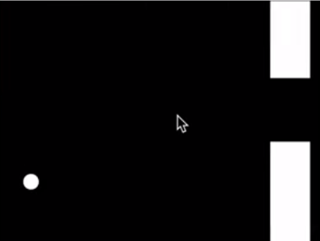
The neural network consists of 4 input nodes, 1 hidden layer and 1 output node. The inputs are – height of the bird, distance of the closest pipe and the top and bottom positions of the closest pipe. Bird has its own brain i.e Neural Network. The activation of the neural network is done by using a sigmoid function This project uses a RNN. Learning rate is given the value of 0.1.
For the implementation of the genetic algorithm, a new criteria of fitness scores are defined. Multiple birds are made to compete with each other in order to get the best neural network. Around 400 birds are running at the same time, each with its own neural network so as to speed up the process of mutation. The bird with a higher fitness score has a better chance of being picked up for becoming the basis of next generation. After each generation ends the neural network from one of the birds is copied and then mutated.
Function Mutate(val):
If Random < rate :
Increment val
Else:
Return val
Map weights and bias accordingly

Results
The project saw a sudden improvement of the neural network with the genetic algorithm as compared with the traditional neural networks. The fitness scores under genetic mutation mutated from 0.001 all the way to 0.6 in extreme cases and 0.4 in moderate cases. After approximately 10 generations the majority of the birds became much better and could easily get a high score.
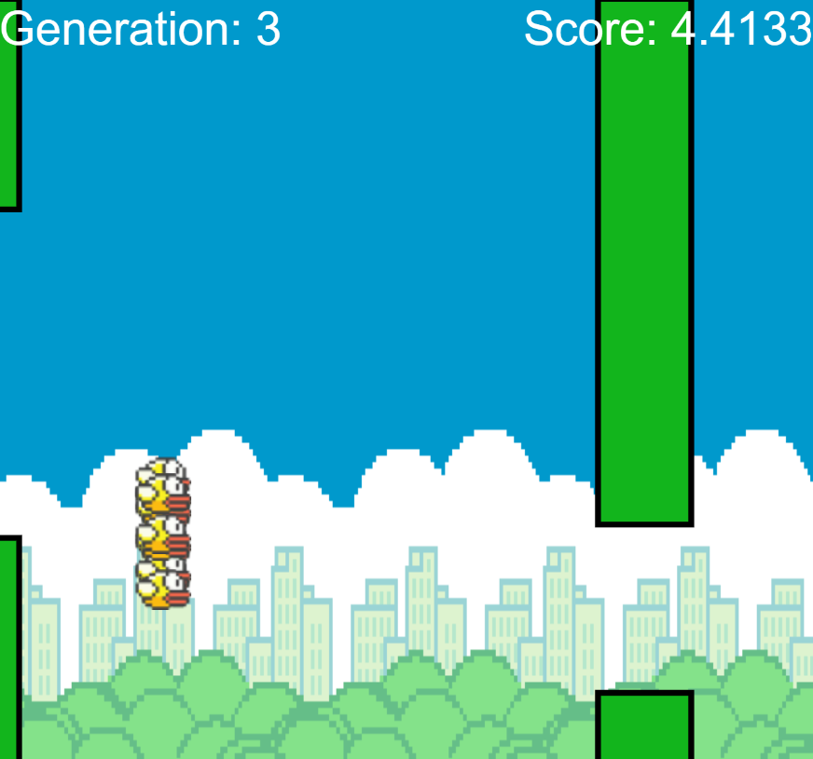

References
- Evolving Neural Networks through Augmenting Topologies
- Evolving Novel Behaviors via Natural Selection
- Evolution 101: Neuroevolution by Danielle Whittaker
- NeuroEvolution on Wikipedia

