To develop and maintain the site we ‘ll use GitHub, which allows for multiple users to make changes and updates easily, with comment on any code change, multiple branches for development and local experimentation and many more. The instructions above refer to the installation of GitHub Desktop for easy usage via GUI instead of the traditional terminal:

* Go to: <https://desktop.github.com/>
  + Click on:



* + Save the .exe file and run it. When the app starts, click on:



* A webpage opens, click on:



* Enter your credentials and click Sign in:

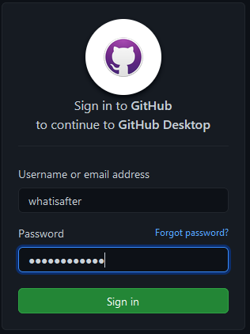

* Allow the site to open the respective links with the GitHub Desktop App. The following screenshots are for Firefox; other browsers follow a similar procedure:
  + Click on “Always allow…” and then “Choose Application”

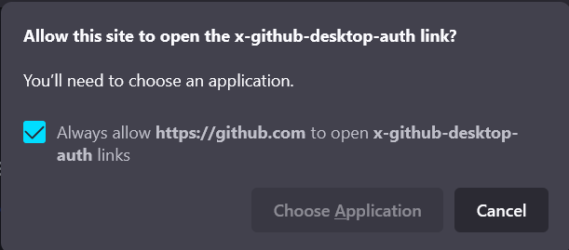

* + Select GitHub Desktop, click on “Always use…” and then “Open Link”:

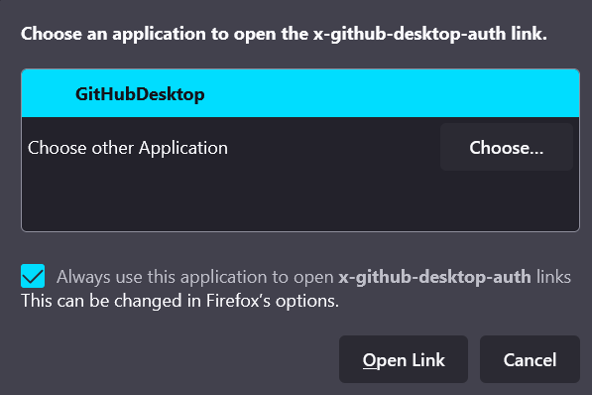

* On the next window, select the appropriate e-mail (in this case [whatisafter@gmail.com](mailto:whatisafter@gmail.com)) and click “Fiinish”:

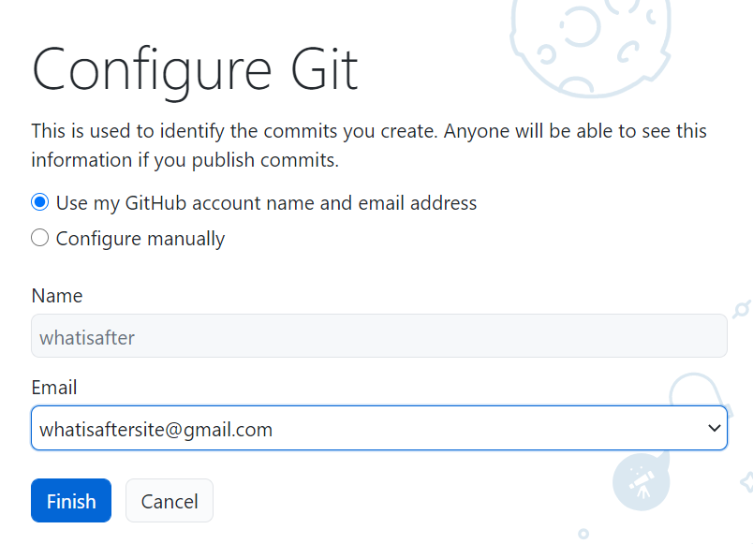

* On the next window, select the desired branch(es) to clone (just the whatisafter/forty-jekyll-theme for now):

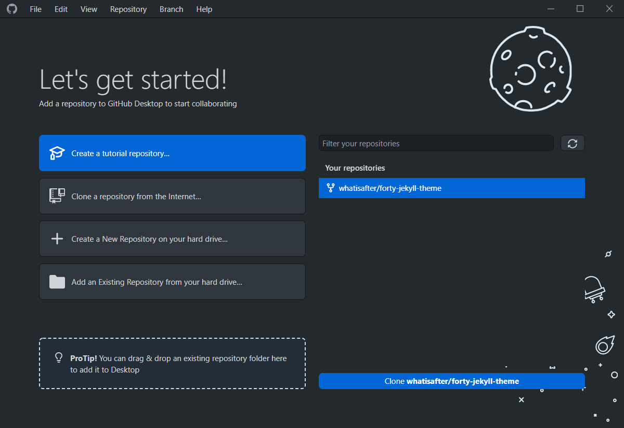

* Choose your desired path for the GitHub folder to be created. The path must end in \GitHub\forty-jekyll-theme:

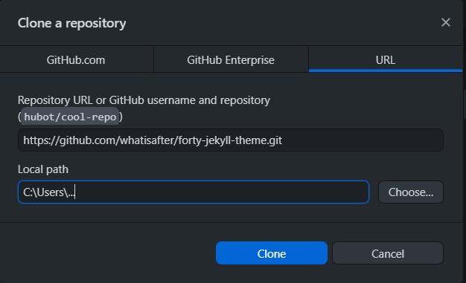

* External repos like the forty-jekyll-theme need to be forked (homemade ones don’t). Select “For my own purposes” and click “Continue”:

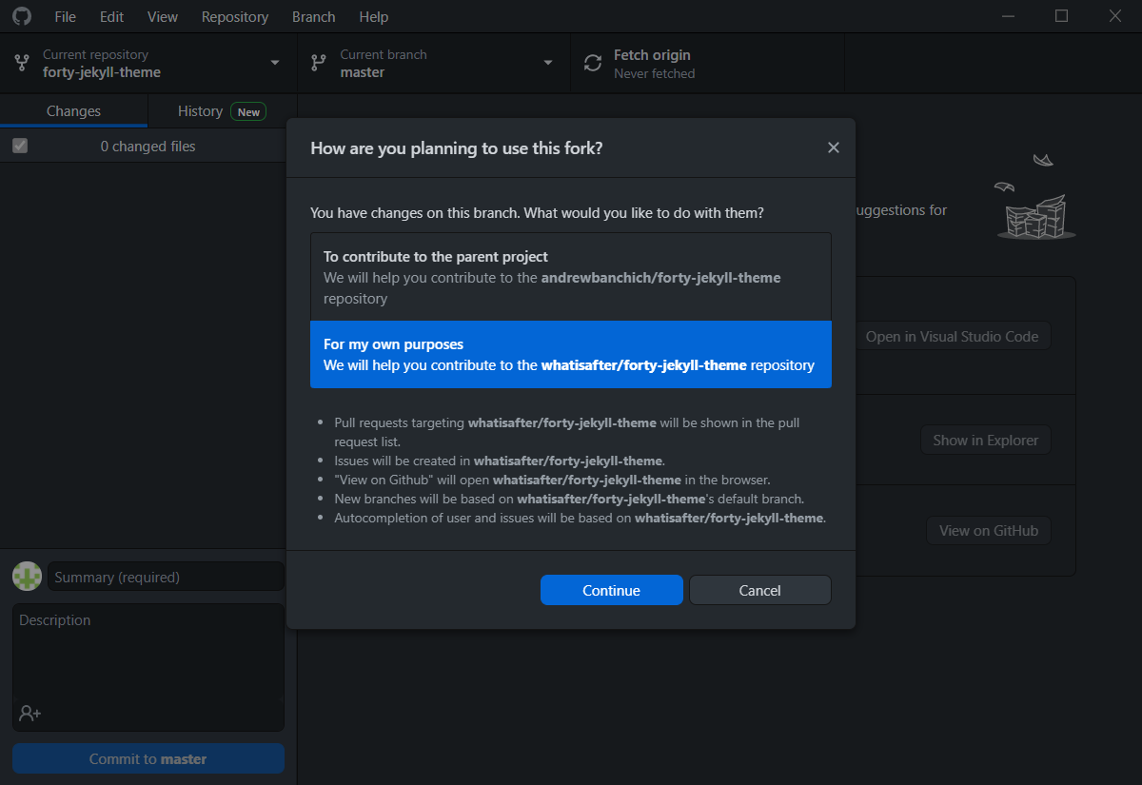

GitHub is now installed and configured ☺

Let’s see the basic usage:

Make a change to a file in the repo folder, to update an element on the site. The change is automatically detected by the GitHub Desktop app. To make the change effective, we need to “push” the changed files to out online repo. To do that:

* Update the summary of the change (use an indicative title), eg: “minor label change”
* Insert in a simple, informative description, eg: “category label change: from “All posts” to “artwork”
* Click “Commit to master”:

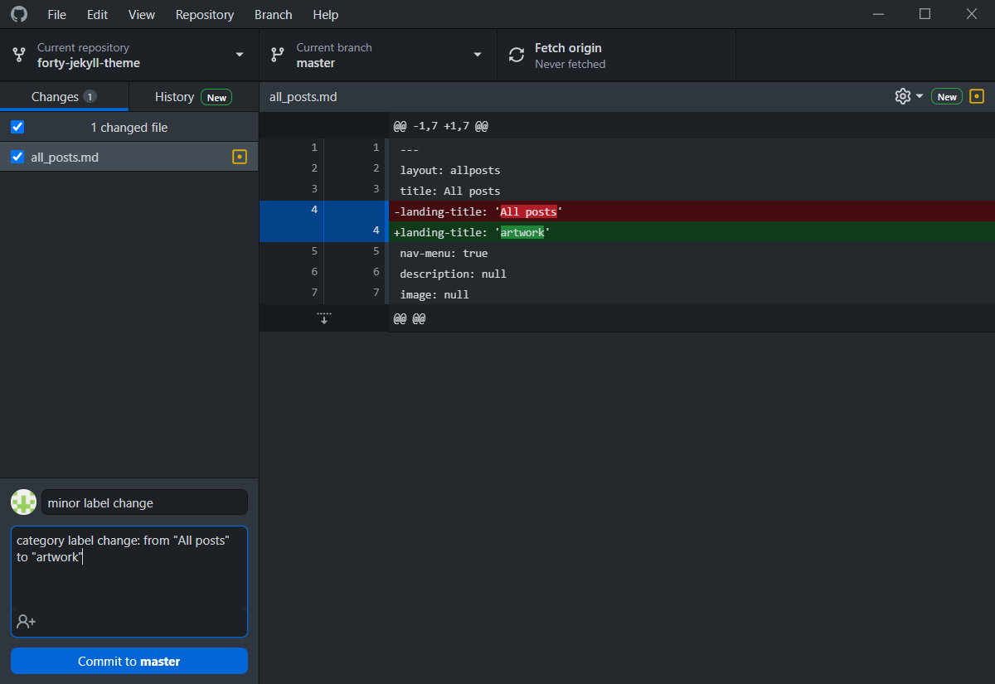

* Click “Push origin”:

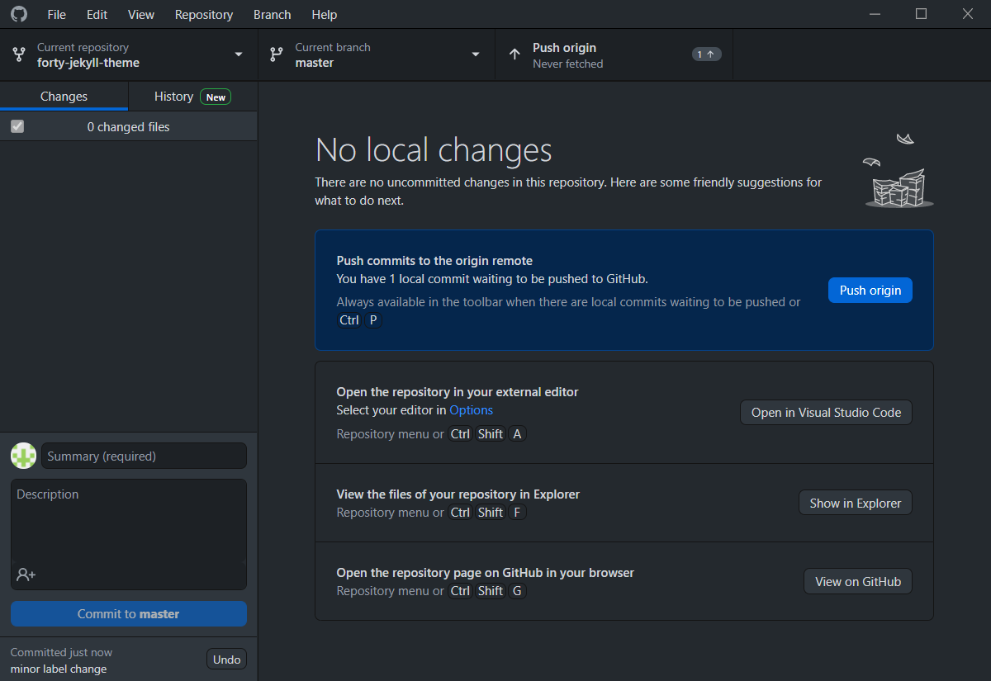

* Wait for a couple of minutes for the change(s) to be visible on the site!

<https://jekyllrb.com/docs/installation/windows/>

Step 1: Go to [RubyInstaller-3.0.1-1 - 2020-04-19](https://github.com/oneclick/rubyinstaller2/releases/tag/RubyInstaller-3.0.1-1)

Save and run the .exe file

Choose “I accept the License” and click Next:

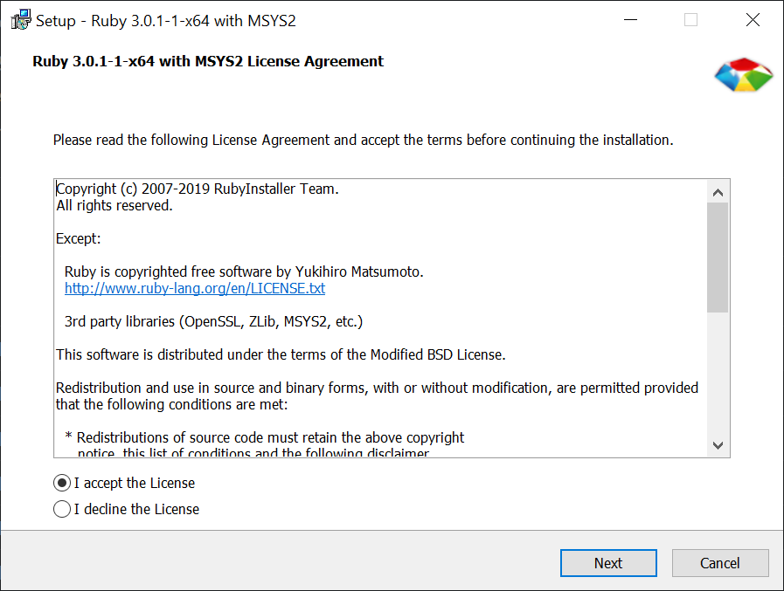

Click Install:

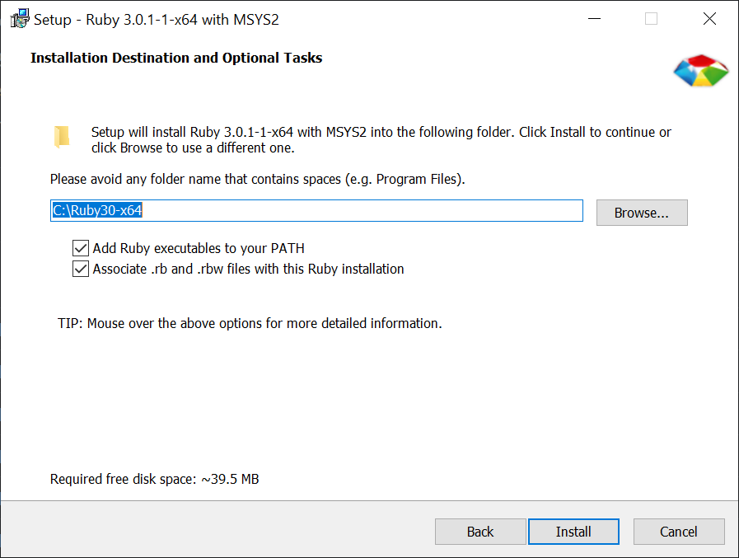

Click Next:

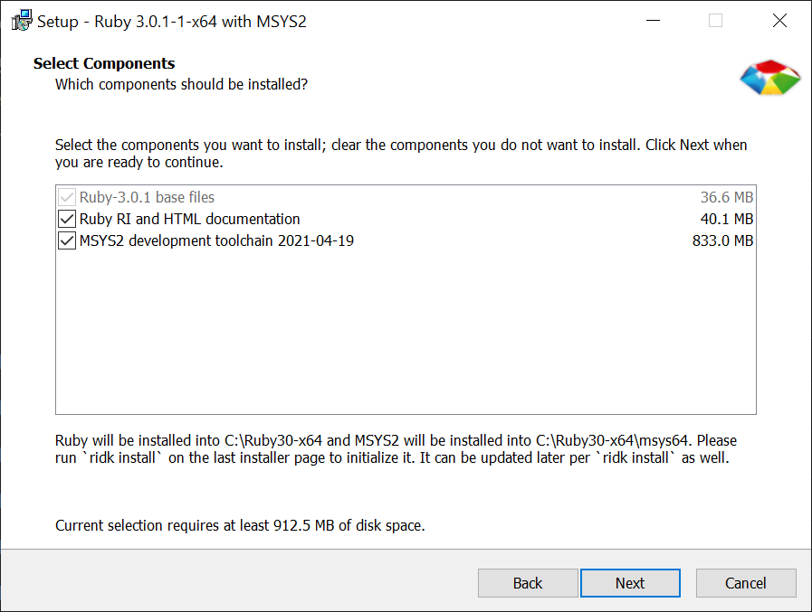

Wait…

On the RubyInstaller2 terminal that pops up, press Enter:

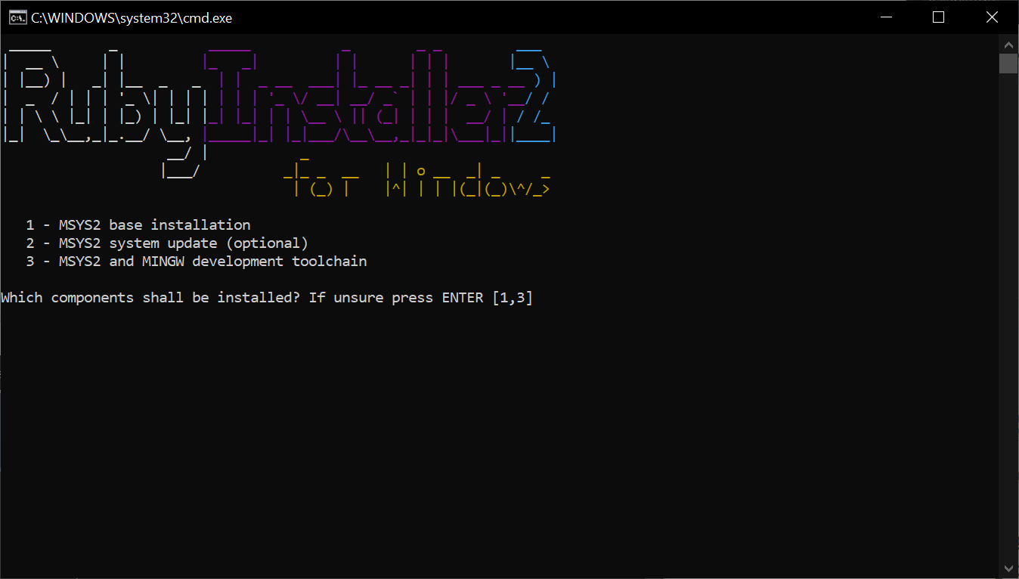

When the installation finishes, press Enter again and the terminal will close:

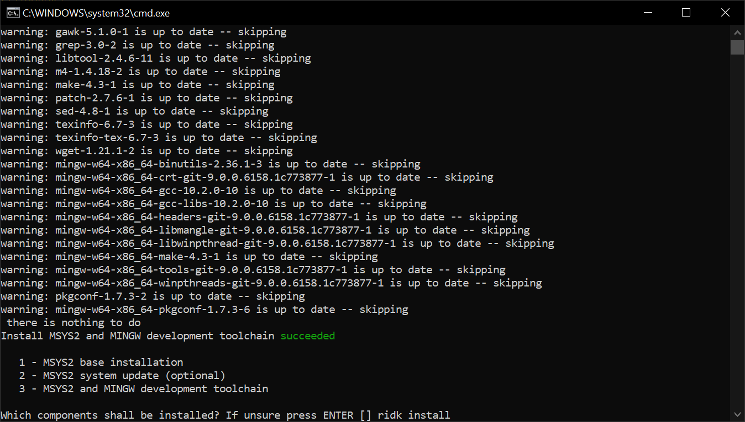

Open a new terminal (Search for cmd or press WinKey + R, type cmd and OK)

Type ”gem install jekyll bundler” and press Enter:

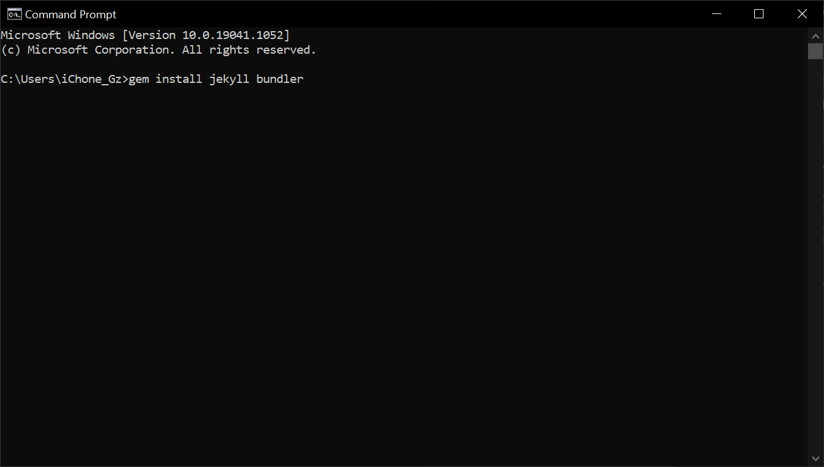

On the same terminal, when the gems installation completes, type jekyll -v and press Enter:

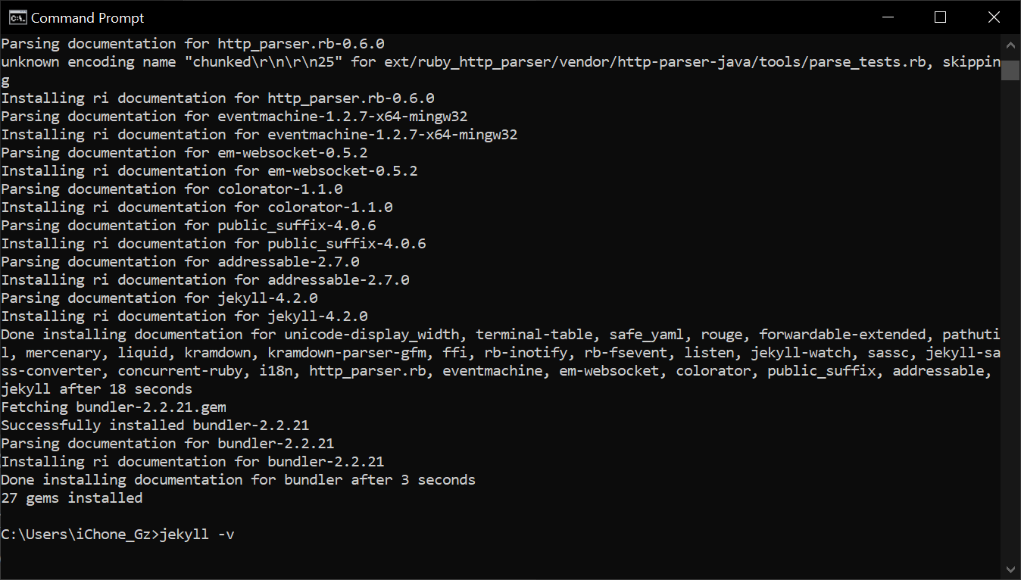

If everything goes as planned, the message Jekyll 4.2.0 is shown.