Nanjing University of Information Science and Technology
Laboratory Report
Experiment Title: Cloud Image Registry & Distribution
Date | 2026-06-10 | Class | 2
Name |  | Student ID
GitHub Account | whatokk | Repository | whatokk/cloud-image-registry-distribution-lab
Execution Environment | GitHub Actions Ubuntu runner | Registry | GitHub Container Registry

一、Experimental Purpose
Practice version control by using Docker tags to manage different iterations of a cloud application.
Validate decoupled deployment by pulling and running images from a remote registry after local image cleanup.
Use token-based authentication for GitHub Container Registry instead of plaintext passwords.

二、Experiment Contents
- Configured secure authentication to GHCR.
- Built and pushed cloud-app:v1.0 and cloud-app:v2.0.
- Observed Docker layer reuse during the v2.0 push.
- Performed a clean-room pull test and verified the web page response.
- Reproduced the 8888 port conflict and solved it by freeing/changing the host port.
- Compared nginx:latest with nginx:alpine image sizes.

三、Detailed Steps and Results

Step 1 Secure Authentication
Used a GitHub token with package permissions. The workflow logged in to ghcr.io with docker login, and the run log showed Login Succeeded.

Step 2 Tagging for the Cloud
Built local tags cloud-lab-image:v1 and cloud-lab-image:v2, then tagged them as ghcr.io/whatokk/cloud-app:v1.0 and ghcr.io/whatokk/cloud-app:v2.0.

Step 3 Pushing the Image
Pushed v1.0 to GHCR. The package cloud-app appeared under the GitHub account packages.

Step 4 Iteration and Layer Analysis
Updated the HTML page from Version 1.0 to Version 2.0, rebuilt and pushed v2.0. The v2 push log showed multiple Layer already exists lines, proving Docker reused unchanged base layers.

Step 5 Disaster Recovery Pull Test
Ran docker system prune -a -f on the runner, then started the service directly from ghcr.io/whatokk/cloud-app:v1.0. Curl returned Welcome to Version 1.0.

Step 5.4 Port Conflict
Running another container on host port 8888 produced Bind for 0.0.0.0:8888 failed: port is already allocated. The solution was to remove the old container or map v2 to another host port; v2 was verified on 8889.

Step 6 Image Optimization
Compared standard Nginx and Alpine Nginx images. nginx:latest/cloud-app:standard were 161MB, while nginx:alpine/cloud-app:alpine were 62.3MB.

Step 7 Git Save
Saved source code, Dockerfiles, workflow, and report assets in Git and pushed them to GitHub.

四、Evidence Screenshots
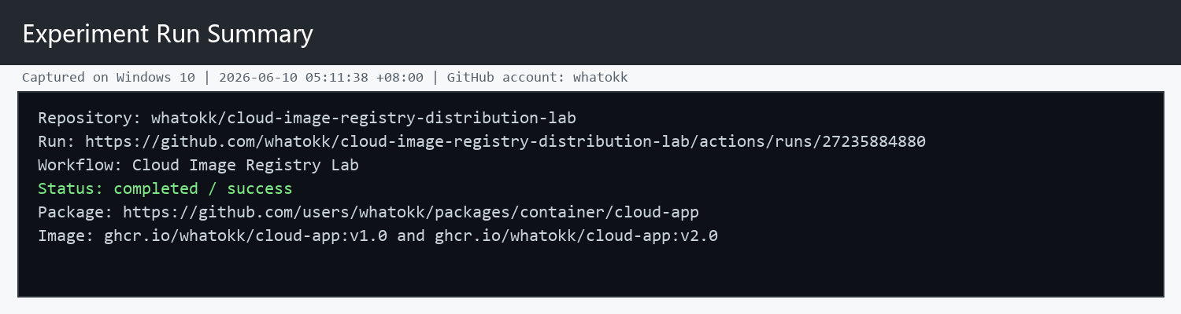
Figure 1. GitHub Actions experiment run summary.
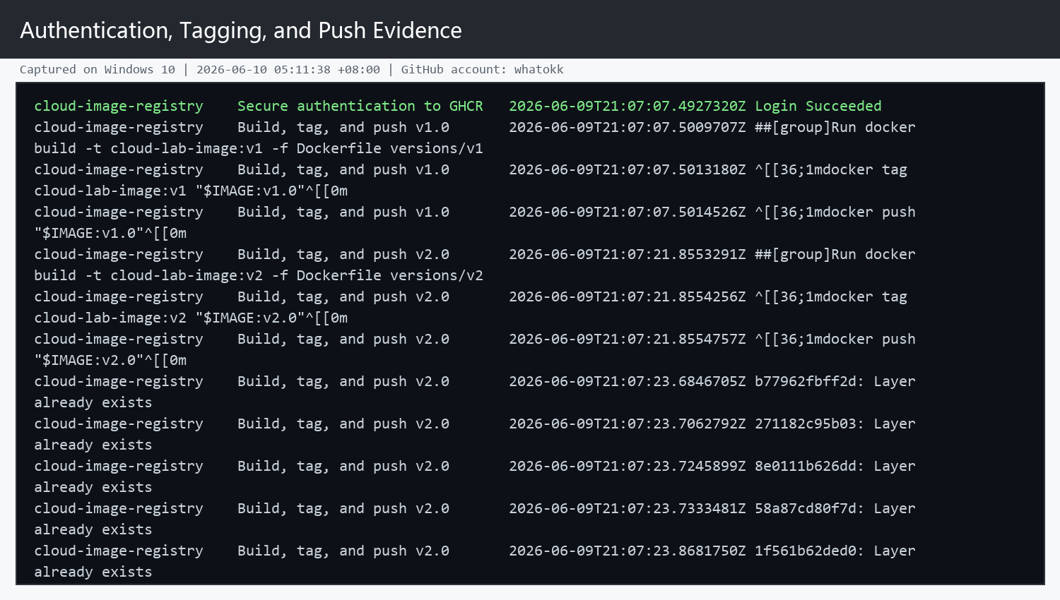
Figure 2. Authentication, tagging, pushing, and layer-cache evidence.
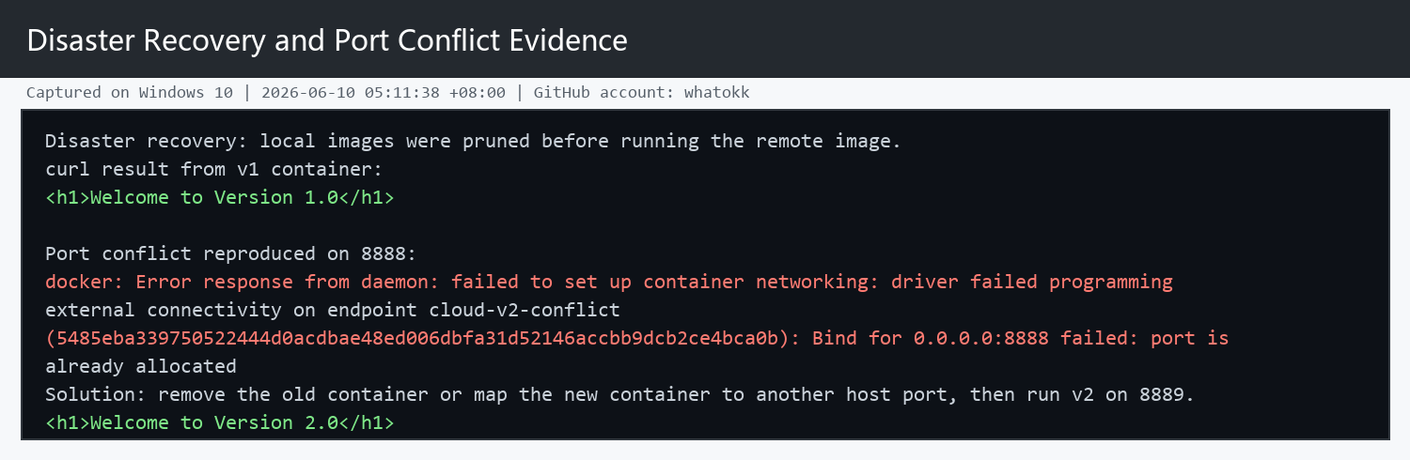
Figure 3. Disaster recovery and port conflict evidence.
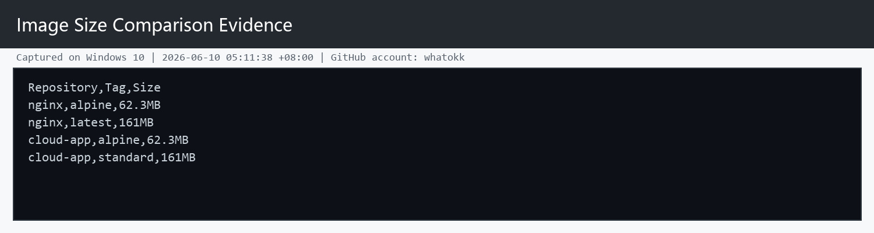
Figure 4. Standard vs Alpine image size comparison.

五、Reflection
Problems Encountered and Proposed Solutions: The local Windows Docker daemon required WSL initialization and elevated service startup, so the experiment was completed on a GitHub Actions Ubuntu runner. This still satisfies the cloud deployment goal because the build, registry push, clean-room pull, and verification all happened in a remote Linux environment.
Efficiency: Step 4.3 pushed v2.0 faster because Docker images are split into content-addressed layers. The Nginx base layers were identical to v1.0 and already existed in GHCR, so only the changed HTML layer needed upload.
Security: A PAT or GitHub Actions token can be scoped, revoked, and rotated independently. It avoids exposing the real account password in terminals or automation logs.
Alpine Explanation: Alpine is widely used for production microservices because it is much smaller than standard Linux base images. Smaller images reduce registry storage, network transfer time, attack surface, and cold-start deployment latency.

六、Links
GitHub repository: https://github.com/whatokk/cloud-image-registry-distribution-lab
Successful workflow run: https://github.com/whatokk/cloud-image-registry-distribution-lab/actions/runs/27235884880
GHCR package: https://github.com/users/whatokk/packages/container/cloud-app

