Software Requirements Specification

Version 1.0

April 21, 2013

What’s App to Eat Android Application

<<Any comments inside double brackets such as these are not part of this SRS but are comments upon this SRS example to help the reader understand the point being made.

Refer to the SRS Template for details on the purpose and rules for each section of this document.

This work is based upon the submissions of the Spring 2013 TINF11B3. The students who submitted these team projects were Thomas Lang, Thomas Franken and Sebastian Bantz. >>

Table of Contents

Table of Contents i
List of Figures ii
1.0. Introduction 2
1.1. Purpose 2
1.2. Scope of Project 2
1.3. References 2
1.4. Overview of Document 2
2.0. Overall Description 3
2.1 System Environment 3
2.2 Functional Requirements Specification 4
Use case: Navigate to Verwalten 4
Use case: Navigate to Suche 5
Use case: Navigate to Einkaufsliste 5
Use case: Add new Recipe 6
Use case: View Recipe List 7
Use case: View Recipe 8
Use case: Delete a Recipe 9
Use case: Edit a Recipe 10
Use case: Search Recipes by Standard algorithm 11
Use case: Search Recipes by Ingredient/s 12
Use case: Add Recipe Ingredients to Shopping List 13
Use case: Delete all Ingredient from Shopping List 14
Use case: Delete Ingredient from Shopping List 15
Use case: Edit quantity of Ingredient from Shopping List 16
3. Appendix 18
Use case Diagram 18
Flow Chart Diagram 18
Screen Overview 18
Rezepte 19
Suche 20
Suche nach Zutaten 21
Einkaufsliste 22
Verwalten 22
Neues Rezept 23
Rezept anzeigen 24
Liste Anzeigen 25

List of Figures

Figure 1 - System Environment 4

1.0. Introduction

1.1. Purpose
The purpose of this document is to present a detailed description of the What’s App to Eat Android Application. It will explain the purpose and features of the system, the interfaces of the system, what the system will do, the constraints under which it must operate and how the system will react to external stimuli. This document is intended for both the stakeholders and the developers of the system.

1.2. Scope of Project
To get an Overview over the scope of this project, please refer to the Use Case Diagram in the appendix.

1.3. References
IEEE. IEEE Std 830-1998 IEEE Recommended Practice for Software Requirements Specifications. IEEE Computer Society, 1998.

1.4. Overview of Document
The next chapter, the Overall Description section, of this document gives an overview of the functionality of the product. It briefly explains every use case in our scope including an activity diagram.
The Appendix holds all additional resources needed for our project such as flow charts and use case diagrams which do not appear in the overall description of our project.

2.0. Overall Description

2.1 System Environment
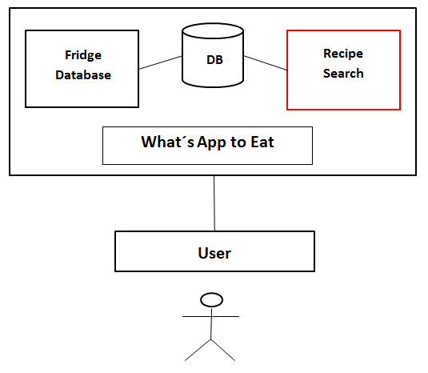
Figure 1 - System Environment

The What’s App to Eat Android Application has one active actor, one database and is divided into two separate systems. This SRS covers only the Recipe Search system.
The User can access the entire system directly.
<< The two systems of the application complement each other in their functionality but are programmed by two groups. The separation into two systems was made so that both groups could work on one system independently. >>

2.2 Functional Requirements Specification
This section outlines the use cases of the What’s App to Eat Android Application.

Use case: Navigate to Verwalten
Activity Diagram:

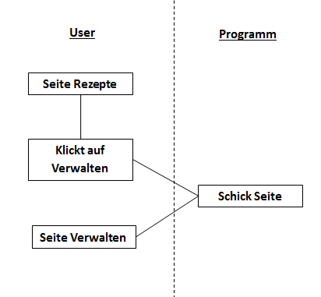

Brief Description

In order to manage my recipes
As a user
I want to navigate to Verwalten

Given I am in Rezepte
When I click on Verwalten
Then I should see the screen Verwalten
And there should be a Liste anzeigen button
And there should be a Neuer Eintrag button

Use case: Navigate to Suche
Activity Diagram:

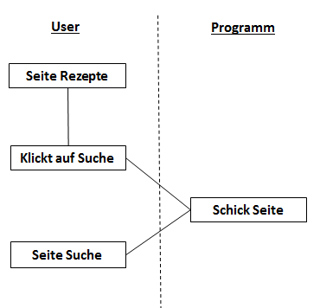

Brief Description

In order to search for a recipe
As a User
I want to navigate to Suche

Given I am in Rezepte
When I click on Suche
Then I should see the screen Suche
And there should be a Algemeine Suche button
And there should be a Zutatensuche button

Use case: Navigate to Einkaufsliste
Activity Diagram:

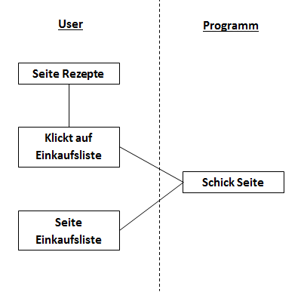

Brief Description

In order to see my shopping list
As a User
I want to navigate to Einkaufsliste

Given I am in Rezepte
When I click on Einkaufsliste
Then I should see the sreen Einkaufsliste
And it should contain all the ingredients which are currently in my list
And there should be an edit button for each entry
And there should be a delete button for each entry
And there should be a Einkaufsliste leeren button

Use case: Add new Recipe
Activity Diagram:

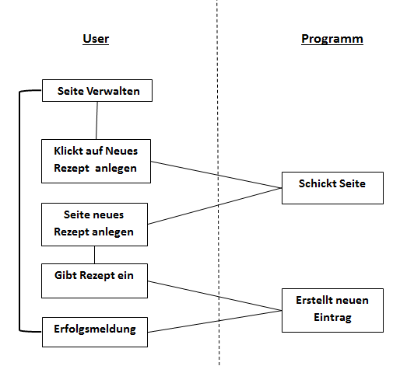

Brief Description

In order to add a new recipe
As a user
I want to create a new recipe

Given I am in Verwalten
When I click on Neues Rezept Anlegen
Then I should see a recipe page
And it should be empty
And I should be able to edit the input fields

Given I am on the recipe page
And all mandatory fields are filled out
When I click on anlagen
Then I should see a success message
And I should see the screen Verwalten

Use case: View Recipe List
Activity Diagram:

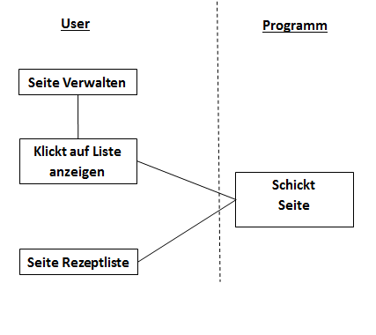

Brief Description

In order to see all my recipes
As a user
I want to open my recipe list

Given I am in Verwalten
When I click on Liste Anzeigen
Then I should see a Rezept Liste
And it should contain all the recipes
And there should be a show button for each entry
And there should be an edit button for each entry
And there should be a delete button for each entry

Use case: View Recipe
Activity Diagram:
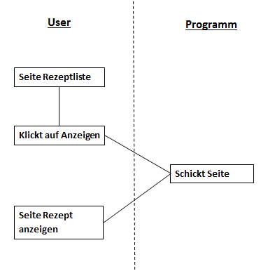

Brief Description

In order to see the ingredients of a recipe
As a user
I want to be shown the details of a recipe

Given I am in Rezeptliste
When I click on anzeigen
Then I should see a screen Rezept anzeigen
And it should contain the details of the recipe I selected
And there should be a Einkaufsliste button

Use case: Delete a Recipe
Activity Diagram:

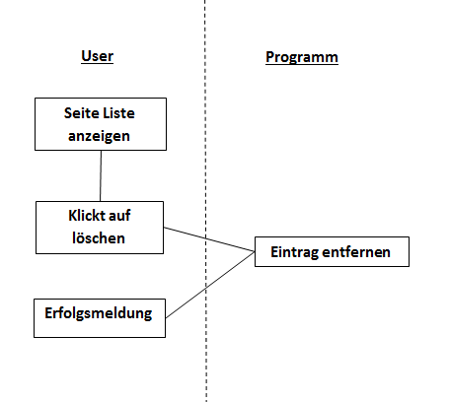

Brief Description

In order to get rid of recipes I don’t like
As a user
I want to delete a recipe

Given I am in Liste anzeigen
When I click on löschen
Then I should see a success message

Use case: Edit a Recipe
Activity Diagram:

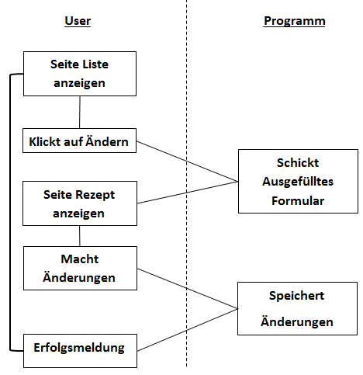

Brief Description

In order to change a recipe to my liking
As a user
I want to edit a recipe

Given I am in Liste anzeigen
When I click on edit
Then I should see the recipe page
And I should be able to edit the entries

Use case: Search Recipes by Standard algorithm
Activity Diagram:

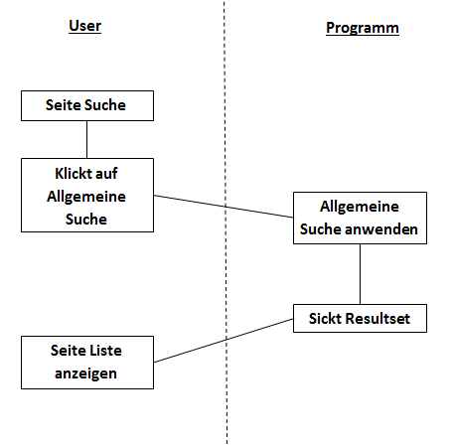
Brief Description

In order to get all the recipes for which I have all ingredients in my fridge
As a user
I want to perform a simple search

Given I am in Suche
When I click on Allgemeine Suche
Then I should see a Rezept Liste
And it sould contain all the recipes I can cook

Use case: Search Recipes by Ingredient/s
Activity Diagram:

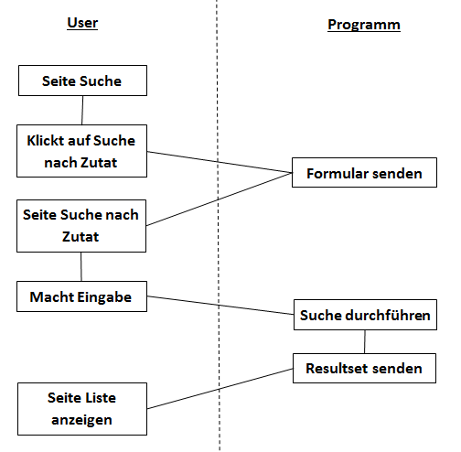

Brief Description

In order to get all the recipes which contain one or more specific ingredient
As a user
I want to perform a search with the ingredient/s the recipe should contain

Given I am in Suche
When I click on Zutatensuche
Then I should see the input screen
And I should be able to edit all entry fields

Given I am in Input Screen
And all input fields are filled out
When I click on Suche
Then I should see a Rezept Liste
And it should contain all the recipes matching my search criteria

Use case: Add Recipe Ingredients to Shopping List
Activity Diagram:

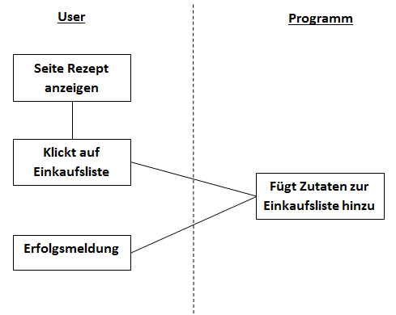

Brief Description

In order to remember all the ingredients I need to buy for a specific recipe
As a user
I want to add all the ingredients of a recipe to my shopping list

Given I am in Rezept anzeigen
When I click on In Einkaufsliste
Then I should see a success message

Use case: Delete all Ingredient from Shopping List
Activity Diagram:

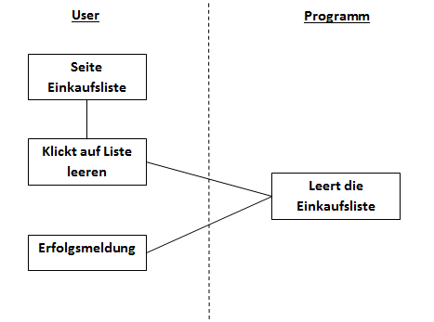

Brief Description

In order to quickly empty my shopping list
As a user
I want to delete my entire shopping list with one button

Given I am in Einkaufsliste
When I click on Liste leeren
Then I should see a success essage
And the list should be empty

Use case: Delete Ingredient from Shopping List
Activity Diagram:

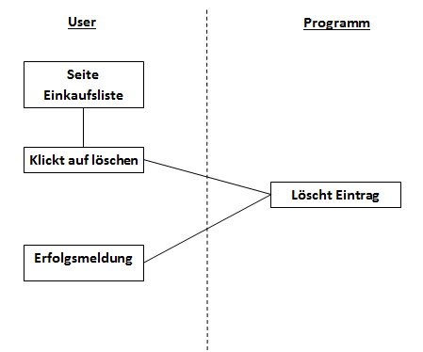

Brief Description

In order to delete a single ingredient from my shopping list
As a user
I want to delete that specific ingredient

Given I am in Einkaufsliste
When I click on löschen
Then I should see a success message

Use case: Edit quantity of Ingredient from Shopping List
Activity Diagram:

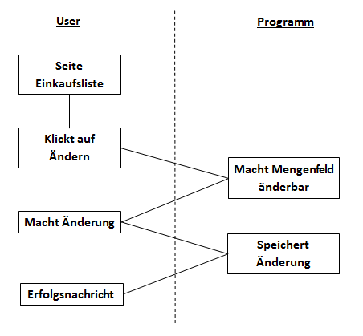

Brief Description

In order to adjust the quantity of the ingredients in my shopping list
As a user
I want to edit the quantity field of my shopping list

Given I am in Einkaufsliste
When I click on Ändern
Then I the quantity field of the entry I selected should be editable

Given I am in Einkaufsliste
And I have edited the quantity field of an entry
When I click on ok
Then I should see a success message

3. Appendix

Use case Diagram
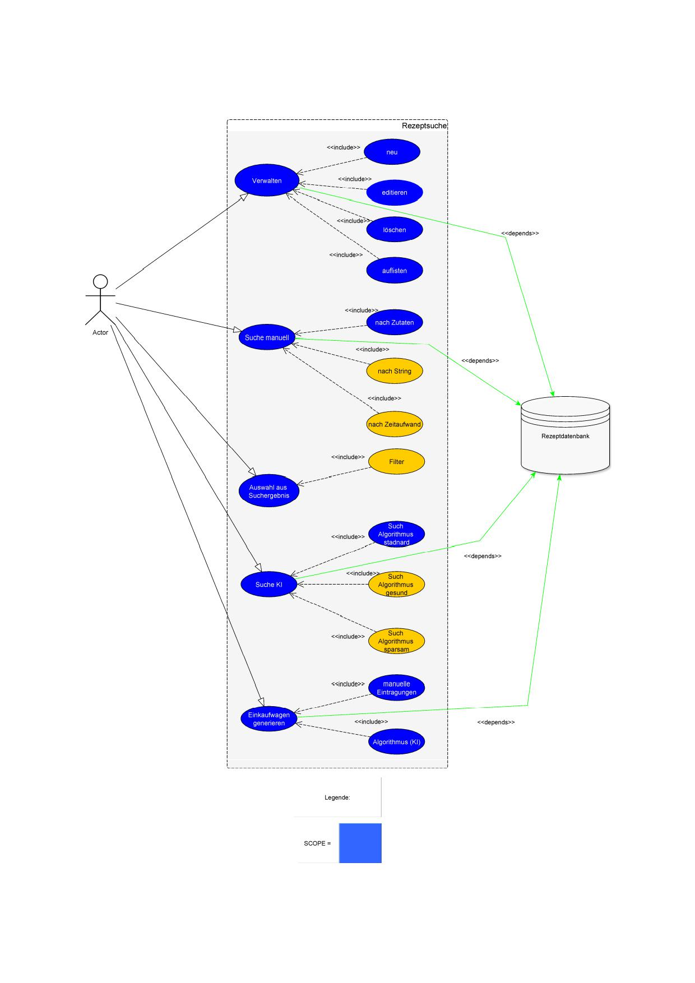

Flow Chart Diagram

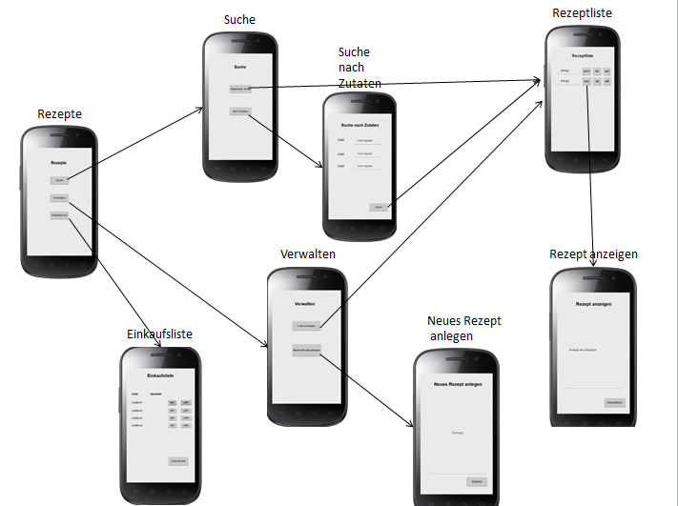

Screen Overview

Rezepte
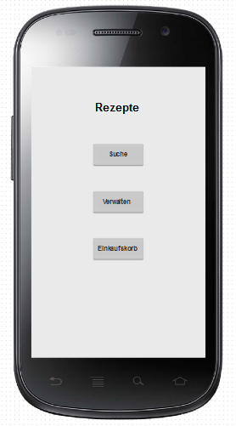

Suche
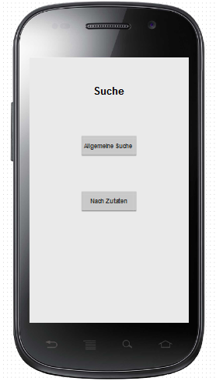

Suche nach Zutaten
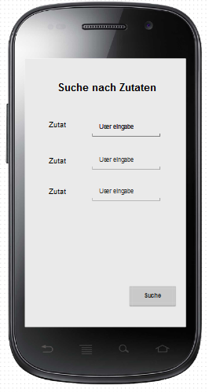

Einkaufsliste
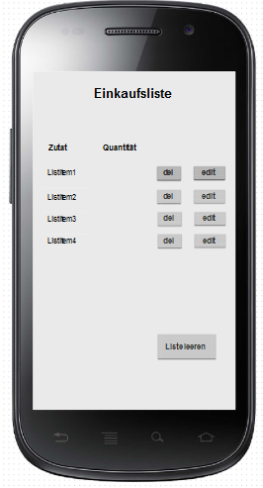

Verwalten

Neues Rezept
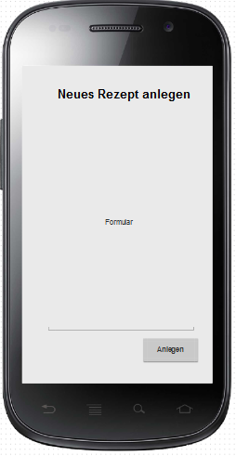

Rezept anzeigen
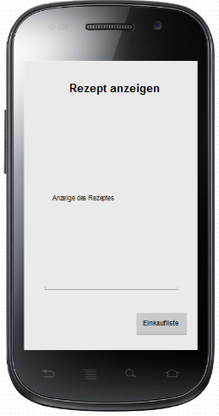

Liste Anzeigen
