Help file

1.Paste Apache Tomcat in Any one Drive
2.Set environment variable in My computer Properties

JAVA_HOME : C:\Program Files\Java\jdk1.6.0_01
Path : C:\Program Files\Java\jdk1.6.0_01\bin
CATALINA_HOME: E:\apache-tomcat-6.0.18

3. Copy that project folder “code” and paste the below path
E:\apache-tomcat-6.0.18\webapps

4. install software’s

1. Install my sql set up 5.0
2. Install mysql administrator
3. Install navicat8lite_mysql_en

After finished installed all s/w
Open navicat8lite_mysql_en window
Create new database at shop
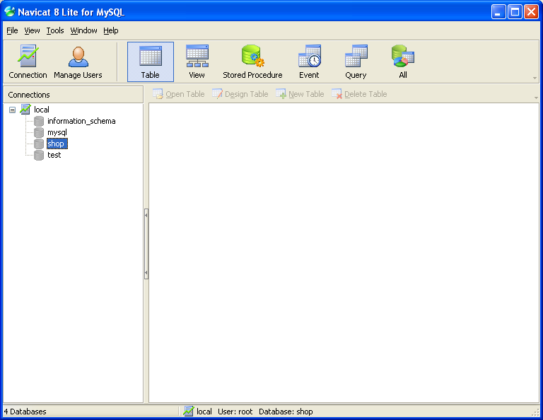

Open mysql administrator
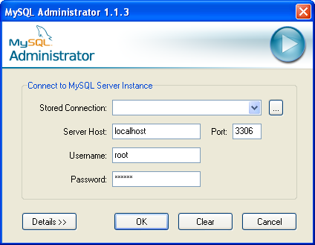

Click restores

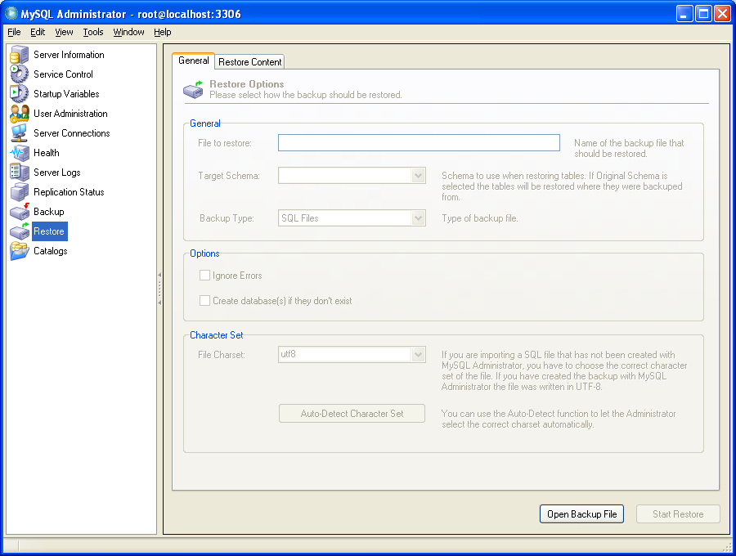

Open given backup file for shop.sql and click start restore button

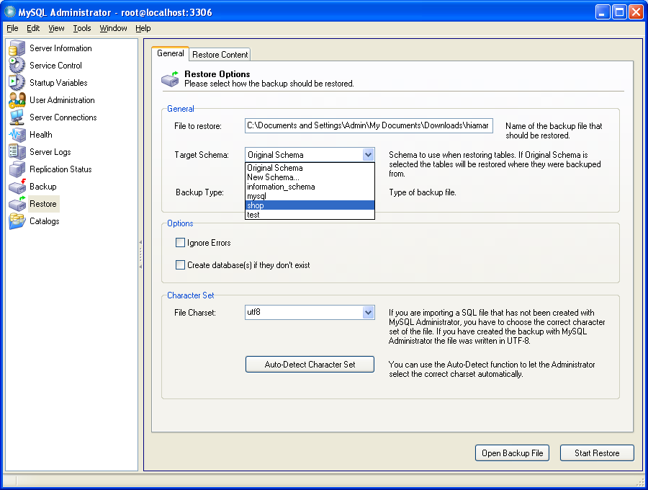

6. Start the tomcat-Go to apache tomcat folder--→bin-→Shutdown-→Startup--→ Then open Browser-→ Type the URL
http://localhost:8080/auctide/s

