Location Based Routing for Mobile ad-hoc network

External interfaces requirement

user interfaces: java Swing

hardware interfaces: Any pentium based machine

software interfaces: jdk1.5.0 and MS access

Communication interface : java net package

function requirements

dfd four level

level 0 :

Node1

Node2

Node3

Node 4

level 1 : core Resolution
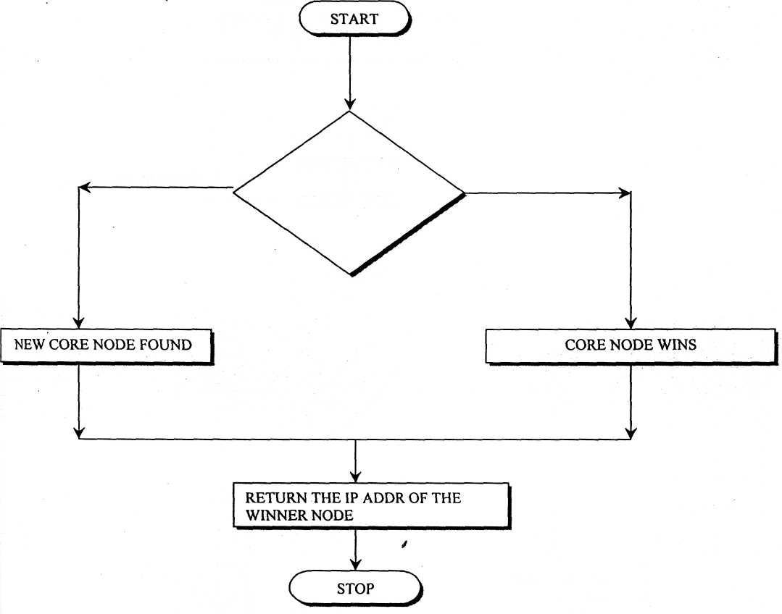
IS MY.IPADDR
> COREIPADDR

level2 : Expand ring search
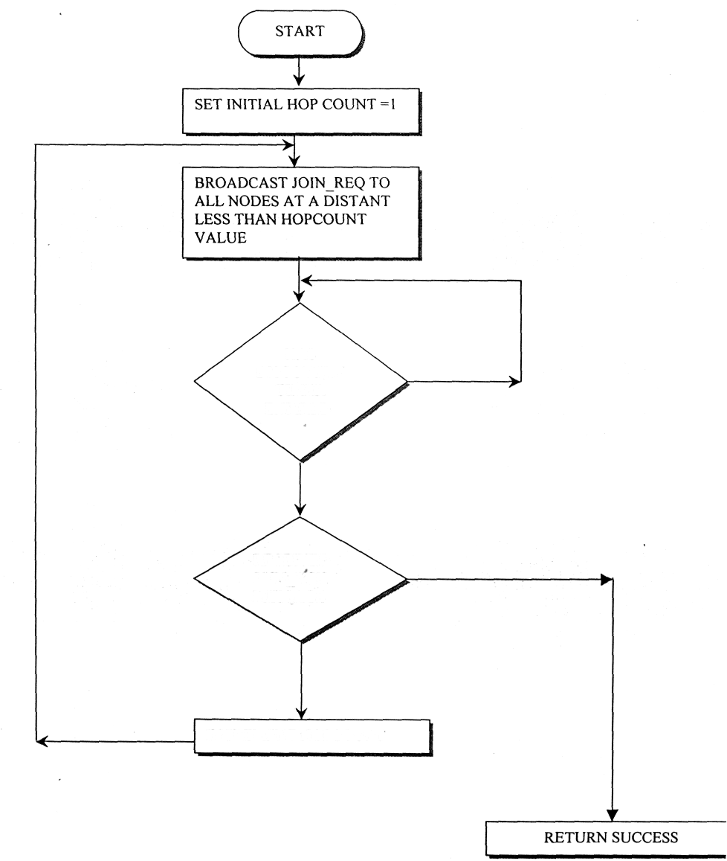

HAS DISCOVERY
TIMER EXPIRED
RECEIVED JOIN_ACK MESSAGE
INCREMENT HOPCOUNT
level 2

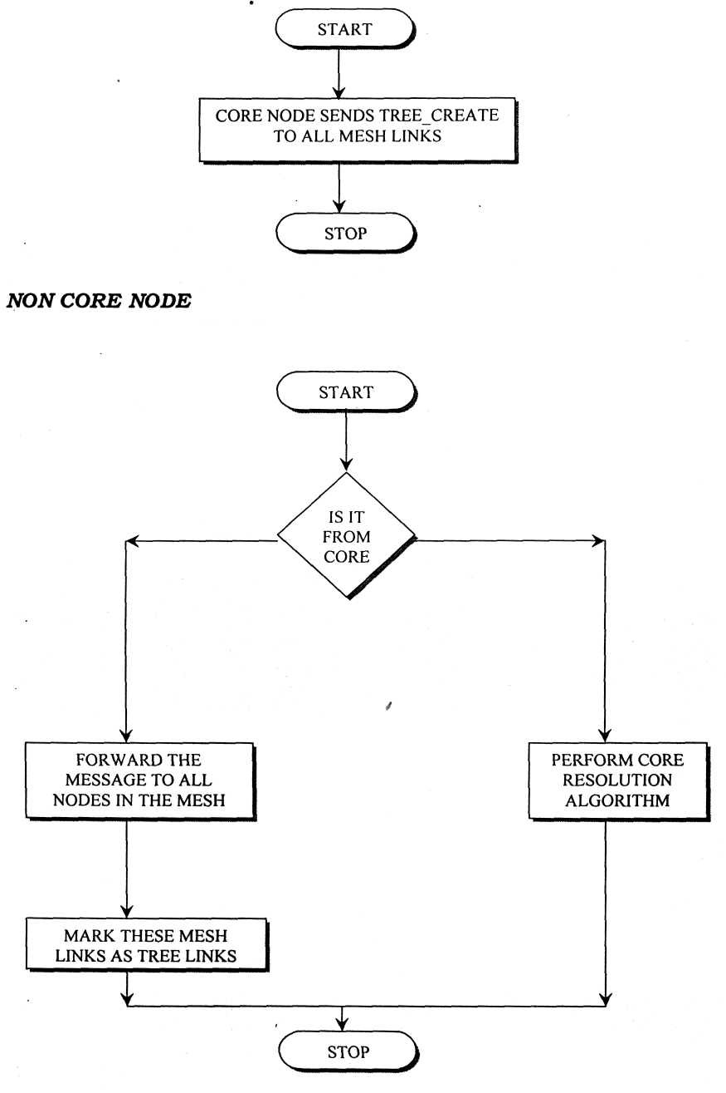

Information Flow
User
Route Discover
Check node
Core Node
Recore
Transmission

Encrypt

Decrypt

Process Description

Process 1
To initiate the Route Discovery, node transmits a "Route Request" as a single local broadcast packet, which is received by (approximately) all nodes currently on the transmission range of, including node. Each Route Request identifies the initiator and target of the Route Discovery, and also contains a unique request identification determined by the initiator of the Request. Each Route Request also contains a record listing the address of each intermediate node through which this particular copy of the Route Request has been forwarded.

Process 2
After route discovery, to find the core node of the system then compares code node and user defined node in core class. If the core node and user defined destination node are same then it transmit the file to the corresponding destination node

Process 3
When originating or forwarding a packet using a source route, each node transmitting the packet is responsible for confirming that data can flow over the link from that node to the next hop.
Process 4
- Source sends the encrypted data packet to the destination through the route discovered.
- Destination decrypts the data packet received from the source and sends the acknowledgement.

Performance Requirements
- Minimum four terminals
Design constrains
- It takes more time for transmission.

Software Attributes
- Reliability
- Portability
- Security

