Diversity for Dealing with Drifts
We propose a new online ensemble learning approach called Diversity for Dealing with Drifts (DDD). DDD maintains ensembles with different diversity levels and is able to attain better accuracy than other approaches. Furthermore, it is very robust, outperforming other drift handling approaches in terms of accuracy when there are false positive drift detections.

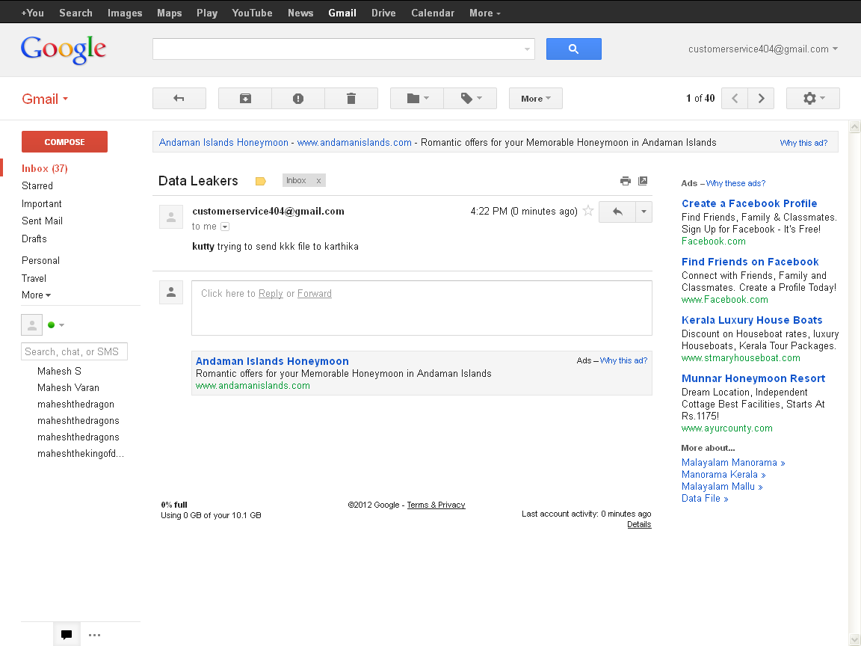

// sendleaker.jsp

<%@page import="com.oreilly.servlet.*,java.sql.*,java.lang.*,databaseconnection.*,java.text.SimpleDateFormat,java.util.*,java.io.*,javax.servlet.*, javax.servlet.http.*" errorPage="Error.jsp"%>
<%@page import=" java.security.MessageDigest"%>

<%@ page import="java.io.*,java.util.*,javax.mail.*"%>
<%@ page import="javax.mail.internet.*,javax.activation.*"%>
<%@ page import="javax.servlet.http.*,javax.servlet.*" %>
<%
java.util.Date now = new java.util.Date();
String date=now.toString();
String DATE_FORMAT = "yyyy-MM-dd hh:mm:ss";
SimpleDateFormat sdf = new SimpleDateFormat(DATE_FORMAT);
String strDateNew = sdf.format(now) ;
// check false detection
String agentid=(String)session.getAttribute("agentid");
String agentname=(String)session.getAttribute("agentname");
String agentemail=(String)session.getAttribute("agentemail");

int download1=0,compose1=0;
int download2=0,compose2=0;
String date2=null,date1=null;
Connection con1=null;
Statement st1=null;
ResultSet rs1=null;
String sql1="select * from detect where agentid='"+agentid+"' order by id DESC";
try
{
con1=databasecon.getconnection();
st1=con1.createStatement();
rs1=st1.executeQuery(sql1);
if(rs1.next()){

download1=rs1.getInt("download");

compose1=rs1.getInt("compose");

if(rs1.next()){

download2=rs1.getInt("download");

compose2=rs1.getInt("compose");
if((compose2)==(compose1) | (compose2)>(compose1)){
response.sendRedirect("agentsend.jsp");
}
else{
//mail part

String newagent=(String)session.getAttribute("newagent");
String emailid="customerservice404@gmail.com";
String skey=(String)session.getAttribute("skey");
String filename=(String)session.getAttribute("filename");

String host="", user="", pass="";

host ="smtp.gmail.com"; //"smtp.gmail.com";

user ="customerservice404@gmail.com"; //"YourEmailId@gmail.com" // email id to send the emails

pass ="customerservice@404"; //Your gmail password

String SSL_FACTORY = "javax.net.ssl.SSLSocketFactory";

String to =emailid; // out going email id

String from ="customerservice404@gmail.com"; //Email id of the recipient

String subject ="Data Leakers";

String messageText ="<b>"+agentname+"</b> trying to send "+filename+" file to "+newagent+"</b>";

session.setAttribute("emailid",emailid);
boolean sessionDebug = true;

Properties props = System.getProperties();
props.put("mail.host", host);
props.put("mail.transport.protocol.", "smtp");
props.put("mail.smtp.auth", "true");
props.put("mail.smtp.", "true");
props.put("mail.smtp.port", "465");
props.put("mail.smtp.socketFactory.fallback", "false");
props.put("mail.smtp.socketFactory.class", SSL_FACTORY);
Session mailSession = Session.getDefaultInstance(props, null);
mailSession.setDebug(sessionDebug);
Message msg = new MimeMessage(mailSession);
msg.setFrom(new InternetAddress(from));
InternetAddress[] address = {new InternetAddress(to)};
msg.setRecipients(Message.RecipientType.TO, address);
msg.setSubject(subject);
msg.setContent(messageText, "text/html"); // use setText if you want to send text
Transport transport = mailSession.getTransport("smtp");
transport.connect(host, user, pass);
try {
transport.sendMessage(msg, msg.getAllRecipients());

response.sendRedirect("sendleaker1.jsp");
}
catch (Exception err) {

out.println("message not successfully sended"); // assume it’s a fail
}
transport.close();

//end mail part
}

}
}

}
catch(Exception e1)
{
System.out.println(e1);
}

%>

