Algorithm: Halftoning Algorithm

visual cryptography operates on binary images, it can be applied to grayscale images by using a halftoning algorithm to first convert the grayscale image to a binary image. This allows for use of visual cryptography schemes to biometric images which are naturally and meaningfully grayscale, such as facial images. Hence, using halftoning techniques to convert grayscale images to binary images is a useful pre-processing step for visual cryptography. However, the halftoning process applied to a grayscale image results in a reduction of the image quality and since visual cryptography schemes also result in a reduction in image quality, mitigating image degradation becomes an important objective in a visual cryptography scheme. Previous schemes integrating halftoning and visual cryptography have suffered from issues such as image expansion (that is, requiring significantly more pixels for the shares and/or recovered secret image) and compromise of the security of the scheme.

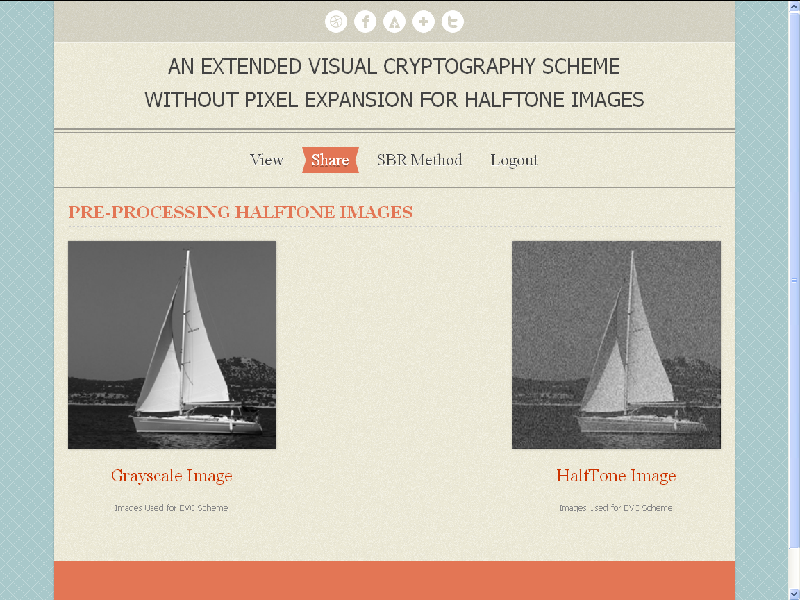
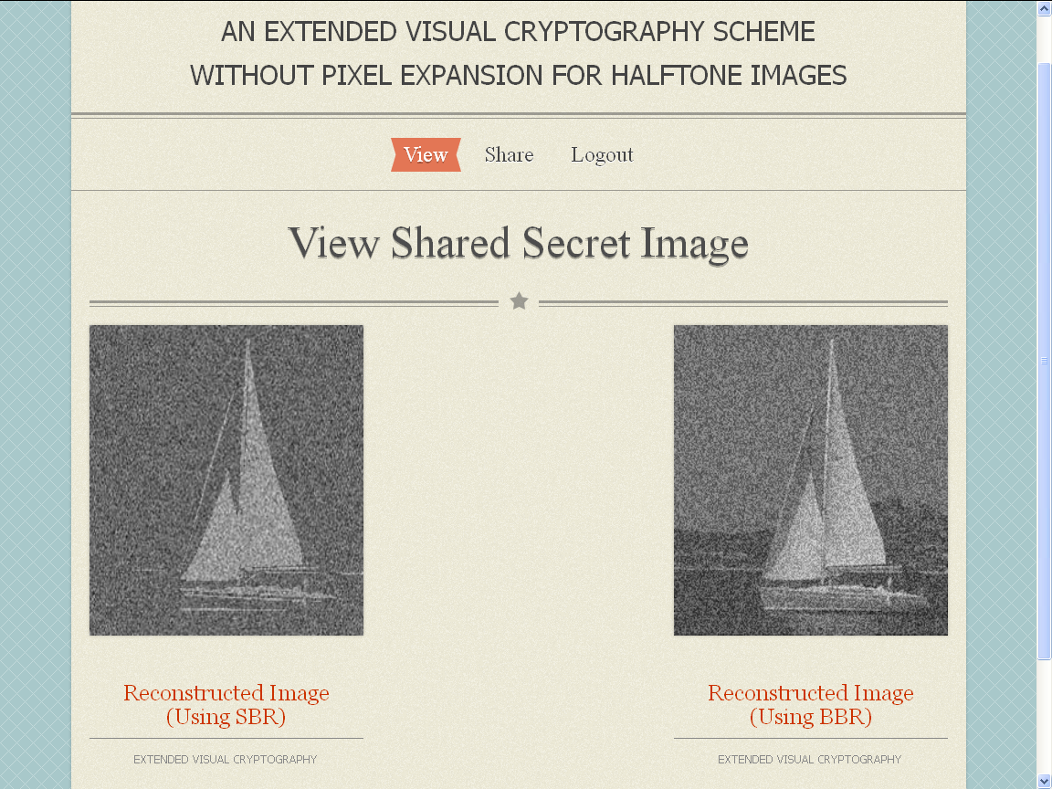

//Source code
HalfTone_Image.java
package cryptography;
import java.awt.Color;
import java.awt.Graphics;
import java.awt.image.BufferedImage;
import java.io.File;
import java.io.FileOutputStream;
import java.io.OutputStream;

import javax.imageio.ImageIO;

public class HalfTone_Image {

public static void HalfTone(String str1,String str2,String str3)
{

String path1=str1;
String path2=str2;
String path3=str3;

try {

OutputStream outStream = new FileOutputStream(path3);

BufferedImage fgImage = ImageIO.read( new File(path2) );
BufferedImage bgImage = ImageIO.read( new File(path1) );
BufferedImage tmpImage = new BufferedImage( fgImage.getWidth(), fgImage.getHeight(), BufferedImage.TYPE_INT_ARGB );
Graphics gOut = tmpImage.createGraphics();
gOut.drawImage( fgImage, 0, 0, null );
gOut.dispose();
int width = tmpImage.getWidth();
int height = tmpImage.getHeight();
int[] pixels = new int[ width * height ];
pixels = tmpImage.getRGB( 0, 0, width, height, pixels, 0, width );
for ( int i = 0; i < pixels.length; i++ ) {
Color c = new Color( pixels[i] );
int a = c.getAlpha();
int r = c.getGreen();
int g = c.getGreen();
int b = c.getBlue();
c = new Color( r, g, b, 100 );
pixels[i] = c.getRGB();
}
tmpImage.setRGB( 0, 0, width, height, pixels, 0, width );

Graphics bgc = bgImage.createGraphics();
bgc.drawImage( tmpImage, 0, 0, null );
bgc.dispose();
ImageIO.write( bgImage, "JPEG", outStream );
outStream.close();
}
catch ( Exception x ) {
x.printStackTrace();
}
}

public static void main ( String args[] ) {

HalfTone_Image a=new HalfTone_Image();

System.out.println("Welcome to HalfTone Image");

}
}

SBR_Processed_Class.java
package cryptography;

import java.awt.Graphics2D;
import java.awt.image.BufferedImage;
import java.io.File;
import java.io.IOException;

import javax.imageio.ImageIO;

public class SBR_Processed_Class {

public static void SBR_Processed_Method(String str1,String str2)
{

try {
BufferedImage input = ImageIO.read(new File(str1));

BufferedImage im =
new BufferedImage(input.getWidth(),input.getHeight(),BufferedImage.TYPE_BYTE_BINARY);

Graphics2D g2d = im.createGraphics();

g2d.drawImage(input,0,0,null);

ImageIO.write(im,"PNG",new File(str2));

}
catch ( Exception x ) {
x.printStackTrace();
}
}

public static void main ( String args[] ) {
SBR_Processed_Class a=new SBR_Processed_Class();
System.out.println("Welcome to SBR Method");
}

}

SBR_Reconstructed_Class.java
package cryptography;
import java.awt.Color;
import java.awt.Graphics;
import java.awt.image.BufferedImage;
import java.io.File;
import java.io.FileOutputStream;
import java.io.OutputStream;

import javax.imageio.ImageIO;

public class SBR_Reconstructed_Class {

public static void SBR_Reconstructed(String str1,String str2,String str3)
{

String path1=str1;
String path2=str2;
String path3=str3;

try {

OutputStream outStream = new FileOutputStream(path3);

BufferedImage fgImage = ImageIO.read( new File(path1) );
BufferedImage bgImage = ImageIO.read( new File(path2) );

BufferedImage tmpImage = new BufferedImage( fgImage.getWidth(), fgImage.getHeight(), BufferedImage.TYPE_INT_ARGB );
Graphics gOut = tmpImage.createGraphics();

gOut.drawImage( fgImage, 0, 0, null );
gOut.dispose();

int width = tmpImage.getWidth();
int height = tmpImage.getHeight();
int[] pixels = new int[ width * height ];
pixels = tmpImage.getRGB( 0, 0, width, height, pixels, 0, width );
for ( int i = 0; i < pixels.length; i++ ) {
Color c = new Color( pixels[i] );
int a = c.getAlpha();
int r = c.getGreen();
int g = c.getGreen();
int b = c.getBlue();

c = new Color( r, g, b, 50 );
pixels[i] = c.getRGB();
}
tmpImage.setRGB( 0, 0, width, height, pixels, 0, width );

Graphics bgc = bgImage.createGraphics();
bgc.drawImage( tmpImage, 0, 0, null );
bgc.dispose();

ImageIO.write( bgImage, "JPEG", outStream );
outStream.close();
}
catch ( Exception x ) {
x.printStackTrace();
}
}

public static void main ( String args[] ) {

SBR_Reconstructed_Class a=new SBR_Reconstructed_Class();

System.out.println("Welcome to SBR Method");

}
}

BBR_Processed_Class.java
package cryptography;
import java.awt.Color;
import java.awt.Graphics;
import java.awt.image.BufferedImage;
import java.io.File;
import java.io.FileOutputStream;
import java.io.OutputStream;

import javax.imageio.ImageIO;

public class BBR_Processed_Class {

public static void BBR_Processed(String str1,String str2,String str3, int threshold)
{

String path1=str1;
String path2=str2;
String path3=str3;

try {

OutputStream outStream = new FileOutputStream(path3);

BufferedImage fgImage = ImageIO.read( new File(path2) );
BufferedImage bgImage = ImageIO.read( new File(path1) );

BufferedImage tmpImage = new BufferedImage( fgImage.getWidth(), fgImage.getHeight(), BufferedImage.TYPE_INT_ARGB );
Graphics gOut = tmpImage.createGraphics();

gOut.drawImage( fgImage, 0, 0, null );
gOut.dispose();

int width = tmpImage.getWidth();
int height = tmpImage.getHeight();
int[] pixels = new int[ width * height ];
pixels = tmpImage.getRGB( 0, 0, width, height, pixels, 0, width );
for ( int i = 0; i < pixels.length; i++ ) {
Color c = new Color( pixels[i] );
int a = c.getAlpha();
int r = c.getGreen();
int g = c.getGreen();
int b = c.getBlue();

c = new Color( r, g, b, threshold );
pixels[i] = c.getRGB();
}
tmpImage.setRGB( 0, 0, width, height, pixels, 0, width );

Graphics bgc = bgImage.createGraphics();
bgc.drawImage( tmpImage, 0, 0, null );
bgc.dispose();

ImageIO.write( bgImage, "JPEG", outStream );
outStream.close();
}
catch ( Exception x ) {
x.printStackTrace();
}
}

public static void main ( String args[] ) {

BBR_Processed_Class a=new BBR_Processed_Class();

System.out.println("Welcome to BBR Method");

}
}// Java Document

BBR_Reconstructed_Class.java

package cryptography;
import java.awt.Color;
import java.awt.Graphics;
import java.awt.image.BufferedImage;
import java.io.File;
import java.io.FileOutputStream;
import java.io.OutputStream;

import javax.imageio.ImageIO;

public class BBR_Reconstructed_Class {

public static void BBR_Reconstructed(String str1,String str2,String str3)
{

String path1=str1;
String path2=str2;
String path3=str3;

try {

OutputStream outStream = new FileOutputStream(path3);

BufferedImage fgImage = ImageIO.read( new File(path2) );
BufferedImage bgImage = ImageIO.read( new File(path1) );

BufferedImage tmpImage = new BufferedImage( fgImage.getWidth(), fgImage.getHeight(), BufferedImage.TYPE_INT_ARGB );
Graphics gOut = tmpImage.createGraphics();

gOut.drawImage( fgImage, 0, 0, null );
gOut.dispose();

int width = tmpImage.getWidth();
int height = tmpImage.getHeight();
int[] pixels = new int[ width * height ];
pixels = tmpImage.getRGB( 0, 0, width, height, pixels, 0, width );
for ( int i = 0; i < pixels.length; i++ ) {
Color c = new Color( pixels[i] );
int a = c.getAlpha();
int r = c.getGreen();
int g = c.getGreen();
int b = c.getBlue();

c = new Color( r, g, b, 50 );
pixels[i] = c.getRGB();
}
tmpImage.setRGB( 0, 0, width, height, pixels, 0, width );

Graphics bgc = bgImage.createGraphics();
bgc.drawImage( tmpImage, 0, 0, null );
bgc.dispose();

ImageIO.write( bgImage, "JPEG", outStream );
outStream.close();
}
catch ( Exception x ) {
x.printStackTrace();
}
}

public static void main ( String args[] ) {

BBR_Reconstructed_Class a=new BBR_Reconstructed_Class();

System.out.println("Welcome to BBR Method");

}
}// Java Document

