Mechanism: Encryption & Decryption Algorithm
Ensuring the usefulness of electronic data sources while providing necessary privacy guarantees is an important unsolved problem. So here we are using the following algorithm for encrypting the privacy and decrypting it. So as it ensure privacy guarantees.

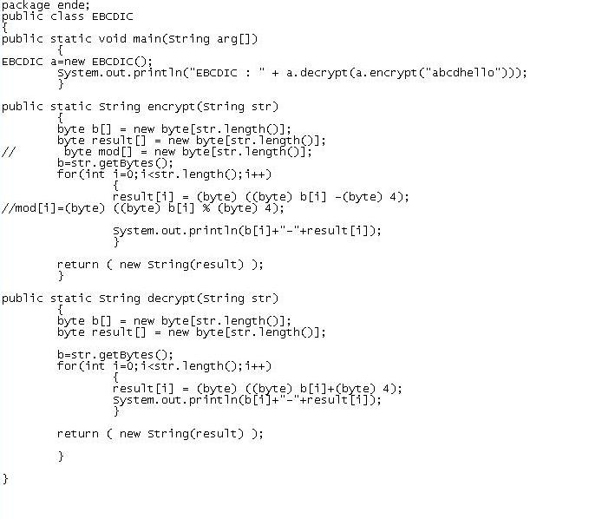

Screen Shots:

