**User-Oriented FEC Decoding Scheme for Wireless Sensor Networks with Star Topologies**

**ABSTRACT:**

In recent years, wireless sensor networks (WSNs) have attracted a great deal of research attention from both academia and industry. In most cases, WSNs employ the adaptive forward error correction (FEC) coding schemes dynamically adapting to the channel, while paying less attention to user’s requirements. Sometimes, the decoding delay and the decoding performance of WSNs are more crucial than the power consumption for users. We propose an FEC decoder for the trade-off among decoding delay, complexity, and performance according to user’s needs. The proposed decoder designed for short packet transmission is a two-stage hybrid decoder (TSHD) including a serial min-sum decoder and an adaptive list decoder. For hard decision decoding, our simulation results show that the proposed TSHD scheme outperforms the existing schemes with less average complexity.

**EXISTING SYSTEM:**

Wireless sensor networks (WSNs) are widely used in industry, medical assistance, video surveillance, etc. In WSNs, a large number of small sensor nodes are deployed surround the sensed object to collect data for users. The most important challenge is to design sensors efficiently to minimize the wireless sensor resource. In order to lower the decoding latency and reduce the transmitting power, WSNs tend to include an forward error correction (FEC) coding to avoid retransmissions.

Traditionally, LDPC decoders and trellis decoders are performed separately based on their own code structures, since convolutional codes decoded by BP algorithms directly always results in poor performance, this is mainly due to a large number of short cycles (especially 4-cycles) in its parity check matrix. In our previous work, we proposed a method to design systematic feed-forward convolutional codes with no 4-cycles (SFCC-N4) which has a sparse parity check matrix and is suitable for BP decoding. In this paper, we try to combine the LDPC decoder and the trellis decoder together for application in star-WSNs.

**PROPOSED SYSTEM:**

In our proposed scheme, the SFCC-N4 code is used as the encoder and its associated decoder is a two-stage hybrid decoder (TSHD) with a modified serial min-sum decoder and an adaptive list decoder. The TSHD has several merits such as adaptive optimization, low average computation without performance loss, suitable for short packet transmissions. As we will show, the TSHD has a good trade-off among complexity, decoding delay, and performance.

**ARCHITECTURE:**

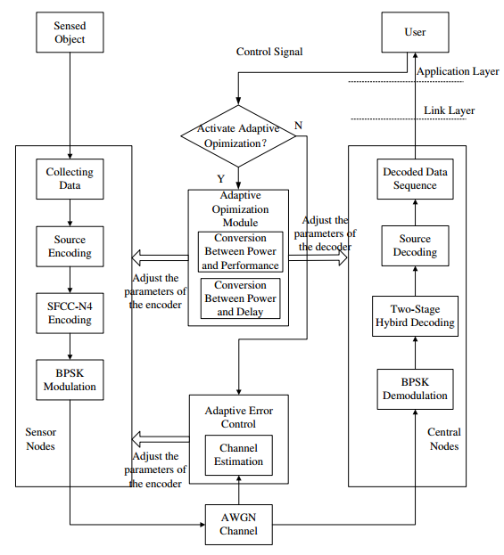

# Module Description:

1. **Source Encoding and decoding**

A regular binary (2N,J,2J) LDPC code with J ”1”s in each column and 2J ”1”s in each row can be described by a sparse parity check matrix H of size M × 2N . The minsum algorithm is composed of two phases of message passing, i.e., the variable-to-check node message passing L(qnm ) and the check-to-variable node message passing L(r mn). L(q n ) denotes the a posteriori log-likelihood ratio (LLR) of variable n. L(p n ) represents the a priori LLR of variable n. Moreover, N (m) = {n|h mn = 1} denotes the set of variable nodes connecting to check node m, and M (n) = {m|h mn = 1} denotes the set of check nodes connecting to variable node n. N (m)\{n} represents the set N (m) other than variable node n, similarly, M (n)\{m} represents the set M (n) other than check node m.

**B. SFCC-N4 Encoding:**

The systematic feed-forward convolutional codes with no 4-cycles (SFCC-N4) which has a sparse parity check matrix and is suitable for BP decoding. we try to combine the LDPC decoder and the trellis decoder together for application in star-WSNs. In our proposed scheme, the SFCC-N4 code is used as the encoder and its associated decoder is a two-stage hybrid decoder (TSHD) with a modified serial min-sum decoder and an adaptive list decoder.

**C. THE TWO-STAGE HYBRID DECODER:**

In TSHD, the first stage employs low complexity modified serial min-sum decoder to explore the received vector, and the second stage applies the powerful M-algorithm to correct rest errors. In the modified serial min-sum decoder, the variable nodes are updated one-by-one in sequence and a check node is activated whenever its message is demanded by a neighboring variable node. At the first stage, the modified serial min-sum decoder generates a binary estimated coded sequence, which might not be a valid codeword. Whenever the path departs from a valid codeword at trellis depth t (or time t), the adaptive list decoder applies M-algorithm to re-decode the erroneous segment from time t ′ to t by extending the single path to Mp survivor paths, where Mp is the list size of the M-algorithm decoder.

# System Configuration:-

# H/W System Configuration:-

# System : Pentium IV 2.4 GHz.

# Hard Disk  : 40 GB.

# Floppy Drive : 1.44 Mb.

# Monitor : 15 VGA Colour.

# Mouse : Logitech.

# Ram : 512 MB.

# S/W System Configuration:-

* Operating System : Windows 95/98/2000/XP/7/8
* Front End : Java Swing
* Technology used : Java.

**Conclusion:**

In this paper, an FEC scheme was presented for the tradeoff among decoding delay, complexity, and performance according to user’s needs. The proposed scheme combining two decoders without interleaver has at least three merits:

1) Adaptive optimization;

2) Low average computation without performance loss;

3) Suitable for short packet transmissions.

The adaptive list decoder is superior to the single Malgorithm decoder with small survivor paths. Compared with SMAD in medium-to-high SNR region, the ALD has noticeable computational savings by hard decision decoding without performance loss. Moreover, the adaptive optimization mechanism makes TSHD suitable for WSNs applications.

**References:**

[1] I. F. Akyildiz, W. Su, Y. Sankarasubramaniam, and E. Cayirci, “A survey on sensor networks,” IEEE Commun. Magazine, vol. 40, no. 8, pp. 102–114, Aug. 2002.

[2] S. Howard, K. Iniewski, and C. Schlegel, “Error control coding in low-power wireless sensor networks: When is ECC energy-efficient?” EURASIP Journal on Wireless Communications and Networking, pp. 1–14, Apr. 2006.

[3] J. A. Gutierrez, M. Naeve, E. Callaway, M. Bourgeois, V. Mitter, and B. Heile, “IEEE 802.15.4: A developing standard for low-power, lowcost wireless personal area networks,” EURASIP Journal on Wireless Communications and Networking, vol. 15, no. 5, pp. 12–19, Sep. 2001.

[4] E. shih, S. Cho, N. Ickes, R. Min, A. Sinha, A. Wang, and A. Chandrakasan, “Physical layer driven protocol and algorithm design for energy-efficient wireless sensor networks,” ACM SIGMOBILE’01, pp. 272–287, July 2001.

[5] Y. Sankarasubramaniam, I. F. Akyildiz, and S. W. McLaughlin, “Energy efficiency based packet size optimization in wireless sensor networks,” IEEE International Workshop on Sensor Network Protocols and Applications, 2003, pp. 1–8, 2003.