Radiologist’s Assessment of the Rules to Create Synthetic Structured Reports
Contributed by Ana Miguel Simões, Radiology Resident at ULS Trás-os-Montes e Alto Douro
Template Review: Rectal Cancer Staging
This assessment reflects my perspective as a practicing radiologist, grounded in current clinical practice and updated MRI staging concepts based on the 2025 rectal cancer MRI review (https://pubmed.ncbi.nlm.nih.gov/39772798/ - referred to as article 2025 from now on). I aim to clarify the rationale behind recommended modifications to the current structured template and propose an updated version for discussion. Please note that my comments are not framed from the perspective of model development, so some explanations may seem overly detailed. You are encouraged to extract only what is relevant for your application.
Local Tumour Status
- Morphology – I believe that in this point there should be two “sections”, because when we speak about “composition” (not a scientific term) of a tumour we classify it as “solid/mucinous” and when we speak about “morphology” we write about “polypoid/semi-annular/annular” (annular = circumferential). In the article 2025, they add a point whether a tumour is mucinous or not, which is also interesting.
- The lower pole of the tumour can also be referred as distal tumour boundary or lower tumour border.
- We should add a topic about “Distance from anal verge to distal tumour border”, which allows the estimation of the location of the tumour in the low, mid or high rectum (distances from 0 to 5 cm, 5.1 cm to 10 cm and 10.1 cm to 15 cm, respectively). The distance from anorectal junction in more pertinent in low rectal tumours due to the potential surgical impact. Both distances should be routinely mentioned.
- In T staging:
  - We usually cannot distinguish in MRI if a tumour is T1 or T2, so these are classified together (T1-T2)
  - In T3 staging, we can measure the distance of extension beyond the muscularis propria, so we can specify the subclassification of a, b, c or d. However, it can be difficult to precisely indicate this measurement, so that it why some articles group a with b and c with d (referring to the groups that have different prognostic implications), but I believe we can assume options for all 4 subcategories.
  - It is important to subclassify a tumour in T4a (peritoneal/peritoneal reflection invasion) or T4b (other structures/organs invasion).
- There are some considerations about involvement of the peritoneum, since a tumour can only be T4a if it is an anterior/lateral tumour above the anterior peritoneal reflection – I believe these rules are defined further on.
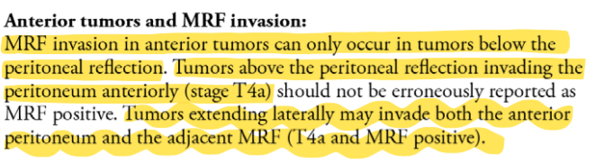
- In T4b tumours, it is essential to indicate which are the invaded structures.
- The concern about sphincteric invasion is valid in tumour involving the low rectal region, especially with staging ≥T3, so I redid that topic. Furthermore, there are some nuances concerning the impact of sphincteric complex involvement and T-staging – for example, the involvement of the internal sphincter doesn’t have an impact on T staging (but it has surgical implications, so it must be mentioned); on the other hand, involvement of the external sphincter implies a T4b staging.
- Concerning MRF involvement, the most recent cutoff for “clear/involved” is > 1 mm and ≤ 1 mm of distance between the primary tumour (that should be ≥T3)/EMVI/tumour deposit and the MRF, respectively. So, “threatened” is a previous classification that is now considered outdated. When we say that MRF is clear, we can indicate the minimum distance from the tumour/EMVI/tumour deposit and the MRF, but I believe it is not mandatory. When the MRF is involved, we should indicate where the point of contact is in the clock position. And, in line with what I mentioned previously, MRF should only be considered involved where there is MRF - posteriorly if above the anterior peritoneal reflection or in any position below it.
N-staging
- Concerning lymph nodes, there are some relevant points considering its location and criteria for suspicion:
  - Regional lymph nodes include:
    - Mesorectal lymph nodes – in which the described criteria apply (size cutoffs of 5 and 9 mm, malignant morphologic characteristics…).
    - Extramesorectal lymph nodes (specifically obturator and internal iliac nodes) – only size is important (≥7 mm), so morphologic criteria are not relevant.
  - Non-regional lymph nodes (inguinal, external iliac, common iliac, …) – are considered metastatic disease (M in the TNM criteria).
  - We should also indicate the level of the most cranial suspicious lymph node, since it can affect the radiotherapy field. However, from what I can recall, it is not a frequent reporting topic and since it is not present on the article 2025, I believe it is not “standard procedure” to be mentioned on the report.
- According to recent TNM staging, we can classify the N beyond negative and positive - cN1 if 1-3 suspicious regional nodes and cN2 if ≥4 suspicious regional lymph nodes are present. So this could be updated.

- Some report templates also include M staging (due to non-regional lymph node and other metastases that can be detected, like bone and peritoneum). However, I believe this is a field that we can mention when it is positive (M1), but we cannot say for sure when it is negative (M0) – because there can be metastasis that are not on the field of view of the MRI (that is small); for example, the most common site of distant metastasis of the rectal cancer is the liver, that is not evaluated on this MRI (patients usually do CT for M staging). So, this is more food for thought, because there are templates which mention it (Radiology Assistant) and other that do not (Article 2025).
- We also include a conclusion with the staging in the end of the report. It is not on the template but appears in the examples.

Updated Staging Template
Local tumour status:
Morphology: [Polypoid/(semi-)annular]
Mucinous component: [yes/no]
Circumferential tumour involvement: from [ ] to [ ] o’clock
Distance from anal verge to distal tumour border: [ ] cm – [low/mid/high] rectal tumour
Distance from anorectal junction to distal tumour border: [ ] cm
Relation to anterior peritoneal reflection: [below/in the level of/above]
Tumour length: [ ] cm
T-stage: [T1–2/T3a/T3b/T3c/T3d/T4a/T4b]
If T4b, structures with possible invasion: [ ]
In low rectal tumours:
Anal sphincter complex invasion: [No/Involves internal sphincter only/+ intersphincteric plane/+ external sphincter]
If yes, lowest part of invasion [upper/middle/distal] third of anal canal

Mesorectal fascia (MRF) involvement: [clear(> 1 mm)/involved(≤ 1 mm)]
If involved: at [ ] o’clock by [tumour/EMVI/tumour deposit]

Lymph nodes and tumour deposits:
Total number of suspicious mesorectal lymph nodes : [ ]
Optional to include in report:
[ ] nodes with short axis ≥ 9 mm
[ ] nodes with short axis 5–8 mm and at least 2 morphologic suspicious criteria
[ ] nodes with short axis 5 mm and all 3 morphologic suspicious criteria
[ ] mucinous nodes (any size)

Total number of suspicious extramesorectal lymph nodes : [ ] [obturator/internal iliac lymph node]
N-stage: [N0/N1/N2]
Number of tumour deposits within the mesorectum: [ ]
Extramural vascular invasion (EMVI):
Presence of EMVI: [yes/no]
If positive: at [ ] o’clock

DISCUSSION POINTS
T staging
- Are the proposed values based on the article “Value of Tumour Size as a Prognostic Variable in Colorectal Cancer”? I cannot open the full text. I understand that “vertical tumour size” can induce in error, but I believe they are referring to T staging, and not the superior-inferior extension of the tumour. If you think it’s better, you can send me the full text for further analysis.
- The tumour length that we describe in the reports refers to the distance from the superior to the inferior border of the tumour. The tumoural size described in the article (T staging) refers to the axial (“horizontal”) total extension of the tumour, that is visually evaluated by radiologists and is not “numerically described” in the report (except the extramural component).
- Concerning T staging, we don’t measure the axial size of the tumour. What really matters is the disruption of hypointense (dark) line of muscularis (determining a T3) and further extension into the mesorectal fat (subclassification in a, b, c and d), and the possible invasion of other structures (T4a or T4b).
- So, I know you need some numbers to limit what the LLM can write but concerning T staging we only do visual examination + measurement of extension into the mesorectal fat in T3 tumours. The tumour length that we write about is not included in the T staging, it is important for surgical planning. However, if it really important to define something that is not numerically described in the reports, the best option should be look for endorectal ultrasound rectal cancer staging; however, it is a different technique (more precise), and again, we don’t have describe that information on the reports.

Relation to the Anterior Peritoneal Reflection
- The anterior peritoneal reflection (APR) is like a “point” (it “specifically was recorded as the insertion site into the colon”). It is very important, so I think that as a rule it should be mentioned in the report.
- Distance measurement: the random distance generated (0 to 15 cm) that you mention should either be considered from the anal verge (I think it’s better) or from the anorectal junction. The estimation of high/medium/low rectum (with the 5-10-15 cm rule) is from the anal verge. I believe this is important to understand, since the articles that I will mention below measure the APR from the anal verge (really close to the anus) or from the anorectal junction (the distance above the anal canal – which is more superior)
- I agree with you; I believe the thresholds should be adjusted. I underline that this distance is not applied in clinical practice, but I did find some articles trying to define it. The big disclaimer is that there is a lot of variability between people, with many involved factors (article from Yuqin). But I will sum up the articles that I found concerning the distance of the APR:
  - Gollub (https://ajronline.org/doi/10.2214/AJR.11.7602#:~:text=Tumour%20Relationship%20to%20Anterior%20Peritoneal,3).&text=In%20eight%20cases%2C%20the%20readers,difficulty%20in%20distinguishing%20tumour%20margins) – From the anorectal junction:
    - Radiologist 1 – mean 6.89 cm, range 4.1-12.8 cm
      - Men – 6.76 cm
      - Women – 7.18 cm
    - Radiologist 2 - 6.7 cm, range 3.5-13 cm
      - Men – 6.65 cm
      - Women – 6.83 cm
From the anal verge: 10.9 cm (men and women)
  - Surgical books: From anal verge, 8 cm in men and 6 cm in women
  - Yiqun (https://pubmed.ncbi.nlm.nih.gov/26945377/) – From anal verge:
    - Men – 10 ± 1.2 cm
    - Women – 10.4 ± 1.1 cm
    - Total – 10.1 ± 1.2 cm
  - Zhang (https://bmcmedimaging.biomedcentral.com/articles/10.1186/s12880-021-00583-7) – From anal verge:
    - Men – 9.62 ± 1.47 cm
    - Women – 9.57 ± 0.68 cm
    - Total – 9.6 ± 1.22 cm
I found a source that generates some formulas in relation to the height, but this all demonstrates the variability of these measurements, and the numerous related factors that are still being studied. If it is really necessary, we also have to consider the proposed ranges and the measurements points from the anal verge. With these studies I think we can come up with a solution.
Invasion into Adjacent Structures
- It is difficult to correlate the tumour length and the probability of invasion, as previously referred. A lesion can have a low longitudinal (vertical) extension (so, it is small) but be very invasive (deep extension).
- Invasion into adjacent structures is a T4b staging (T4a only considers the peritoneum or anterior peritoneal reflection).
- External sphincter invasion is also a T4b stage. So, tumours that are close to the anorectal junction with extension to the sphincter complex can also be T4b.
- However, not all sphincter involvement modifies the T stage (to T4b) – If the involved sphincter is the internal sphincter, then the T stage is not modified, but should be described for surgical planning (print from Radiology Assistant). So, not all sphincter involvement impacts the T stage, but should still be described in the report.
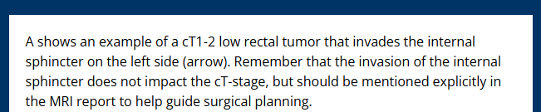
- Sphincter involvement should be considered in tumours “close” to the anorectal junction, as described in the “distance dependency” subtopic.
- A tumour can invade not only the sphincter but also other structures that are very close to that region, too.
- The 1 cm cut-off is somewhat arbitrary; I can’t find other measure in the literature.
- If invasion is present, we usually specify the involved structures, not particularly the lowest part (we have to describe to the surgeons the deepest point they have to remove, if they go to surgery).

Clock-Face Quadrant Map with Anatomical Structures
I believe it is easier to rewrite the quadrants (I confused myself when trying to correct the previous ones - if something doesn’t sound right, please question me)
- Quadrant 1 (left) and 4 (right)
  - Above – Peritoneum, small bowel, large bowel, urinary bladder, ureters, uterus, cervix, ovaries, external iliac vessels
  - Below – Urinary bladder, urethra, ureters, prostate, seminal vesicles, vagina, obturator muscle, ischioanal space, external anal sphincter, levator ani and puborectalis muscle
  - Crossing – Peritoneum, urinary bladder, ureters, seminal vesicles, uterus, cervix, ovaries
- Quadrant 2 (left) and 3 (right)
  - Above – Small bowel, large bowel, internal iliac vessels, piriform muscle, sacrum and sacral fascia
  - Below – Obturator muscle, ischioanal space, sacrospinous and sacrotuberous ligament, sacrum and sacral fascia, external anal sphincter, levator ani and puborectalis muscle
  - Crossing – I believe there isn’t really a crossing in the posterior margin, since it is not covered by peritoneum when crossing and above the reflection (only present anteriorly and laterally when above the reflection).
Notes:
- Obturator muscle below in all quadrants, since it has a lateral position (even though it is more anterior)
- Pelvic sidewall and musculature are a little vague, I tried to make it more specific
- I removed bowel loops when crossing the reflection, I think it makes more sense above the reflection, but I lack practical cases concerning this.
  - “The most relevant reference while staging rectal cancer is the anterior peritoneal reflection, which we should look for in the plane immediately below any pelvic small bowel loops and the sigmoid take-off.” - https://pmc.ncbi.nlm.nih.gov/articles/PMC7471246/pdf/13244_2020_Article_890.pdf

Mesorectal Fascia Involvement (MRF)
- If positive, indicate where it is located in the clock face and what is the intervening structure, as suggested in the template.
- It can occur in all T3 tumours (not only T3c and T3d). The involvement of the peritoneum (T4a) does not preclude the invasion of MRF (T4a MRF +), since in the high rectum the peritoneum covers the anterior and lateral margins and the MRF covers the posterior margin.
- The distance from mesorectal fascia can be superior to 10 mm – a random patient selected by me on my hospital had a maximum distance of 23mm from the rectal wall margin to the MRF (it also depends on a lot of factors and on the level of measurement). Obviously, the cutoff with clinical impact in staging is the 1 mm from the MRF for involvement (not 2 mm), as previously stated.
  - A practical example in the case of that patient: we could have a tumour with mesorectal fat extension of 16mm, corresponding to a T3d tumour, but with a free MRF (distance >1 mm from MRF)
- Why is there exclusion above ARJ (I presume it is anorectal junction) anteriorly? The most important concept is the lack of mesorectal fascia in anterior tumours at the level and above the anterior peritoneal reflection, and not the anorectal junction. And this only applies to anterior/lateral tumours.
- I have some difficulty understanding the rules for T4 tumours. Low tumours have less mesorectal fat plane (the mesorectum “narrows” when “going down”), so they are naturally closer to the mesorectal fascia, but it applies to T3 and T4 tumours.
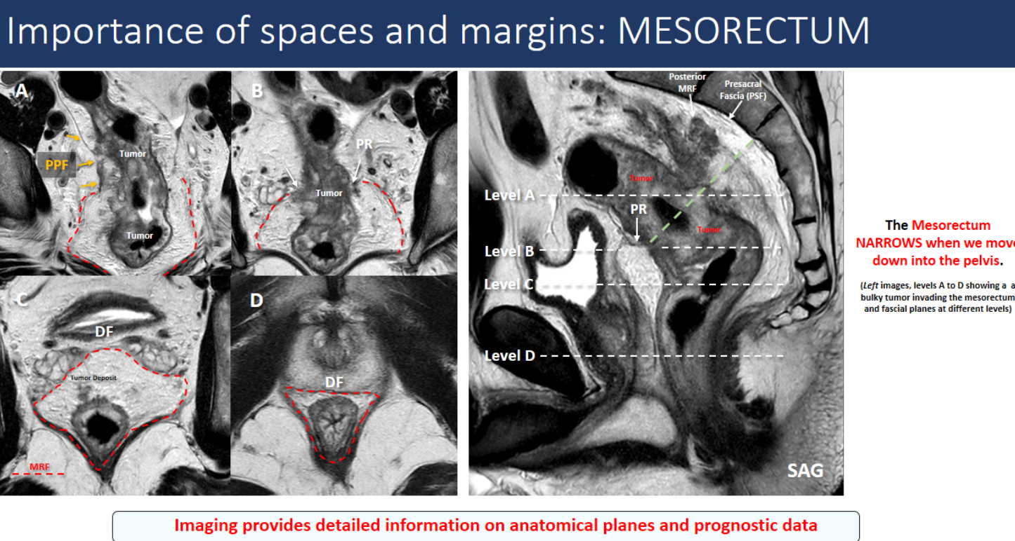
(https://epos.myesr.org/posterimage/esr/ecr2023/164274/mediagallery/931144?deliveroriginal=1)
- Extensive tumours involving several clock position above the anterior peritoneal reflection (for example, from 1 to 6 o’clock) can invade both the peritoneum and the mesorectal fascia (T4a MRF+).
- This is a very important category, so it should be always mentioned as free or involved.
- I would review the clock hours that define the location of the peritoneal reflection – 10 to 2 o’clock in the mid rectum and 9 to 3 o’clock in the high rectum (this is based on drawing interpretations, so it is subjective, tell me what you think).
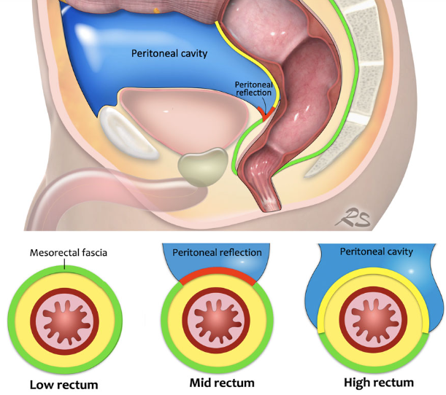

Lymph Node Assessment and Tumour Deposits
- I agree, if also taking into account the previous revision on the N-staging in the template section.
Extramural Vascular Invasion (EMVI)
- It applies to T3 and T4 tumours.
- If positive, indicate where it is located in the clock face.

REVIEW OF THE PROPOSED REPORTS
- Example 1:
  - I think it is natural sounding. Some topics I would organize differently, but this is a personal opinion (for example, mucinous component should be denied close to the initial description of the tumour, because it is all related to its “composition”).
  - On the technique, we also perform an axial T1 centred on the pelvis (it is mentioned in example 2 and 3).
  - I believe we should include the description of the distance to the anal verge, that allow us to indicate the low/mid/high rectum location of the tumour.
  - In this case, the highest margin of the tumour is at 18.2 cm. Considering that the lowest margin considered is higher than the consensual points (it is measured from the anorectal junction, and not the anal verge, which we use to consider the 5-10-15 cm rule), and that the rectum ends at 15 cm, this tumour also involves the sigmoid, which should be mentioned.
  - If EMVI positive, we should indicate where in the clock face.

- Example 2 (I did not repeat what previously noted in other examples):
  - It is natural sounding.
  - Since it is a low rectal tumour, the topic about sphincter invasion shouldn’t have been applied? It is “not applicable” in the code.
  - The mucinous component is not mentioned, as well as the anterior peritoneal fascia (this last one makes sense, since it is a low tumour).
  - The invasion of the right sacrotuberous ligament (quadrant 3) is not possible in a tumour thar extends from 11 to 5 o’clock (quadrants 4, 1 and 2). The left sacrotuberous ligament could be involved (quadrant 2).
  - Circumferential resection margin and mesorectal fascia are not synonyms, so I believe it is “safer” that we only speak about the MRF.
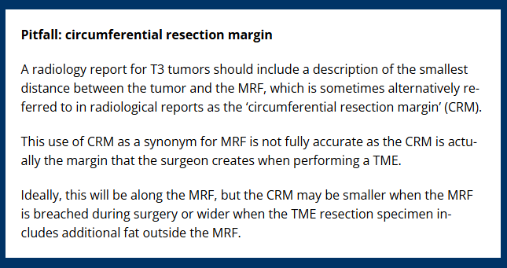
- In the N stage, I think it should be clear that the suspicious nodes are mesorectal. We can deduct it, but it should be clear.
- Impression – could also mention in which side there is the invasion of the ligament.

- Example 3 (I did not repeat what previously noted in other examples):
  - It is natural sounding.
  - We have to review the cut-offs, perhaps it is located above the anterior peritoneal reflection.

