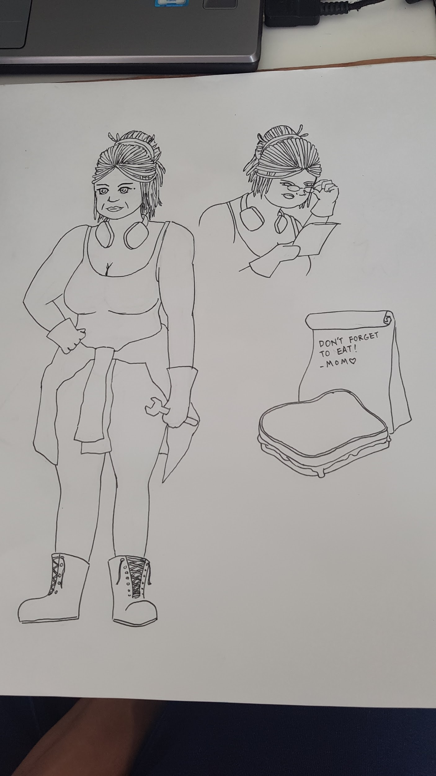

^just fast sketch to get the idea

A stout dark skinned lady with black dreads bunched into a messy high ponytail. Madelyn Kiehla (nicknamed Maddie) is an African-American woman in her 50s who works as an engineer/armskote/storewoman of the forces the protagonist works for. She's a single mother, who's husband died in the war. She raises twin girls who she writes to often and sends money to to provide for their education. She is seen as a motherly figure amongst the soldiers, as she jokingly refers to the loadouts she gives them as her 'homemade lunches'. Secretly she struggles with the dilemma of arming her sons and daughters to kill and eventually be killed, and providing a safe future for her children.

AN: I don’t think Maddie will provoke difficult moral dilemmas because she operates relatively far from the warfront, however I do think she would be an interesting addition that helps to ease players in, like a tutorial character of sorts. I think she also has value as a recurring character who players will get to meet again and unlock more dialogue options with if they choose the right options that will allow them to survive and get back to base safely, though cowardly options may also affect her disposition to the player. I think another possible mechanic that could work with Maddie is the ability to grant the player different loadouts. I understand that in real war soldiers just receive a standard issue loadout but if we suspend disbelief for a moment I think it could add a lot of variety. For example in a situation where the player is being approached by a wild dog, and the 2 options are to run or kill the dogs, perhaps a 3rd option of feeding the dogs with treats would appear because the player chose a certain set of items when he/she was preparing with Maddie.

Scene

You walk out of the mess hall, your last good meal for a while (or ever) sitting in your belly. Unlike your platoon mates who are scarfing down plate after plate of fish and chips, you decide to spend your last hour before the mission begins not stuffing your face.

You wander the relatively quiet hanger. It seems most of the workers have gone on break too, though some hang around, minding their own business.

"Whatcha standing around for, sweetie?" you hear a familiar, Southern accent call out to you. You turn to see a dark skinned, handsome stout lady sitting on a wooden stool. She puts down some metallic instruments in her hands with a light clang, beaming at you, her pearly white grin contrasting against the grease smudges that cover her cheeks and forehead.

"Hey Maddie" you chuckle and walk over to the motherly engineer. She pulls a second stool for you to sit. "Something on your mind hun? Shouldn't you be at the mess right now?"

"Got no appetite for more fries." you shrug. "Well how about a good ol' PB&J then?" A simple meal of 2 slices of white bread and a generous spreading of creamy peanut butter and jam, oozing on the edges, is presented to you. You weren't feeling particularly peckish but the sight of the homemade treat gave you newfound appetite as you dug in and allowed the sweet blueberry and sticky peanut butter dance on your tastebuds.

Watching your expression brighten, Madelyn lets out a hearty laugh. "There, much better! Don't want to see you sulking around no more." As she smiles her expression softens, looking at you with a caring gaze.

“Feeling nervous?” she asks, softer, as you lick the remaining jam of the sides of your mouth. “I mean, it's what we signed up for. Gotta do what ya gotta do.” You say with a shrug, though you don’t seem to believe the words coming from your own mouth.

“Ain’t that the truth.” she shakes her head. There’s a brief moment of silence, as Madelyn just stares at the ground, before speaking up. “Listen, I know you don’t need hearing this from me, but war ain’t no game. Don’t go out there doing suicide missions or fighting to the bitter end or any of that movie bullshit ya hear me? Don’t throw your life away for nothin’!”

“A little late for that now…” you mumble under your breath, but she seems to have heard it for she slams her fist onto the workbench, causing you to jolt upright ad regret talking back. “No. It. Ain’t.” Madelyn’s eyes narrow. “All you busters think about is fighting for the country, going out in a blaze of glory! Well look where that got my hubby.” The anger in her tone subsides as she lifts her hand to show 2 rings on her ring finger - one belonged to her deceased husband who died in battle a year ago, you recall.

“I’m proud of him. I really am. He loved what he did and he loved this country and I’m proud of him. But I’d much rather have him here. Much rather have my babies at home still have someone to call daddy.” Another moment passes. “Listen hun, do me a favour. Everytime you're about to do somethin', think about your folks back home. They’re waiting for you. Come home safe alright?” You nod slowly.

The sounds of footsteps and chattering begins to grow louder. It appears that the rest of your platoon have filled their bellies and are heading over to get their equipment. Madelyn quickly wipes her face in her shirt sleeve, before looking up at you with a grin, back to her usual cheery self just like that. “Well I can wish all I want but if ya can’t shoot straight then what’s the point eh?” She jokingly punches your arm. “All this old coot can do is give you the best equipment possible and hope you make it out ok.” She balances a pair of reading glasses on the bridge of her nose - tiny compared to the rest of her, and scrutinises a clipboard. “Let’s see here, what’s on the menu...”

**Options**

**Sniper Rifle/8x scope - allows player to take targets out from afar, or just change the mission entirely from a section type battle to silent long range sniping mission**

**Matador/Rocket Launcher - create diversions, large scale damage, take out buildings, armored vehicles or large groups of people**

**Demolition Kit - create diversions, destroy structures and walls**

**Extra rations - last longer away from camp, possible to feed victims, civilians, use as a bargaining tool, various uses.**

**Med Kit - provide first aid to wounded allies, civilians or hostages**

**Drone - able to send in a scout ahead of the team to survey the area through the air**