ScreenShots From Alphabetical_testing file

Sheet A

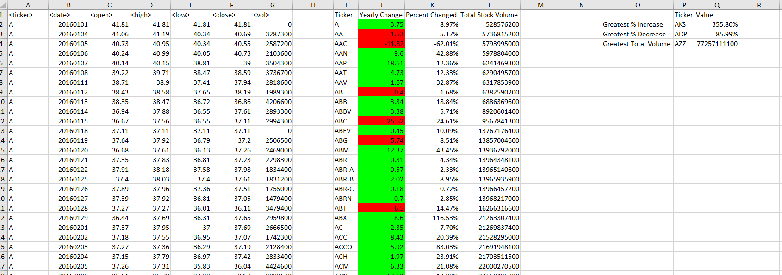

Sheet B

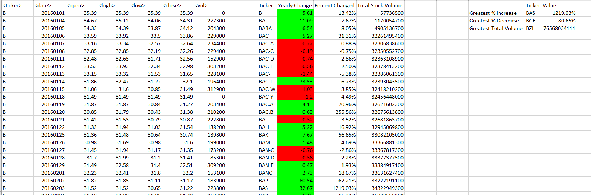

Sheet C

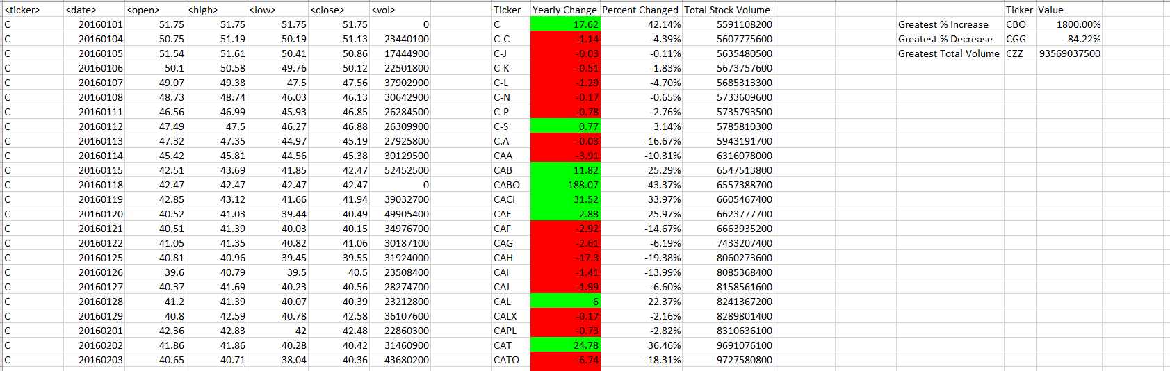

Sheet D

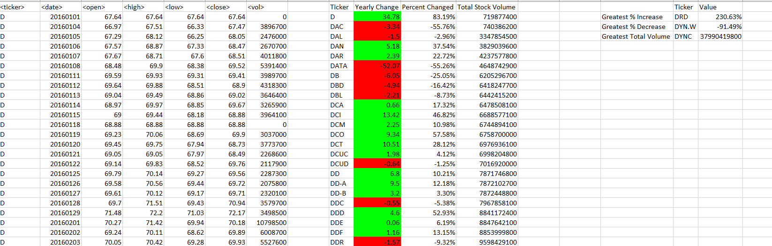

Sheet E

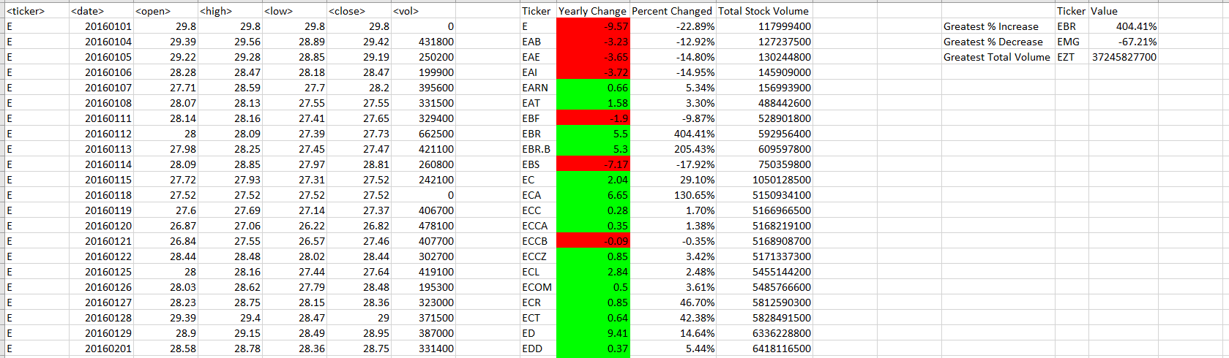

Sheet F

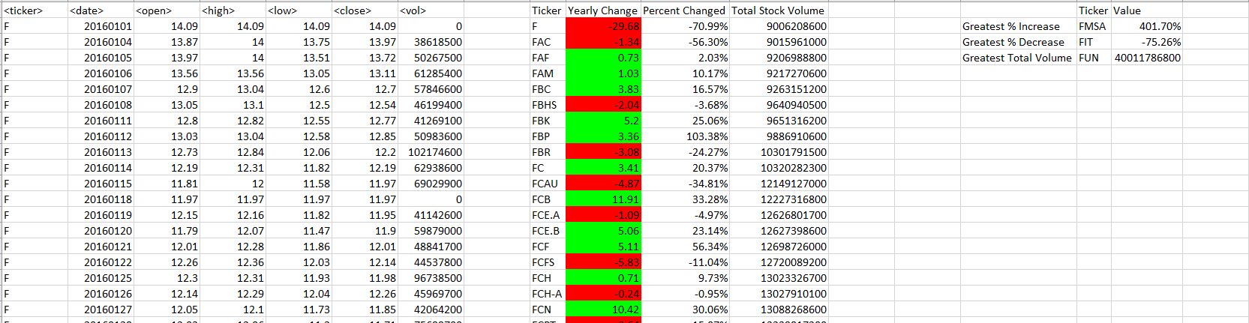

Sheet P

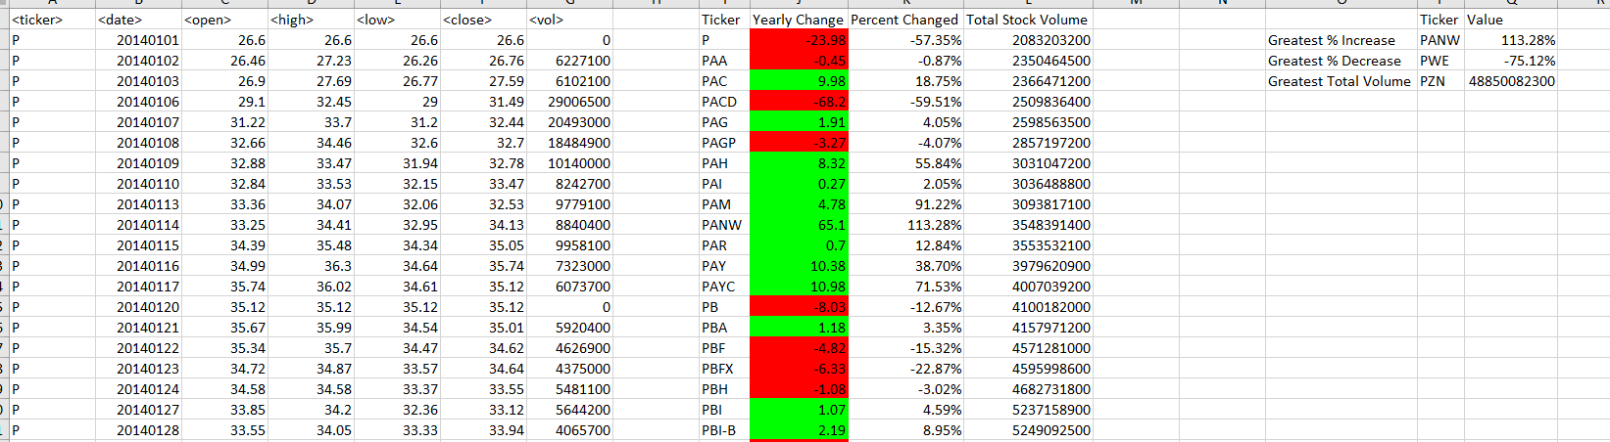

ScreenShots From Multiple Year Stock Data file

Sheet 2016

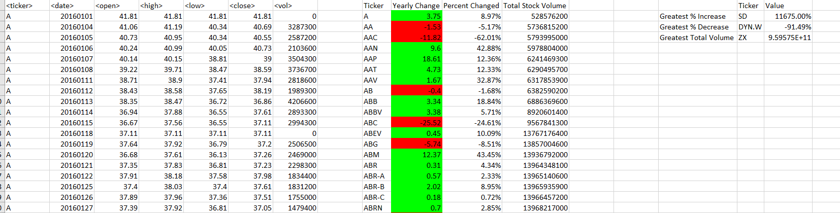

Sheet 2015

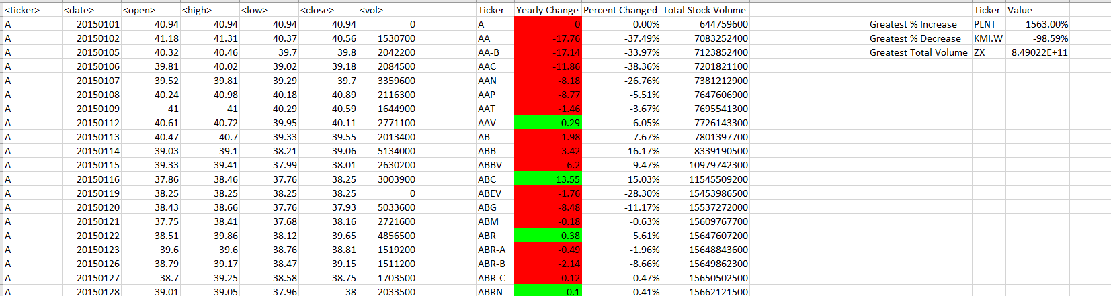

Sheet 2014

