人工智能第二次作业

6.8 Consider the graph with 8 nodes A1, A2, A3, A4, H, T, F1, F2. Ai is connected to

Ai+1 for all i, each Ai is connected to H, H is connected to T, and T is connected to each

Fi. Find a 3-coloring of this graph by hand using the following strategy: backtracking with

conflict-directed backjumping, the variable order A1, H, A4, F1, A2, F2, A3, T, and the

value order R, G, B.

答：

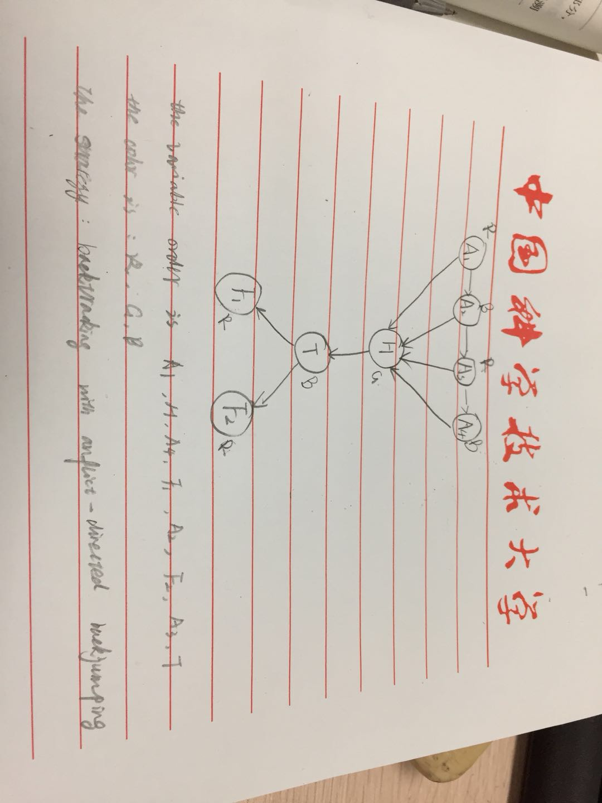

6.9 Explain why it is a good heuristic to choose the variable that is most constrained but the

value that is least constraining in a CSP search.

答：因为选择“最受约束变量”进行启发式搜索，在搜索过程中它会选择最快导致失败的变量，从而实现对树的剪枝。这样如果一个变量X没有剩余可选的合法值，就会马上选择X并且检测到失败，从而能够避免其他最终也会选择X的无意义的搜索再进行下去。