- <$Scr_Ps::0>In the US standard system, the inch (in) 1” (double apostrophe) is the primary unit, with the foot (ft) 1’ (single apostrophe) and mile (mi) used for larger distances.
- In the metric system, the base unit for length is the meter (m). Its subdivisions include the centimeter (cm), millimeter (mm). The kilometer (km), equivalent to 1,000 m is used for longer distances.
- For navigation on water (marine), air, and space, the <$Scr_Cs::2>Nautical Mile<!$Scr_Cs::2> (NM) unit of length is used.
<!$Scr_Ps::0>
<$Scr_Ps::1><table>
<title> Length units for US Standard and Metric systems</title>
<tabular>
<row header='yes'>
<cell>U.S. Standard</cell>
<cell>Metric</cell>
<cell>Conversions</cell>
</row>
<row>
<cell>12 inches = 1 foot</cell>
<cell>1 centimeter (cm) = 10 millimeters</cell>
<cell> 1 inch = 2.54 cm</cell>
</row>
<row>
<cell>3 feet = 1 yard</cell>
<cell>1 meter = 100 centimeters</cell>
<cell>1 ft = 0.3048 m</cell>
</row>
<row>
<cell>1,760 yards = 1 mile</cell>
<cell>1 kilometer = 100,000 centimeters</cell>
<cell>1 yd = 0.9144 m</cell>
</row>
<row>
<cell>5,280 feet = 1 mile</cell>
<cell> 1 kilometer = 1,000 meters</cell>
<cell> 1 mile = 1.6093 km</cell>
</row>
</tabular>
</table>
<!$Scr_Ps::1>

<$Scr_Ps::1><table>
<title> Length units for US Standard and Metric systems</title>
<tabular>
<row>
<cell> 1 Nautical Mile = 6,076 ft</cell>
<cell>1 Standard Mile = 5,280 ft</cell>
<cell>1 Kilometer = 3,280.84 ft</cell>
</row>
</tabular>
</table>
<!$Scr_Ps::1>
<$Scr_Ps::1><figure xml:id="length_comparison">
<!-- Source: roger gill/>
-->
<caption>Visual comparison of Kilometer, Statute Mile and Nautical mile</caption>
<image width="60%" source="images/length_comparison.png"/>
</figure>
<!$Scr_Ps::1>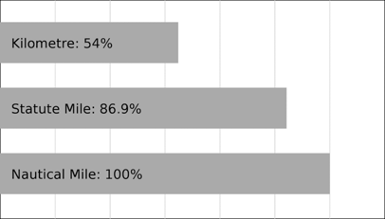
  - <$Scr_Ps::0>Fathom: A nautical measurement equal to 6 feet or 1.8288 meters. It is commonly used for measuring depth in water. Finger tip to finger tip
<image width="40%" source="images/fathom.png"/>
<!$Scr_Ps::0>