WHAT ARE NPT FITTINGS?

NPT(National Pipe Tapered) standard was initially defined for plumbing applications. The metal-to-metal contact in NPT fittings relies on the deformation of the threads to form a secure seal.

- Fittings Learning Center Fittings and Adapters What are NPT Fittings?
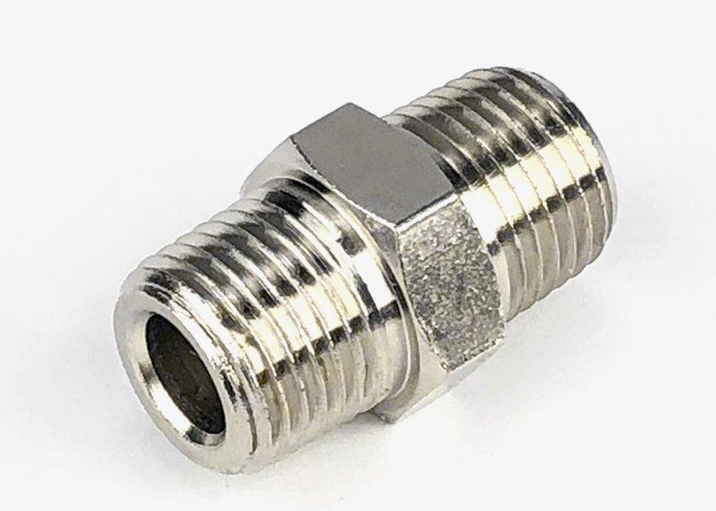
Image description: A NPT fitting
- NPT or national pipe, or National Pipe Tapered, is an American standard defined under the AMSE B1.20.1. The standard outlines the dimensions and tolerances of tapered threads for pipes and fittings. Unlike straight threads, tapered threads give a more reliable seal, especially when used with a sealant material like Teflon tape. The standard is more than a hundred years old and was initially defined for plumbing applications; however, it has seen effective use in hydraulic and gas conveyance as well.
- CHARACTERISTICS OF NPT THREADS
NPT threads are defined by the following features:
- The taper angle is 1^{O} 47’ (measured from the center axis of the NPT fitting)
- Flat crests and troughs
- 60^{O} angle between each crest and trough
- The outer diameter of an NPT fitting is measured at the midpoint of the taper
- Pitch (the distance between threads) is measured in threads per inch (TPI)
SIZING IN NPT THREADS
NPT defines both internal and external threads on fittings that conform to the standard; hence sizing charts give diameter measurements for both male and female parts. As a result, all male and female fitting types have consistency, adhering to the same taper rate – change in thread diameter per unit length. For the NPT standard, the taper rate is ¾ inch per foot or 1/16 inch per inch.
- Since the O.D. is measured from the midpoint, confusion may arise when selecting the correct size fitting. An NPT fitting labeled as 1/8” has an actual outer diameter of 3/8”. So be careful when selecting NPT fittings, as you may end up using a fitting that’s too loose. The chart below summarizes the dimensions of some commonly used sizes. Note that some NPT fitting sizes have the same TPI; hence they can be used on each other on account of the taper.

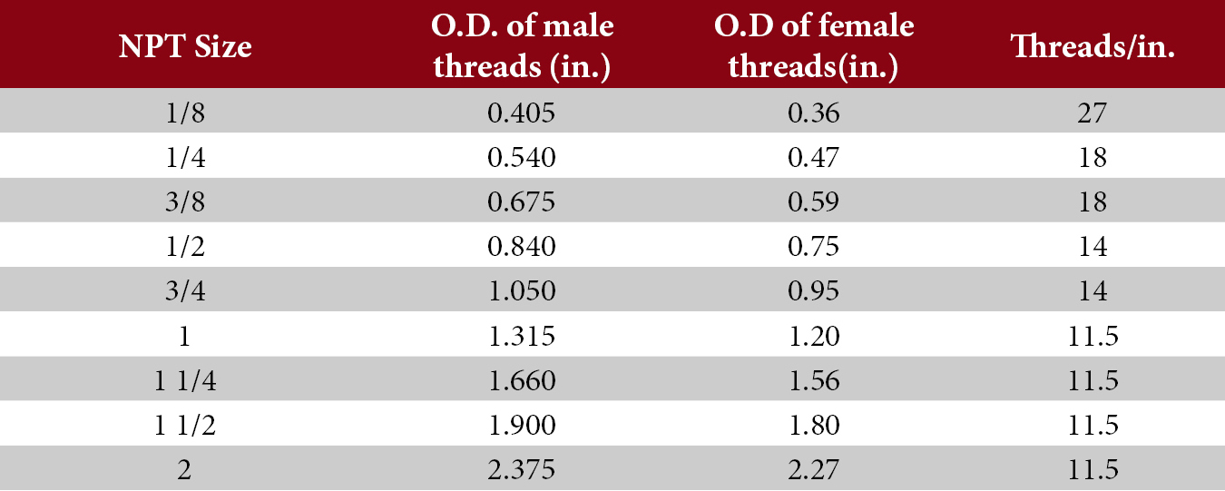
ADVANTAGES OF USING NPT THREAD FITTINGS
Given that the standard has been around for a while, it has a set of advantages when being used. It is readily available in vendor inventories, with multiple sizes and materials to choose from. This allows you to use them for many applications at varying pressures. Moreover, they can be assembled in a simple manner as the metal-to-metal contact offers an excellent seal.
DISADVANTAGES OF USING NPT THREAD FITTINGS
The metal-to-metal contact in NPT fittings relies on the deformation of the threads to form a secure seal. This, however, means that one cannot use them in applications that require frequent disassembly.
If used improperly, that is, without correct alignment, overtightening, or wrong sizing, ports may expand, and cracks may form on the threads. This, in turn, leads to the formation of leakage pathways from where the medium can leak out. It is for this reason that NPT fittings are not recommended for extremely high-pressure applications.

