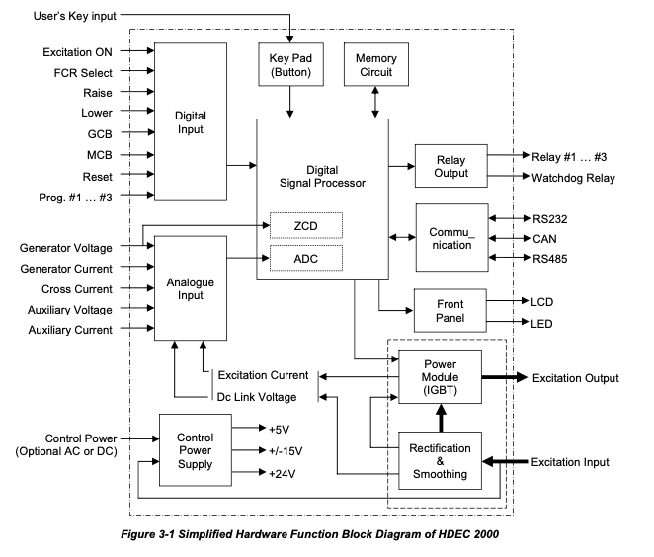

Digital Inputs
Figure 3-1 Simplified Hardware Function Block Diagram of HDEC 2000
HDEC2000 unit provides seven digital inputs for pre-defined functions and three digital inputs for programmable functions. Digital inputs can be controlled by external dry contact or PLC open collector output. In all cases, the digital inputs should be connected with potential free contact (or switch). Each function of digital inputs is described below.
Excitation ON (START/STOP) command
This input determines the condition of excitation on (or off). If this input circuit is closed, HEC2000 unit regulates the excitation power through the power module (IGBT). If this input is opened, the excitation output power is cut off. Continuous contact should be used for this input command.
Normally, This input may be closed while the prime mover speed is higher than specified value (typically 50 ...90% of nominal), If the prime mover speed is lower than specified value, or if the generator heavy fault signal is activated, this input should be opened.
However, in case of shunt power application (excitation power is supplied from the transformer connected with generator output terminal) with no external control power and with no excitation input contactor, the excitation on input may be always closed. Alternatively, in this case, we recommend that the excitation input contactor may be installed for the protective purpose, and excitation on input channel may be connected with the auxiliary contact of excitation input contactor instead of external excitation on command. Figure 3-2 shows the typical schematic diagram of excitation on control for the shunt power application with no control power.
In above case (shunt power application with no control power, and input contactor is installed), we strongly recommend that the maximum speed for excitation on is less than approximately 70% of nominal to prevent initial voltage overshoot due to hardware voltage buildup function. See the voltage buildup function for more information.
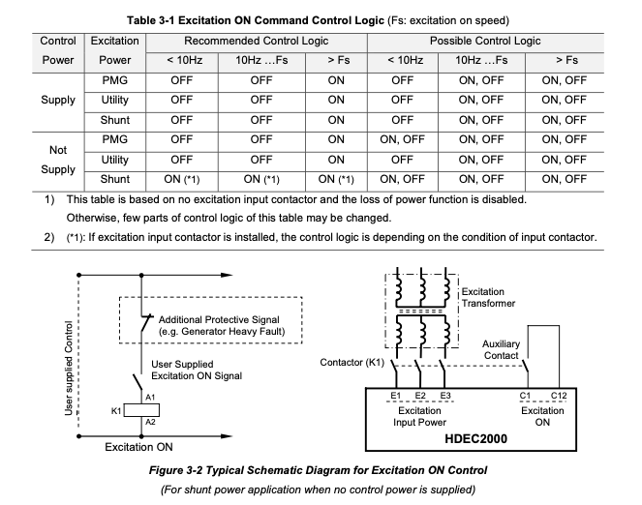

Table 3-1 shows the recommended excitation on control logic depending on excitation power and external control power. However user can modify the control logic depending on application. For more relative or detailed information, see ready mode function and loss of power function in this section. Or, please contact Electro Electric Systems - Hyundai Heavy Industries Co., LTD.
Especially, in cases that the loss of power is enabled and the loss of power option is configured with [Reset soft Start Time], even though it is not recommended, this input can be always closed for simple application.
Manual select command (non Automatic mode)
This input determines the basic regulation mode of HDEC2000 unit. If this input circuit is closed, HDEC2000 unit operates with FCR mode. Otherwise, the unit operates with AVR mode, VAR mode or PF mode depending on other digital inputs and configuration parameters. Continuous contact should be accepted for this input command.
FCR mode is prior to all operating modes and functions. In the FCR mode, all limitation functions and some protective functions are disabled.
Raiser, Lower command
This input(s) adjusts the setpoint (reference) of active operating mode. The raise command increases the setpoint, and the Lower command decreases the setpoint of active operating mode. These actions are enabled while the corresponding input circuit is closed. If the setpoint of active operating mode reaches to its [max Setpoint] or [min Setpoint], these actions are disabled. Momentary contact should be accepted for these input commands.
The total ramping time which is required to traverse from minimum to maximum setpoint is determined by [Setpoint Traversing Rate] parameter of active operating mode.
MCB (Machine circuit breaker) status
This digital input channel detects on/off status of the machine (generator) circuit breaker which connects the generator to the electrical bus or other generators. If this input channel is used, normal-opened auxiliary contact of generator circuit breaker should be connected.
If this input circuit is closed, HDEC2000 selects either reactive droop compensation or cross current compensation depending on [CCC Enabled] parameter when the operating mode is not FCR Mode. If this input circuit is opened, HDEC2000 unit disables both the Droop (droop compensation) and CCC (cross current compensation) modes.
The MCB status is not essential part of excitation system. Sometimes it can be omitted. If the excitation system is designed for the generator to be always operated with AVR mode without droop compensation and without CCC, MCB status input circuit can be always opened. Otherwise, if the excitation system is designed for the generator to be always operated with AVR mode with droop compensation, this input circuit can be always closed.
Alternative, if no auxiliary contact of generator circuit breaker is available or user wants to simple hardwire configuration, the [Virtual MCB] parameter having three options (None, Close, Open) can be used instead of auxiliary contact of physical circuit breaker. The functions of three options listed below are described. But, to enable the CCC function, the auxiliary contact of physical circuit breaker is essentially required.
[None]: MCB status of HDEC 2000 software is determined by the digital input connected with actual generator circuit breaker
[Close]: MCB status of HDEC 2000 software is always settled with closed condition. [Open]: MCB status of HDEC 2000 software is always settled with opened condition.
GCB (Grid circuit breaker) status
This digital input channel normally detects the on/off status of grid circuit breaker (not machine circuit breaker) which connects the generator to the infinite power grid (not island grid) in comparison with generator output rating. If this input channel is used, normal-opened auxiliary contact of grid circuit breaker (or combined logic status of some circuit breakers) must be connected.
The logical combination of GCB status, MCB status and related configuration parameters select either VAR mode or PF mode. Table 3-2 shows that the operating-mode selection logic depending on the digital inputs and configuration parameters.
If MCB and GCB status are closed, and [VAR/PF Mode] is configured with [VAR] or [PF], HDEC2000 unit operates either VAR mode or PF mode while the FCR mode is not selected. The VAR mode or PF mode is selected by the setting of [VAR/PF Mode] parameter. Otherwise, HDEC2000 unit operates with AVR mode.
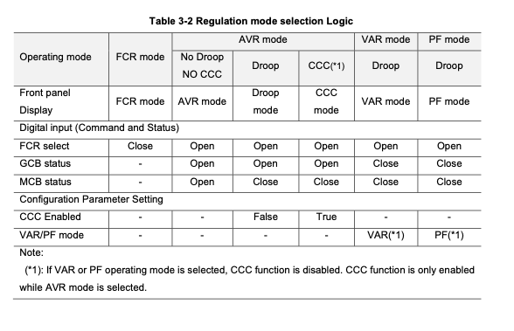

Due to the safety reason, we recommend that this digital input channel may be connected with the logically combined status of some user’s circuit breakers which determine VAR or PF mode depending on the power grid configuration.
Programmable #1, #2, #3 input (Command or Status)
HDEC2000 unit provides three programmable input channels for flexible configuration. Any function pre-defined by HDEC2000 software can be assigned for the programmable digital input channel.
If the input circuit is closed, the assigned function corresponding to its digital input channel is enabled (activated).The useable functions are listed and described below.
[None]: No function is assigned and no action is executed.
[Preposition]: If a corresponding input circuit is closed, HDEC2000 unit changes the setpoint of all operating modes (AVR, FCR, VAR and PF) to the pre-settled [Preposition Setpoint] of each operating mode. This function is useful for initialization of setpoint adjusted by user or for the application which required the fixed setpoint permanently. Momentary or continuous contact may be accepted for this function depending on application.
In some cases, this function is used to prevent excessive over voltage when circuit breaker is opened from the condition that the generator operates with FCR mode, and heavy load.
[SecondaryUnit]: This function determines that HDEC2000 unit operates with primary (master) or secondary (backup) unit for redundant application configured with two HDEC2000 units. If a corresponding input circuit is closed, HDEC2000 unit operates with the secondary unit. The secondary unit always tracks the primary unit via CAN communication. This function is not supported now, and the revision for this function is planned later. Continuous contact may be accepted for this function.
[LocalRequest]: HDEC2000 unit can be commanded from three directions via three devices of digital input commands of left panel (local command), COM0 port (RS232) and COM2 port (RS485, read only now). This function determines that the local command (physical digital input command) is priority.
If a corresponding input circuit is closed while the HDEC2000 unit is controlled remotely, then the commands from remote device are disregarded. Momentary contact may be accepted for this function. For more information about remote access, see separated MODBUS communication manual.
[SecondarySoftStart]: This function is used for the special application (e.g. the different two kind’s loads are powered from one generator at different time). If corresponding input circuit is closed, The HDEC2000 unit controls the voltage setpoint by using the second soft start parameter set. Even though the status of digital input is changed during soft starting processing, the changed event is not applied, but it may be applied with next excitation on event. For more information, see soft start function.
Alarm Reset command
When the input circuit is closed, this input clears the latching status of all fault events of the output relay assigned for fault event, internal software fault flag, front panel fault messages and fault LED. Momentary contact may be accepted for this command.
Analog Input and Output
HDEC2000 unit measures nine analogue signals. The seven signals are external inputs and two other signals are internally measured. The processing procedure of analogue signals is described below.
First, all analogue signals are converted to suitable low level by means of resistive divider, shunt resistor, current transformer or current sensor. Next, the analogue signals are transmitted to ADC (analogue to digital converter) through operational amplifiers, analogue filter circuits and MUX (multiplex). Finally, DSP (digital signal processor) performs quantization, digital filtering and signal conversion for the analogue signals. HDEC2000 unit performs control and other functions by using of these signals.
The analogue signals measured by HDEC2000 unit are listed below:
- Three phase-to-phase generator voltages (A-B phase, B-C phase, C-A phase, C-A phase).
- GeneratorBphasecurrent
- Crosscurrentloopinput
- AuxiliaryvoltageinputandAuxiliarycurrentinput
- Dclinkvoltage(excitationvoltage)
- Excitationcurrent Generator voltage sensing This signal is normally measured from sensing voltage transformer installed on generator inside or generator circuit breaker cubicle. HDEC2000 unit provides three voltage sensing range (110Vac, 220Vac and 460Vac). HDEC2000 unit automatically selects voltage measuring range by using the turn ratio of sensing voltage transformer and the generator nominal voltage. The unit supports both single phase and three phase sensing system. In case of three phase sensing system, the average of three phase-phase voltage is obtained for the purpose of regulating. In case of single phase sensing system, the A-C phase voltage is obtained. We recommend that user designs three phase sensing system for the more stable (smaller feedback ripple) voltage feedback and the fast regulation response. The combination of true rms technique and optimum digital filtering technique achieves very stable and fast control of the generator voltage even though the sensing voltage has very high harmonic component. This voltage sensing signal is used for most of function as well. Generator B-phase current sensing
- This signal is measured from current transformer having 1A or 5A secondary current. And the current transformer must be installed on generator B-phase. This signal is used for reactive droop compensation, VAR/PF control and other functions.
- When very big induction motor is started by using only one generator, if the starting current is higher than approximately 1.5 times of rated generator current and the starting current should be limited lower than proper level, the current transformer and the current input range of HDEC2000 unit must be considered to prevent the saturation (or over range) problem of both component.
- Cross current loop input
- The current signal called cross current loop input for reactive differential compensation (for reactive load sharing between generators) is measured from the loop circuit consist of some current transformers having 1A secondary current. And the all current transformers must be installed on generator B-phase.
- To obtain equal reactive load sharing by cross current compensation, the turn ratio of cross current CTs of all paralleled generators should be same based on percent output rating of each generator.
- The 2Ω burden resistor is installed internally in the HDEC2000 unit for compensating the unequal reactive power sharing caused by different resistance of interconnection cables. By this reason, no external burden resistor is required. Also, the internal auxiliary relay controlled automatically by MCB status is installed in HDEC2000 unit. By this reason, additional auxiliary contact of generator circuit breaker is not required for the cross current compensation.
- Auxiliary voltage input, Auxiliary current input
- Normally, HDEC2000 unit controls the generator voltage (or other controllable parameter depending on operating mode) by using the setpoint determined by raiser (or lower) input channel. Sometimes, the auxiliary analogue signal called Auxiliary Input (auxiliary voltage or auxiliary current) adjusts the generator voltage together with raise and lower commands depending on application.
- Two kinds of analog signal can be connected with HDEC2000 unit at the same time. Even though HDEC2000 unit measures both signals simultaneously, HDEC2000 unit controls the generator voltage by using the converting signal called analog reference, and the analog reference is converted from either auxiliary voltage or auxiliary current depending on [Aux Input Type] parameter.
- After the analog reference is calculated from auxiliary input, the analog reference is multiplied with [AUX Gain] of each operating mode. And then, the multiplied value (analog reference * Gain) is summed up with the setpoint of each operating mode depending on [Aux Input Summing Type] parameter. Summed-up values (analog reference * Gain) are defined as a percentage of rated quantities for all operating modes.
- HDEC 2000 User Manual Rev. D

