NTRODUCTION
HDEC 2000 is an automatic voltage regulator for excitation control system of synchronous machine. The unit is designed on the basis of Hyundai’s long period (more than 30 years) experience in design, manufacturing and testing of synchronous machine together with newest digital signal process techniques.
Besides automatic voltage regulation function, all regulation functions, limiting functions and most of protective functions for excitation system enable the HDEC 2000 unit to be used in a wide range of applications. All of these features are achieved by the combination of reliable hardware design and the optimized software technology.
SYSTEM DESCRIPTION
The key function of HDEC2000 unit is the automatic voltage regulation of synchronous generator through excitation current control by means of PID (proportional, integral, derivative) control algorithm. To perform it, the unit provides control software and some different kinds of hardware devices such as PWM IGBT stage, DIOs, measuring devices (AIs), and communication interfaces etc, and the unit also provides most of functions required by user’s application. Simplified Overall IO and internal architecture of HDEC2000 unit are shown in Figure 1-1.
HDEC 2000 User Manual Rev. D
User’s Local Access
HDEC 2000
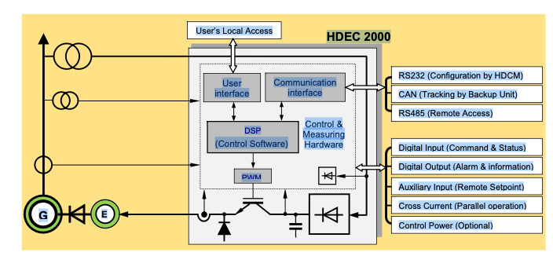
Figure 1-1 Simplified Overall IO and internal architecture of HDEC2000
Control Software and Function Blocks
Control Software containing function blocks is the brain or the heart of HDEC2000 unit. The software controls all of hardware which performs its own task of self diagnosis, measurement, regulation, limitation function, protective function, monitoring and communication. Control software is an executable codes set and stored in nonvolatile Flash memory.
The function blocks especially perform major regulation functions and limitation functions, and a part of control software. The most of function blocks are designed based on excitation system models of IEEE421.5 standard.
Excitation Power Flow
Excitation input power is normally supplied from the excitation transformer connected with generator output terminals or supplied from a permanent magnet generator (PMG). Some case, excitation input power may be supplied from external utility. Excitation output power of HDEC2000 unit is supplied to excitation winding of main machine or exciter machine after rectification and smoothing process through power module (switching IGBT) controlled by regulation output signal (PWM duty) of software function block of HDEC2000 unit.
Control Power
No external control power is normally required for HDEC2000 unit since the control power is internally supplied from excitation input power. For few special application, either ac or dc power source may be supplied externally. Control power is used as driving power of each component in the HDEC2000 unit. See Section 3 (Functional Description) and Appendix C (Specification) for more detailed information.
Sensing Input and Auxiliary Input
The voltage and current sensing signals for HDEC2000 unit are measured from sensing transformer installed on generator or generator external cubicle. Both of single phase or three phase voltage sensing configuration is supported by HDEC2000 unit. In case of current sensing system, single phase sensing is available and cross current loop sensing is also available. Excitation voltage and excitation current signals are sensed by measuring device installed internally.
For remote control application by analogue signal, +/-10Vdc, 4 ...20mA or other standard signal is available and the HDEC200 unit also provides the control capability by the analog signal.
Digital Input and Output
Most of control Tasks such as excitation on/off, Auto/Manual and Setpoint Adjust are achieved via digital input signal. The HDEC2000 unit provides seven digital inputs for predefined functions and three digital inputs for programmable functions. Digital inputs can be controlled with dry contactor or PLC open collector signal. The HDEC2000 unit provides three programmable output relays and one watchdog relay also.
Communications
Three communication ports are provided for initial configuration in the factory (or commissioning in site), for data exchange between HDEC2000 units for redundant system and for remote access. The communication ports consist of RS232 (COM0), CAN (COM1) and RS485 (COM2) ports.
User Interface
he HDEC2000 unit provides three kinds of user interface devices which consist of front panel LCD display, LED lamps and key pad (buttons). Most of operating information such as analogue signals, limitation information and fault events are displayed on the LCD display panel. And the unit also provides the capability for configuration of important parameters and some useful operational functions.
Configuration and monitoring Software
The Configuration and monitoring software for HDEC2000 unit called HDCM is connected through RS232 communication port on the front panel. The HDCM software provides very useful functions such as parameter configuration, setpoint adjustment, control gain estimation and real time measurement for factory setup and site commissioning.

