Braking circuits are essential to the proper operation of systems that employ a variable frequency drive (VFD) and electric motor controlling a high inertia load. Cranes, elevators, and centrifuges are just a few applications in which the VFD will be subject to potentially large amounts of regenerated energy from the motor.

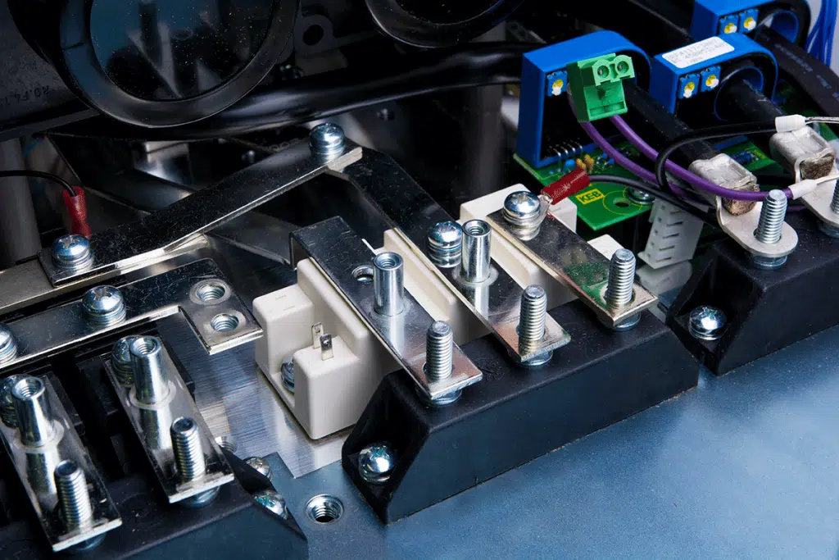
A brake chopper inside a KEB F5 VFD.
The CEMF (counter electromotive force) created by a running motor increases during deceleration or overhauling, essentially turning the motor into an electric generator. The rate of deceleration/overhauling and size of the load will determine how much CEMF voltage is generated. This voltage will add to the voltage already present on the drive’s DC bus capacitors.
In general, VFDs are not designed to return energy from a motor back to the utility. The input bridge rectifiers of the drive will only allow for supply power in and cannot pass power back to the main supply.

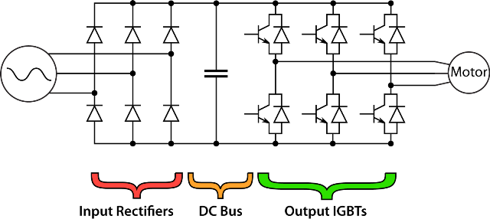
Diagram showing the topology of a VFD.
Related Video: How Pulse Width Modulation Works in a VFD
Consequently, the DC bus voltage will increase with the voltage received back from the motor. If the voltage level rises above the maximum rating of the capacitors, then damage will result.
So, an intermediate braking circuit is necessary to dissipate the excess voltage. Let’s take a look at how this is accomplished with the KEB F5 inverter.

Brake chopper
Typically, a braking circuit (sometimes known as the “chopper” circuit) is controlled by the drive and consists of a power transistor and resistor(s) that are connected across the drive’s DC bus.
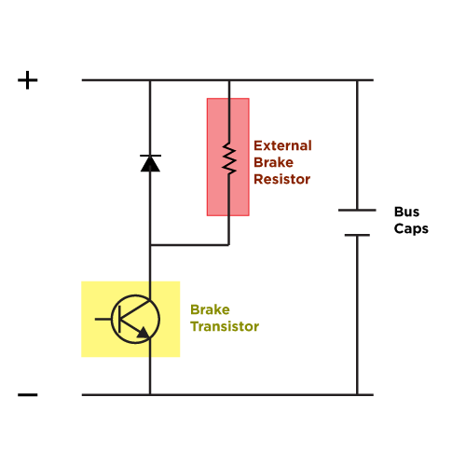
Brake transistor circuit

F5 drives come in both 200V and 400V models. Working with a 400V model F5 on a 3-phase supply voltage of 480VAC, the drive will measure an idle bus voltage of 672VDC (480VAC x √3). The default voltage level at which the F5 will trigger the braking transistor is 780VDC (380VDC for 200V models) – this level is programmable.
The F5 will monitor the bus voltage and if it begins to rise above the trigger level, it will turn on the braking transistor, sending current flow to the braking resistor(s) where the energy will be used up in the form of heat.

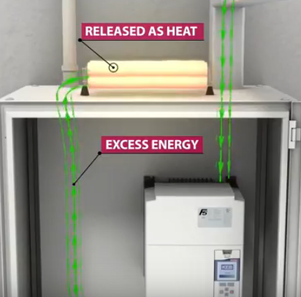
Regen energy is dissipated as heat.

Once the bus voltage falls below the trigger level, the F5 will turn off the braking transistor. The F5’s maximum DC bus voltage level is 840VDC (420VDC for 200V models). If for some reason there is a failure in the braking circuit (i.e. open braking resistor) and the excess voltage can’t be dispersed, the F5 will trigger the error E.OP (over-potential) when the DC bus voltage reaches higher than the rated maximum value. When the error is triggered, the drive will stop operation.

