<$Scr_Ps::0>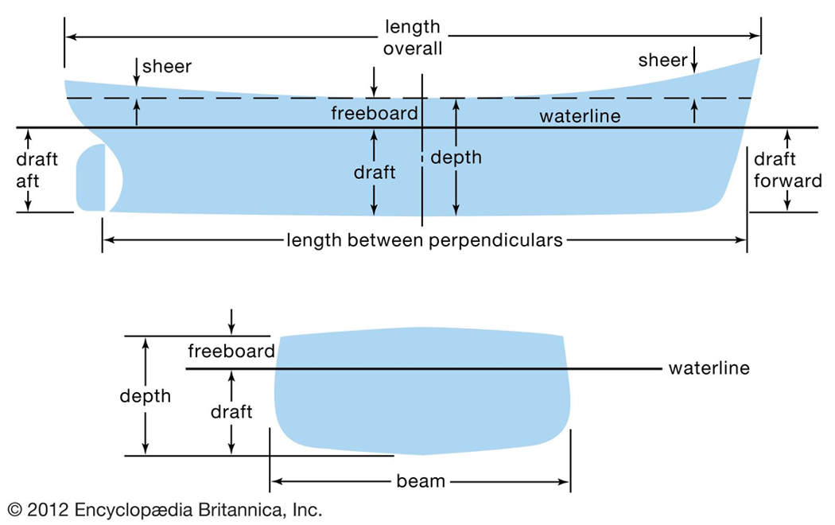
<!$Scr_Ps::0><$Scr_Ps::1><table xml:id="principle_dimensions">
<title>Principle Dimensions</title>
<tabular>
<row header="no">
<cell>Length, overall</cell>
<cell>160 m</cell>
<cell>(525 ft)</cell>
</row>
<row>
<cell>Beam</cell>
<cell> 27 m</cell>
<cell>(89 ft) </cell>

</row>
<row>
<cell>Depth, to main deck </cell>
<cell> 16.8 m</cell>
<cell>(55 ft)</cell>
</row>
<row>
<cell>Draft, load line</cell>
<cell> 7.35 m</cell>
<cell>(24 ft) </cell>
</row>
<row>
<cell>Masthead Height, above keel </cell>
<cell> 44 m</cell>
<cell>(144 ft) </cell>
</row>
<row>
<cell>Total installed Power</cell>
<cell>16,800 kW </cell>
<cell>(22,500 hp)</cell>

</row>
<row>
<cell>Design Speed </cell>
<cell>18 knots</cell>
<cell>(20.7 mph)</cell>

</row>

</tabular>
</table>

<table xml:id="nsmv_capacities">
<title>Capacities</title>
<tabular>
<row header="no">
<cell>Cadet Berths</cell>
<cell>600</cell>
</row>
<row>
<cell>Officers and Crew Berths (Single Occupancy)</cell>
<cell>100</cell>
</row>
<row>
<cell>Additional Berths (Double Occupancy)</cell>
<cell>60</cell>
</row>
<row>
<cell>RO-RO Cargo Space</cell>
<cell>990 m<$Scr_Cs::2>^2<!$Scr_Cs::2></cell>
</row>
<row>
<cell>Deck Container Capacity</cell>
<cell>60 TEU</cell>
</row>
<row>
<cell>Fuel Marine Gas Oil</cell>
<cell>2169 m<$Scr_Cs::2>^3<!$Scr_Cs::2></cell>
</row>
<row>
<cell>Fresh Water</cell>
<cell>1234 m<$Scr_Cs::2>^3<!$Scr_Cs::2></cell>
</row>
<row>
<cell>Salt Water Ballast</cell>
<cell>3567 m<$Scr_Cs::2>^3<!$Scr_Cs::2></cell>
</row>
<row>
<cell>Fresh Water Ballast</cell>
<cell>1275 m<$Scr_Cs::2>^3<!$Scr_Cs::2></cell>
</row>
<row>
<cell>Gray Water</cell>
<cell>655 m<$Scr_Cs::2>^3<!$Scr_Cs::2></cell>
</row>
<row>
<cell>Black Water</cell>
<cell>166 m<$Scr_Cs::2>^3<!$Scr_Cs::2></cell>
</row>

</tabular>
</table><!$Scr_Ps::1>

