Comp 445 Theory Assignment 2

1. (a). Yes it is possible. It will allow caching data on the receiving server side, what It do is when user is not online, SMTP will keep sending messages to user, until he is online. And the security is a disadvantage.

(b).

2. Client and Server will give a constant number, because it is a small number of interacting hosts that need to share some files. But on the P2P is working, because we have people sharing them, we still go help with download and upload.

3. If the window size is exceeded to 2^k – 1 and the size same with the actually sending file length. So when sending the file and if getting part of the file, the window size cannot know where to resend. Because it will resend the all length file again, this is if there is a processor crashed and we cannot reply the message back to the sender, after the timeout the sender will resend the all thing. Since we’ve already got part of the file, we can say it’s not correct, the window length cannot be bigger than 2^k -1

4. It may congest the network, the application level will resolve the congested network and keep UDP purpose and advantages. TCP is fine because it will not send anything when the network is congested.

5. Because 00 + 01 = 01, and 01 + 00 = 01, even the data gets changed but eventually we still will get the same values

6.

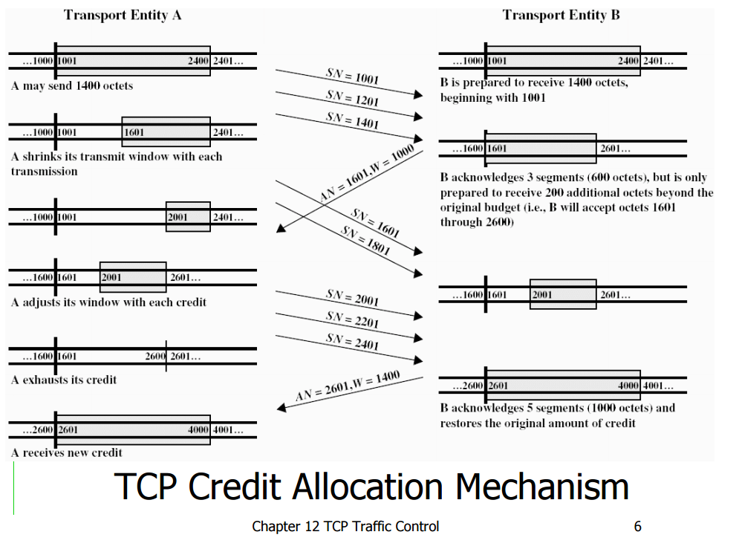

7. The network-assisted congestion control that it will give our feedbacks from routers. The end-end will not feedback at all. TCP cannot communicated with the network layer, it will require to know more before it can do anything.

8. The virtual circuit will know receiver address. Each router will create a forwarding table that will tell the next interface, the virtual circuit number and outgoing interface.

9. CIDR is classes inter Domain Routing. Advantage to allow more flexible allocation of Internet Protocol addresses and can eliminate wastefulness and to provide mechanisms for route aggregation. Disadvantage, let we cannot more confirm the original system of IP address.

10. The routers will have a NAT translation table that connect the outside IP to inside IP ports. With this is can easily forward the connection to the correct devices. And there are ways for non-NAT host to act like a NAT as well