# 登录注册服务

## 代码:

用户

import com.baomidou.mybatisplus.annotation.IdType;  
import com.baomidou.mybatisplus.annotation.TableField;  
import com.baomidou.mybatisplus.annotation.TableId;  
import com.baomidou.mybatisplus.annotation.TableName;  
import io.swagger.annotations.ApiModel;  
import io.swagger.annotations.ApiModelProperty;  
import lombok.Data;  
import lombok.NoArgsConstructor;  
  
import java.io.Serializable;  
  
@ApiModel(value = "`user`")  
@Data  
@NoArgsConstructor  
@TableName(value = "`user`")  
public class User implements Serializable {  
 public static final String *COL_ID* = "id";  
 public static final String *COL_USER_NAME* = "user_Name";  
 public static final String *COL_USER_PASSWARD* = "user_Passward";  
 public static final String *COL_NICKNAME* = "nickName";  
 public static final String *COL_USER_PHONE* = "user_phone";  
 public static final String *COL_ADDRESS* = "address";  
 public static final String *COL_ROLE_ID* = "role_ID";  
 @TableId(value = "id", type = IdType.*AUTO*)  
 *// 使用ApiModelProperty来标注字段属性。* @ApiModelProperty(value = "主键id", example = "1")  
 private Integer id;  
 @TableField(value = "user_Name")  
 @ApiModelProperty(value = "用户名", example = "张三")  
 private String userName;  
 @TableField(value = "user_Passward")  
 @ApiModelProperty(value = "用户密码", example = "1234")  
 private String userPassward;  
 private String nickname;  
 private String userPhone;  
 private String address;  
 private Integer roleId;  
}

管理员

package com.xpu.entity;  
  
import com.baomidou.mybatisplus.annotation.IdType;  
import com.baomidou.mybatisplus.annotation.TableField;  
import com.baomidou.mybatisplus.annotation.TableId;  
import com.baomidou.mybatisplus.annotation.TableName;  
import io.swagger.annotations.ApiModel;  
import io.swagger.annotations.ApiModelProperty;  
import lombok.Data;  
import lombok.NoArgsConstructor;  
  
import java.io.Serializable;  
  
@ApiModel(value="`admin`")  
@Data  
@NoArgsConstructor  
@TableName(value = "`admin`")  
public class Admin implements Serializable {  
 */**  
 * 主键id  
 */* @TableId(value = "id", type = IdType.*AUTO*)  
 @ApiModelProperty(value="主键id")  
 private Integer id;  
  
 @TableField(value = "admin_Name")  
 @ApiModelProperty(value="管理员用户名" ,example = "admin")  
 private String adminName;  
  
 @TableField(value = "admin_Password")  
 @ApiModelProperty(value="管理员密码",example = "admin")  
 private String adminPassword;  
  
 @TableField(value = "`name`")  
 @ApiModelProperty(value="管理员姓名")  
 private String name;  
  
 public static final String *COL_ID* = "id";  
  
 public static final String *COL_ADMIN_NAME* = "admin_Name";  
  
 public static final String *COL_ADMIN_PASSWORD* = "admin_Password";  
  
 public static final String *COL_NAME* = "name";  
}

控制层

package com.xpu.controller;  
  
import com.xpu.entity.Admin;  
import com.xpu.entity.R;  
import com.xpu.entity.User;  
import com.xpu.service.AdminService;  
import com.xpu.service.UserService;  
import com.xpu.utils.MD5Utils;  
import io.swagger.annotations.Api;  
import io.swagger.annotations.ApiOperation;  
import io.swagger.annotations.ApiResponse;  
import io.swagger.annotations.ApiResponses;  
import org.springframework.beans.factory.annotation.Autowired;  
import org.springframework.stereotype.Controller;  
import org.springframework.web.bind.annotation.*;  
  
import javax.servlet.http.HttpServletRequest;  
import javax.servlet.http.HttpSession;  
import java.util.HashMap;  
  
@Api(tags = "用户登录管理")  
@Controller  
@RequestMapping("/user")  
public class LoginController {  
 @Autowired  
 UserService userService;  
 @Autowired  
 AdminService adminService;  
  
 @PostMapping("/login")  
 @ResponseBody  
 @ApiOperation(value = "登录接口", notes = "登录接口的说明,参数类型如\n" +  
 "{\n" +  
 " \"flag\" :1,\n" +  
 " \"user\":{ \n" +  
 " \"username\": \"abc\",\n" +  
 " \"password\": \"123456\"\n" +  
 " }\n" +  
 "}")  
 @ApiResponses({  
 @ApiResponse(code = 200, message = "调用成功"),  
 @ApiResponse(code = 401, message = "无权限")  
 }  
 )  
 public R login(@RequestBody HashMap<String, Object> map,HttpServletRequest req) {  
 int flag = (int) map.get("flag");  
 HashMap userMap = (HashMap) map.get("user");  
 User user = new User();  
 user.setUserName((String) userMap.get("username"));  
 user.setUserPassward((String) userMap.get("password"));  
 if (flag == 1) {  
 user.setUserPassward(MD5Utils.*getMD5*(user.getUserPassward()));  
 User loginuser = userService.userLogin(user);  
 if (loginuser != null) {  
 HttpSession session = req.getSession();  
 session.setAttribute("user", loginuser);  
 session.setAttribute("isLogin", true);  
 if (loginuser.getRoleId() == 1)  
 return new R(true, loginuser, "采购员登录成功");  
 else  
 return new R(true, loginuser, "客户登录成功");  
 }  
 } else if (flag==0) {  
 *//管理登录业务* Admin admin = new Admin();  
 admin.setAdminName((String) userMap.get("username"));  
 admin.setAdminPassword((String) userMap.get("password"));  
 Admin loginAdmin = adminService.adminLogin(admin);  
 if (loginAdmin != null) {  
 req.getSession().setAttribute("admin", loginAdmin);  
 req.getSession().setAttribute("isLogin", true);  
 return new R(true, loginAdmin, "管理员登录成功");  
 }  
 }  
 return new R("登录失败");  
 }  
  
 @PostMapping("/register")  
 @ResponseBody  
 @ApiOperation(value = "注册接口", notes = "注册需要除id外的字段必填")  
 @ApiResponses({  
 @ApiResponse(code = 200, message = "调用成功"),  
 @ApiResponse(code = 401, message = "无权限")  
 }  
 )  
 public R register(@RequestBody User user) {  
 *//查询一下 用户名有没有被注册* User webUser=userService.selectUserByUserName(user.getUserName());  
 if(webUser!=null)  
 return new R(false,"用户名已被注册");  
 user.setUserPassward(MD5Utils.*getMD5*(user.getUserPassward()));  
 boolean flag = userService.userRegister(user);  
 return new R(flag,user,flag ? "注册成功" : "注册失败");  
 }  
  
 @GetMapping("logout")  
 @ResponseBody  
 @ApiOperation(value = "退出登录接口", notes = "清空session后退出")  
 public R logout(HttpServletRequest req) {  
 req.getSession().invalidate();*//清空session 返回登录页* return new R(true,"退出登录成功");  
 }  
  
  
}

后台运行截图：

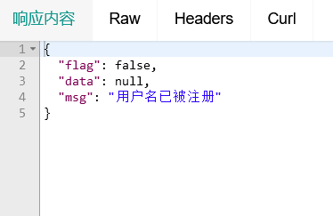

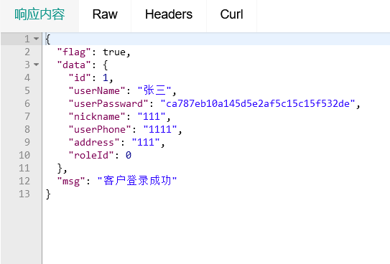

前台登录注册截图：

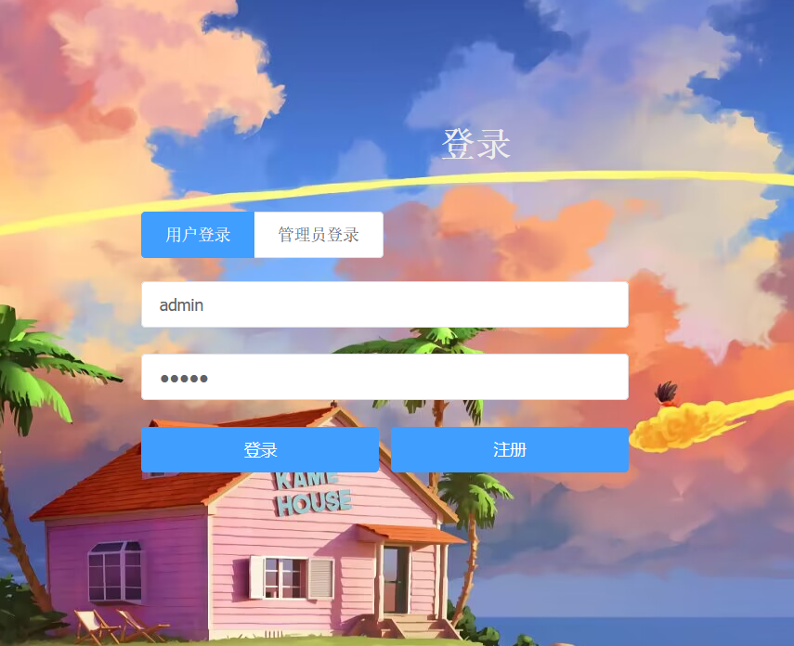

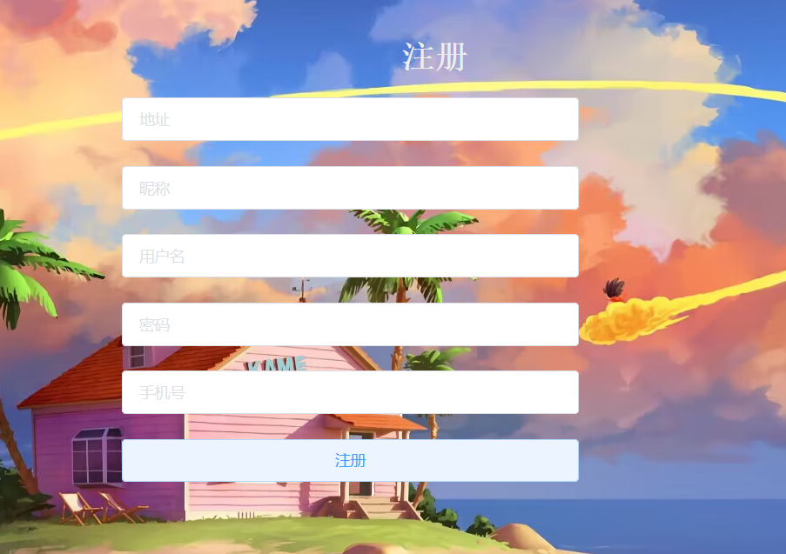

# 用户服务

用户：

package com.xpu.entity;  
  
import com.baomidou.mybatisplus.annotation.IdType;  
import com.baomidou.mybatisplus.annotation.TableField;  
import com.baomidou.mybatisplus.annotation.TableId;  
import com.baomidou.mybatisplus.annotation.TableName;  
import io.swagger.annotations.ApiModel;  
import io.swagger.annotations.ApiModelProperty;  
import lombok.Data;  
import lombok.NoArgsConstructor;  
  
import java.io.Serializable;  
  
@ApiModel(value = "`user`")  
@Data  
@NoArgsConstructor  
@TableName(value = "`user`")  
public class User implements Serializable {  
 public static final String *COL_ID* = "id";  
 public static final String *COL_USER_NAME* = "user_Name";  
 public static final String *COL_USER_PASSWARD* = "user_Passward";  
 public static final String *COL_NICKNAME* = "nickName";  
 public static final String *COL_USER_PHONE* = "user_phone";  
 public static final String *COL_ADDRESS* = "address";  
 public static final String *COL_ROLE_ID* = "role_ID";  
 @TableId(value = "id", type = IdType.*AUTO*)  
 *// 使用ApiModelProperty来标注字段属性。* @ApiModelProperty(value = "主键id", example = "1")  
 private Integer id;  
 @TableField(value = "user_Name")  
 @ApiModelProperty(value = "用户名", example = "zhangsan")  
 private String userName;  
 @TableField(value = "user_Passward")  
 @ApiModelProperty(value = "用户密码", example = "1234")  
 private String userPassward;  
 private String nickname;  
 private String userPhone;  
 private String address;  
 private Integer roleId;  
}

管理员：

package com.xpu.entity;  
  
import com.baomidou.mybatisplus.annotation.IdType;  
import com.baomidou.mybatisplus.annotation.TableField;  
import com.baomidou.mybatisplus.annotation.TableId;  
import com.baomidou.mybatisplus.annotation.TableName;  
import io.swagger.annotations.ApiModel;  
import io.swagger.annotations.ApiModelProperty;  
import lombok.Data;  
import lombok.NoArgsConstructor;  
  
import java.io.Serializable;  
  
@ApiModel(value="`admin`")  
@Data  
@NoArgsConstructor  
@TableName(value = "`admin`")  
public class Admin implements Serializable {  
 */**  
 * 主键id  
 */* @TableId(value = "id", type = IdType.*AUTO*)  
 @ApiModelProperty(value="主键id")  
 private Integer id;  
  
 @TableField(value = "admin_Name")  
 @ApiModelProperty(value="管理员用户名" ,example = "admin")  
 private String adminName;  
  
 @TableField(value = "admin_Password")  
 @ApiModelProperty(value="管理员密码",example = "admin")  
 private String adminPassword;  
  
 @TableField(value = "`name`")  
 @ApiModelProperty(value="管理员姓名")  
 private String name;  
  
 public static final String *COL_ID* = "id";  
  
 public static final String *COL_ADMIN_NAME* = "admin_Name";  
  
 public static final String *COL_ADMIN_PASSWORD* = "admin_Password";  
  
 public static final String *COL_NAME* = "name";  
}

控制：

package com.xpu.controller;  
  
  
import com.xpu.entity.*;  
import com.xpu.service.InvoiceService;  
import com.xpu.service.OrderformService;  
import com.xpu.service.UserService;  
import com.xpu.utils.MD5Utils;  
import io.swagger.annotations.Api;  
import org.springframework.stereotype.Controller;  
import org.springframework.web.bind.annotation.*;  
  
import javax.annotation.Resource;  
import javax.servlet.http.HttpServletRequest;  
import java.util.ArrayList;  
  
@Api(tags = "用户管理")  
@Controller  
@RequestMapping("/userinfo")  
public class UserController {  
 @Resource  
 UserService userService;  
 @Resource  
 OrderformService orderformService;  
 @Resource  
 InvoiceService invoiceService;  
 @ResponseBody  
 @PostMapping("/addUser")  
 public R addUser(@RequestBody User user) {  
 System.*out*.println("前台：user" + user);  
 user.setUserPassward(MD5Utils.*getMD5*(user.getUserPassward()));  
 int count = userService.insertUser(user);  
 System.*out*.println(count);  
 boolean flag = count > 0;  
 return new R(flag, String.*valueOf*(count));  
 }  
  
 @ResponseBody  
 @GetMapping("/deleteUserById")  
 public R deleteUserById(Integer uid, HttpServletRequest req) {  
 Admin admin = (Admin) req.getSession().getAttribute("admin");  
 if(admin==null)  
 return new R(false, "管理未登录！");  
 User user = userService.selectUserById(uid);  
 if (user == null)  
 return new R(false, "无该用户");  
 ArrayList<Orderform> orderList = orderformService.selectUserAllOrderByUserId(uid);  
 if (orderList.isEmpty())  
 System.*out*.println("该用户无订单！");  
 *//查询与该用户相关的所有发票信息* ArrayList<Invoice> invoiceList = invoiceService.selectUserAllInvoiceByUserID(uid);  
 if (invoiceList.isEmpty())  
 System.*out*.println("该用户无发票！");  
 *//删除这些发票信息与订单信息  
 //删除该用户所有发票信息* for (Invoice inv : invoiceList)  
 invoiceService.removeById(inv.getId());  
 *//删除该用户所有相关订单信息* for (Orderform ord : orderList)  
 orderformService.deleteOrderById(ord.getId());  
 *//删除用户信息* boolean deleteSuccess = userService.delete(uid);  
 return new R(deleteSuccess, deleteSuccess ? "删除成功" : "删除失败");  
 }  
  
 @ResponseBody  
 @GetMapping("/selectUserById")  
 public R selectUserById(Integer id) {  
 User user = userService.selectUserById(id);  
 boolean flag = (user != null);  
 return new R(flag, user, flag ? "查询成功！" : "无该用户！");  
 }  
  
 @ResponseBody  
 @GetMapping("/selectALLUser")  
 public R selectALLUser() {  
 ArrayList<User> userList = userService.selectALLUser();  
 boolean flag =!userList.isEmpty();  
 return new R(flag,userList,flag?"查询成功":"无内容");  
 }  
  
 @ResponseBody  
 @PostMapping("/updateUserById")  
 public R updateUserById(@RequestBody User user) {  
 System.*out*.println(user);  
 int count = userService.updateUser(user);  
 boolean flag = (count > 0);  
 return new R(flag, flag ? "更新成功！" : "更新失败！");  
 }  
}

后台测试截图：

增加用户：

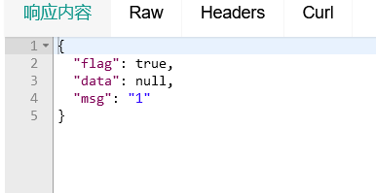

查询所有用户：

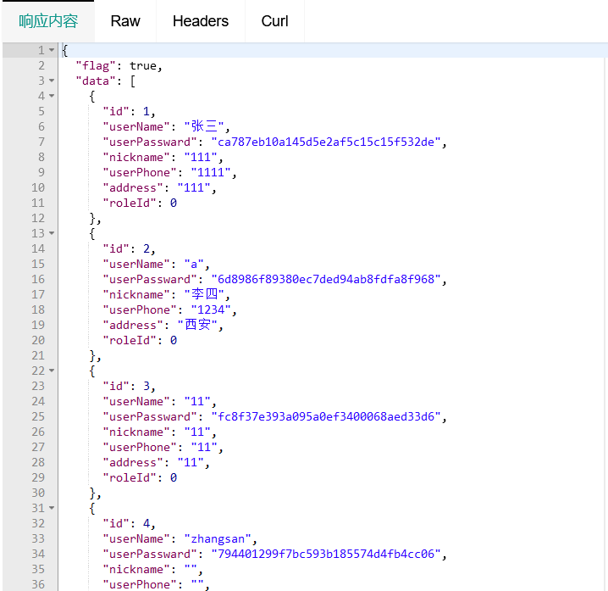

查询单个用户：

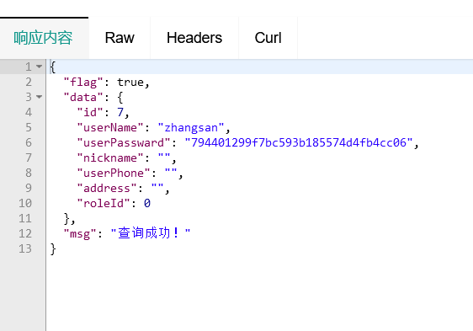

更新用户：

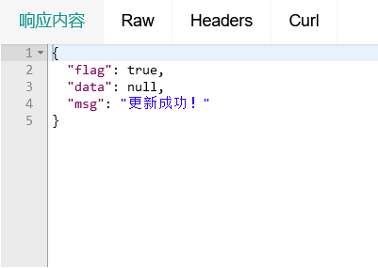

前端截图：

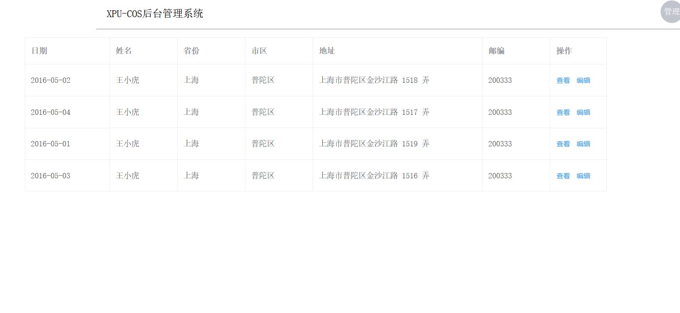

# 商品服务：

管理员

package com.xpu.entity;  
  
import com.baomidou.mybatisplus.annotation.IdType;  
import com.baomidou.mybatisplus.annotation.TableField;  
import com.baomidou.mybatisplus.annotation.TableId;  
import com.baomidou.mybatisplus.annotation.TableName;  
import io.swagger.annotations.ApiModel;  
import io.swagger.annotations.ApiModelProperty;  
import lombok.Data;  
import lombok.NoArgsConstructor;  
  
import java.io.Serializable;  
  
@ApiModel(value="`admin`")  
@Data  
@NoArgsConstructor  
@TableName(value = "`admin`")  
public class Admin implements Serializable {  
 */**  
 * 主键id  
 */* @TableId(value = "id", type = IdType.*AUTO*)  
 @ApiModelProperty(value="主键id")  
 private Integer id;  
  
 @TableField(value = "admin_Name")  
 @ApiModelProperty(value="管理员用户名" ,example = "admin")  
 private String adminName;  
  
 @TableField(value = "admin_Password")  
 @ApiModelProperty(value="管理员密码",example = "admin")  
 private String adminPassword;  
  
 @TableField(value = "`name`")  
 @ApiModelProperty(value="管理员姓名")  
 private String name;  
  
 public static final String *COL_ID* = "id";  
  
 public static final String *COL_ADMIN_NAME* = "admin_Name";  
  
 public static final String *COL_ADMIN_PASSWORD* = "admin_Password";  
  
 public static final String *COL_NAME* = "name";  
}

用户：

package com.xpu.entity;  
  
import com.baomidou.mybatisplus.annotation.IdType;  
import com.baomidou.mybatisplus.annotation.TableField;  
import com.baomidou.mybatisplus.annotation.TableId;  
import com.baomidou.mybatisplus.annotation.TableName;  
import io.swagger.annotations.ApiModel;  
import io.swagger.annotations.ApiModelProperty;  
import lombok.Data;  
import lombok.NoArgsConstructor;  
  
import java.io.Serializable;  
  
@ApiModel(value="`user`")  
@Data  
@NoArgsConstructor  
@TableName(value = "`user`")  
public class User implements Serializable {  
 @TableId(value = "user表主键id，业务无关", type = IdType.*AUTO*)  
 private Integer id;  
  
 @TableField(value = "user_Name")  
 @ApiModelProperty(value="用户名",example = "zhangsan")  
 private String userName;  
  
 @TableField(value = "user_Passward")  
 @ApiModelProperty(value="用户密码",example = "1234")  
 private String userPassward;  
  
 private String nickname;  
  
  
 private String userPhone;  
  
  
 private String address;  
  
  
 private Integer roleId;  
 public static final String *COL_ID* = "id";  
  
 public static final String *COL_USER_NAME* = "user_Name";  
  
 public static final String *COL_USER_PASSWARD* = "user_Passward";  
  
 public static final String *COL_NICKNAME* = "nickName";  
  
 public static final String *COL_USER_PHONE* = "user_phone";  
  
 public static final String *COL_ADDRESS* = "address";  
  
 public static final String *COL_ROLE_ID* = "role_ID";  
}

商品：

package com.xpu.entity;  
  
import com.baomidou.mybatisplus.annotation.IdType;  
import com.baomidou.mybatisplus.annotation.TableField;  
import com.baomidou.mybatisplus.annotation.TableId;  
import com.baomidou.mybatisplus.annotation.TableName;  
import io.swagger.annotations.ApiModel;  
import io.swagger.annotations.ApiModelProperty;  
import lombok.Data;  
import lombok.NoArgsConstructor;  
  
import java.io.Serializable;  
  
@ApiModel(value="commodity")  
@Data  
@NoArgsConstructor  
@TableName(value = "commodity")  
public class Commodity implements Serializable {  
 @TableId(value = "id", type = IdType.*AUTO*)  
 @ApiModelProperty(value="商品主键id",example = "1")  
 private Integer id;  
  
 @TableField(value = "commodity_Name")  
 @ApiModelProperty(value="商品名称",example = "苹果")  
 private String commodityName;  
  
 @TableField(value = "commodity_repertory")  
 @ApiModelProperty(value="库存",example = "100")  
 private Integer commodityRepertory;  
  
 @TableField(value = "upOrDown")  
 @ApiModelProperty(value="上架/下架",example = "1")  
 private Integer upordown;  
  
 @TableField(value = "commodity_price")  
 @ApiModelProperty(value="商品价格",example = "15.5")  
 private Double commodityPrice;  
  
 private static final long *serialVersionUID* = 1L;  
  
 public static final String *COL_ID* = "id";  
  
 public static final String *COL_COMMODITY_NAME* = "commodity_Name";  
  
 public static final String *COL_COMMODITY_REPERTORY* = "commodity_repertory";  
  
 public static final String *COL_UPORDOWN* = "upOrDown";  
  
 public static final String *COL_COMMODITY_PRICE* = "commodity_price";  
}

后端截图：

商品插入：

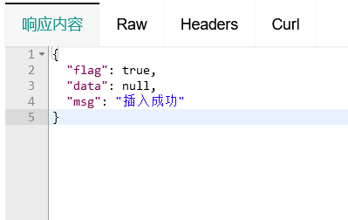

商品删除

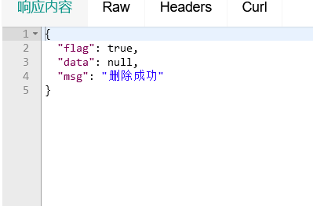

商品修改：

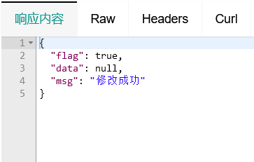

前端：

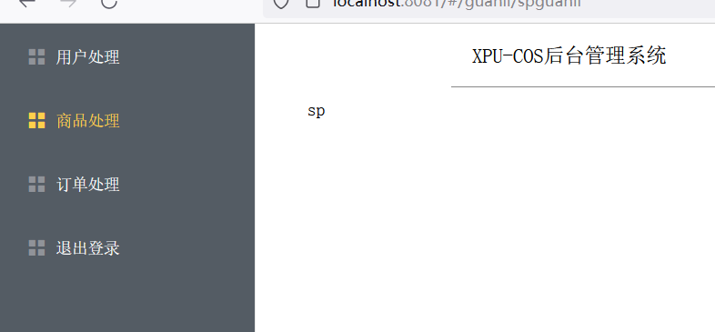

# 购买服务

管理员：

package com.xpu.entity;  
  
import com.baomidou.mybatisplus.annotation.IdType;  
import com.baomidou.mybatisplus.annotation.TableField;  
import com.baomidou.mybatisplus.annotation.TableId;  
import com.baomidou.mybatisplus.annotation.TableName;  
import io.swagger.annotations.ApiModel;  
import io.swagger.annotations.ApiModelProperty;  
import lombok.Data;  
import lombok.NoArgsConstructor;  
  
import java.io.Serializable;  
  
@ApiModel(value="`admin`")  
@Data  
@NoArgsConstructor  
@TableName(value = "`admin`")  
public class Admin implements Serializable {  
 */**  
 * 主键id  
 */* @TableId(value = "id", type = IdType.*AUTO*)  
 @ApiModelProperty(value="主键id")  
 private Integer id;  
  
 @TableField(value = "admin_Name")  
 @ApiModelProperty(value="管理员用户名" ,example = "admin")  
 private String adminName;  
  
 @TableField(value = "admin_Password")  
 @ApiModelProperty(value="管理员密码",example = "admin")  
 private String adminPassword;  
  
 @TableField(value = "`name`")  
 @ApiModelProperty(value="管理员姓名")  
 private String name;  
  
 public static final String *COL_ID* = "id";  
  
 public static final String *COL_ADMIN_NAME* = "admin_Name";  
  
 public static final String *COL_ADMIN_PASSWORD* = "admin_Password";  
  
 public static final String *COL_NAME* = "name";  
}

用户：

package com.xpu.entity;  
  
import com.baomidou.mybatisplus.annotation.IdType;  
import com.baomidou.mybatisplus.annotation.TableField;  
import com.baomidou.mybatisplus.annotation.TableId;  
import com.baomidou.mybatisplus.annotation.TableName;  
import io.swagger.annotations.ApiModel;  
import io.swagger.annotations.ApiModelProperty;  
import lombok.Data;  
import lombok.NoArgsConstructor;  
  
import java.io.Serializable;  
  
@ApiModel(value="`user`")  
@Data  
@NoArgsConstructor  
@TableName(value = "`user`")  
public class User implements Serializable {  
 @TableId(value = "user表主键id，业务无关", type = IdType.*AUTO*)  
 private Integer id;  
  
 @TableField(value = "user_Name")  
 @ApiModelProperty(value="用户名",example = "zhangsan")  
 private String userName;  
  
 @TableField(value = "user_Passward")  
 @ApiModelProperty(value="用户密码",example = "1234")  
 private String userPassward;  
  
 private String nickname;  
  
  
 private String userPhone;  
  
  
 private String address;  
  
  
 private Integer roleId;  
 public static final String *COL_ID* = "id";  
  
 public static final String *COL_USER_NAME* = "user_Name";  
  
 public static final String *COL_USER_PASSWARD* = "user_Passward";  
  
 public static final String *COL_NICKNAME* = "nickName";  
  
 public static final String *COL_USER_PHONE* = "user_phone";  
  
 public static final String *COL_ADDRESS* = "address";  
  
 public static final String *COL_ROLE_ID* = "role_ID";  
}

控制：

package com.xpu.controller;  
  
import com.alibaba.fastjson.JSON;  
import com.alibaba.fastjson.serializer.SerializerFeature;  
import com.xpu.entity.*;  
import com.xpu.service.CommodityService;  
import com.xpu.service.InvoiceService;  
import com.xpu.service.OrderformService;  
import io.swagger.annotations.Api;  
import io.swagger.annotations.ApiOperation;  
import io.swagger.annotations.ApiResponse;  
import io.swagger.annotations.ApiResponses;  
import org.springframework.stereotype.Controller;  
import org.springframework.web.bind.annotation.GetMapping;  
import org.springframework.web.bind.annotation.RequestMapping;  
import org.springframework.web.bind.annotation.ResponseBody;  
  
import javax.annotation.Resource;  
import javax.servlet.http.HttpServletRequest;  
import java.util.Date;  
import java.util.HashMap;  
  
@Api(tags = "购买服务接口")  
@Controller  
@RequestMapping("/buy")  
public class BuyController{  
 @Resource  
 CommodityService commodityService;  
 @Resource  
 OrderformService orderformService;  
 @Resource  
 InvoiceService invoiceService;  
  
 @ResponseBody  
  
 @ApiOperation(value = "购买商品", notes = "购买商品接口的说明\n" +  
 "参数类型为 购买商品的id,购买数量num")  
 @ApiResponses({  
 @ApiResponse(code = 200, message = "调用成功"),  
 @ApiResponse(code = 401, message = "无权限")  
 }  
 )  
 @GetMapping("buyCommodity")  
 public R buyCommodity(int id, int num, HttpServletRequest req) {  
 if(num<=0){  
 return new R(false, "输入数量有误");  
 }  
 User loginuser = (User) req.getSession().getAttribute("user");  
 if (loginuser != null) {  
 System.*out*.println("当前客户:" + loginuser.getNickname());  
 *//根据参数查询商品信息* Commodity good = commodityService.selectCommodityById(id);  
 *//减少库存数量* if (good != null) {  
 System.*out*.println("打算购买" + num + "个" + good.getCommodityName());  
 if (good.getCommodityRepertory() < num) {  
 return new R(false, "库存不足,无法购买");  
 }  
 if (good.getUpordown() < 1)  
 return new R(false, "商品还未上架");  
 *//新增订单* Orderform order = new Orderform();  
 order.setCommodityId(id);  
 order.setUserId(loginuser.getId());  
 order.setCommodityAmount(num);  
 order.setOrderformPrice(good.getCommodityPrice() * num);  
 int count = orderformService.addOrder(order);  
 boolean orderAddSuccess = count > 0;  
 good.setCommodityRepertory(good.getCommodityRepertory() - num);  
 *//更新商品信息* boolean commodityUpdateSuccess = commodityService.updateCommodity(good);  
 *//开发票* Invoice invoice = new Invoice();  
 invoice.setCommodityId(good.getId());*//商品id* invoice.setInvoiceDate(new Date()); *//开票日期* invoice.setOrderformId(order.getId());*//订单id* invoice.setUserId(loginuser.getId());*// 用户id* invoice.setInvoiceDrawer("XPU");  
 int invoiceCount = invoiceService.addInvoice(invoice);  
 boolean invoiceAddSuccess = invoiceCount > 0;  
 if (commodityUpdateSuccess && invoiceAddSuccess && orderAddSuccess) {  
 HashMap<String, Object> map = new HashMap<>();  
 map.put("good", good);*//商品信息* map.put("invoice", invoice);*//发票信息* map.put("order", order);*//订单信息  
 //格式化时间* String invoiceStr = JSON.*toJSONStringWithDateFormat*(map, "yyyy-MM-dd HH:mm:ss", SerializerFeature.*WriteDateUseDateFormat*);  
 return new R(true,JSON.*parse*(invoiceStr), "购买成功");  
 }  
  
 } else  
 return new R(false, "无该商品");  
  
 }  
  
 return new R(false, "用户未登录");  
 }  
}

后端：

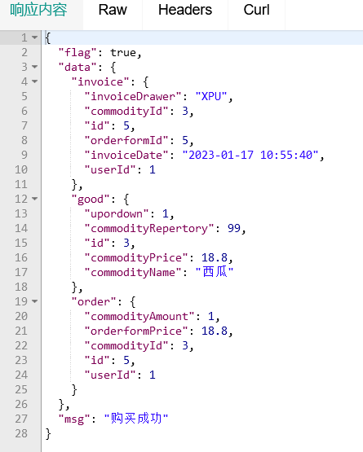

# 订单服务：

管理员：

package com.xpu.entity;  
  
import com.baomidou.mybatisplus.annotation.IdType;  
import com.baomidou.mybatisplus.annotation.TableField;  
import com.baomidou.mybatisplus.annotation.TableId;  
import com.baomidou.mybatisplus.annotation.TableName;  
import io.swagger.annotations.ApiModel;  
import io.swagger.annotations.ApiModelProperty;  
import lombok.Data;  
import lombok.NoArgsConstructor;  
  
import java.io.Serializable;  
  
@ApiModel(value="`admin`")  
@Data  
@NoArgsConstructor  
@TableName(value = "`admin`")  
public class Admin implements Serializable {  
 */**  
 * 主键id  
 */* @TableId(value = "id", type = IdType.*AUTO*)  
 @ApiModelProperty(value="主键id")  
 private Integer id;  
  
 @TableField(value = "admin_Name")  
 @ApiModelProperty(value="管理员用户名" ,example = "admin")  
 private String adminName;  
  
 @TableField(value = "admin_Password")  
 @ApiModelProperty(value="管理员密码",example = "admin")  
 private String adminPassword;  
  
 @TableField(value = "`name`")  
 @ApiModelProperty(value="管理员姓名")  
 private String name;  
  
 public static final String *COL_ID* = "id";  
  
 public static final String *COL_ADMIN_NAME* = "admin_Name";  
  
 public static final String *COL_ADMIN_PASSWORD* = "admin_Password";  
  
 public static final String *COL_NAME* = "name";  
}

用户：

package com.xpu.entity;  
  
import com.baomidou.mybatisplus.annotation.IdType;  
import com.baomidou.mybatisplus.annotation.TableField;  
import com.baomidou.mybatisplus.annotation.TableId;  
import com.baomidou.mybatisplus.annotation.TableName;  
import io.swagger.annotations.ApiModel;  
import io.swagger.annotations.ApiModelProperty;  
import lombok.Data;  
import lombok.NoArgsConstructor;  
  
import java.io.Serializable;  
  
@ApiModel(value="`user`")  
@Data  
@NoArgsConstructor  
@TableName(value = "`user`")  
public class User implements Serializable {  
 @TableId(value = "user表主键id，业务无关", type = IdType.*AUTO*)  
 private Integer id;  
  
 @TableField(value = "user_Name")  
 @ApiModelProperty(value="用户名",example = "zhangsan")  
 private String userName;  
  
 @TableField(value = "user_Passward")  
 @ApiModelProperty(value="用户密码",example = "1234")  
 private String userPassward;  
  
 private String nickname;  
  
  
 private String userPhone;  
  
  
 private String address;  
  
  
 private Integer roleId;  
 public static final String *COL_ID* = "id";  
  
 public static final String *COL_USER_NAME* = "user_Name";  
  
 public static final String *COL_USER_PASSWARD* = "user_Passward";  
  
 public static final String *COL_NICKNAME* = "nickName";  
  
 public static final String *COL_USER_PHONE* = "user_phone";  
  
 public static final String *COL_ADDRESS* = "address";  
  
 public static final String *COL_ROLE_ID* = "role_ID";  
}

订单：

package com.xpu.entity;  
  
import com.baomidou.mybatisplus.annotation.IdType;  
import com.baomidou.mybatisplus.annotation.TableField;  
import com.baomidou.mybatisplus.annotation.TableId;  
import com.baomidou.mybatisplus.annotation.TableName;  
import io.swagger.annotations.ApiModel;  
import io.swagger.annotations.ApiModelProperty;  
import lombok.Data;  
import lombok.NoArgsConstructor;  
  
import java.io.Serializable;  
  
  
@Data  
@NoArgsConstructor  
@TableName(value = "purchaseorder")  
@ApiModel(value="采购订单表单对象",description="采购订单对象")  
public class Purchaseorder implements Serializable {  
 @TableId(value = "id", type = IdType.*AUTO*)  
 @ApiModelProperty(value="采购订单主键id",example = "1")  
 private Integer id;  
  
 @TableField(value = "commodity_ID")  
 @ApiModelProperty(value="商品id" ,example = "1001")  
 private Integer commodityId;  
  
 @TableField(value = "add_Amount")  
 @ApiModelProperty(value="采购该商品的数量",example = "20")  
 private Integer addAmount;  
  
 private static final long *serialVersionUID* = 1L;  
  
 public static final String *COL_ID* = "id";  
  
 public static final String *COL_COMMODITY_ID* = "commodity_ID";  
  
 public static final String *COL_ADD_AMOUNT* = "add_Amount";  
}

后端测试：

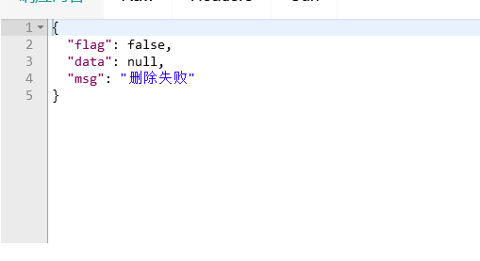

前端

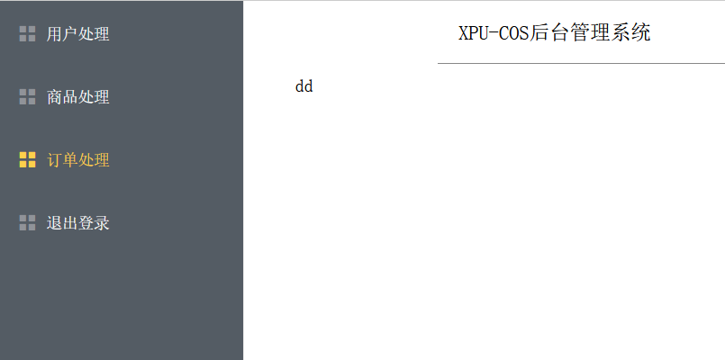

# 发票服务：

用户：

package com.xpu.entity;  
  
import com.baomidou.mybatisplus.annotation.IdType;  
import com.baomidou.mybatisplus.annotation.TableField;  
import com.baomidou.mybatisplus.annotation.TableId;  
import com.baomidou.mybatisplus.annotation.TableName;  
import io.swagger.annotations.ApiModel;  
import io.swagger.annotations.ApiModelProperty;  
import lombok.Data;  
import lombok.NoArgsConstructor;  
  
import java.io.Serializable;  
  
@ApiModel(value="`user`")  
@Data  
@NoArgsConstructor  
@TableName(value = "`user`")  
public class User implements Serializable {  
 @TableId(value = "user表主键id，业务无关", type = IdType.*AUTO*)  
 private Integer id;  
  
 @TableField(value = "user_Name")  
 @ApiModelProperty(value="用户名",example = "zhangsan")  
 private String userName;  
  
 @TableField(value = "user_Passward")  
 @ApiModelProperty(value="用户密码",example = "1234")  
 private String userPassward;  
  
 private String nickname;  
  
  
 private String userPhone;  
  
  
 private String address;  
  
  
 private Integer roleId;  
 public static final String *COL_ID* = "id";  
  
 public static final String *COL_USER_NAME* = "user_Name";  
  
 public static final String *COL_USER_PASSWARD* = "user_Passward";  
  
 public static final String *COL_NICKNAME* = "nickName";  
  
 public static final String *COL_USER_PHONE* = "user_phone";  
  
 public static final String *COL_ADDRESS* = "address";  
  
 public static final String *COL_ROLE_ID* = "role_ID";  
}

管理员：

package com.xpu.entity;  
  
import com.baomidou.mybatisplus.annotation.IdType;  
import com.baomidou.mybatisplus.annotation.TableField;  
import com.baomidou.mybatisplus.annotation.TableId;  
import com.baomidou.mybatisplus.annotation.TableName;  
import io.swagger.annotations.ApiModel;  
import io.swagger.annotations.ApiModelProperty;  
import lombok.Data;  
import lombok.NoArgsConstructor;  
  
import java.io.Serializable;  
  
@ApiModel(value="`admin`")  
@Data  
@NoArgsConstructor  
@TableName(value = "`admin`")  
public class Admin implements Serializable {  
 */**  
 * 主键id  
 */* @TableId(value = "id", type = IdType.*AUTO*)  
 @ApiModelProperty(value="主键id")  
 private Integer id;  
  
 @TableField(value = "admin_Name")  
 @ApiModelProperty(value="管理员用户名" ,example = "admin")  
 private String adminName;  
  
 @TableField(value = "admin_Password")  
 @ApiModelProperty(value="管理员密码",example = "admin")  
 private String adminPassword;  
  
 @TableField(value = "`name`")  
 @ApiModelProperty(value="管理员姓名")  
 private String name;  
  
 public static final String *COL_ID* = "id";  
  
 public static final String *COL_ADMIN_NAME* = "admin_Name";  
  
 public static final String *COL_ADMIN_PASSWORD* = "admin_Password";  
  
 public static final String *COL_NAME* = "name";  
}

发票

package com.xpu.entity;  
  
import com.baomidou.mybatisplus.annotation.IdType;  
import com.baomidou.mybatisplus.annotation.TableField;  
import com.baomidou.mybatisplus.annotation.TableId;  
import com.baomidou.mybatisplus.annotation.TableName;  
import io.swagger.annotations.ApiModel;  
import io.swagger.annotations.ApiModelProperty;  
import java.io.Serializable;  
import java.util.Date;  
import lombok.Data;  
import lombok.NoArgsConstructor;  
  
@ApiModel(value="invoice")  
@Data  
@NoArgsConstructor  
@TableName(value = "invoice")  
public class Invoice implements Serializable {  
 @TableId(value = "id", type = IdType.*AUTO*)  
 @ApiModelProperty(value="")  
 private Integer id;  
  
 @TableField(value = "user_ID")  
 @ApiModelProperty(value="")  
 private Integer userId;  
  
 @TableField(value = "commodity_ID")  
 @ApiModelProperty(value="")  
 private Integer commodityId;  
  
 @TableField(value = "invoice_Date")  
 @ApiModelProperty(value="")  
 private Date invoiceDate;  
  
 @TableField(value = "orderForm_ID")  
 @ApiModelProperty(value="")  
 private Integer orderformId;  
  
 @TableField(value = "invoice_Drawer")  
 @ApiModelProperty(value="")  
 private String invoiceDrawer;  
  
 private static final long *serialVersionUID* = 1L;  
  
 public static final String *COL_ID* = "id";  
  
 public static final String *COL_USER_ID* = "user_ID";  
  
 public static final String *COL_COMMODITY_ID* = "commodity_ID";  
  
 public static final String *COL_INVOICE_DATE* = "invoice_Date";  
  
 public static final String *COL_ORDERFORM_ID* = "orderForm_ID";  
  
 public static final String *COL_INVOICE_DRAWER* = "invoice_Drawer";  
}

后端：

查询所有发票：

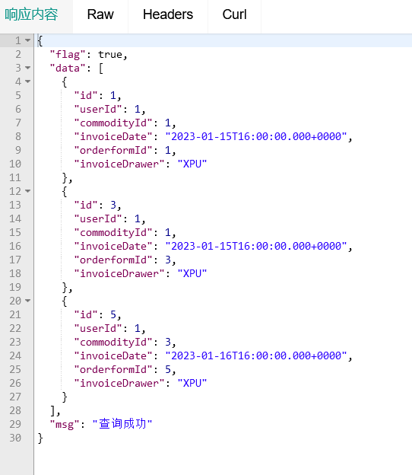

前端：

