As a wife, mother of two, student and dog owner, I have a lot of items to remember throughout the day. To be able to reduce my stress and keep up with my own workload, I decided to create a program that can reduce the craziness of life. I’m probably not the only one with a crazy life, so there are probably others that could also benefit from this program.

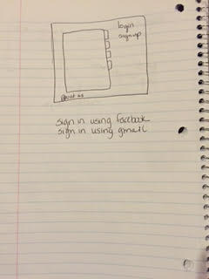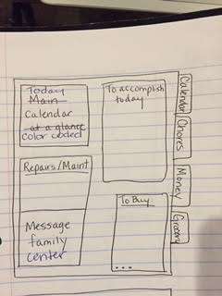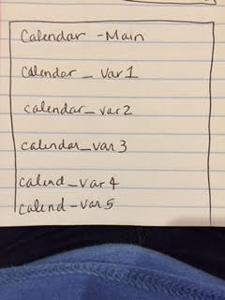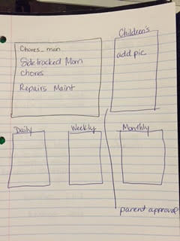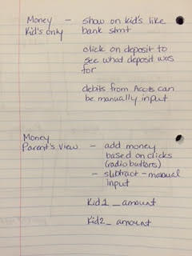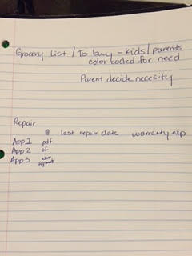

All screens can be accessed by the owner; but, children’s pages will only be able to access their own pages.

