

**Georgia Tech Open Regatta**

**March 30th, 2019**

**Organizing Authority:** Georgia Tech Sailing Club

**Location**: Lake Lanier Sailing Club, Flowery Branch, GA

**NOTICE OF RACE**

**1 RULES**

1.1 The regatta will be governed by the rules as defined in *The Racing Rules of Sailing*.

1.2 The ICSA Collegiate Dinghy Class Rules will apply.

1.3 The Optimist Class Association rules will apply.

1.4 The J/24 & Melges 24 Class rules will apply.

**2 CLASSES**

2.1 Racing will take place in C420s, J/24s, Melges 24s, and Optimists (juniors only).

**3 SUPPLIED BOATS**

3.1The Organizing Authority will provide 14 C420 sailboats for racing. Please contact the Organizing Authority for details on chartering a J/24.

**4 ELIGIBILITY**

4.1 The C420 class is open to a combination of teams and individuals filling 14 boats on a first come first serve basis.

4.2 Other classes are open to all sailors who meet the class requirements.

4.3 The J/24 Class and Melges 24 Class must have at least one Georgia Tech Sailing Club member or Georgia Tech alumnus as part of their crew. The race committee can assist with finding Georgia Tech affiliate crew members.

**5 FEES & ENTRY**

5.1 Required fees are as follows:

|  |  |  |  |
| --- | --- | --- | --- |
| Class | Fee Before 3/15 | Fee 3/15 & After |  |
| 420 | $100 | $120 | Racing in supplied C420, 2 regatta t-shirts, 2 bagged lunches, 2 dinner tickets |
| Optimist | $30 | $35 | 1 regatta t-shirt, 1 bagged lunch, 1 dinner ticket |
| J/24 + Melges 24 | $120 | $150 | 1 regatta t-shirt, bagged lunches for skipper and all crew, 1 dinner ticket |

5.2 All regatta fees are per boat

5.3 Registration fees are to be paid via the regatta website or in person on the day of the event via PayPal, credit card, cash, check, and Venmo (@gtsailing).

5.4 Payment made in advance is preferable

5.5 Payment must be received in order to reserve a spot in any boat provided by the Organizing Authority.

**6 SCHEDULE**

6.1

*Date Time Event*

Friday 30 March TBA GT Sailing Alumni Event

Saturday 31 March 0900-1000 Competitor Check-in/Registration

1000 Competitor’s Meeting

1045 First Warning Signal

1830 Casual Dinner at LLSC Clubhouse

1900 Awards Ceremony

**7 SAILING INSTRUCTIONS**

7.1 Sailing instructions will be available at check-in. They will be posted on the event website by 0900 on March 29th.

**8 VENUE**

8.1 Attachment I shows the layout of the regatta venue.

**9 THE COURSES**

9.1 Courses details and diagrams will be available in the sailing instructions.

**10 FORMAT**

10.1 Format for the C420 class will be single division fleet races with no rotations.

10.2 All other racing will be standard fleet racing.

**11 SCORING**

11.1 All races will be scored using the Low Point System in Appendix A of the RRS, except as modified by the Sailing Instructions

**12 RADIO COMMUNICATION**

12.1 Except in an emergency, a boat that is racing shall not make voice or data transmissions and shall not receive voice or data communication that is not available to all boats.

**13 PRIZES**

13.1 Prizes will be given for 1st, 2nd, and 3rd place in each fleet (C420, Optimist, J/24, Melges 24).

**14 DISCLAIMER OF LIABILITY**

14.1 Competitors participate in the regatta entirely at their own risk. See RRS 4, Decision to Race. The organizing authority will not accept any liability for material damage or personal injury or death sustained in conjunction with or prior to, during, or after the regatta.

**15 FURTHER INFORMATION**

15.1 For further information please contact:

GT Sailing Commodore: Wheeler Sutton, [wheelersutton@gmail.com](mailto:wheelersutton@gmail.com), 404-630-4839

GT Sailing Executive Board: [gtsailingexec@googlegroups.com](mailto:gtsailingexec@googlegroups.com)

Attachment I – Regatta Venue

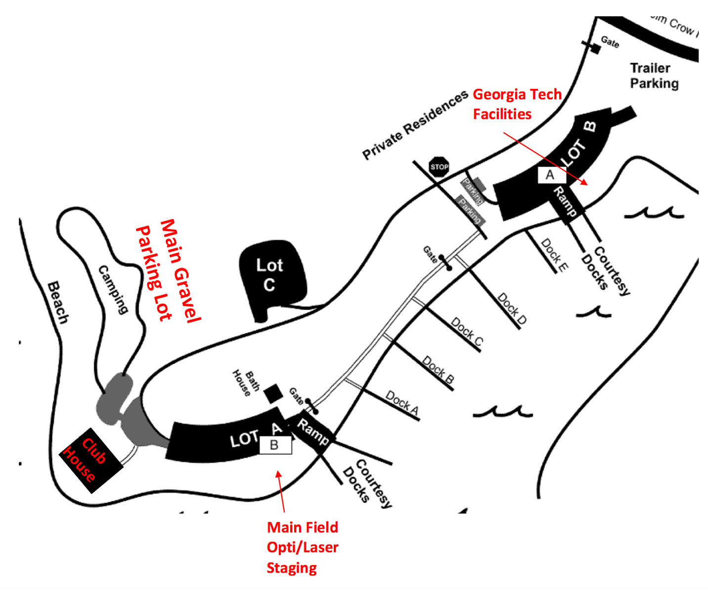

**Opti Staging Area**