Operating Manual for NCBOOT32.EXE

Purpose
Ncboot32.exe is provided to maintain the following functions.
- BOOT function (Maintain the CNC system data, Backup the SRAM, etc.)
- IPL menu of CNC
- Display of CNC power-on screen
- Display of CNC alarm screen
- Reconnection on the communication failure
- Start up the registered application program using data window library
- Automatic showing BOOT/IPL screen at next CNC start (in case of FS30i/31i/32i/35i, PMi-A, FS0i-D and FS0i-F)

Installation
On the installation of the HSSB drivers, Ncboot32.exe is copied onto the System32 folder of Windows NT/2000/XP.
Refer to the Readme2.txt for detailed description for the driver installation.

Start up
Ncboot32.exe will start up automatically, and stay resident in the system tray, when the Windows starts up.
(Example: Ncboot32.exe icon is located on center.)

Termination
It is not necessary to terminate Ncboot32.exe. If you want to terminate Ncboot32.exe, right-click the icon on the system tray and click "End" on the pop-up menu.
While the window of Ncboot32.exe is opened, the "End" menu cannot be selected.

Start sequence
You can select the start sequence using the rotary switch on the CNC main PCB (in case of FS30i/31i/32i/35i, PMi-A, FS0i-D, FS0i-F), or HSSB board of CNC side. In case of PC integrated type i-series, this rotary switch is located on the main PCB.

In case of connecting to an FS30i/31i/32i/35i, PMi-A, FS0i-D, FS0i-F
Position F: Maintenance mode
Position 0: Normal mode
Position E: Asynchronous mode

In case of connecting to a CNC except for FS30i/31i/32i/35i, PMi-A, FS0i-D, FS0i-F
Position 0: Maintenance mode
Position 1: Normal mode
Position 2: Asynchronous mode

In case of connecting to a Power Mate
Position 0: Maintenance mode
Position 1: Asynchronous mode

Start sequence of the maintenance mode
- Wait until the connection with CNC is made successfully.
- Display the BOOT screen.
- Display the IPL screen.
- Display the CNC power-on screen,
- Initialize the work area of the FOCAS2 library.
- Invoke the registered application programs.
- Watch the HSSB error and the CNC system alarm.

Start sequence of the normal mode
- Wait until the connection with CNC is made successfully.
- Initialize the work area of the FOCAS2 library.
- Invoke the registered application programs.
- Watch the HSSB error and the CNC system alarm.

Start sequence of the asynchronous mode
- CNC starts without waiting for the connection.
- After the connection has made, PC executes the below mentioned initialization.
- Initialize the work area of the FOCAS2 library.
- Invoke the registered application programs.
- Watch the HSSB error and the CNC system alarm.

HSSB multi-connection
Ncboot32.exe supports the multi-connection of the HSSB.
Each CNC connected by the HSSB is managed by the unit of "Node". The BOOT screen, the IPL screen and the system alarm screen are opened for the individual node.

Start up the registered application programs
The application programs which use the FOCAS2 library cannot work normally before the initialization of work area for that library.
These programs can be invoked and executed after the initialization of work area is completed if you register them beforehand.
The registration of the application programs should be done for the individual node.

(FOCAS2 : FANUC Open CNC API Specifications version 2)

Explanation of each Ncboot32.exe window
* You have to use Mouse to open the Ncboot32.exe window.

Status window
The status window will be opened by double-clicking the icon on the system tray, or clicking "Open" of the pop-up menu which appears when you right-click the icon.
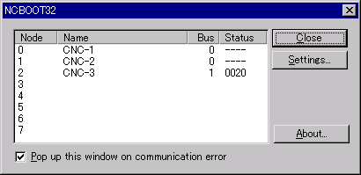
"Node": Node number
"Name": Node name (Defined previously at the HSSB control panel applet on Windows NT/2000/XP)
"Bus": Hardware status (0:Connection error, 1:Connecting)

"Status": Software status (Hexadecimal)
In case of connecting to an FS30i/31i/32i/35i, PMi-A, FS0i-D, FS0i-F
Bit2: BOOT has completed
Bit3: IPL has completed
Bit4: Hardware switch position 0
Bit5: Display 30 lines in IPL/CNC system alarm window
Bit7: Internal flag
Bit8: CNC system alarm occurs
Bit9: Internal flag
Bit10: Internal flag
In case of connecting to a CNC except for FS30i/31i/32i/35i, PMi-A, FS0i-D, FS0i-F
Bit1: Hardware switch position 1
Bit2: BOOT has completed
Bit3: IPL has completed
Bit4: Hardware switch position 2
Bit5: Internal display interface is used (FS150i only)
Bit6: Connected on the HSSB Port 2
Bit7: Internal flag
Bit8: CNC system alarm occurs
In case of connecting to a Power Mate
Bit2: BOOT has completed
Bit3: IPL has completed
Bit4: Hardware switch position 1
Bit6: Connected on the HSSB Port 2
Bit8: CNC system alarm occurs

[Pop up this window on communication error]:
If this box is checked, this window will pop up on communication error.

[Close]: Close this window.
[Settings...]: Open the optional setting window.
[About...]: Open the version information window.

Optional setting window
Register the application programs which invoked after the initialization of the work area for the FOCAS2 library, using this window. In case of FS30i/31i/32i/35i, PMi-A, FS0i-D and FS0i-F, you can set also whether the BOOT/IPL screen is invoked or not at the next CNC start.
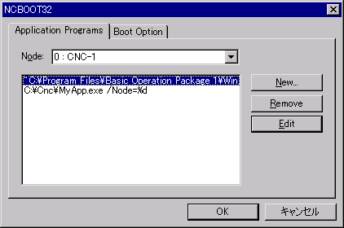
[Node]: Select node for registering the application programs. The application programs for the selected node are listed in the list box.
[New...]: Register new application program. If the path string contains the space character, path string will be enclosed by the double-quotation, automatically.
[Remove]: Remove the selected line.
[Edit]: Edit the selected line for the command line arguments. The string "%d" in the argument will converted to the related node number. If you want to use the "%" character, write it as "%%".

Example) When you want to invoke the Basic Operation Package 1 for the node after the initialization of the work area for the FOCAS2 library, edit the command line as follows.

"C:\Program Files\Basic Operation Package 1\WinBOP32.exe" /Node=%d

In case of FS30i/31i/32i/35i, PMi-A, FS0i-D and FS0i-F, "Boot Option" tab is available at the Option setting window.
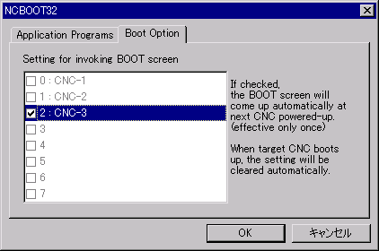
When you check the check box that is located left side of the CNC name that is not shown with gray color, at next CNC start, corresponding BOOT/IPL screen will be invoked regardless of the setting of rotary switch. This setting is effective only once; the check will be cleared automatically by Ncboot32.exe.

BOOT window
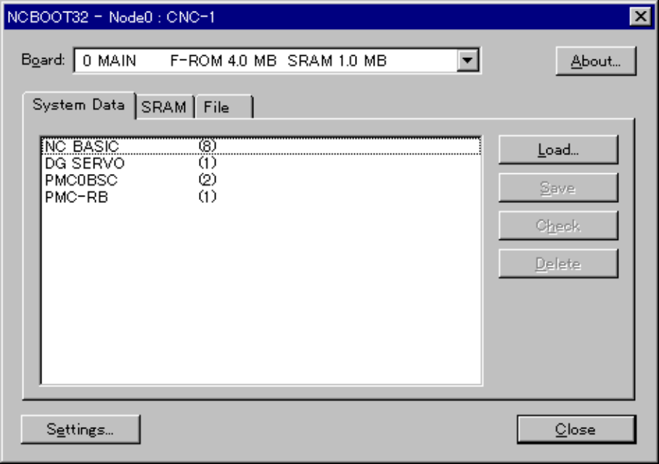
[Board]: Select the board from this list, if the sub boards exist.
[Settings...]: Change the file location.

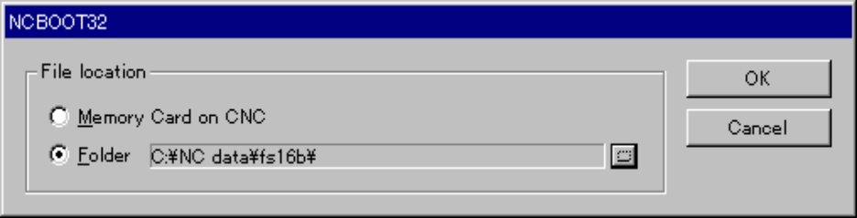
Select the memory card on CNC or the folder of PC.
You may change the file location at any time.

"Memory Card on CNC": specifies the memory card slot of CNC side
- LCD-mounted type CNC : Left side slot of the Display unit
- Stand-alone type CNC without Display unit : Slot on the CNC control unit
- Stand-alone type CNC with Display unit : Left side slot of the Display unit
(“Display unit” means the LCD unit that does not have the PC function, at the above explanation.)
"Folder": specifies the folder of PC
In case of using the card slot of the CNC with PC function, or the PANEL i, select "Folder" and choose the driver name given to the memory card by Windows.

Maintain the system data
You can handle the NC system data (Control software, Ladder program, etc.) on this window.
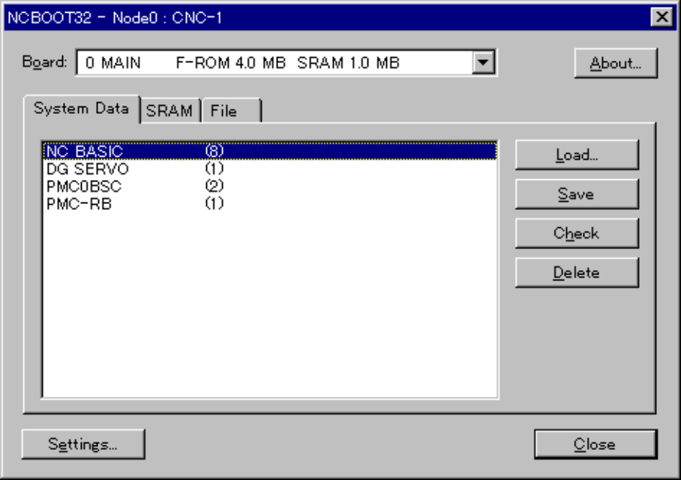
[Load...]: The file selection window will open; Select the file to be loaded to CNC.
[Save]: Save the selected NC system data to the file.
[Check]: Verify the selected NC system data.
[Delete]: Delete the selected NC system data.

On FS150i, in case that the NC’s Boot function is 60I8/E or former, when you want to update the User software made by the Machine Tool Builders (i.e. Ladder program, Macro executor program, C language executor program), please delete the corresponding old User software before writing from PC side. The files to be cared are as follows.

PMC-NB0A, PMC-NB0B, PMC-NB0C, PMC-NB0D, PMC-NB0E, PMC-NB0F,
PD1M256K, PD1M0.5M, PD1M1.0M, PD1M1.5M, PD1M2.0M, PD1M3.0M, PD1M4.0M,
CLB USER

Backup/Restore the SRAM
You can backup and restore the SRAM data on CNC on this window.
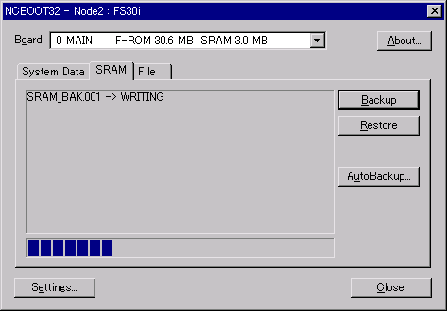
[Backup]: Backup the SRAM to the file.
[Restore]: Restore the SRAM from the file.

The center window shows the operating status.
As with the NC, the filename is determined automaticallｙ. Therefore, you cannot rename it.

In case of FS30i/31i/32i/35i, PMi-A, FS0i-D and FS0i-F, the CNC has a function that the contents of SRAM are backed up into FROM automatically. (at BOOT software 60W1-07 or later) On the PC side operation, the automatically saved data can be restored into the SRAM. When [AutoBackup...] button is pressed, the following window is displayed.
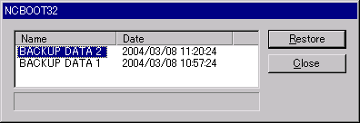
Select one of the saved images at "Name" and press [Restore] button, and then the corresponding SRAM data will be restored.

File operation
You can handle the files on the memory card on CNC side or at the PC folder, on this window.
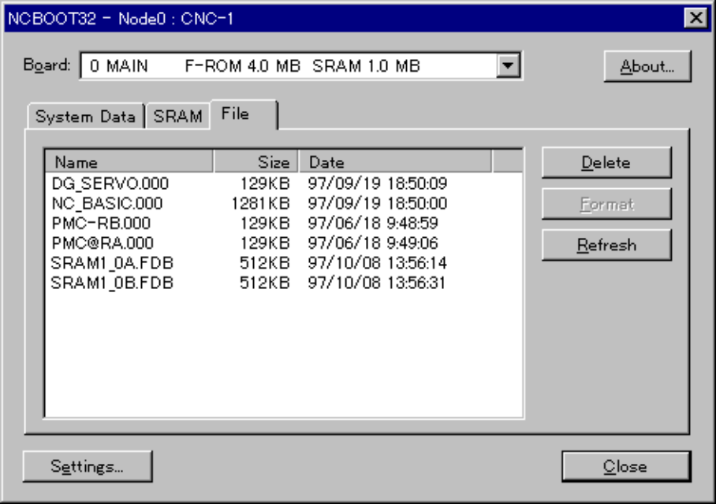
[Delete]: Delete the selected file.
[Format]: Format the memory card. This button is enabled when you select the “Memory Card on CNC” by [Settings...] button.
[Refresh]: Refresh the file list. Push this button when you change the memory card or the floppy disk.

IPL window
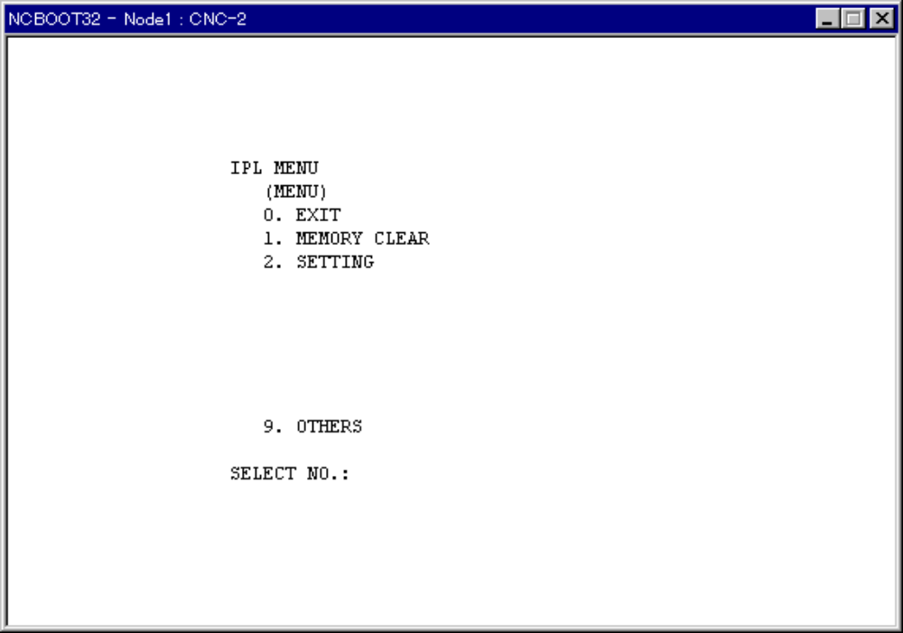
The contents of this window are different depending on the model of CNC. Operate according to the menu.

CNC system alarm window
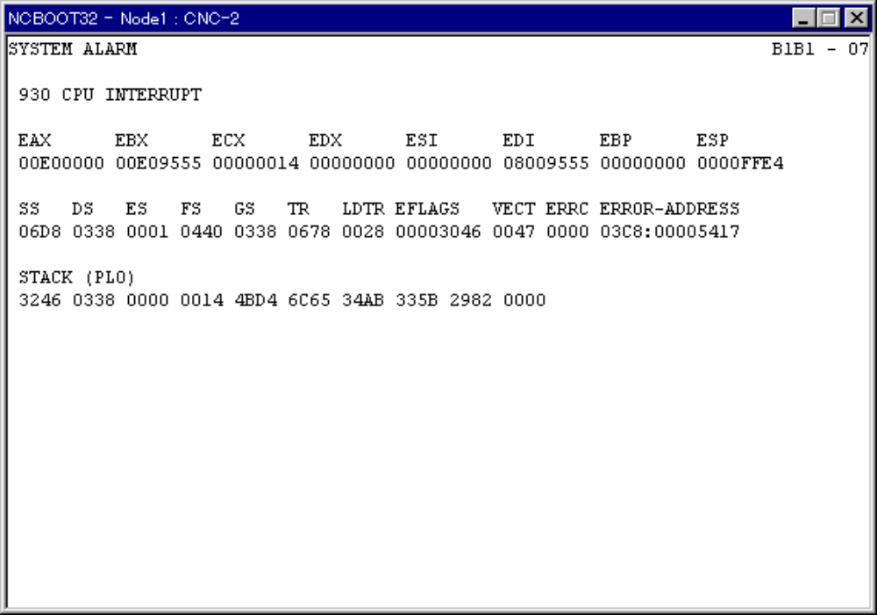
This window appears when the CNC system alarm occurs.

Notification of HSSB communication error to the application program
When Ncboot32.exe detects the HSSB communication error and the re-establishment of the HSSB communication, Ncboot32.exe sends the message to all the application under execution. In order to use this message at the application program, it should register "FANUC-HSSB-COMMUNICATION" message by RegisterWindowMessage beforehand and handle the message by WindowProc.

The parameter, wParam, of the message indicates the HSSB communication status.
wParam = 0 Communication error occurs
This shows the HSSB communication stops at the hardware level.

wParam = 1 Communication re-established
This shows the HSSB communication is re-established and Data window function becomes usable.

The parameter, lParam, indicates the node number.

Example
Step 1
Register the message when the application program starts up.
In this example, the message ID is saved to the global variable, g_uHssbMsg, by InitInstance.

BOOL CMyApp::InitInstance()
{
g_uHssbMsg = RegisterWindowMessage("FANUC-HSSB-COMMUNICATION");
:
:

Step 2
Handle the message.
The message is sent to the top-level window, not to the child window. If the received message is matched with the message ID saved at the above Step 1 and the node number is the ones that is used at the application program, the process for the HSSB communication error or re-establishment of the HSSB communication should be executed.
In this example, we assume the global variable, g_uMyNode, holds the node number being used.

LRESULT CMyDlg::WindowProc(UINT message, WPARAM wParam, LPARAM lParam)
{
if (message == g_uHssbMsg && lParam == g_uMyNode) {
switch (wParam) {
case 0:
// Process for the HSSB communication error
break;
case 1:
// Process for the re-establishment of HSSB communication
break;
}
return 0;
}

return CDialog::WindowProc(message, wParam, lParam);
}

History

Version 5.00
- The HSSB interface board for PCI Express is supported.

Version 4.09
- The function to monitor a fan alarm is enhanced.

Version 4.08
- Apply to the password function for the MEM format file of the Macro executor.

Version 4.06
- NCBoot32.exe supports 60W4/01 of CNC BOOT.
- Apply to Windows 7 Professional.

Version 4.05
- NCBoot32.exe supports the older version than OSR2 of Windows 95.

Version 4.04
- NCBoot32.exe supports 60M9/03, 60MA/03, 60MB/02, 60WA/03 and 60WB/03 of CNC BOOT.

Version 4.03
- When the language of Windows is not Japanese, it is not possible to execute [SAVE], [LOAD] and [DELETE] operations. This problem is corrected.
- When CNC BOOT system is 60W1 or 60W2 series, the Basic Assembly B1 to B4 of CNC software cannot be loaded. This problem is corrected.

Version 4.02
- NCBoot32.exe is supported to 60M9, 60MA, 60MB, 60WA and 60WB series of CNC BOOT.

Version 4.00
- Apply to Windows Vista Business.
- The loading operation of another F-ROM file was prohibited while a F-ROM file is loading.

Version 3.07
- When connecting with CNC except for FS30i/31i/32i, DELETE key does not work in IPL window. This problem is corrected.

Version 3.05
- NCBOOT32.EXE may not be started sometimes after it displays the message "Reset request is not accepted by CNC/PMC". This problem is corrected.

Version 3.04
- If PC was rebooted while connecting with FS30i/31i/32i, a SYSTEM ALARM screen might appear when CNC Screen Display Function started. This problem is corrected. You also need a BOOT software 60WI-07 or later.
- In case of connecting with FS30i/31i/32i, if the power of PC was turned on again before the PC starts up completely, a SYSTEM ALARM screen might appear. This problem is corrected.
- The BOOT window disappears abnormally when restoring the "NO DATA" item on the AutoBackup window for FS30i/31i/32i. This problem is corrected.
- A series and version information of the BOOT software are added on the BOOT screen.
- The size of BOOT window, Load window, and AutoBackup window has been enlarged to see all digits of file time stamps.

Version 3.03
- Sometimes MDI keyboard on the PANEL i which connected to FS30i does not respond when automatic logon setting is enabled in Windows XP. This problem is corrected.
- This document format is changed from Word 6 to Word 97/2000.
- Description about the rotary switch position E is added in Start sequence section for FS30i/31i/32i.
- A document error about a status bit position is corrected in Status window section for FS30i/31i/32i.

Version 3.02
- The FROM/SRAM management function that is supported newly at FS30i/31i/32i has been supported.

Version 3.01
- PMC for FS30i/31i/32i has been supported.

Version 3.00
- FS30i/31i/32i has been supported.

Version 2.19
- The data window library can be applied to Windows XP Professional.

Version 2.18
- Ncboot32 don't sometimes delete a macro library file when they load a conversation macro file, has been amended.

Version 2.17
- The tray icon was clearly displayed.

Version 2.16
- NCBoot32 could not load the file of less than 1024 bytes. This problem has been amended.

Version 2.15
- In Power Mate i (881I), the loading unit number compulsorily adjusts to '1', when system is BOOT and the data size is 128K.

Version 2.14
- NCBoot32 has been amended so that the function, "Start up the registered application program", which had been impossible at PC reboot by the update of version 2.12, is recovered.

Version 2.13
- When the thermal error of the hard disk occurred, its error message does not appear, has been amended.

Version 2.12
- The interface area between CNC/PMC will not be reset in case that the HSSB communication error is not detected when NCBoot32 is re-invoked. (This is for the Windows NT multi-user environment.)

Version 2.10
- 150i has been supported.

Version 2.07
- The notification of HSSB communication error to the application program is supported.

Version 2.06
- Power Mate i has been supported.

Version 2.05
- The communication error window has been abolished. Instead of that, the status window will pop up on communication error. (It is possible to disable to pop up the status window by the check box on the status window.)
- Power Mate-H and Power Mate-D have been supported.
- MDI key driver has been supported.

Version 2.01 to 2.04
- Not shipped.

Version 2.00
- First release.

