CSE 179: Lab5

3/1/19

Dongjun Cho

* Task 1
  + I run the MPI processes within single machines, so I didn’t use “-machinefile machines.”
  + Make Makefile for MIP_simple.c
  + 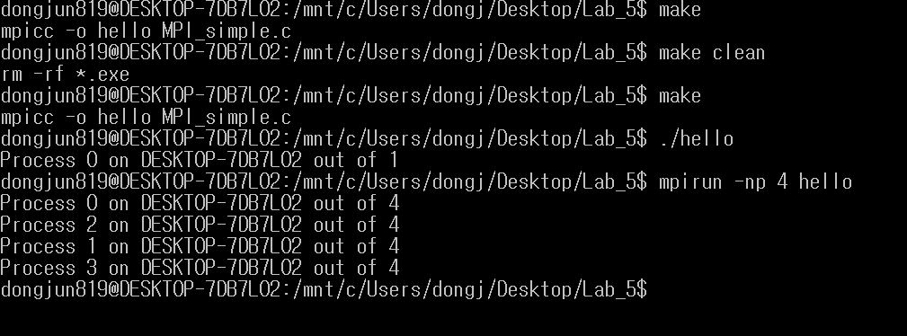
* Task 2
  + The result of MPI_Ring shows that the processes 0 received message from process 1,2 and 3 when I run 4 machines
  + My MPI_ring.c code follows this step
    - If the rank is 0
      * send a message containing its rank to the process with rank 1
      * receive a message from the process with rank n – 1
      * print the message to the screen
    - If the rank is greater than 0
      * receive a message from the process with rank i – 1
      * verify that the message contains the integer i - 1,
      * replace the integer i - 1 with the integer i,
      * send the modified message to the process with rank i+1.
  + MIP_ring.c code shows error if the machine size is smaller than 2.
    - For example, it has to be “mpirun -np (Number >= 2) helloring”
  + I tried to implement the code to show name of the processor, but it shows random sign for some reason.
  + 