CSE 179

Lab_6

3/15/2019

Dongjun Cho

* Task 1: Collective communication
  + 1.1
    - Calculating the square of the value and broadcast

|  |  |  |
| --- | --- | --- |
| Initialize variable | Modified variable | Execution time (seconds) |
| 4 | 16 | 0.017081 |
| 6 | 36 | 0.009166 |
| 8 | 64 | 0.013811 |

* + 1.2
    - Using use MPI_scatter/gather, MPI_scatterv/gather
    - Value: 10
    - Execution Time= 0.037315
    - 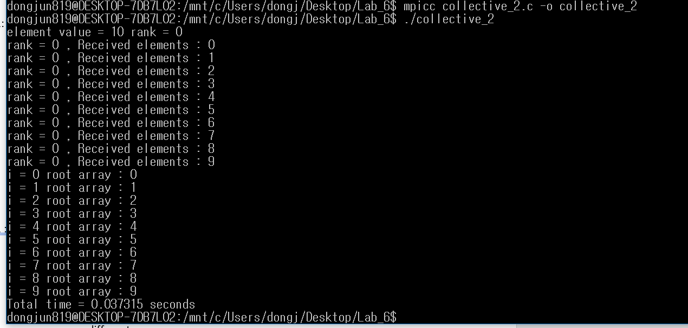
    - 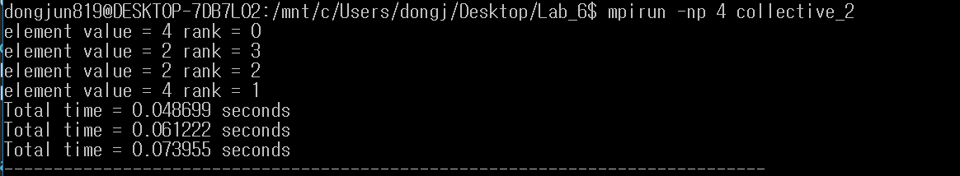
* Task 2 : Cartesian topology
  + 1.
    - Changed from “MPI_Comm_rank(cartcomm, &rank);”
    - To “MPI_Comm_rank(MPI_COMM_WORLD, &rank);”
    - Result
      * The number from local rank and the global MPI_COMM_WORLD rank is different.
  + 2.
    - 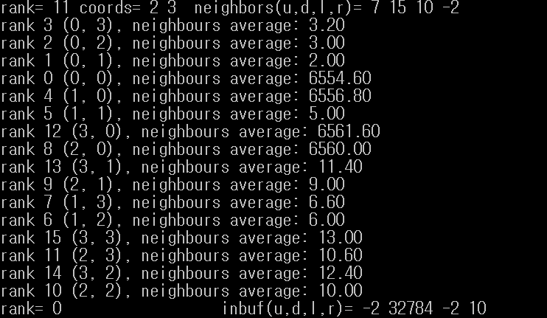
* Task 3: MPI I/O
  + 1.
    - Open the file and write by using individual file pointers
    - 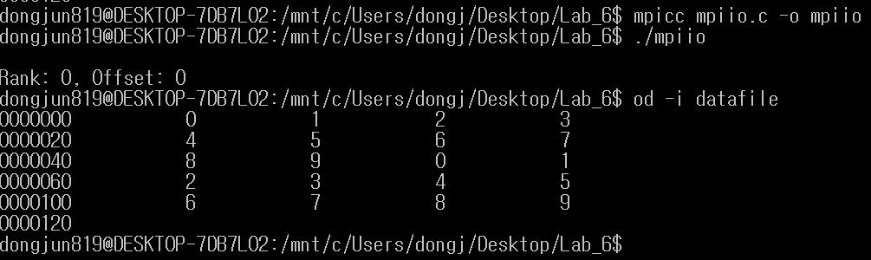
  + 2.
    - Re-open the file and read by using explicit offset
    - 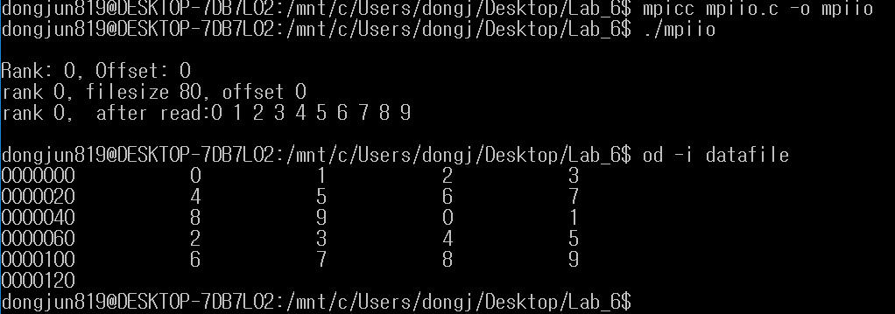
  + 3.
    - Each process writes the data just read in the following way
    - 