CSE 179 Lab 7

CUDA_GPU

Task 1: devicequery

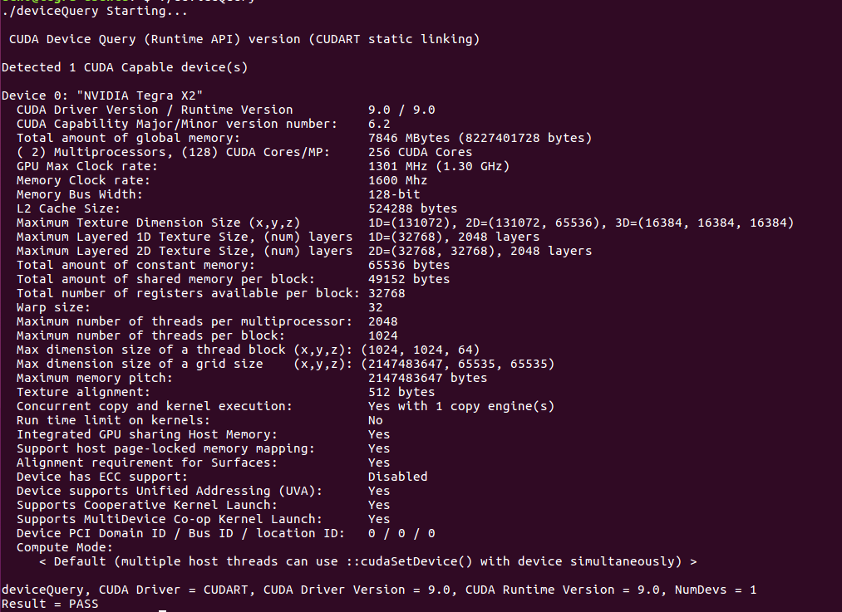

* How many GPU devices are there in your machine?
  + 1
* What is the maximum amount of shared memory per thread block?
  + 49152 blocks
* What is the maximum dimension size of a thread block?
  + 1D = (131072)
  + 2D = (131072, 65536)
  + 3D = (16384, 16384, 16384)
* What is the maximum number of registers available per thread block?
  + 32768
* What is the global memory size?
  + 7846 MBytes

Task 2: Find the maximum

