CSE 179 Lab_8

Dongjun Cho

4/19/19

Rules for a cell’s state transition at each step

* A live cell with zero or one live neighbor dies from loneliness.
* A live cell with four or more live neighbors dies due to overpopulation.
* A dead cell with two or three live neighbors becomes alive.
* Otherwise, a cell's state stays unchanged.

Dead: 0 Lives: 1

Location of the neighbors (how you divided cells up per processes,)

* 3 neighbors in corner
  + In order to move to corner, it should move diagonal
  + In order to move diagonal, it should move left/right and move up/down.
  + Placed neighbors
    - Bottom right corner
      * Move down and right
    - Bottom left corner
      * Move down and left
    - Top left corner
      * Move up and left
    - (ignore the top right because there are 3 neighbors in corner)
* 5 neighbors in edge
  + In order to move to edge, it should just move to left/right/up/down
  + Edge should cover corners
  + Placed neighbors
    - Top edge
      * Covers Top left and Top right corner
    - Bottom edge
      * Covers Bottom left and Bottom right corner
    - Left edge
      * Covers Top left and Bottom left corner
    - Right edge
      * Covers Top right and Bottom right corner
    - Add one more neighbor in right edge (5 neighbors in edge)
* 8 neighbors in middle
  + Cell in middle have eight neighbors that include every corner and edge

Test/Results

6x4 Matrix 3x3 Matrix

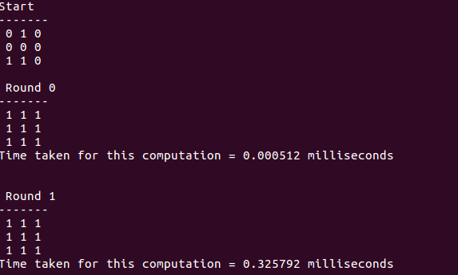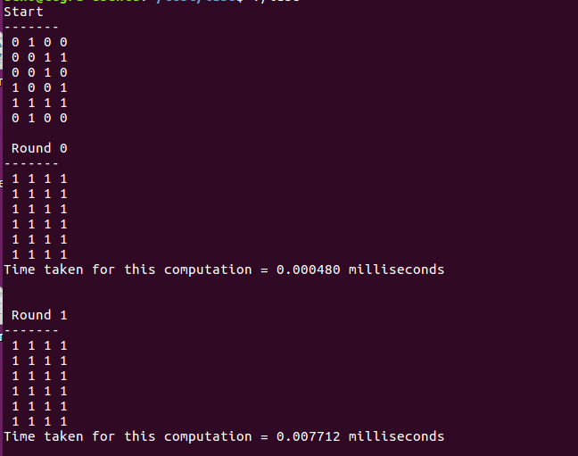

The correct result for the live cell (1) should increase every round.

(Have error in round 0 and round 1 table)