CSE 179 Lab 9

Dongjun Cho

4/26/19

Performance Data (Normal Matrix multiplication)

4X4 2X2

* + - 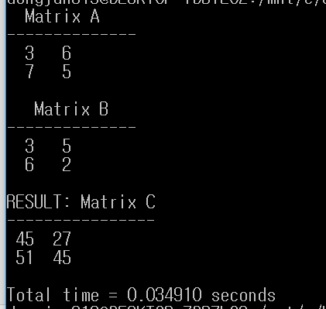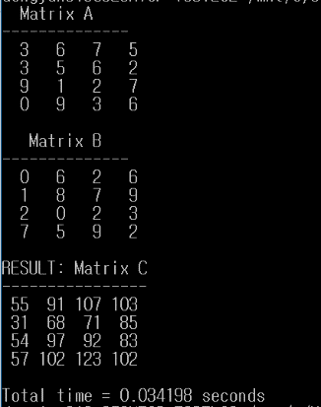

Performance Data (Serial/ Block Matrix multiplication)

4X4 2X2

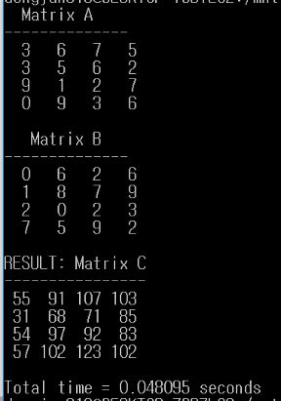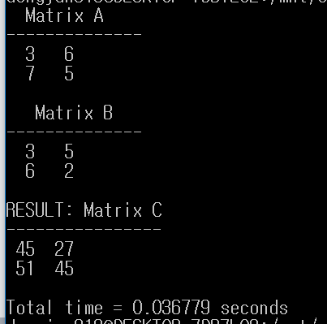

* Generate the two random nxn matrices which are “Matrix A” and “Matrix B.”
  + Both row and column have same number of size (n)
* Matrix size (n) is always divisible by block size (q)
  + n/q
* There are two types of matrix multiplication
  + Normal Matrix multiplication
  + matrix of the serial version (Block_mat_mult)
* Had to make it print both normal and serial version
  + Couldn’t figure out how to print both
  + Just comment the serial version for the turned in source code