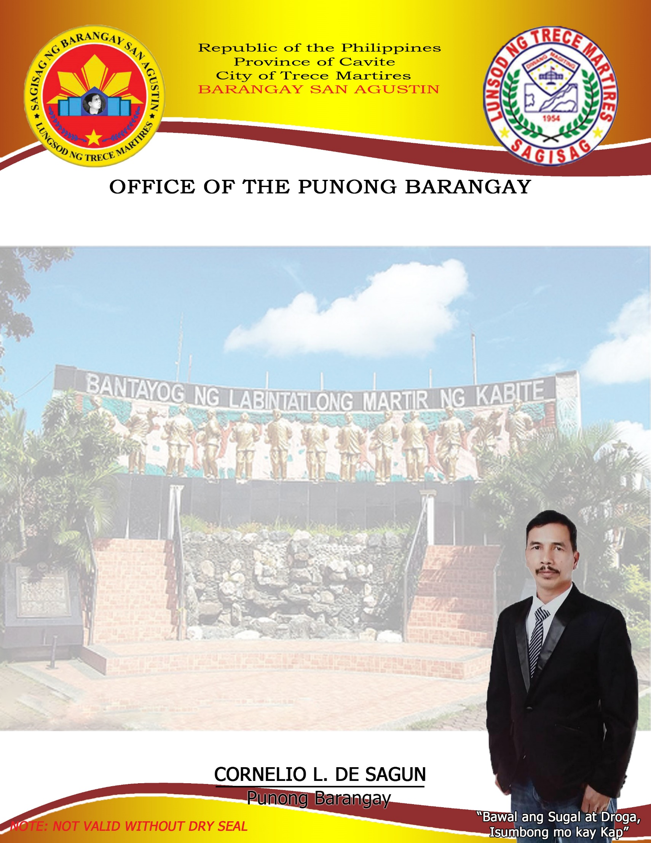

**BARANGAY CLEARANCE**

Date: 2023-02-03 00:00:00

**CORNELIO L. DE SAGUN**

Punong Barangay

**RAYMOND Z. SILAN**

SK Chairman

**BARANGAY COUNCILOR:**

**Henry F. Salazar**

Committee on Housing &

Infrastructure Dev`t

**Midel M. Masicap**

Committee on Meeting & Hearing

**Eduardo M. Perey**

Committee on Health & Sanitation

**Ronan V. Roxas**

Committee on Livelihood & Job Opportunities

**Reynaldo P. Diloy**

Committee on Agriculture

**Gregorio M. Sidamon**

Committee on Peace & Order

**Reynaldo D. Masicap**

Committee on Education, Sports & Social Welfare

**Janice P. Sidamon**

Barangay Secretary

**Joselito A. Bahala**

Barangay Treasurer

This is to certify that MR / MS. dasdasd

Single / Married / Widow, 2 years of age, is personally known to me being a

resident of ­­_________________________________­­­­­_________________________________

Barangay San Agustin, Trece Martires City, Cavite a man / woman of good moral

character and has no criminal record nor has been charged of any involving turpitude

in this Barangay hence, clearance is given to him / her.

Issued upon request for: asdasdas

This certification is valid for six (6) mos. Period from the date issued.

____________________________

Applicant’s Signature

**CTC No : _______________**

**Issued at: San Agustin, TMC**

**Issued on: _______________**

**O.R. No. : _______________**

