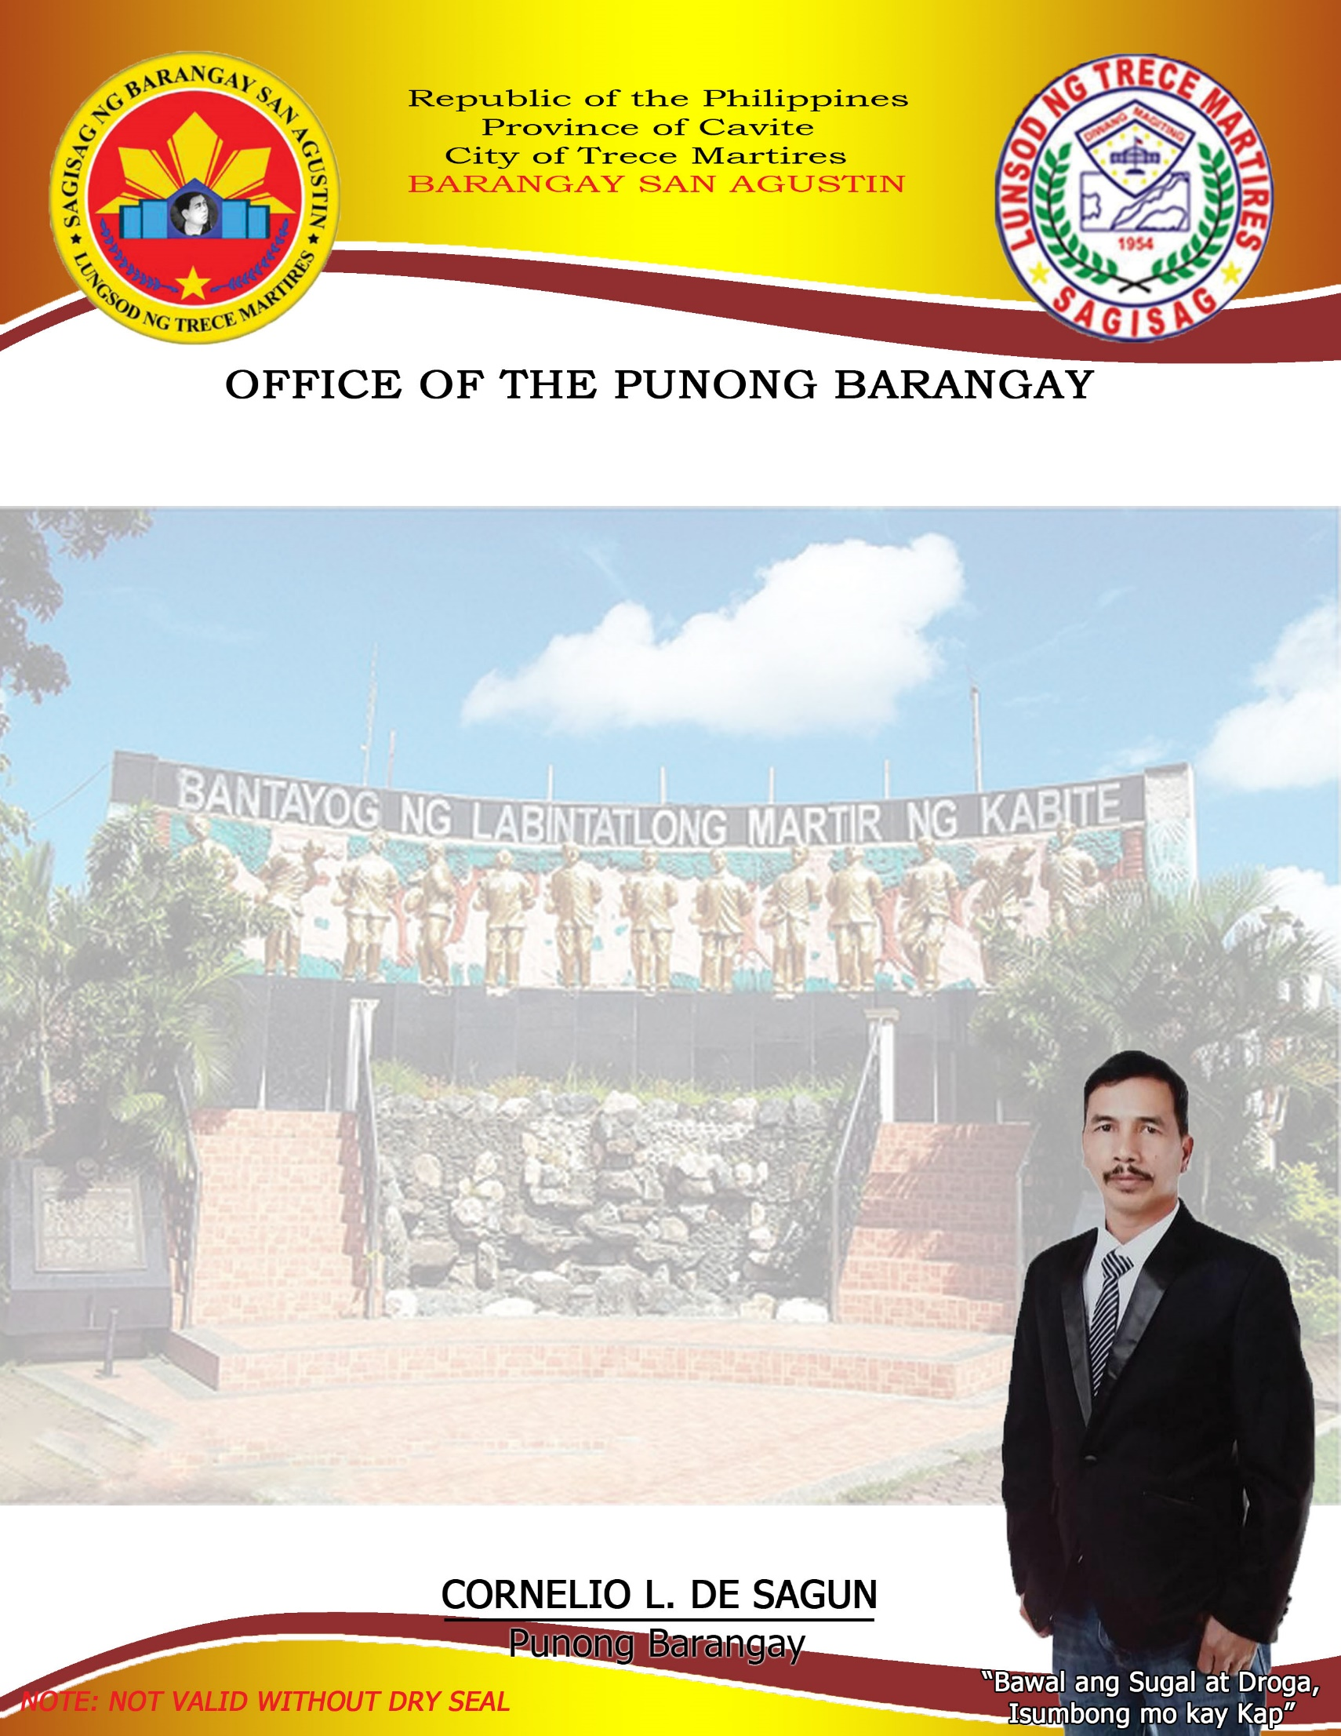

**BUSINESS CLEARANCE**

**No: _______________________**

**CORNELIO L. DE SAGUN**

Punong Barangay

**RAYMOND Z. SILAN**

SK Chairman

**BARANGAY COUNCILOR:**

**Henry F. Salazar**

Committee on Housing &

Infrastructure Dev`t

**Midel M. Masicap**

Committee on Meeting & Hearing

**Eduardo M. Perey**

Committee on Health & Sanitation

**Ronan V. Roxas**

Committee on Livelihood & Job Opportunities

**Reynaldo P. Diloy**

Committee on Agriculture

**Gregorio M. Sidamon**

Committee on Peace & Order

**Reynaldo D. Masicap**

Committee on Education, Sports & Social Welfare

**Janice P. Sidamon**

Barangay Secretary

**Joselito A. Bahala**

Barangay Treasurer

This is to certify that we interpose no objection regarding the request of:

**APPLICANT** : ${name}

**TRADE NAME** : ${trade}

**TYPE OF BUSINESS :** ${type}

**LOCATION** ${location}

**______________________________________________________**

**EXPIRATION DATE**: **DECEMBER 31, 2023**

This certification is being issued upon the request of the said applicant in connection with the requirement for securing/applying for **RENEWAL and NEW BUSINESS PERMIT.**

**Issued this** ${day}**day of** ${month}**, 2023**

Res. Cert. No. _________ ___________

Issued At SAN AGUSTIN, TMC

Issued On __________ ____________

O.R. No. _______________________

Issued On _______________________