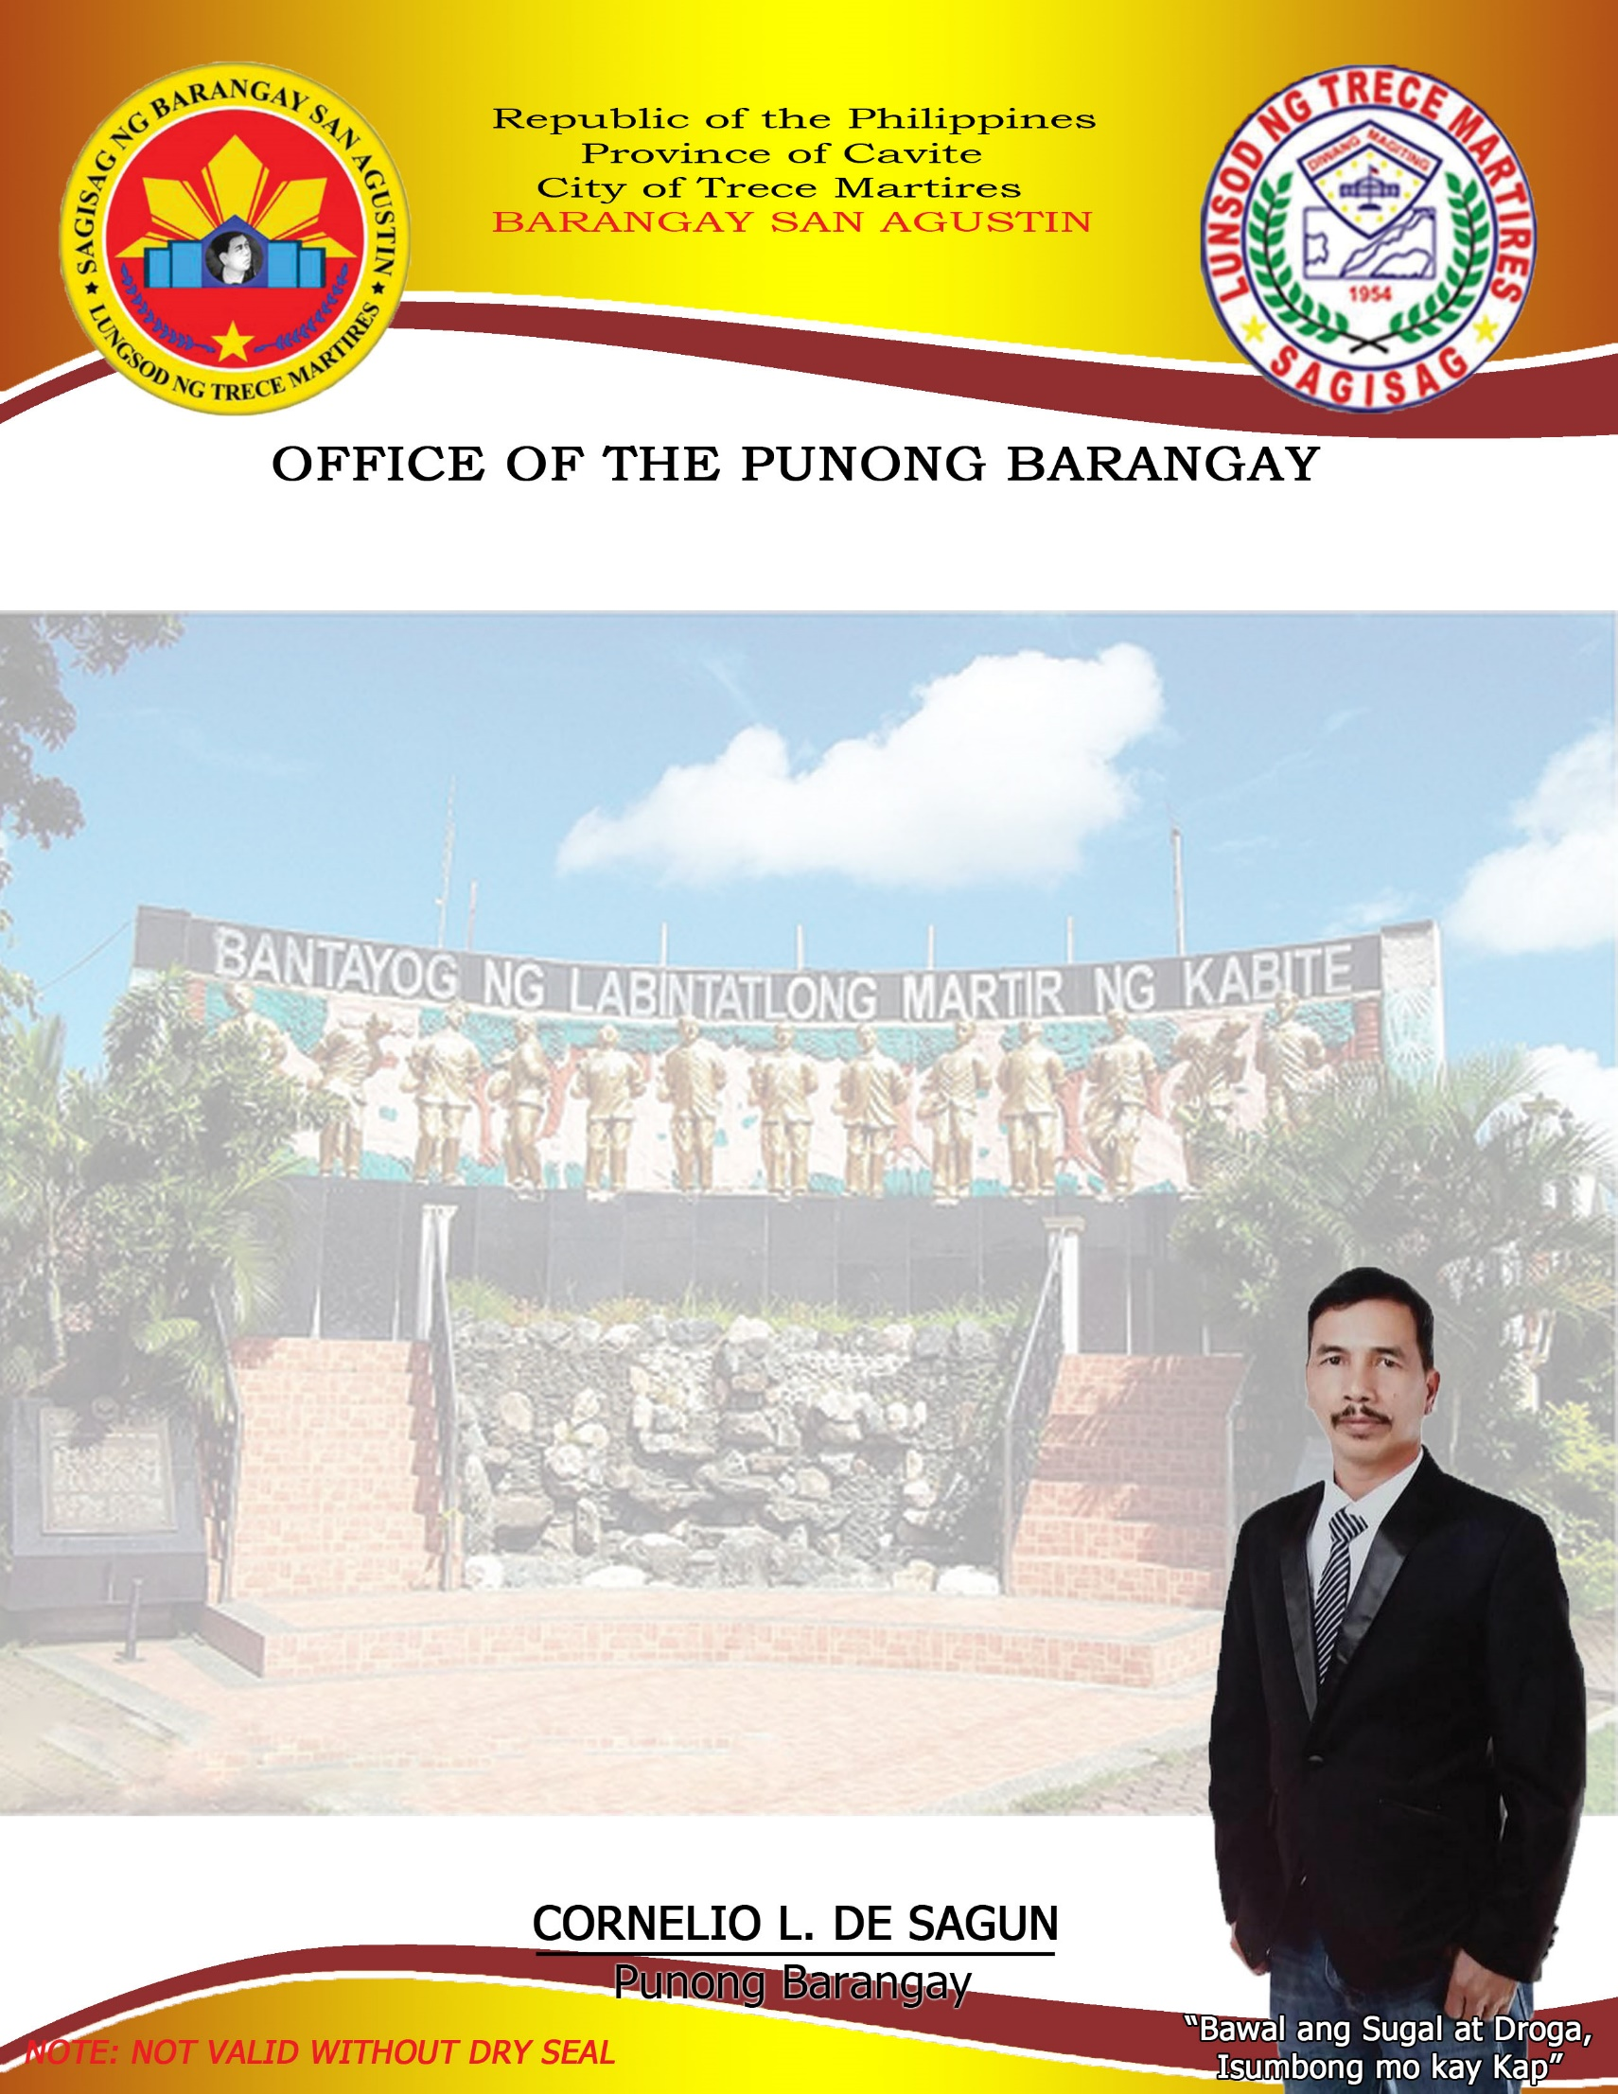

CERTIFICATION

**To whom it may concern,**

This is to certify that **${name}** legal age, Filipino Citizen personally known to me being a resident ofBarangay San Agustin, Trece Martires City, Cavite. Has no criminal record neither has been charged of any involving moral turpitude in this Barangay hence, this certification is given to him/her.

This Certificate of **Residency** is being issued upon the request of the above-mentioned individual for **${purpose}** purpose only**.**

Issued on this **${day}** of **${month} 2024** at Barangay San Agustin, Trece Martires City, Cavite.