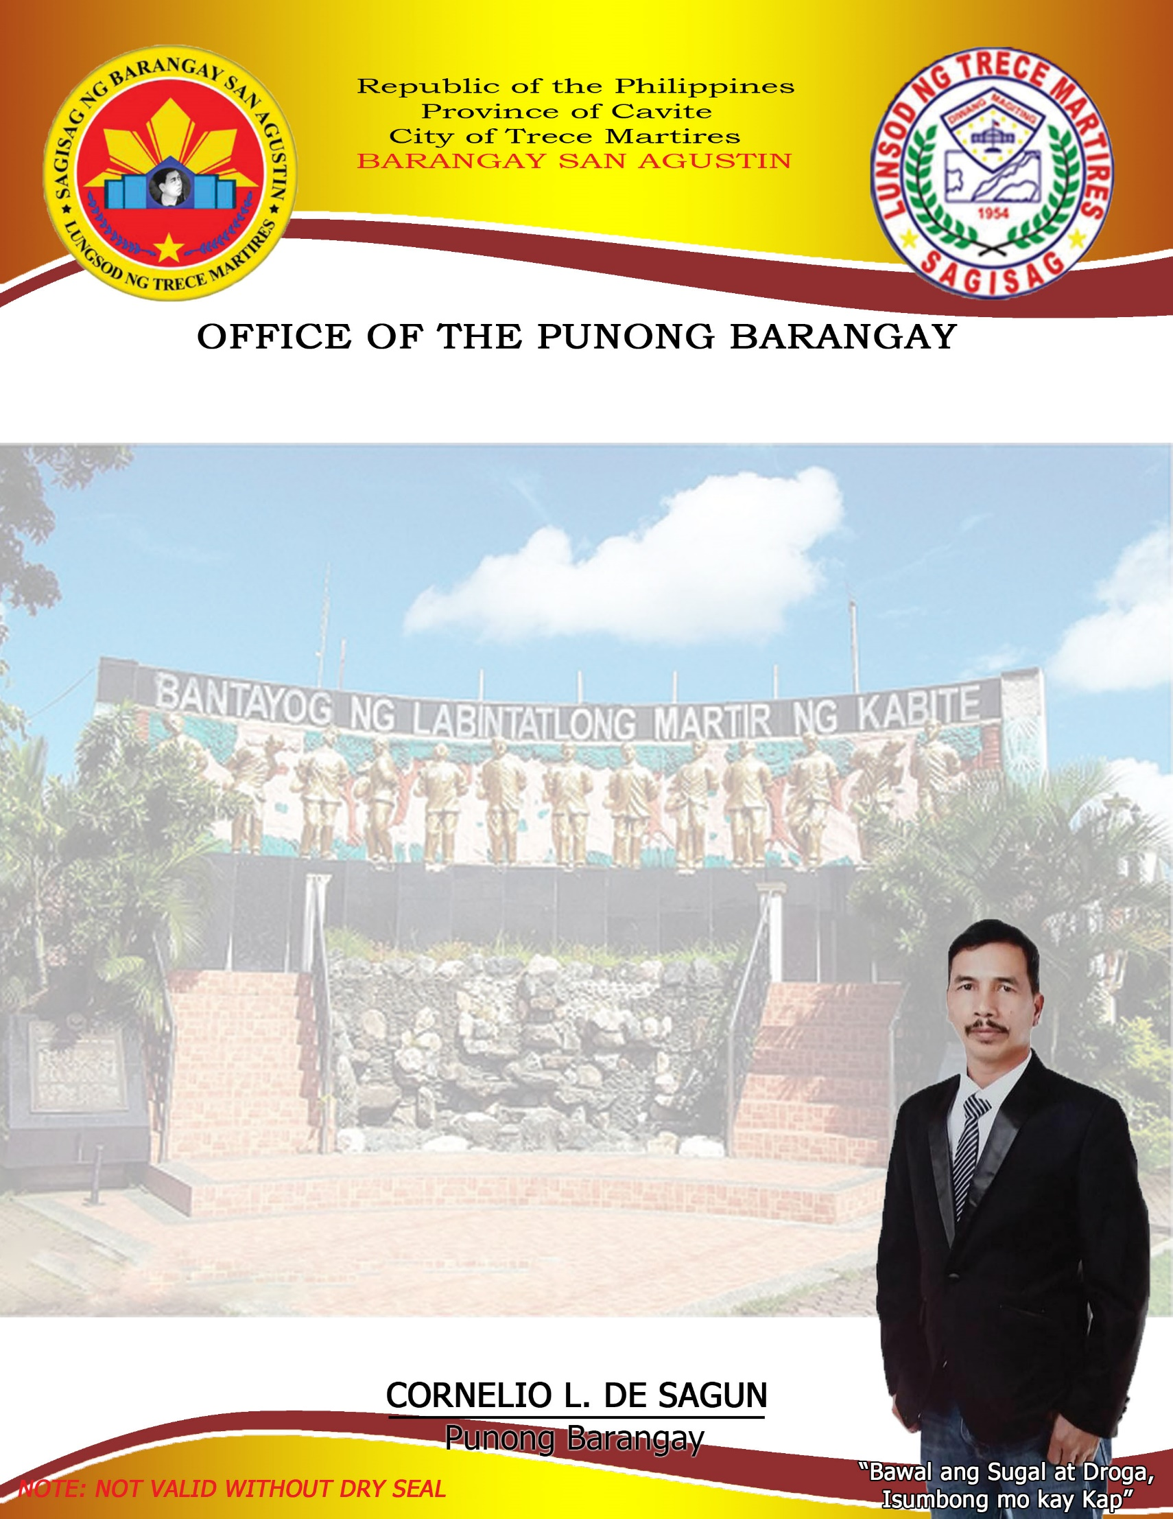

**TRICYCLE PERMIT**

**CORNELIO L. DE SAGUN**

Punong Barangay

**RAYMOND Z. SILAN**

SK Chairman

**BARANGAY COUNCILOR:**

**Henry F. Salazar**

Committee on Housing &

Infrastructure Dev`t

**Midel M. Masicap**

Committee on Meeting & Hearing

**Eduardo M. Perey**

Committee on Health & Sanitation

**Ronan V. Roxas**

Committee on Livelihood & Job Opportunities

**Reynaldo P. Diloy**

Committee on Agriculture

**Gregorio M. Sidamon**

Committee on Peace & Order

**Reynaldo D. Masicap**

Committee on Education, Sports & Social Welfare

**Janice P. Sidamon**

Barangay Secretary

**Joselito A. Bahala**

Barangay Treasurer

Permit No.: ________________

This is to certify that **${name}**

a resident of ${location}

has been granted **CLEARANCE/PERMIT** for the operation of **TRICYCLE** within this Barangay with vehicle particulars described herein subject to all pertinent ordinances and related implementary regulations of the Barangay.

**MAKE/COLOR: ${color}**

**MOTOR NO.: ${motor}**

**PLATE NO.: ${plate}**

**BODY NO.: ${body}**

**CHASIS NO.: ${chasis}**

This Barangay permit shall be valid from date of the issue

Until **December 31, 2023.**

Issued this${day} day of ${month} 2023

Res. Cert. No. ________________

Issued At ________________

Issued On ________________

O.R. No. ________________

****Issued On ________________