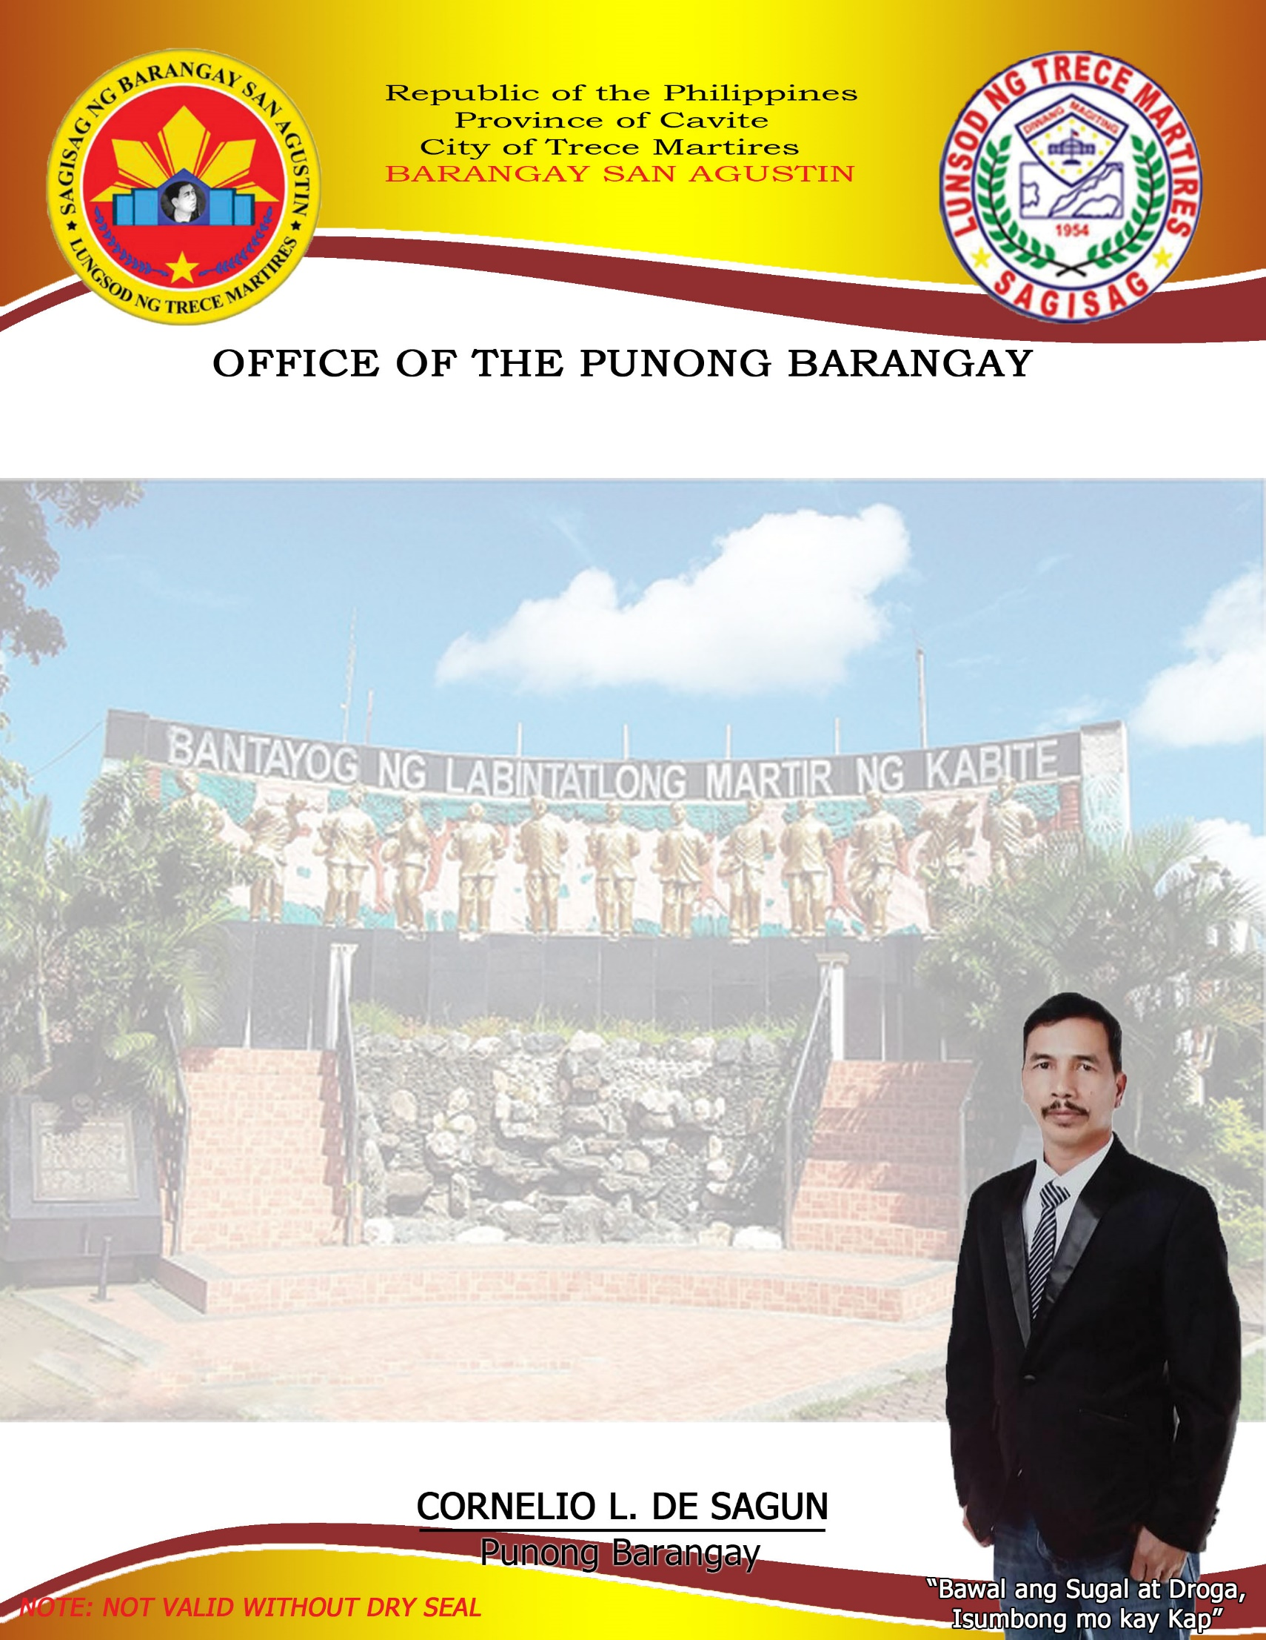

**BARANGAY CLEARANCE**

**CORNELIO L. DE SAGUN**

Punong Barangay

**RAYMOND Z. SILAN**

SK Chairman

**BARANGAY COUNCILOR:**

**Henry F. Salazar**

Committee on Housing &

Infrastructure Dev`t

**Midel M. Masicap**

Committee on Meeting & Hearing

**Eduardo M. Perey**

Committee on Health & Sanitation

**Ronan V. Roxas**

Committee on Livelihood & Job Opportunities

**Reynaldo P. Diloy**

Committee on Agriculture

**Gregorio M. Sidamon**

Committee on Peace & Order

**Reynaldo D. Masicap**

Committee on Education, Sports & Social Welfare

**Janice P. Sidamon**

Barangay Secretary

**Joselito A. Bahala**

Barangay Treasurer

This is to certify that we interpose no objection regarding the request of:

**APPLICANT: ________________________**

**PURPOSE: ________________________________**

_____ ____Residential

__________Commercial

**LOCATION:** **____________________________**

Barangay San Agustin, Trece Martires City

**EXPIRATION DATE**: __________________________

This Certification is being issued upon request of the said applicant in connection for application of Mayor’s permit being applied for.

**Issued this** _______ **day of _________________, 2023**

Res. Cert. No. _____________________

Issued At SAN AGUSTIN, TMC

Issued On _____________________

O.R. No. ______________________

Issued On ______________________

