CRM for Account Managers
How a CRM supports daily tasks, follow-ups, and the ideal dashboard
April 2026

1. How a CRM helps Account Managers
A CRM is your second brain. It removes the mental overhead of tracking relationships so you can focus on what actually matters: conversations and revenue.

Tasks & follow-up automation
- Automatic reminders when a contact goes cold (e.g. no touch in 30 days)
- Task creation triggered from emails or calls — e.g. 'follow up with procurement next Tuesday'
- Pipeline stage triggers: when a deal moves to 'Proposal Sent', a follow-up task is auto-created
- Email logging so every interaction is captured without manual effort
- Recurring check-in schedules for key accounts

What you want to see as an Account Manager
- At-a-glance health of every account (red / amber / green)
- Open tasks and overdue follow-ups front-and-centre
- Upcoming renewals and contract expiry dates
- Recent activity across contacts — who talked to who, and when
- Revenue at risk — accounts with declining engagement or long periods of silence
- Whitespace opportunities — where you have not cross-sold or upsold yet
- NPS or satisfaction scores per account

2. The Ideal Account Manager Dashboard
The dashboard below is built around four things that drive your day: your book's financial health, account signals, your action list, and renewal risk — all in one view.

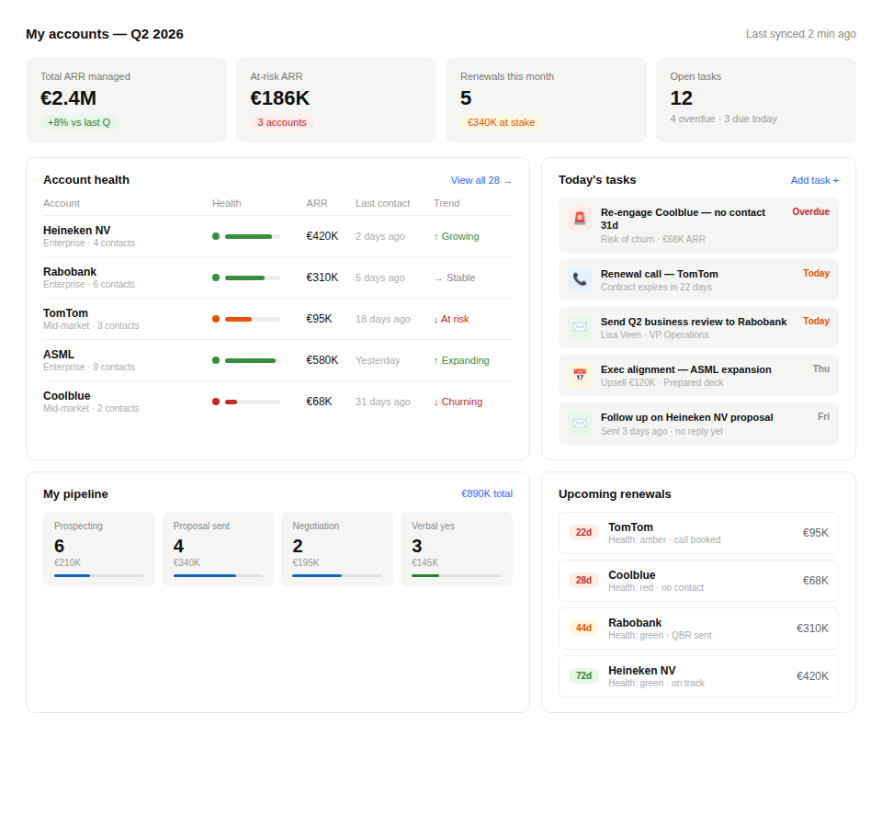
Figure 1 — Account Manager CRM Dashboard (Q2 2026)

Dashboard components explained

Key performance indicators
Four top-line numbers give you the state of your book in under three seconds:

€2.4M  Total ARR Managed  +8% vs last quarter | €186K  At-Risk ARR  3 accounts flagged | 5  Renewals This Month  €340K at stake | 12  Open Tasks  4 overdue · 3 due today

Account health table
Every account is scored and colour-coded. The moment a key account goes cold or health deteriorates, it surfaces here — no hunting through notes. The table below shows the five accounts from the dashboard example:

Account | Segment | ARR | Last Contact | Health | Trend
Heineken NV | Enterprise | €420K | 2 days ago | ● Green | ↑ Growing
Rabobank | Enterprise | €310K | 5 days ago | ● Green | → Stable
TomTom | Mid-market | €95K | 18 days ago | ● Amber | ↓ At risk
ASML | Enterprise | €580K | Yesterday | ● Green | ↑ Expanding
Coolblue | Mid-market | €68K | 31 days ago | ● Red | ↓ Churning

Today's tasks panel
Your action list, prioritised by urgency. At-risk accounts and overdue items float to the top. Each task shows the context — ARR at stake, who to contact, why it matters — so you never need to click into a record just to remember what you were doing.

- Overdue items highlighted in red — churn risk flagged immediately
- Same-day items in amber — renewal calls, QBR delivery, proposal follow-ups
- Upcoming items in grey — scheduled far enough out to plan ahead

Pipeline by stage
A quick pulse on what is in motion across your accounts. Useful for your weekly check-in with your manager and for spotting where deals are getting stuck.

- Prospecting → Proposal Sent → Negotiation → Verbal yes
- Each stage shows deal count and total value — instantly prioritise your week

Upcoming renewals
Sorted by days remaining, colour-coded by urgency. The accounts in red need a call today. The green ones just need to stay warm. No surprises at end-of-quarter.

- Red (under 30 days) — immediate action required
- Amber (30–60 days) — schedule a QBR or executive alignment now
- Green (60+ days) — monitor and maintain regular cadence

3. Summary
A well-configured CRM dashboard removes the cognitive load of account management. Instead of chasing information across emails, spreadsheets, and calendar notes, everything lives in one place — ordered by urgency, linked to revenue, and always up to date. The result is more proactive conversations, fewer missed renewals, and a clearer view of where to invest your time.

The ideal setup combines automated task triggers with a daily-driver dashboard that answers three questions at a glance:

- Which accounts need my attention right now?
- What is at risk of churning or not renewing?
- Where is the biggest opportunity this quarter?

