CRM for Sales Managers
How a CRM supports team management, coaching, forecasting, and revenue analysis
April 2026

1. How a CRM helps Sales Managers
Where an account manager uses a CRM to manage individual relationships, a sales manager uses it to manage a team — tracking performance, coaching reps, forecasting revenue, and removing blockers before they cost a deal.

Task & follow-up automation
- Automated alerts when a rep has not updated a deal in X days — deal rot detection before it is too late
- Reminders to schedule coaching sessions when a rep's win rate or activity level drops below threshold
- Pipeline review tasks auto-scheduled before end-of-quarter crunch
- Notifications when a high-value deal regresses to a previous stage unexpectedly
- Escalation triggers when a deal above a threshold goes cold without manager visibility

What you want to see as a Sales Manager
- Team quota attainment at a glance — each rep vs their individual target
- Pipeline coverage ratio — do you have enough pipeline to hit the number?
- Deal velocity — how long deals take per stage, and where they consistently get stuck
- Win and loss rates by rep, by segment, and by competitor
- Forecast accuracy — predicted vs actual closed revenue over time
- Activity metrics — calls, emails, meetings per rep, and whether they correlate with results
- Deals at risk — high-value opportunities that have gone quiet or stalled
- New pipeline created this period — are reps building enough top-of-funnel?

2. The Ideal Sales Manager Dashboard
The dashboard below gives you full visibility over your team in one view — quota progress, rep performance, pipeline health, deal risk, and forecast — all without clicking into individual records.

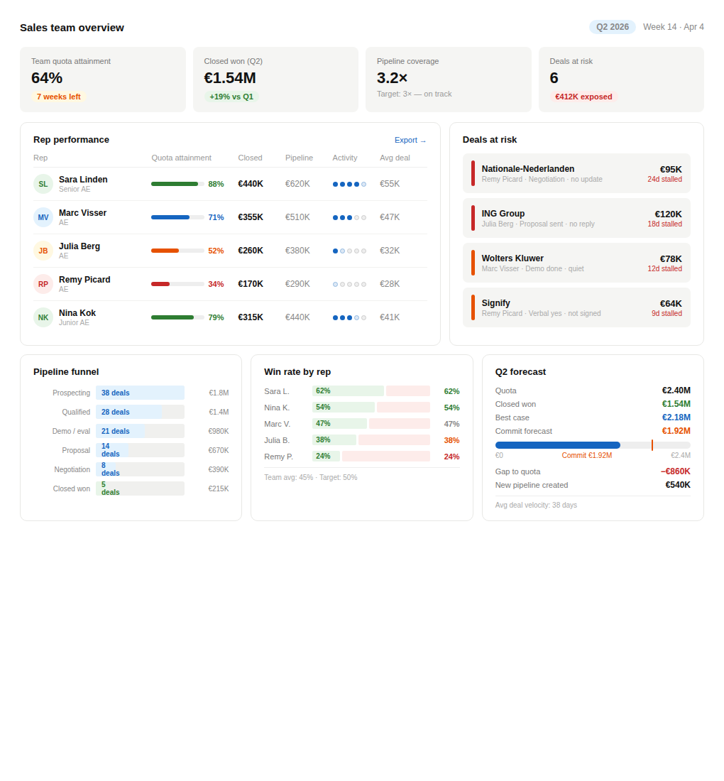
Figure 1 — Sales Manager CRM Dashboard (Q2 2026)

Key performance indicators
Four headline numbers give you the state of your team in under three seconds:

64%  Team quota attainment  7 weeks left in Q2 | €1.54M  Closed won (Q2)  +19% vs Q1 | 3.2×  Pipeline coverage  Target 3× — on track | 6  Deals at risk  €412K exposed

Rep performance
Every rep is scored across six dimensions in a single row — attainment, closed revenue, pipeline value, activity level, and average deal size. You can see immediately who is on track, who needs coaching, and who is a flight risk.

Rep | Attainment | Closed | Pipeline | Activity | Avg deal
Sara Linden  Senior AE | 88% | €440K | €620K | ●●●●○ | €55K
Marc Visser  AE | 71% | €355K | €510K | ●●●○○ | €47K
Julia Berg  AE | 52% | €260K | €380K | ●○○○○ | €32K
Remy Picard  AE | 34% | €170K | €290K | ◑○○○○ | €28K
Nina Kok  Junior AE | 79% | €315K | €440K | ●●●◑○ | €41K

- Activity score (●) shows call, email, and meeting volume relative to the team benchmark
- Remy Picard at 34% attainment with very low activity is the priority coaching conversation this week
- Nina Kok at 79% as a Junior AE signals a strong ramp — worth accelerating

Deals at risk
Stalled deals flagged automatically by days without an update or stage change. Red means immediate intervention required; amber means action this week.

Company | Rep | Stage | Value | Stalled
Nationale-Nederlanden | Remy Picard | Negotiation | €95K | 24 days
ING Group | Julia Berg | Proposal sent | €120K | 18 days
Wolters Kluwer | Marc Visser | Demo / eval | €78K | 12 days
Signify | Remy Picard | Verbal yes | €64K | 9 days

Q2 forecast
Commit, best case, and gap to quota in one table — no spreadsheet hunting needed. Deal velocity at the bottom tells you whether the pipeline you have can realistically close in the time remaining.

Metric | Value
Quota (Q2 target) | €2.40M
Closed won to date | €1.54M
Commit forecast | €1.92M
Best case | €2.18M
Gap to quota | −€860K
New pipeline created | €540K
Avg deal velocity | 38 days

Pipeline funnel
The funnel shows deal count and value at each stage across the whole team. A sudden cliff at one stage tells you exactly where the process is breaking down and where to focus coaching effort.

Stage | Deals | Value | Drop-off
Prospecting | 38 | €1.8M | —
Qualified | 28 | €1.4M | −26%
Demo / eval | 21 | €980K | −25%
Proposal | 14 | €670K | −33%
Negotiation | 8 | €390K | −43%
Closed won | 5 | €215K | −38%

3. Activities, Opportunities & Revenue — Team Timeline
Overlaying activities (dots), opportunity revenue (bars), and actual closed revenue (line) on a single timeline reveals the lag between effort and outcome — typically around six weeks — and turns today's activity level into a revenue forecast.

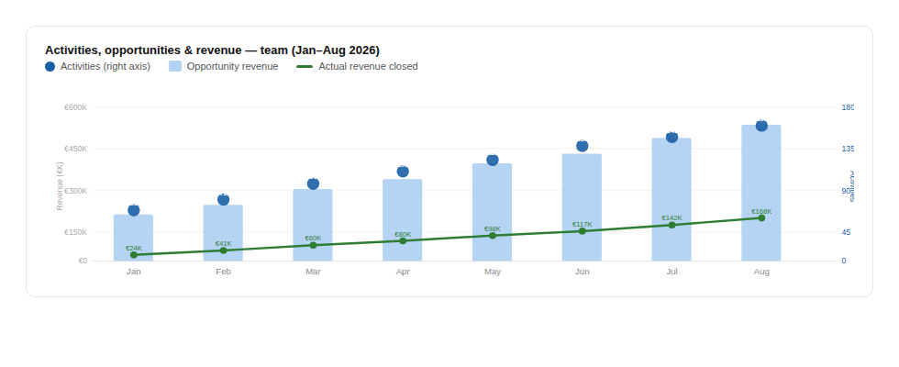
Figure 2 — Team activity (dots) · opportunity revenue (bars) · actual revenue (line) — Jan–Aug 2026

What the timeline tells you
The chart plots three signals across the same time axis, each encoded differently for instant recognition:

- Dots — activity count (calls, emails, meetings). The input lever management can directly influence.
- Bars — opportunity revenue in the pipeline at that point in time. The immediate output of activity.
- Line — actual revenue closed. The lagging outcome, typically appearing 4–8 weeks after the activity that drove it.

The ~6 week lag between the dot trend and the revenue line is the critical insight. It means that revenue problems you see today were caused by low activity six weeks ago — and that a drop in activity today will show up as a shortfall in six weeks, well before end of quarter. This gives you a genuine early warning system: monitor the dots to predict the line.

4. Activity, Opportunities & Revenue — Per Account Manager
Breaking the same three signals down by rep turns the timeline into a precision coaching instrument. The relationship between dots, bars, and line for each rep immediately reveals whether the problem is volume, conversion, or closing — and what specific action will have the most impact.

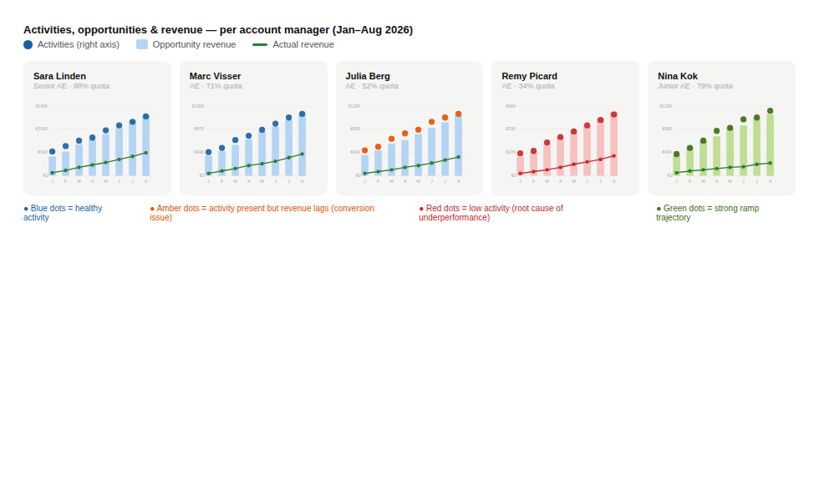
Figure 3 — Activity (dots) · opportunity revenue (bars) · actual revenue (line) per account manager — Jan–Aug 2026

Reading the pattern — three diagnostic signatures
The colour of the dots signals the diagnosis at a glance:

- Blue dots (Sara, Marc) — activity and revenue move together in healthy proportion. Focus: scale up volume to lift revenue further.
- Amber dots (Julia) — activity is present but the revenue line lags the bars significantly. The rep is generating pipeline but not closing it. Focus: deal qualification and late-stage coaching.
- Red dots (Remy) — low activity is the root cause. Everything downstream — pipeline, opportunities, revenue — suffers as a direct consequence. Focus: structured prospecting routine and daily accountability.
- Green dots (Nina) — strong upward ramp across all three signals, exceptional for a Junior AE. Focus: accelerate by pairing with a senior rep on enterprise deals.

Recommended coaching actions — Q2 2026
Based on the activity-to-revenue correlation for each rep, the following actions are recommended:

Rep | Activity | Opps | Revenue | Recommended action | Priority
Sara Linden | 62/mo | 11 | €440K | Replicate outreach cadence across team | Low
Marc Visser | 48/mo | 9 | €355K | Increase prospecting volume by 20% | Med
Julia Berg | 51/mo | 8 | €260K | Qualification & late-stage closing coaching | High
Remy Picard | 24/mo | 4 | €170K | Weekly prospecting block + daily check-ins | Urgent
Nina Kok | 55/mo | 10 | €315K | Pair with Sara on enterprise deal strategy | Low

Activity, opportunities & revenue — coaching overview per rep
The view below complements the dot-bar-line timeline by showing the same three metrics as proportional bars per rep — making the relative scale between reps directly comparable. Where the timeline shows trajectory, this shows where each rep stands right now.

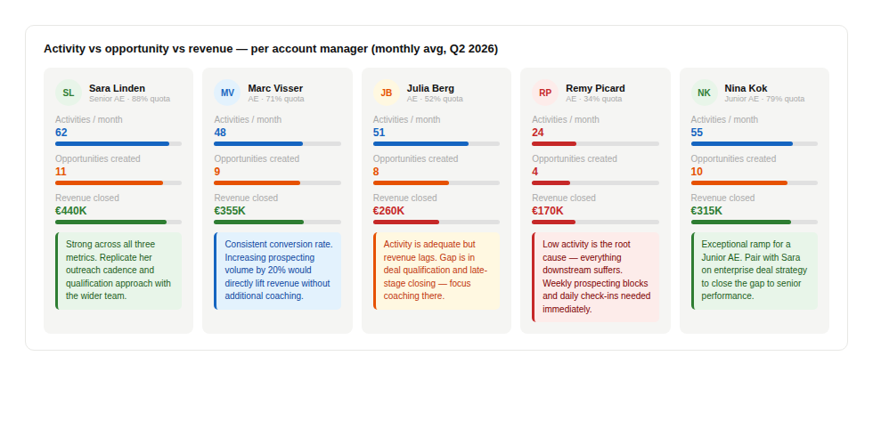
Figure 3b — Activity vs opportunity vs actual revenue per account manager — monthly average Q2 2026

- Sara Linden and Nina Kok — all three bars in close proportion, confirming healthy conversion efficiency throughout the pipeline.
- Marc Visser — bars are proportional but shorter overall. The fix is straightforward: more outreach volume, not a change in approach.
- Julia Berg — activity bar is comparable to the top performers but the revenue bar is significantly shorter. Activity is not translating, pointing to a mid-to-late stage conversion issue.
- Remy Picard — all three bars are the lowest on the team. The root cause is input volume, not conversion quality. Closing coaching will not help until activity increases first.

5. Activity, Opportunities & Revenue — Per Account
The same three-signal view applied at individual account level shows which accounts are being actively nurtured and which are drifting — and whether the opportunity value being built in each account is actually converting to closed revenue.

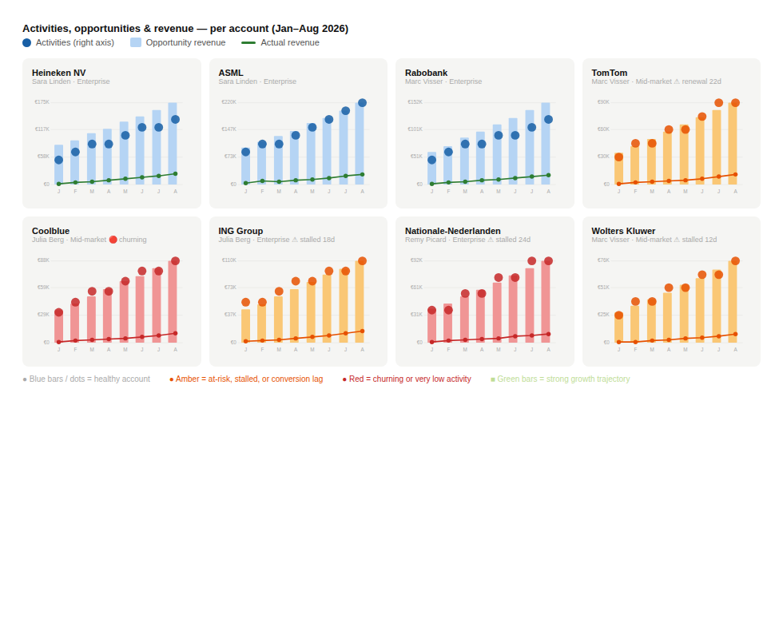
Figure 4 — Activity (dots) · opportunity revenue (bars) · actual revenue (line) per account — Jan–Aug 2026

How to read the per-account charts
Each account card is scaled to its own revenue range so you compare shape, not size. A healthy account shows all three signals rising together. A troubled account shows a widening gap between the bars and the line, or dots that plateau while bars keep growing:

- Heineken NV & ASML (Sara Linden) — blue bars, green line, rising dots. All three signals in alignment. These accounts are being actively managed and converting well.
- Rabobank (Marc Visser) — steady blue signals across all three. Consistent account management delivering predictable revenue growth.
- TomTom (Marc Visser) — amber bars growing steadily but the revenue line is nearly flat. Pipeline is accumulating without converting. Renewal in 22 days makes this the most urgent account in the portfolio.
- Coolblue (Julia Berg) — red bars and a red revenue line that barely moves despite growing opportunity value. High pipeline, very low conversion — a qualification or decision-maker access problem.
- ING Group (Julia Berg) — amber dots are rising but the revenue line lags the bars by a wide and growing margin. Activity is there; the deal process needs a coaching review.
- Nationale-Nederlanden (Remy Picard) — the lowest dot count of all accounts, red bars, and a flat red line. Both activity and conversion are failing simultaneously. This account needs immediate manager involvement.
- Wolters Kluwer (Marc Visser) — amber throughout: moderate activity, growing pipeline, but revenue stubbornly low. A focused closing coaching session should unlock this account.

6. Coaching Conclusions — At a Glance
The scatter chart below plots every rep by their activity volume and quota attainment, placing them in one of four coaching quadrants. Position in the chart determines the prescription — not opinion, but data.

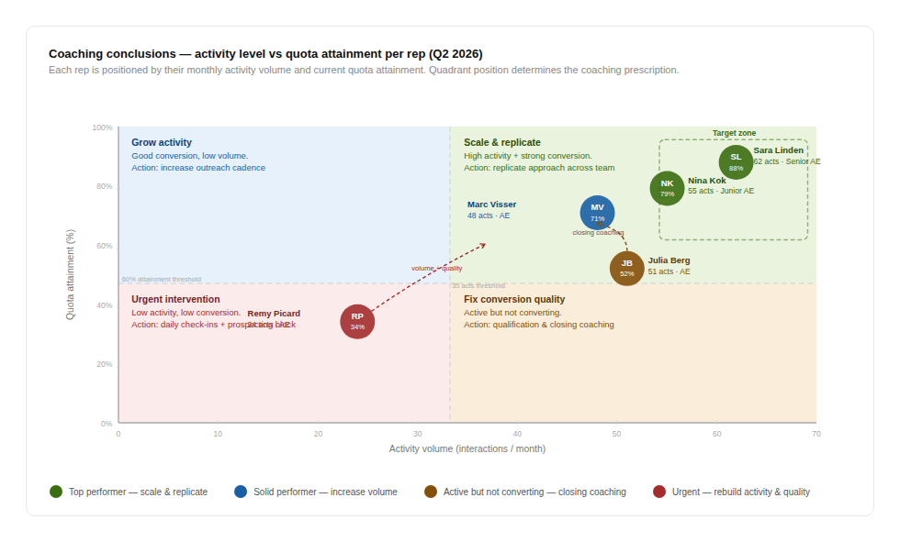
Figure 5 — Coaching quadrant: activity level vs quota attainment per rep (Q2 2026)

Reading the quadrants
The two axes capture the two independent dimensions of sales performance. Together they produce four distinct coaching situations:

- Scale & replicate (top-right) — Sara Linden and Nina Kok sit inside the target zone. High activity is converting to high attainment. Share their approach across the team.
- Grow activity (top-left) — Marc Visser converts well but volume is below the top performers. A 20% increase in prospecting activity, without changing his approach, moves him directly into the target zone.
- Fix conversion quality (bottom-right) — Julia Berg is active but revenue output does not match effort. Coach on deal qualification and late-stage closing — not on increasing call volume.
- Urgent intervention (bottom-left) — Remy Picard is the only rep in the danger quadrant. Both activity and attainment are critically low. First restore volume through structured prospecting blocks, then address conversion quality once activity is stabilised.

The target zone — 55+ interactions per month and 80%+ quota attainment — is where Sara, Nina, and Marc are approaching. The Q2 priority is moving Marc across the threshold and beginning the two-phase recovery plan for Remy.

7. Summary
A well-configured CRM gives a sales manager three capabilities: visibility over what is happening now, an early warning of what is coming, and a clear coaching agenda for each rep and each account.

The dashboard (Section 2) answers the first. It shows quota progress, rep performance, at-risk deals, and the forecast in a single view — no Monday morning status calls needed.

The team timeline (Section 3) answers the second. By overlaying activity dots, opportunity bars, and the revenue line, it surfaces the typical 6-week lag between effort and income — turning today's activity level into a six-week revenue prediction. A drop in dots today is a red flag six weeks before it appears in closed-won.

The per-AM and per-account views (Sections 4 and 5) answer the third. Breaking the same three signals down by rep and then by account makes the coaching agenda concrete: which rep has a volume problem, which has a conversion problem, which has a closing problem — and which specific accounts need manager involvement this week.

Together they answer the five questions that define a sales manager's week:

- Which reps need my attention — and for what specific reason?
- Are we going to hit the number, and what is at risk?
- Where is the pipeline breaking down across the team?
- Is today's activity level enough to sustain next quarter's revenue?
- Which accounts need my direct involvement, and what kind of help?

Used consistently, these views shift the sales manager from reactive firefighter to proactive coach — with the data to back every conversation and the foresight to act before problems show up in the number.

