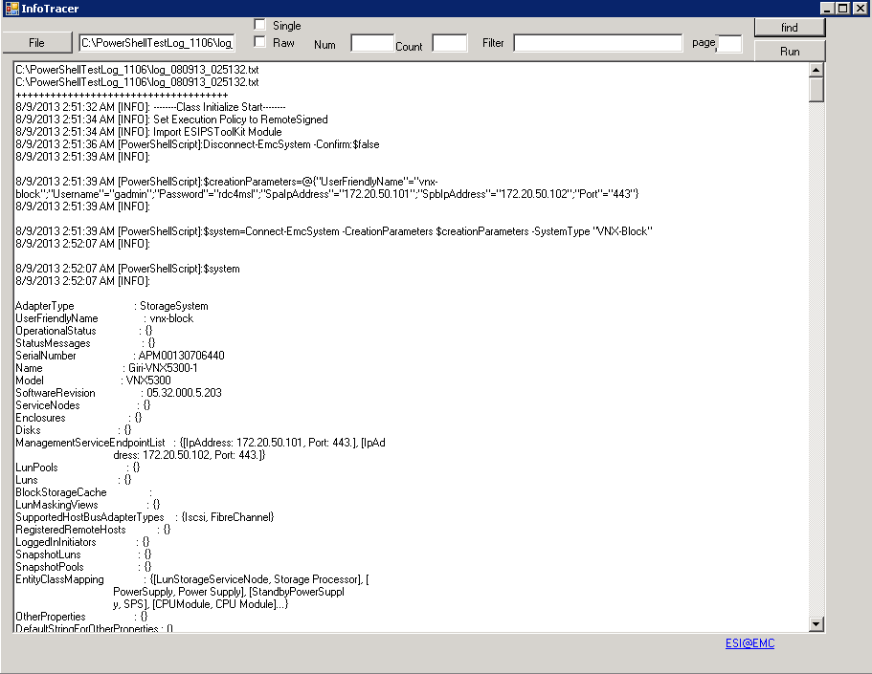

The InfoTracer is a tool for log analyzing, File button is used to choose the log file, If the file is not chose, the default behavior is to select all files in the default fold which is set in configure file. If Single is selected, the latest file in default folder will be selected, this behavior only for no file is specified by File button. Num is used for chose how many latest file in default folder is selected, if the value is not set, all files in default folder is set.

Filter is used to select the specified value, all lines which contained the specified value will be selected and displayed. Count is used to show the N lines before and after the line which contains the filter value.

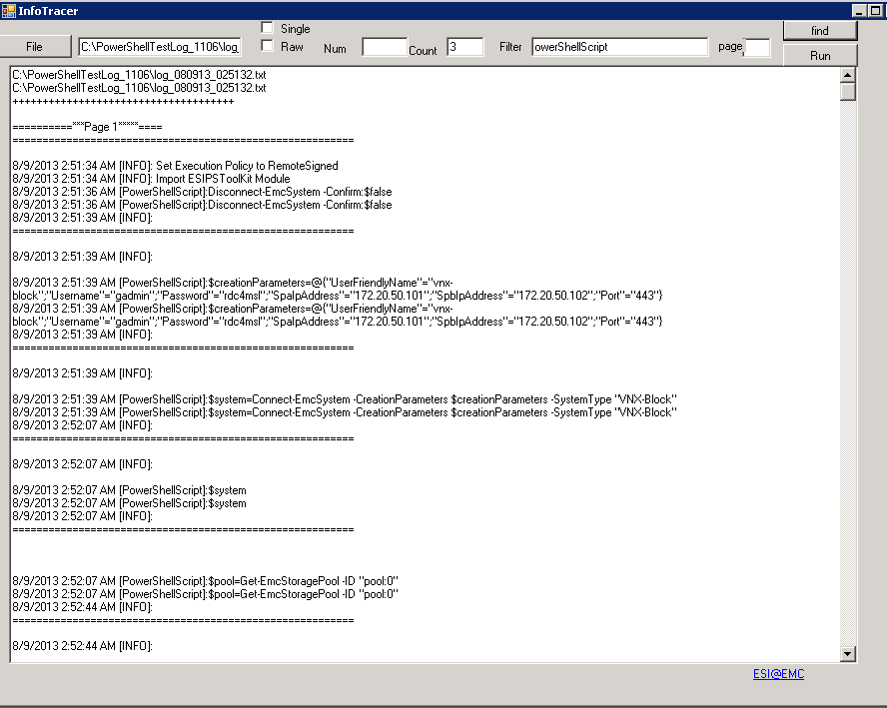

If the log is too large which may more than 200 MB, then open the log may be difficult, then open the log will page number ,there will only display the specified page information.

When using filter and Raw, then all PowerShell script is selected , and if click Run, the script will run in PowerShell session .

