# Instagram Image Asset:

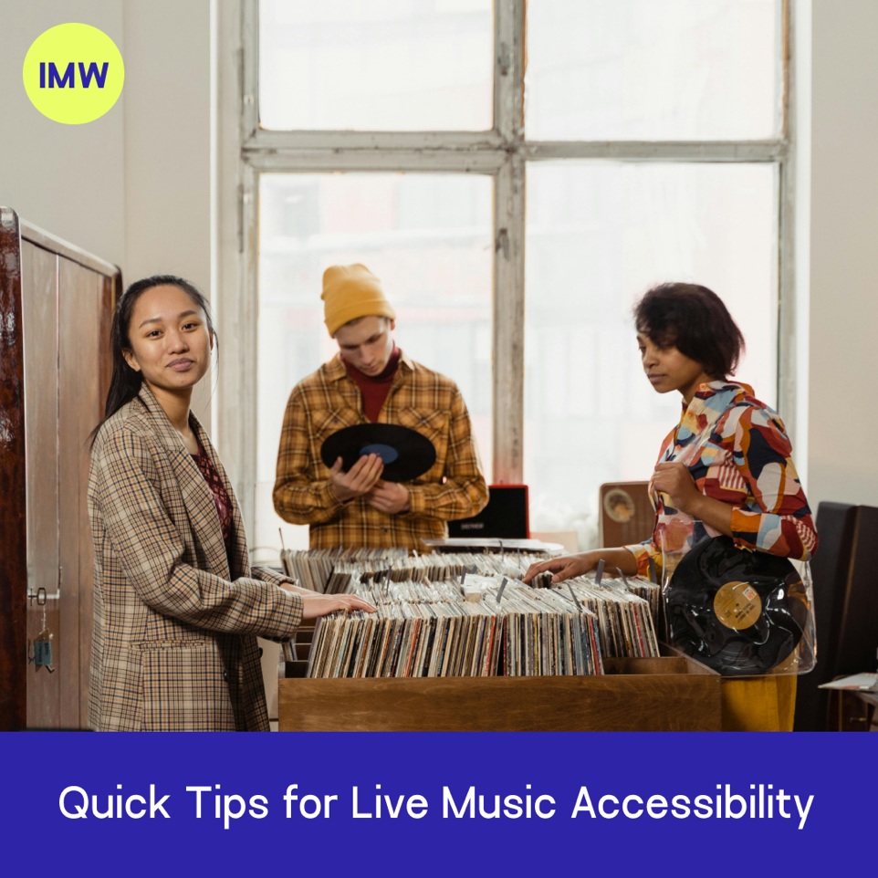

# Alt-text/Image Description:

A woman and a man are searching through vinyl crates in a record store, and another woman is smiling towards the camera. A banner with text over the image reads ‘Quick Tips for Live Music Accessibility’.

# Caption:

If you’re a small venue or other provider of live music, you might think that creating an accessible space for your patrons will be costly or require external expertise – but there are many things you can do on a very small budget to increase the inclusivity of your space!

Head to our website at [www.inmywayaccess.com.au](http://www.inmywayaccess.com.au) to download our Quick Tips for Live Music Accessibility guide for free ♿️ 🎵 link in bio!

# Hashtags:

#LiveMusic #InMyWayAccess #MusicVenue #AccessibleVenue #AccessForAll