# Source Code

# Create the shopping_cart class

class shopping_cart:

def __init__(self):

# Initialize cart as empty list

self.cart_items = []

self.item = self.ItemToPurchase()

self.customer_name = "none"

self.current_date = "January 1, 2020"

def __init__(self, customer_name, current_date):

# Initialize cart as empty list

self.cart_items = []

self.item = self.ItemToPurchase()

self.customer_name = customer_name

self.current_date = current_date

# Step 1: Build the ItemToPurchase class with the following specifications:

# - item_name (string)

# - item_price (float)

# - item_quantity (int)

# Default constructor Initializes item's

# - name = "none"

# - item's price = 0

# - item's quantity = 0

# Method

# - print_item_cost()

# Create the ItemToPurchase class

class ItemToPurchase:

# Default constructor no parameters per assignment prompt

def __init__(self):

self.item_name = "none" # string

self.item_price = 0.0 # float (prompt said 0, but made float)

self.item_quantity = 0 # int

self.item_description = "none" # string

# print total cost of line item per assignment prompt

def print_item_cost(self):

self.price_times_qty = self.item_price * self.item_quantity

print("%s %d @ $%0.2f = $%0.2f" % (self.item_name,

self.item_quantity,

self.item_price,

self.price_times_qty))

# print descriptions

def print_item_description(self):

self.price_times_qty = self.item_price * self.item_quantity

print("%s: %s" % (self.item_name, self.item_description))

# Add an item to the cart by creating an ItemToPurchase object and appending it to the cart list

def add_item(self, ItemToPurchase):

self.cart_items.append(ItemToPurchase)

# Remove item method by popping cart index

def remove_item(self, item_name):

item_found = False

for i in range(len(self.cart_items)):

if item_name in self.cart_items[i].item_name:

item_found = True

print("\t%d %s removed from cart." % (self.cart_items[i].item_quantity, self.cart_items[i].item_name))

self.cart_items.pop(i)

break

if not item_found:

print("\tItem not found in cart. Nothing removed.")

# Modifies an item's description, price, and/or quantity. Has parameter ItemToPurchase. Does not return anything.

def modify_item(self, ItemToPurchase):

item_found = False

for i in range(len(self.cart_items)):

if ItemToPurchase.item_name in self.cart_items[i].item_name:

item_found = True

print("\nItem %s found in cart...Updating..." % ItemToPurchase.item_name)

self.cart_items[i].print_item_cost()

print("\tHas been updated to:")

self.cart_items[i].item_quantity = ItemToPurchase.item_quantity

self.cart_items[i].print_item_cost()

break

if not item_found:

print("\nItem not found in cart. Nothing modified.")

# Show cart contents method

def print_cart_contents(self, what):

print("-------------------------------------")

for x in range(len(self.cart_items)):

print("Item %d: " % (x+1),end="")

if what == "items":

self.cart_items[x].print_item_cost()

elif what == "description":

self.cart_items[x].print_item_description()

print("-------------------------------------")

# Returns quantity of all items in cart. Has no parameters.

def get_num_items_in_cart(self):

return sum([item.item_quantity for item in self.cart_items])

# Determines and returns the total cost of items in cart. Has no parameters.

def get_cost_of_cart(self):

return sum([items.price_times_qty for items in self.cart_items])

# Outputs total of objects in cart.

def print_total(self):

# Check if there are items in the cart

if 0 < len(self.cart_items):

print("%s's Shopping Cart - %s" % (self.customer_name, self.current_date))

print("Number of Items: %d" % self.get_num_items_in_cart())

# print items in cart

self.print_cart_contents("items")

print("Total: $%.2f" % self.get_cost_of_cart())

else:

print("\nSHOPPING CART IS EMPTY")

# Outputs each item's description.

def print_descriptions(self):

# Check if there are items in the cart

if 0 < len(self.cart_items):

print("%s's Shopping Cart - %s" % (self.customer_name, self.current_date))

print("Item Descriptions")

# print items in cart

self.print_cart_contents("description")

else:

print("\nSHOPPING CART IS EMPTY")

# Checkout method to print goodbye msg

def checkout(self):

if (self.get_cost_of_cart() > 0):

print("\nThank you for shopping with us!")

else:

print("\nNothing in your cart, have a nice day!\n")

# Get user input

def print_input():

print("\nMenu options:")

print("\ta - Add Item")

print("\tr - Remove Item")

print("\tc - Change item quantity")

print("\ti - Output items' descriptions")

print("\to - Output shopping cart")

print("\tq - Quit")

print("\t=====================================")

menu_selection = input("\tPlease enter a menu selection and press enter: ")

# input validation

try:

# make sure inputs are from menu list

if (menu_selection in ["a","r","c","i","o","q"]):

return menu_selection

else:

return print_input()

except:

return print_input()

# Init shopping cart object

my_cart = shopping_cart(input("Enter customer's name:\n"), input("Enter today's date:\n"))

print("Customer's name: " + my_cart.customer_name)

print("Today's date: " + my_cart.current_date)

# Shopping loop

checkout = False # loop control variable

while not checkout:

# Present user with menu until checkout is true

user_selection = print_input()

# add or remove items from cart based on user selection, or checkout

match user_selection:

case "a":

new_item = my_cart.ItemToPurchase()

try:

print("\nItem", len(my_cart.cart_items) + 1)

new_item.item_name = str(input("Enter the item name:\n"))

new_item.item_description = input("Enter the item description:\n")

new_item.item_price = float(input("Enter the item price:\n"))

new_item.item_quantity = int(input("Enter the item quantity:\n"))

print("\nAdded to cart: ",end="")

new_item.print_item_cost()

my_cart.add_item(new_item)

except:

print("Sorry, item name, price or quantity was not valid, nothing added.")

case "r":

print("\nREMOVE ITEM FROM CART")

# Print curret cart contents to select from

print("Cart Currently Contains:")

my_cart.print_cart_contents("items")

# get user input of name of item to remove

item_to_remove = input("\nEnter name of item to remove: ")

my_cart.remove_item(item_to_remove)

case "c":

print("\nCHANGE ITEM QUANTITY")

# Print curret cart contents to select from

print("Cart Currently Contains:")

my_cart.print_cart_contents("items")

# initialize an item to pass to modify_item()

modified_item = my_cart.ItemToPurchase()

# get user input of name of item to modify

print("\nWhich item do you want to modify?")

modified_item.item_name = str(input("Enter the item name:\n"))

modified_item.item_quantity = int(input("Enter the new quantity:\n"))

# Send item update data to modify_item to update cart

my_cart.modify_item(modified_item)

case "i":

print("\nOUTPUT ITEMS' DESCRIPTIONS")

my_cart.print_descriptions()

case "o":

print("\nOUTPUT SHOPPING CART")

my_cart.print_total()

case "q":

# end shopping loop

checkout = True

# print good bye msg

my_cart.checkout()

case _:

pass

# Screenshots

## Step 7 Added user input for customer name and date and

## Step 8 Demonstration of Add Item

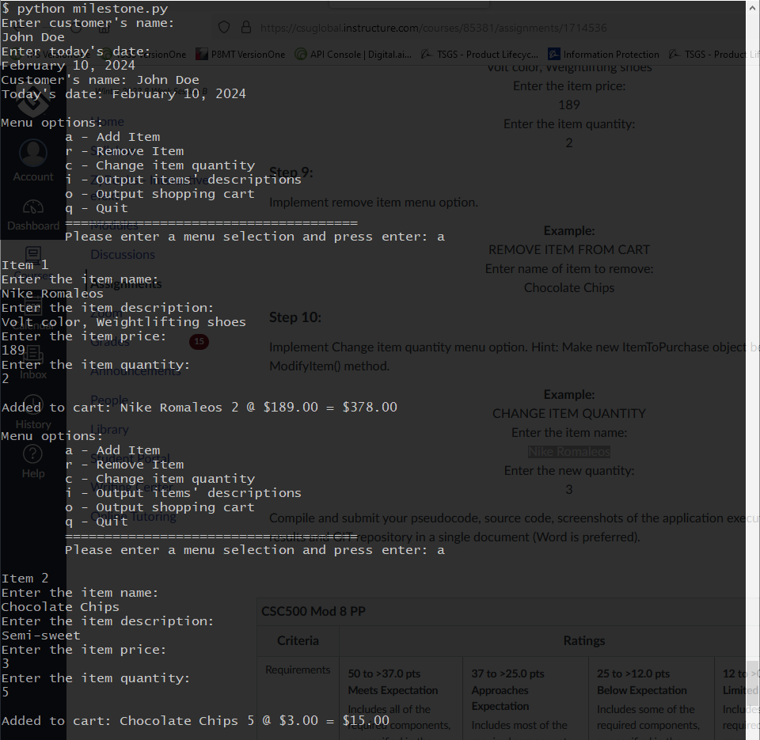

## Step 9 Demonstration of Remove Item

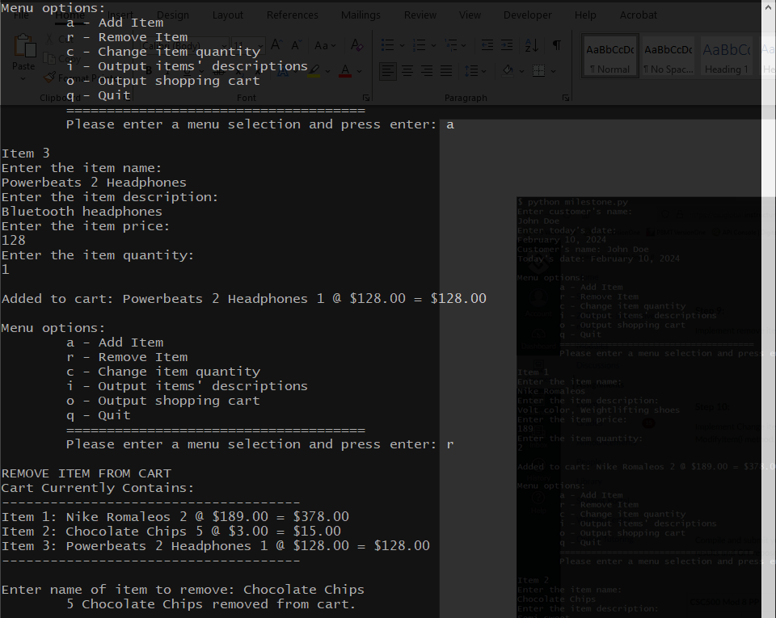

## Step 10 Demonstration of Change Item Quantity

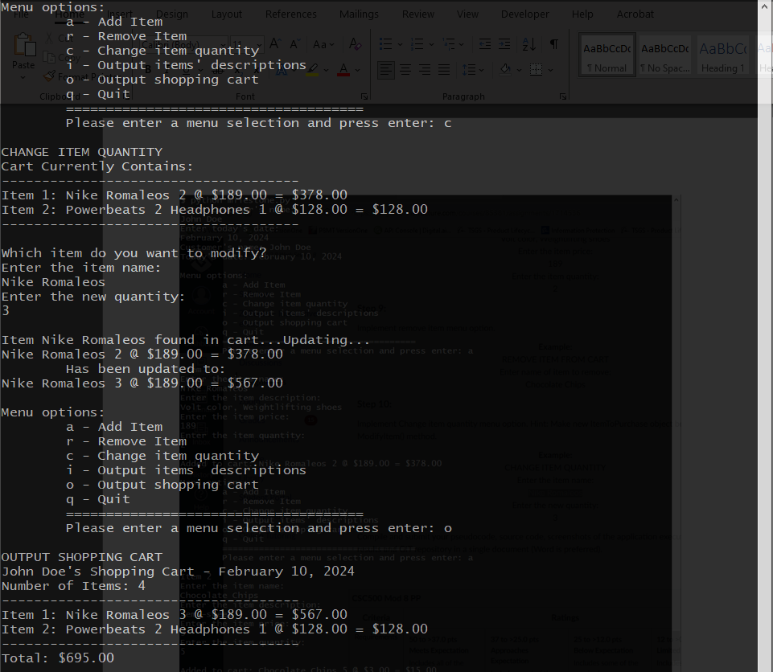

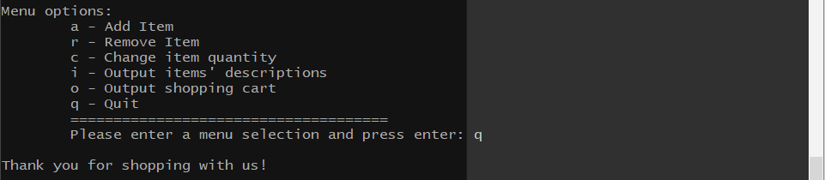

# Github Repository

<https://github.com/wheyluhai/csuglobal/tree/main/CSC500-1/Module_8>