**PROJECT 1**

**420-P24-AS**

**Android Development**

**Teacher : M.Zeroug**

**Student: Walter Henrike**

**2019**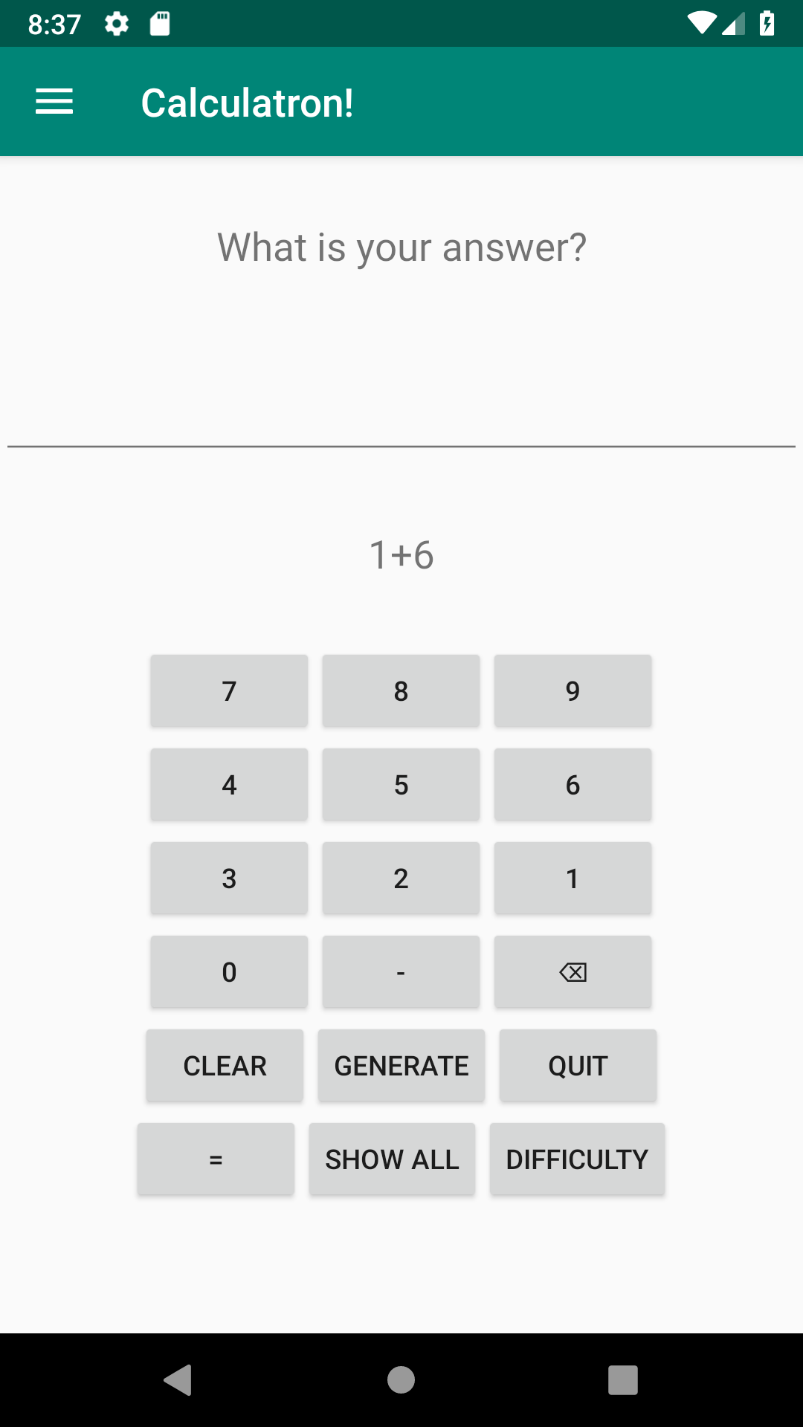

**Img 01 : Simulation Addition Level Easy**

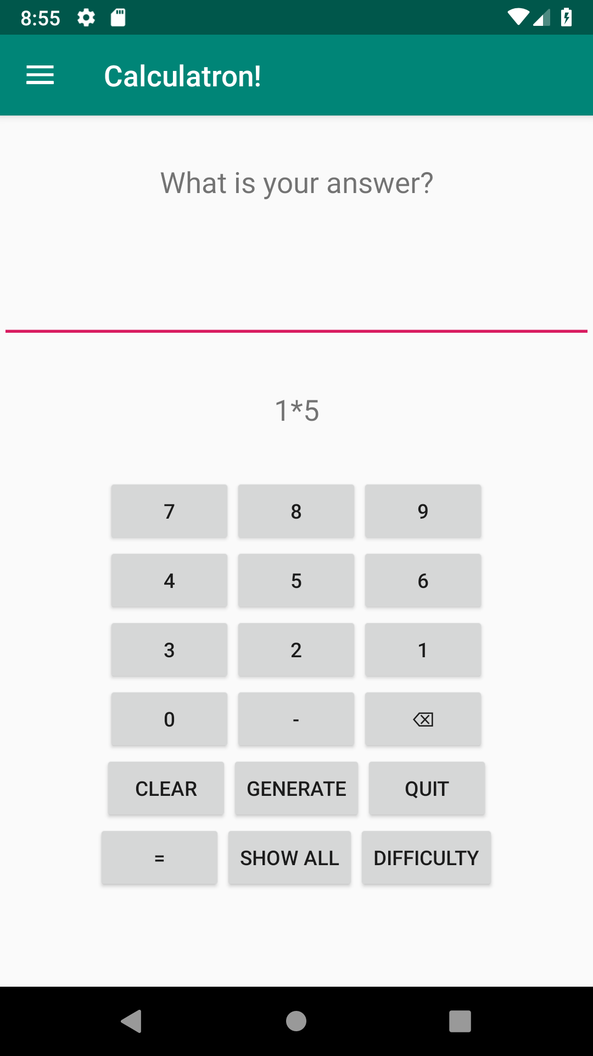

**Img 02 : Simulation Multiplication Level Easy**

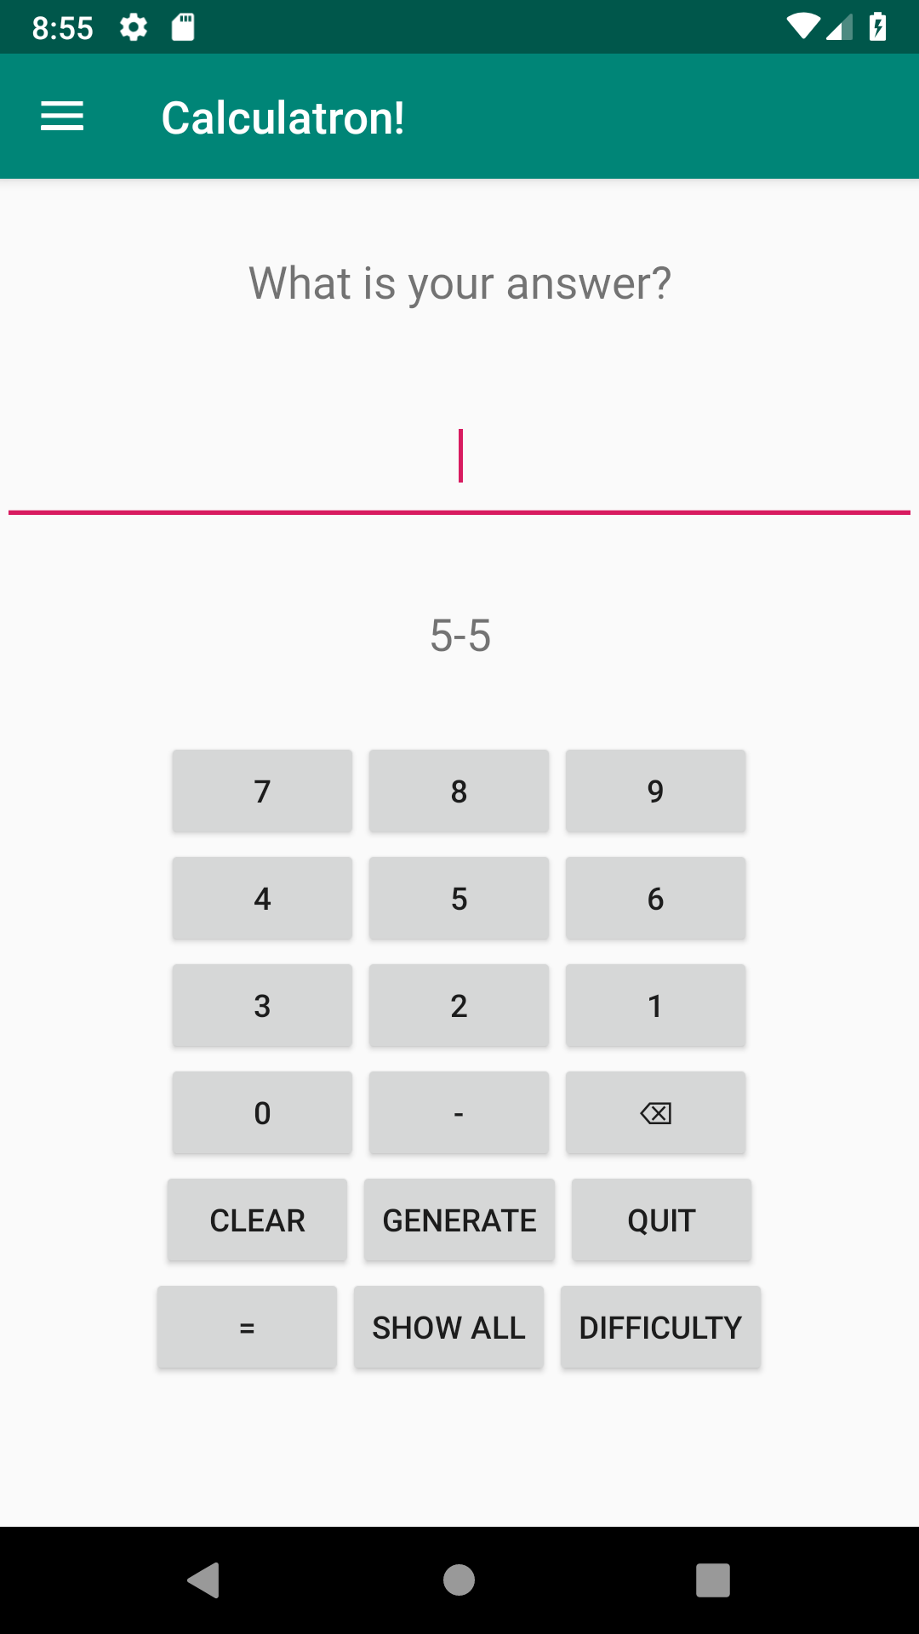

**Img 03 : Simulation Subtraction Level Easy**

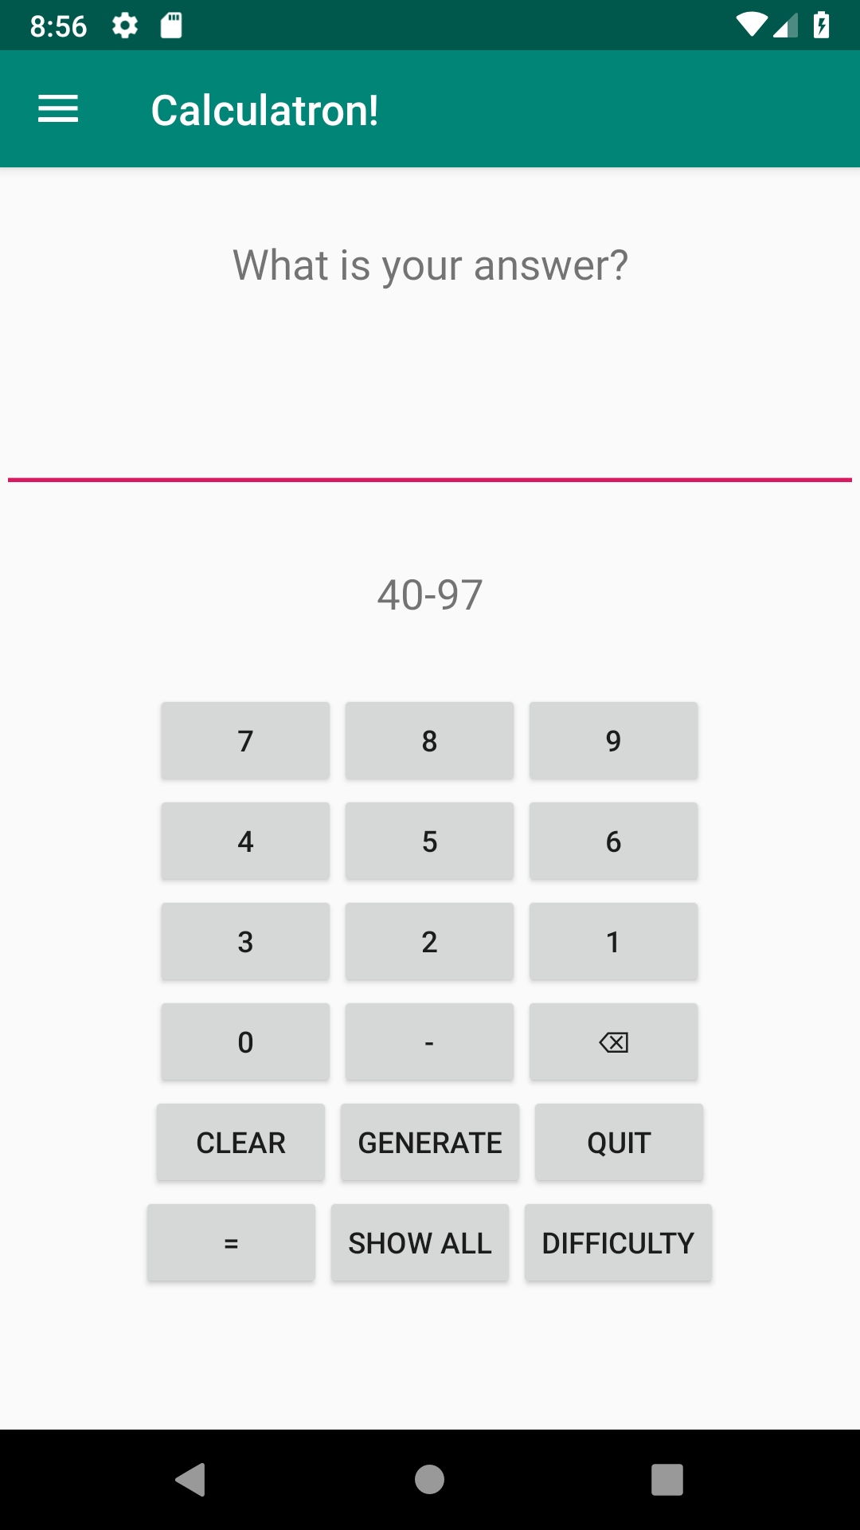

**Img 04 : Simulation Subtraction Level Medium**

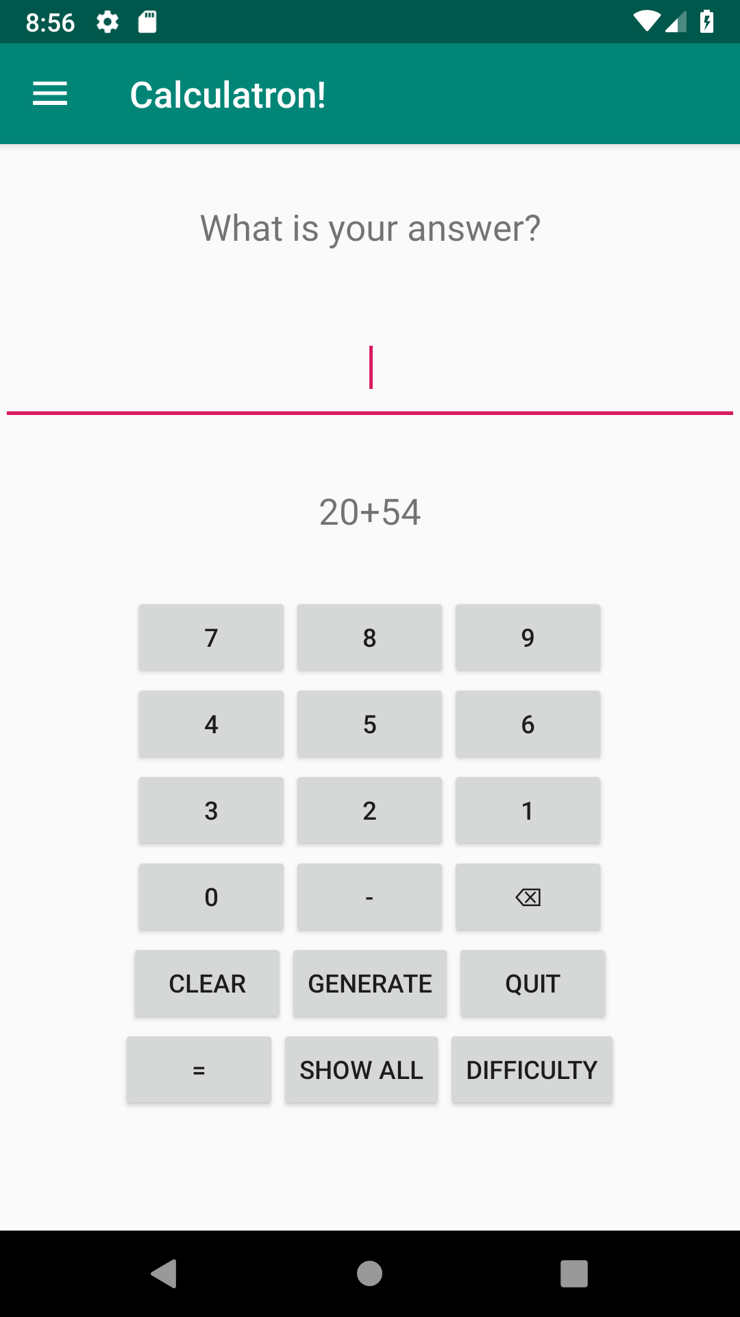

**Img 05 : Simulation Addition Level Medium**

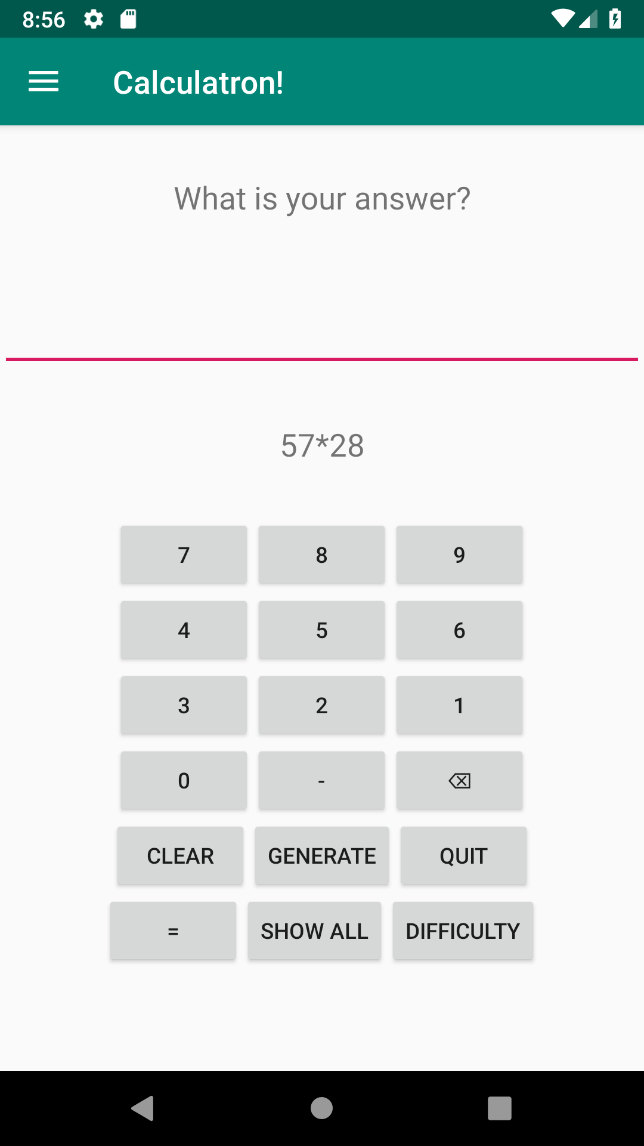

**Img 06 : Simulation Multiplication Level Medium**

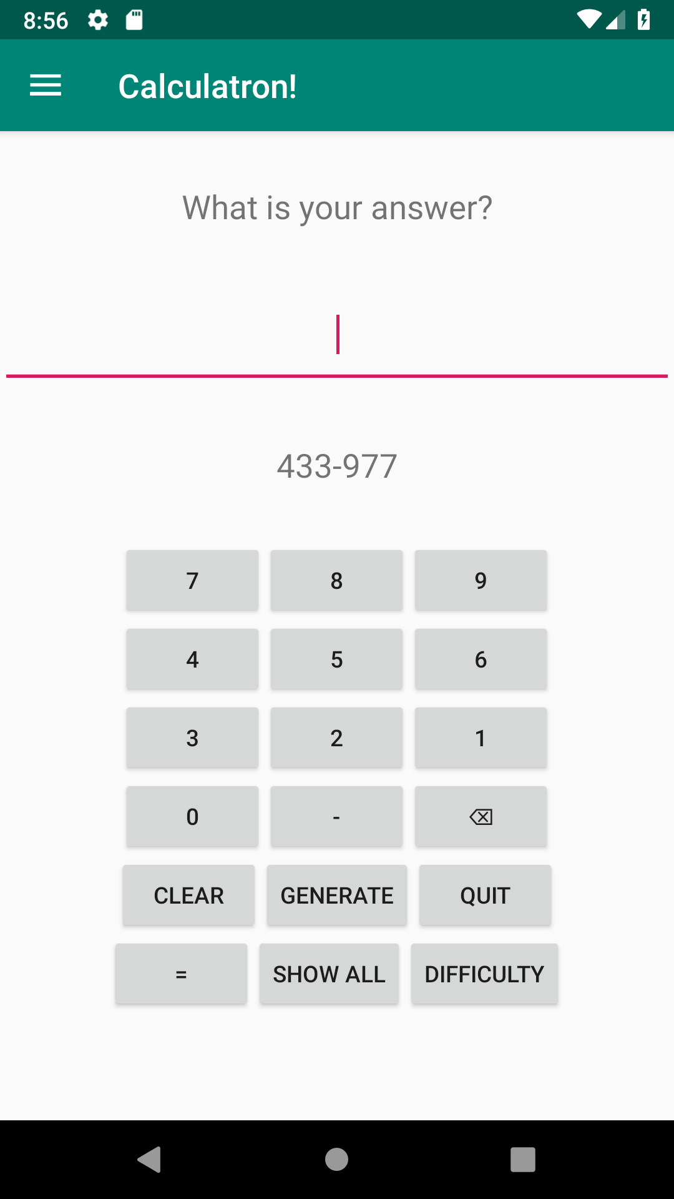

**Img 07 : Simulation Subtraction Level Hard**

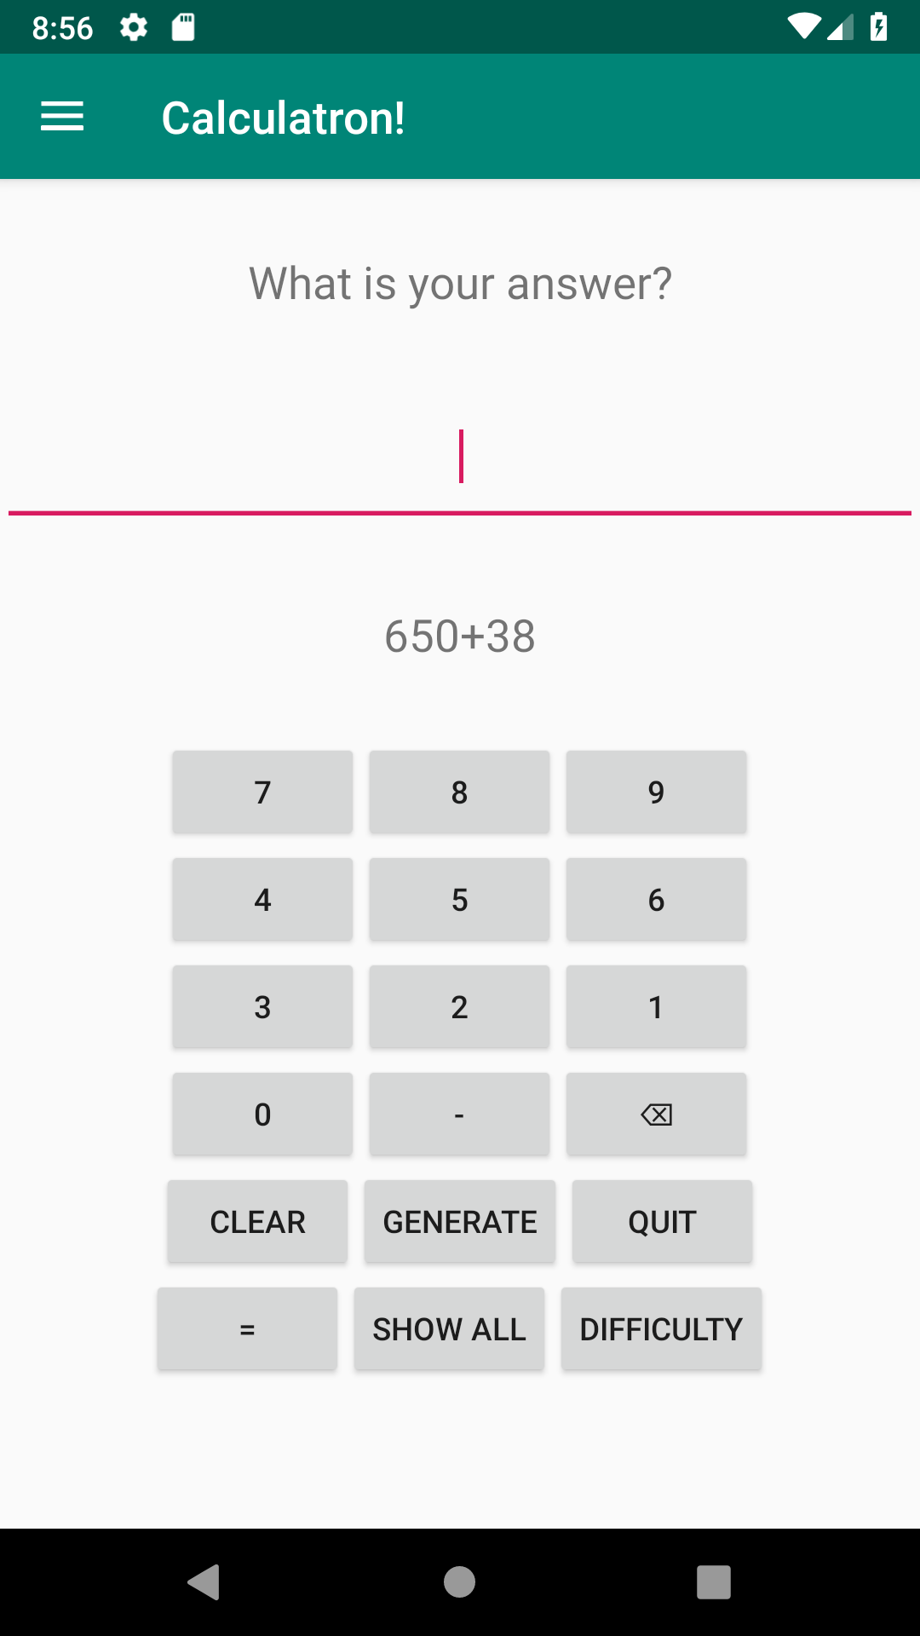

**Img 08 : Simulation Addition Level Hard**

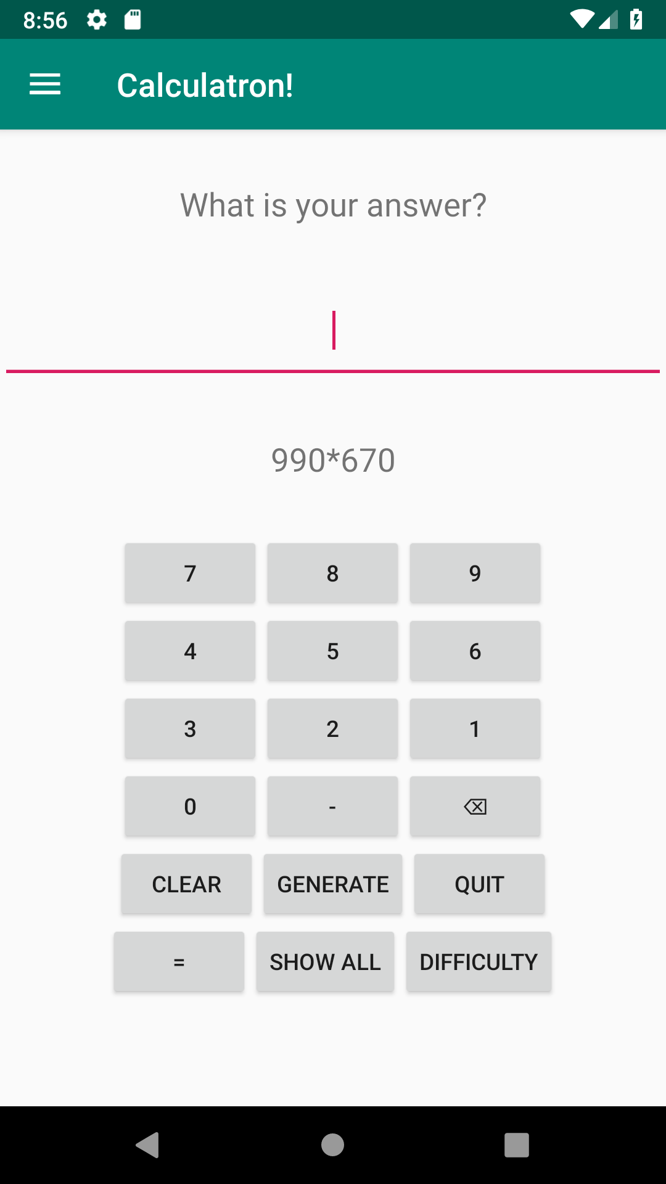

**Img 09 : Simulation Multiplication Level Hard**

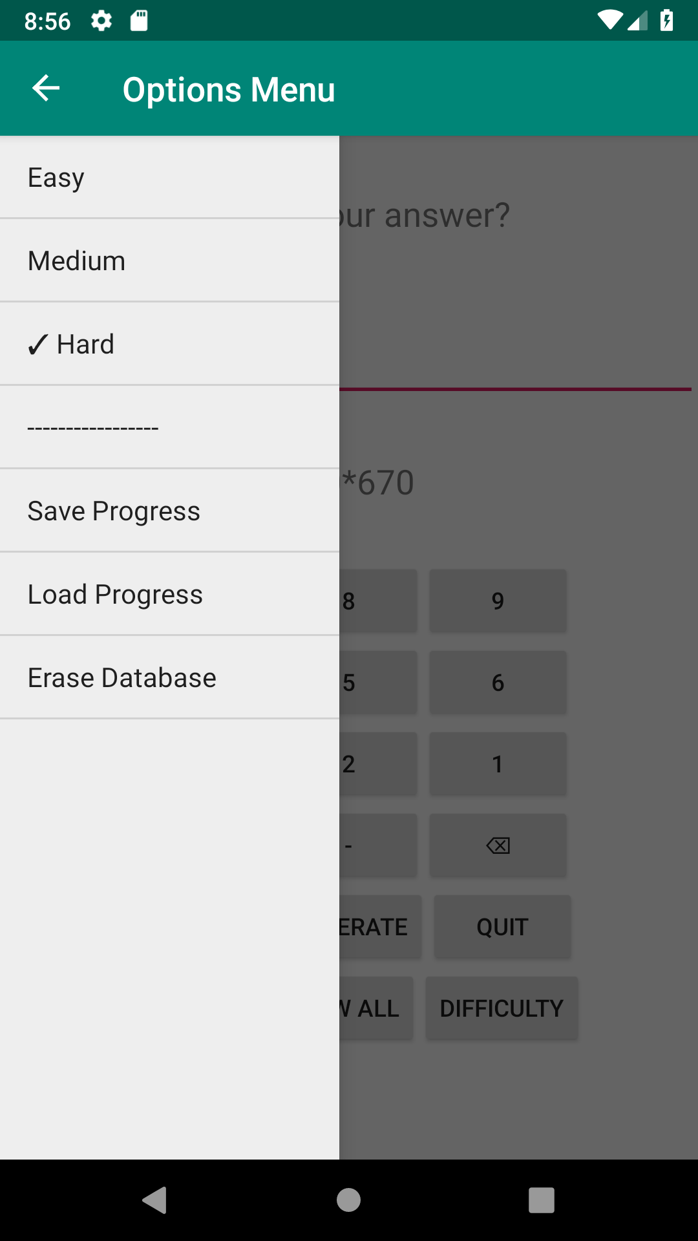

**Img 10 : Options menu (hamburger menu)**

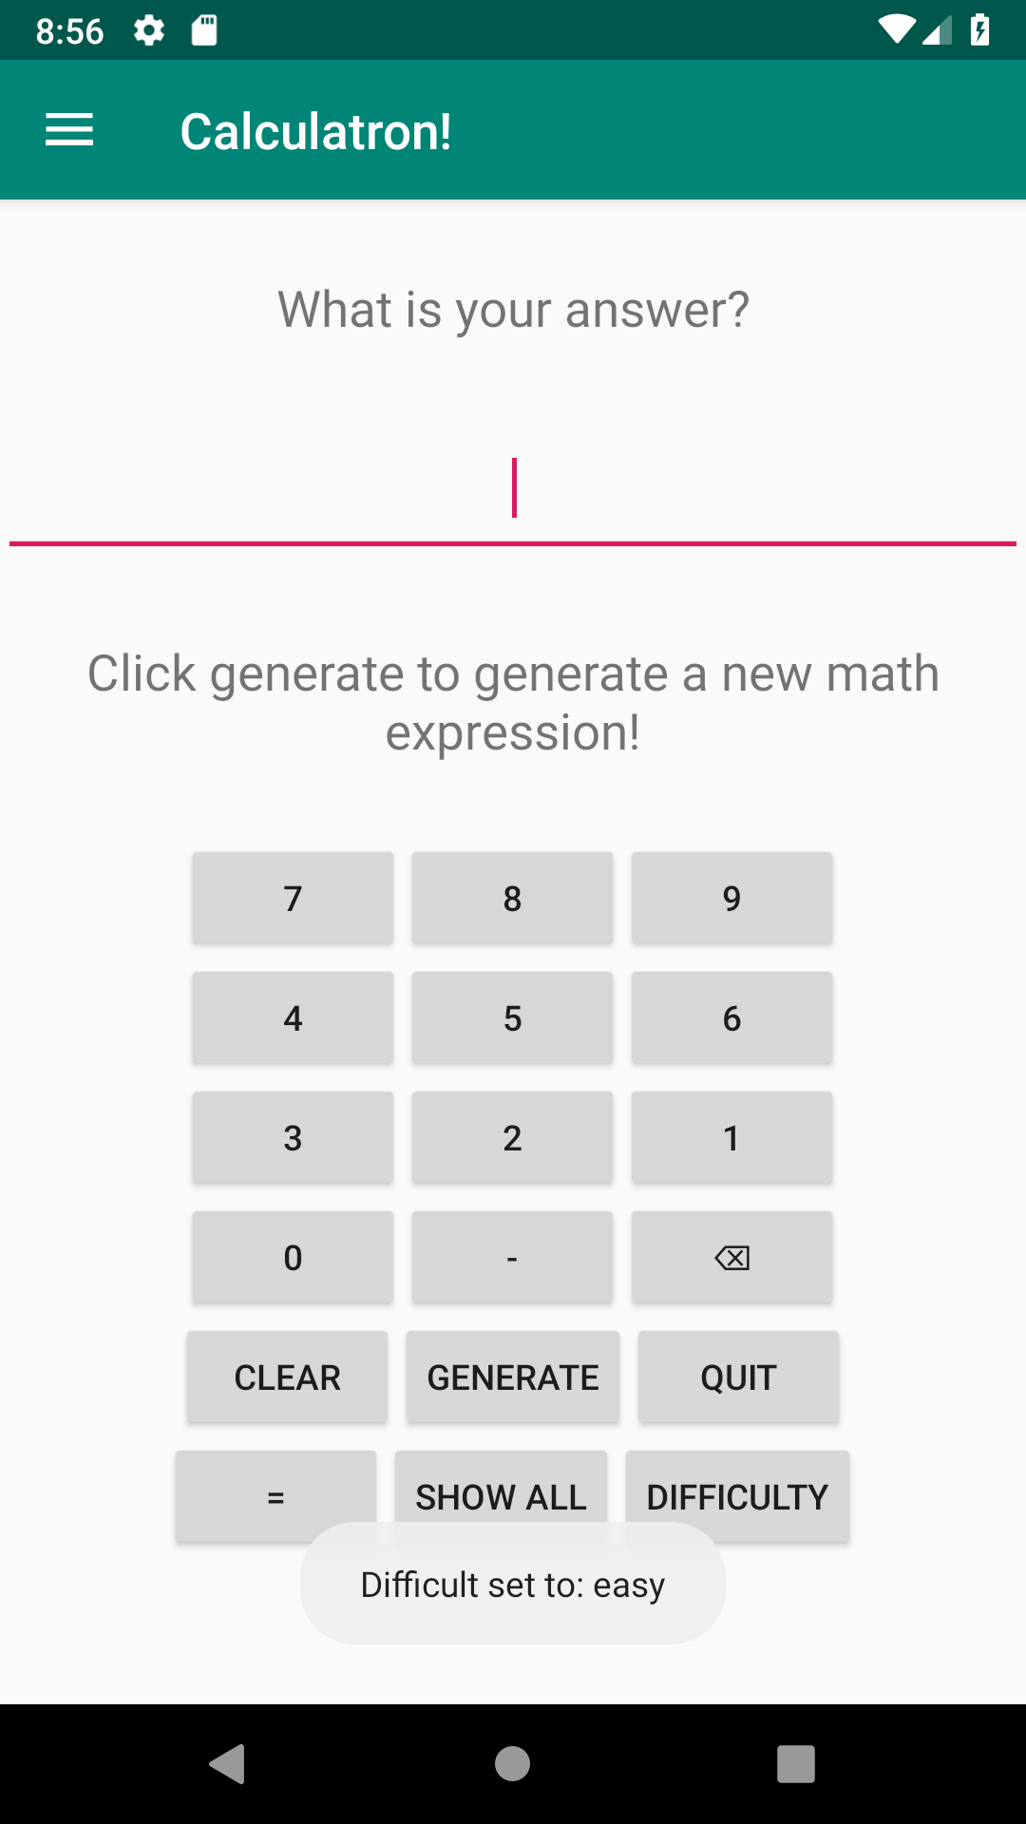

**Img 11: notifications when changing the difficulty**

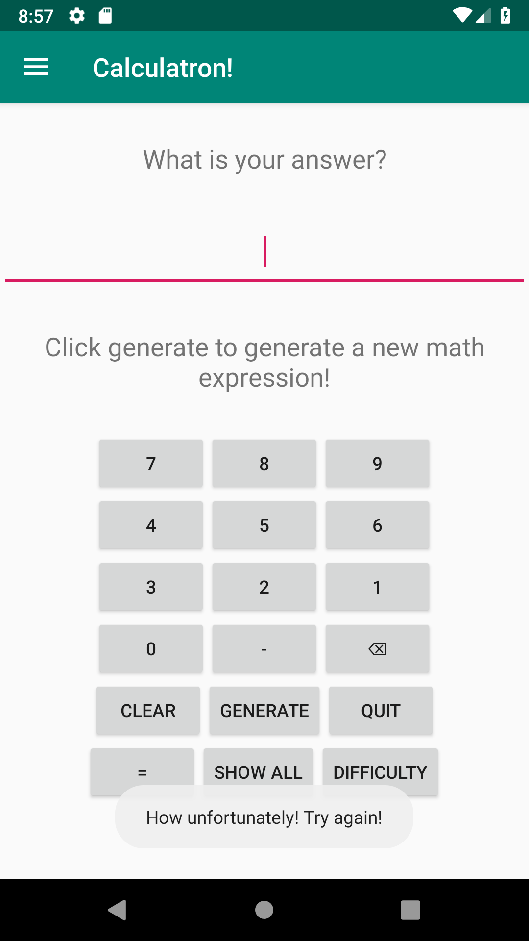

**Img 12 : Notifications when answering wrongly.**

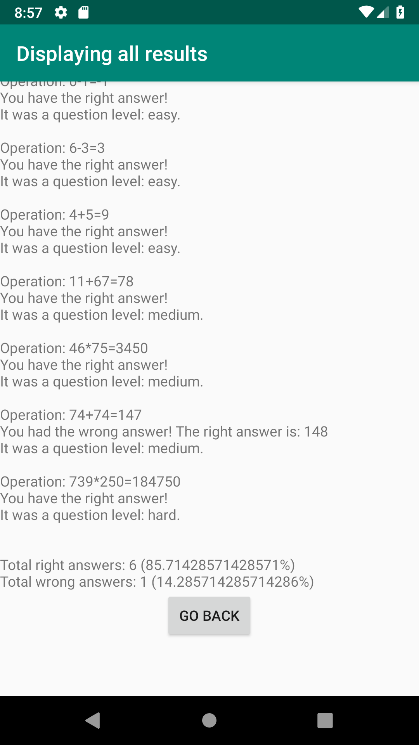

**Img 13 : Displaying all results**

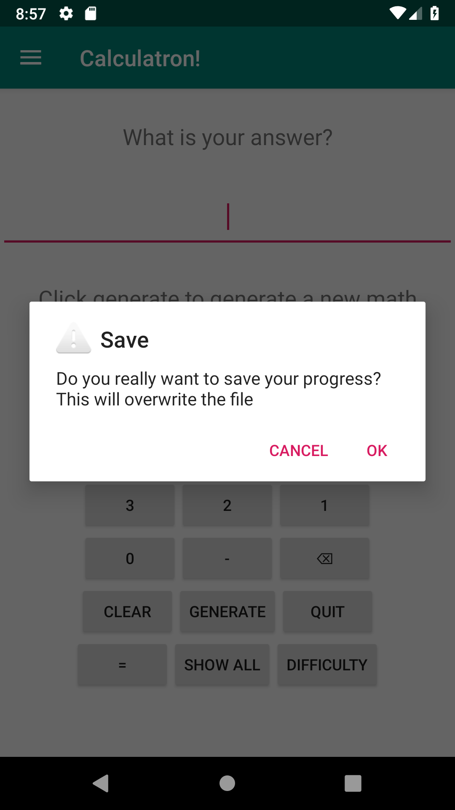

**Img 14 : Notification when saving to the database**

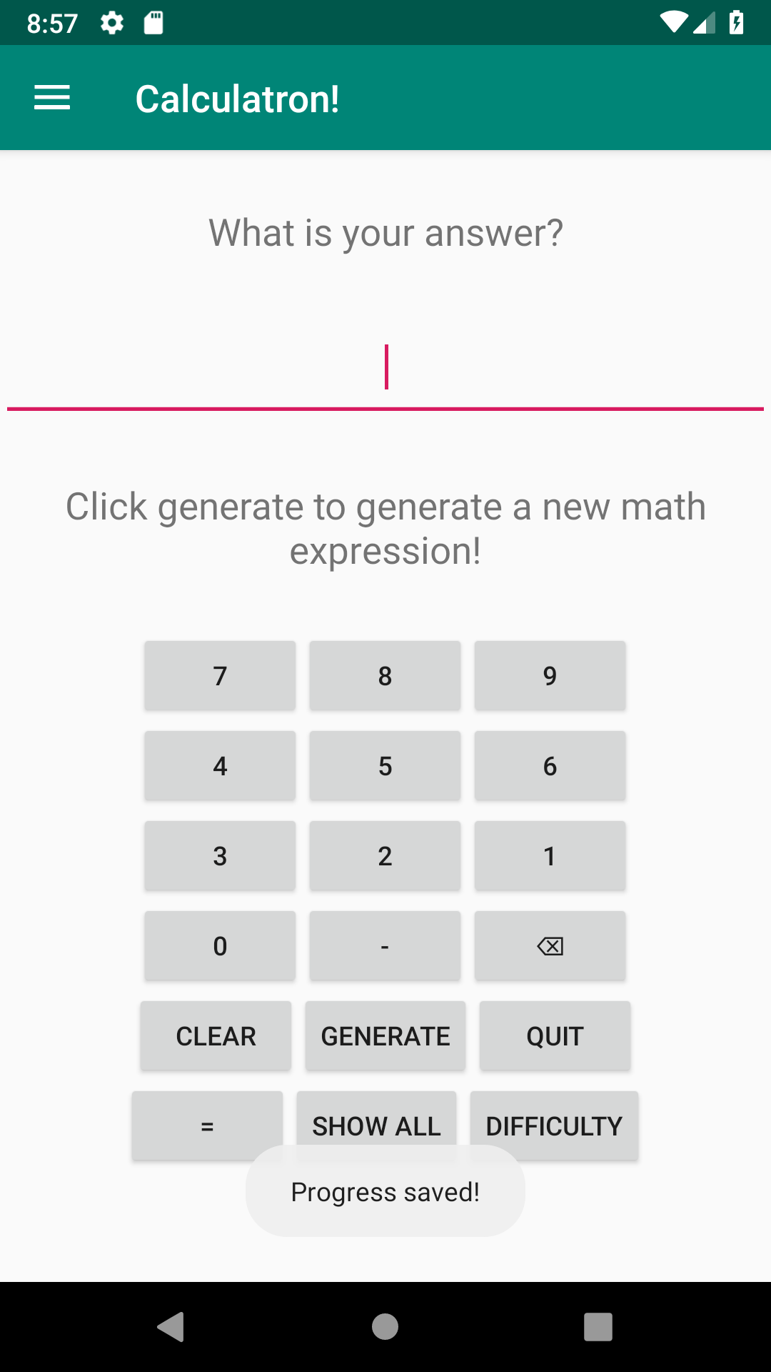

**Img 15 : Notification of the progress being saved**

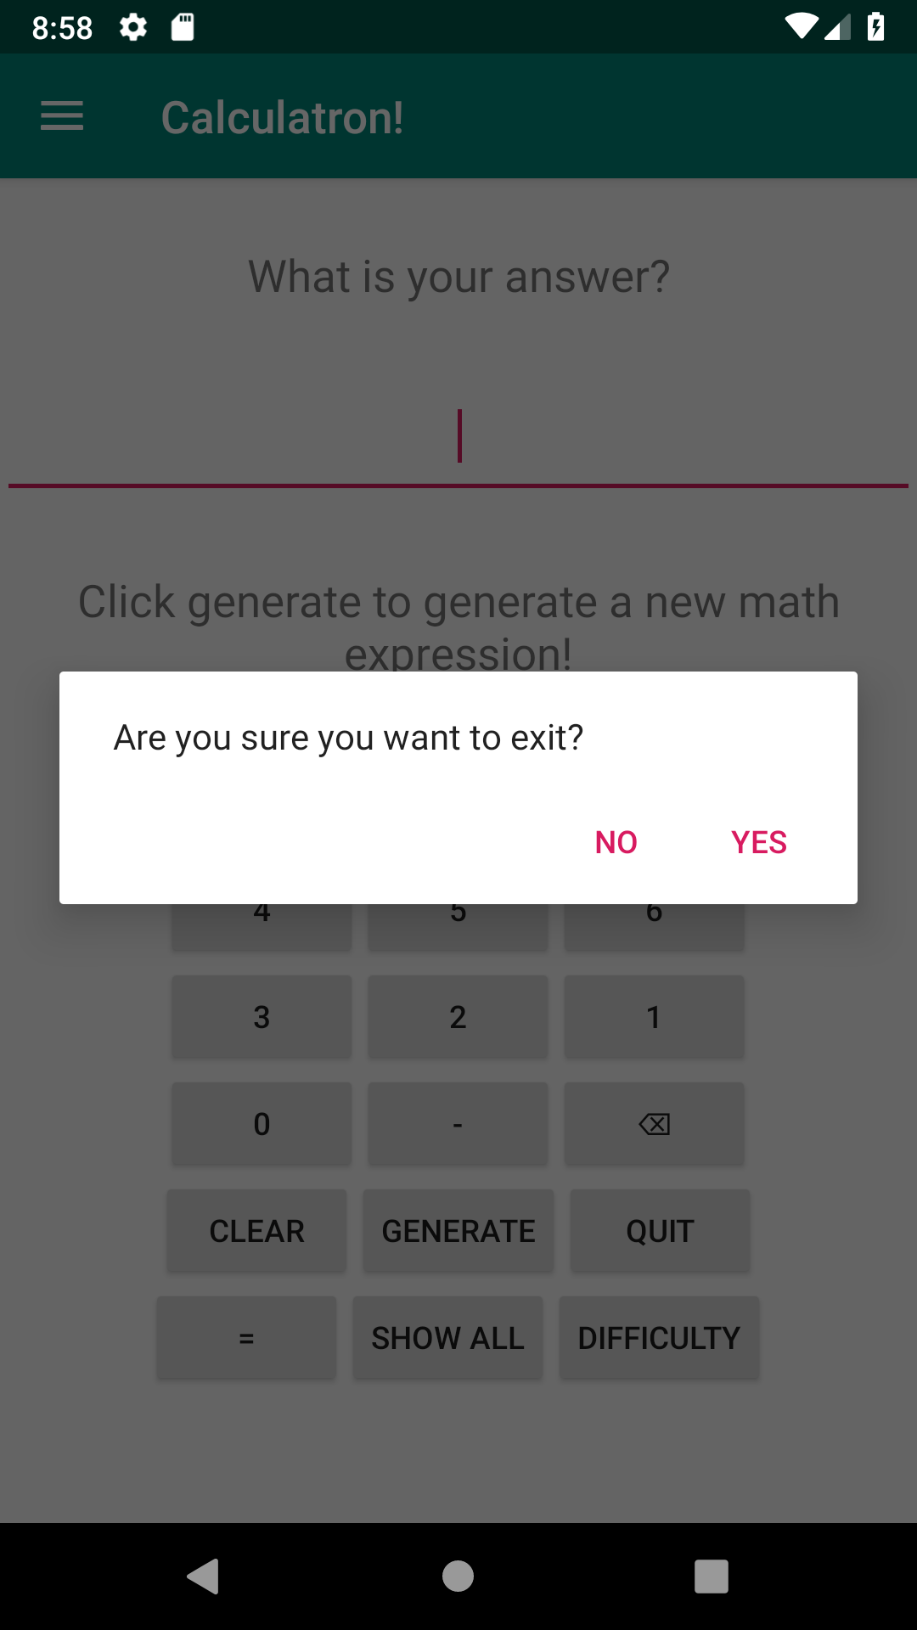

**Img 16 : Notification before quitting the app**