MEMBER FEATURE STORY

**7 Things You Need To Stop Doing To Be More Productive, Backed By Science**

Working smarter, not harder, is the key to better results

[](https://medium.com/@cammipham)

[CamMi Pham](https://medium.com/@cammipham)

Following

Apr 30, 2014

[Tim Gouw](https://unsplash.com/@punttim?utm_source=medium&utm_medium=referral) on [Unsplash](https://unsplash.com/?utm_source=medium&utm_medium=referral)

145K

When I was 17 years old, I used to work and study for about 20 hours a day. I went to school, did my homework during breaks and managed a not-for-profit organization at night. At that time, working long hours landed me countless national campaigns, opportunities to work with A-list organizations and a successful career. As I got older, I started to think differently. I realized that working more is not always the right, or only, path to success.

**Sometimes, working less can actually produce better results.**

Consider a small business owner who works nonstop. Working hard won’t help him compete with his corporate competitors. That’s because time is a limited commodity. An entrepreneur could work 24 hours a day, 7 days a week, but his or her competitor can always spend more money, assemble a team and spend a lot more collective man hours on the same project. Then why have small startups accomplished things that some larger corporations couldn’t? Facebook bought Instagram, a company with 13 employees at the time, for one billion dollars. Snapchat, a startup with 30 employees, was turning down offers from Facebook and Google. Part of each of their successes was based on luck, and some on efficiency.

*The key to success is not working*hard. It’s*working*smart*.*

There’s a notable distinction between being busy and being productive. Being busy doesn’t always necessarily mean you’re being productive. Despite what some might believe, being productive is less about time management and more on managing your energy.It’s the business of life. It’s learning how to spend the least amount of energy to get the most benefits. I personally learned how to reduce my work week from 80 hours to 40 hours, and get a lot more work done in the process. For me, less is more.

**Here are seven things I stopped doing to become more productive.**

**1. Stop working overtime and increase your productivity instead.**

Have you ever wondered where the five-day, 40-hour work week came from? In 1926, Henry Ford, American industrialist and founder of Ford Motor Company, conducted an experiment with his own staff:

He decreased their daily hours from 10 to 8, and shortened the work week from 6 days to 5. As a result, he saw his workers’ productivity increase.

The more you work, the less effective and productive you become over both the short and long term, states a 1980 report from The Business Roundtable titled “Scheduled Overtime Effect on Construction Projects.”

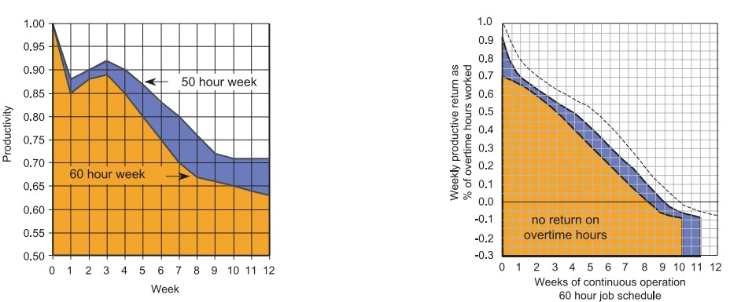

Source: Calculating Loss of Productivity Due to Overtime Using Published Charts — Fact or Fiction

*“Where a work schedule of 60 or more hours per week is continued longer than about two months, the cumulative effect of decreased productivity will cause a delay in the completion date beyond that which could have been realized with the same crew size on a 40-hour week.”*

Source: Calculating Loss of Productivity Due to Overtime Using Published Charts — Fact or Fiction

In an [article](http://www.alternet.org/story/154518/why_we_have_to_go_back_to_a_40-hour_work_week_to_keep_our_sanity?paging=off&current_page=1#bookmark) for AlterNet, editor Sara Robinson referenced research conducted by the US military which revealed that [“losing just one hour of sleep per night for a week will cause a level of cognitive degradation equivalent to a .10 blood alcohol level.”](http://clicktotweet.com/P8l8f) You can get fired for coming to work drunk, but it’s acceptable to pull an all-nighter.

*Irrespective of how well you were able to get on with your day after that most recent night without sleep, it is unlikely that you felt especially upbeat and joyous about the world. Your more-negative-than-usual perspective will have resulted from a generalized low mood, which is a normal consequence of being overtired. More important than just the mood, this mind-set is often accompanied by decreases in willingness to think and act proactively, control impulses, feel positive about yourself, empathize with others, and generally use emotional intelligence.*

Source: [The Secret World of Sleep: The Surprising Science of the Mind at Rest](http://www.amazon.ca/The-Secret-World-Sleep-Surprising/dp/0230107591)

It’s important for us not to overwork ourselves and get enough sleep to maintain a high level of productivity. Next time you’re wondering why you may not be working productively, the reason may be simple as you being deprived of adequate sleep. [(James Maas, a sleep researcher and expert, revealed that at least seven out of every 10 Americans don’t get enough sleep.)](https://experiencelife.com/article/the-healing-power-of-sleep/)

**Did you know?**

* Leonardo da Vinci took multiple naps a day and slept less at night.
* The French emperor Napoleon was not shy about taking naps. He indulged daily.
* Though Thomas Edison was embarrassed about his napping habit, he also practiced this ritual on a daily basis.
* Eleanor Roosevelt, the wife of President Franklin D. Roosevelt, used to boost her energy before speaking engagements by napping.
* Gene Autry, “the Singing Cowboy,” routinely took naps in his dressing room between performances.
* President John F. Kennedy ate his lunch in bed and then settled in for a nap—every day!
* Oil industrialist and philanthropist John D. Rockefeller napped every afternoon in his office.
* Winston Churchill’s afternoon nap was a non-negotiable. He believed it helped him get twice as much done each day.
* President Lyndon B. Johnson took a nap every afternoon at 3:30 p.m. in order to break his day up into “two shifts.”
* Though he was criticized for it, President Ronald Reagan famously took naps as well.

Source:[*5 Reasons Why You Should Take a Nap Every Day — Michael Hyatt*](http://michaelhyatt.com/why-you-should-take-a-nap-every-day.html)

On a personal note, since I started getting at least 7 to 8 hours of sleep each night, I’ve noticed a change: I became a lot more productive and got a lot more work done in comparison to when I worked 16 hours a day. Who knew sleeping was such a great tool for marketers?

**2. Don’t say “yes” too often**

According to the Pareto principle, 20 percent of the effort produces 80 percent of the results; however, 20 percent of the results consumes 80 percent of the effort.Instead of working harder, we should focus primarily on the efforts that produce the majority of the results and forgo the rest. That way, we have more time to focus on the most important tasks. Stop saying “yes” to tasks that yield little or no result.

“The difference between successful people and very successful people is that very successful people say “no” to almost everything.”

— Warren Buffett

So what should you say “yes” to? And when should you say “no”? If you can’t figure out if something is going to be worth your time, consider running a simple split test. Consider tracking everything you do, and the time it takes to complete each task, and the results. Then go back, assess your list to see what did (or didn’t) prove fruitful, and take your findings into consideration to optimize for future tasks.

Most of us say yes more often than we should, for a variety of reasons, including guilt and overstretching ourselves, but also because it is so much easier than saying no. Nobody wants to be the bad guy.

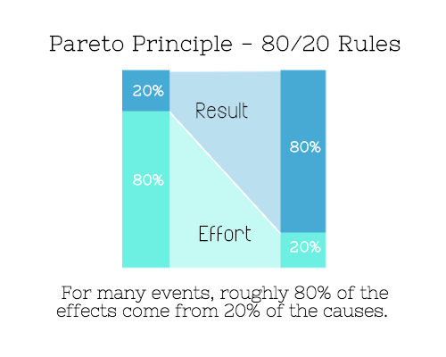

In a [2012 study](http://www.jstor.org/discover/10.1086/663212?uid=3739448&uid=2&uid=3737720&uid=4&sid=21103023192873) published in the *Journal of Consumer Research*, researchers split 120 students in two groups. One group was trained to use the phrase “I can’t” when discussing the specific choices, while the other was trained to use “I don’t” in framing their decisions.

*The students who told themselves “I can’t eat X” chose to eat the chocolate candy bar 61% of the time. Meanwhile, the students who told themselves “I don’t eat X” chose to eat the chocolate candy bars only 36% of the time. This simple change in terminology significantly improved the odds that each person would make a more healthy food choice.*

Next time you need to avoid saying yes, use “I don’t” in your refusal, to reinforce the helpful behavior of saying no to things that aren’t worth it.

Another great trick is to avoid activities that don’t add enough value to your life is the 20-second rule: For activities you shouldn’t be engaging in, or negative habits you want to break, add an element of difficulty, adding on a 20-second roadblock, so to speak, to you starting that activity. For example, if you’re trying to use lessen your use of social media, delete the tempting apps from your phone, so that it takes you another 20 seconds to find your laptop to access them. By adding in an inconvenience, you’ll be less likely to engage with that draining activity or habit.

*Lower the activation energy for habits you want to adopt and raise it for habits you want to avoid. The more we can lower or even eliminate the activation energy for our desired actions, the more we enhance our ability to jump-start positive change.*

Source: [The Happiness Advantage: The Seven Principles of Positive Psychology That Fuel Success and Performance at Work](http://www.amazon.ca/The-Happiness-Advantage-Principles-Performance/dp/0307591549)

**3. Stop doing everything yourself and start letting people help you**

At some point in my career, I was managing a very large community and couldn’t handle it all myself. I burnt out, and the community ended up taking over and managing itself. Surprisingly, members did a better job than I could have ever done on my own. I learned the power of community and [why brands need user-generated content](http://blog.filemobile.com/benefits-user-generated-content/).

Consumers understand what they want and how they want it better than any marketer does. Did you know that, according to [Octoly](http://www.reelseo.com/earned-media-rankings-youtube-octoly/" \t "_blank), user-generated videos are viewed 10 times more than brand-generated videos on YouTube? When seeking information about a particular brand, [over half](http://resources.bazaarvoice.com/rs/bazaarvoice/images/201202_Millennials_whitepaper.pdf) (51 percent) of Americans trust user-generated content more than what’s on the brand’s official website (16 percent) or media coverage on the brand (14 percent). It’s important for marketers to open up and seek help from the brand’s community itself.

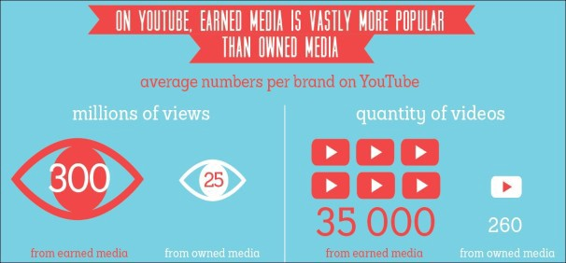

Source: [Earned Media Rankings on YouTube — Octoly](http://www.reelseo.com/earned-media-rankings-youtube-octoly/)

Being a great content marketer is not about creating the best content, but building a great community that will generate high-quality content for you.

It’s important for us to realize we can seek help when we need it. Sometimes it’s impossible to do everything ourselves. It‘s better to let someone, or a team, share the work, giving you more time to focus on the most important tasks. Instead of wasting time and energy overloading yourself or trying to do it alone, let others share the burden and help.

Often times, even if your friends or coworkers can’t help you, simply having them around can help you become more productive.

*Just having friends nearby can push you toward productivity. “There’s a concept in ADHD treatment called the ‘body double,’ ” says David Nowell, Ph.D., a clinical neuropsychologist from Worcester, Massachusetts. “Distractable people get more done when there is someone else there, even if he isn’t coaching or assisting them.” If you’re facing a task that is dull or difficult, such as cleaning out your closets or pulling together your receipts for tax time, get a friend to be your body double.*

Source: [Friendfluence: The Surprising Ways Friends Make Us Who We Are](http://www.amazon.ca/Friendfluence-Surprising-Ways-Friends-Make/dp/0385535430" \t "_blank)

**4. Stop being a perfectionist**

“We found that perfectionism trips up professors on the way to research productivity. The more perfectionistic the professor, the less productive they are,” Dr. Simon Sherry, a psychology professor at Dalhousie University who conducted a [study on perfectionism and productivity](http://www.universityaffairs.ca/perfectionist-professors-have-lower-research-productivity.aspx), told *University Affairs*. Dr. Sherry found a robust correlation between increased perfectionism and decreased productivity.

Here are some problems associated with being a perfectionist:

* They spend more time than required on a task.
* They procrastinate and wait for the perfect moment. In business, if it is the perfect moment, you are too late.
* They miss the big picture while focusing too much on the small things.

Marketers often wait for the perfect moment. In doing so, they end up missing it.

**The perfect moment is NOW.**

**5. Stop doing repetitive tasks and start automating.**

According to a research study conducted by Tethys Solutions, a team of five people who spent 3 percent, 20 percent, 25 percent, 30 percent and 70 percent of their time on repetitive tasks, respectively, reduced their time spent to 3 percent, 10 percent, 15 percent, 15 percent and 10 percent after two months of working to enhance their productivity.

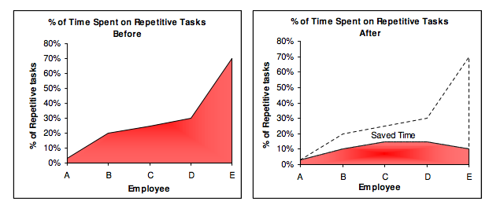

Source: Using Automation Software To Increase Business Productivity & Competitiveness -Tethys Solutions

A week ago, I spent 15 minutes writing a basic Python program. The idea was to generate content from the data, which I pulled from Twitter API using a Ruby bot, and then using Hootsuite to bulk schedule the content. While this task used to take me an entire day to accomplish, it now takes me less than five minutes thanks to automation. Nowadays, whenever I find that I’ve done something more than five times, I ask myself if I can find a program to automate it for me.

You don’t have to be able to code to automate your repetitive tasks. It’s nice to have the skills or the resources, but it’s not a requirement. If you cannot build it, buy it.

People often forget that time is money. People usually do things manually because it’s easy and requires almost no research. It’s manageable to moderate 30 images on Instagram for your user-generated campaign. But if you have to manage 30,000 photos and videos from five different platforms, you need a good digital asset management software. At Filemobile, we help people solve that problem and generate even more user-generated content. Just like managing rich media, you can easily purchase a software to solve almost all of your problems on the internet.

If you still can’t find a solution, you can hire an expert to help you. Keep in mind that you need to spend money to make money and that time is your most valuable commodity.

**Tips for marketers:**check out [GitHub](https://github.com/) or [Google Apps Script library](https://developers.google.com/apps-script/guide_libraries). Often times, you’ll find free, ready-to-use open source code that requires very little programming knowledge.

**6. Stop guessing and start backing up your decisions with data**

If you can optimize websites for search engines, you can optimize your life to grow and reach your maximum potential.

There are countless research studies that can offer insight on optimizing your productivity. For instance, did you know that most people are more easily distracted between noon to 4 p.m.? This was the conclusion that came from research shared by Robert Matchock, an associate professor of psychology at Pennsylvania State University. But even if you can’t find data on a particular question you might have, it doesn’t take a lot of time to run a simple split test and examine your own results.

**7. Stop working, and take some time to do nothing at all.**

Most people don’t realize that when we are too focused on something, we’re essentially locking ourselves in a box which can end up being counterproductive to our work or the results we’re chasing. It’s important to walk away from work once in a while and have some alone time, which is good for the brain and spirit, according to “[The Power of Lonely](http://www.boston.com/bostonglobe/ideas/articles/2011/03/06/the_power_of_lonely/),” from *The Boston Globe*.

*One ongoing Harvard study indicates that people form more lasting and accurate memories if they believe they’re experiencing something alone. Another indicates that a certain amount of solitude can make a person more capable of empathy towards others. And while no one would dispute that too much isolation early in life can be unhealthy, a certain amount of solitude has been shown to help teenagers improve their moods and earn good grades in school.*

Source: [The Power of Lonely](http://www.boston.com/bostonglobe/ideas/articles/2011/03/06/the_power_of_lonely/)

It‘s important to take time for reflection. We often find the solutions we’re looking for when we’re not actively searching for them.

It’s also important to understand that we don’t become more productive overnight. Like everything in life, it requires effort and practice. Change doesn’t happen just by sitting around and waiting for it. Instead, take the time to learn more about your body and find actionable ways to optimize your energy and time for a more successful and happier life.

*Disclosure: Filemobile (acquired by NewZulu) is a former client of my agency,*[*ThinkRenegade*](http://www.thinkrenegade.com/)*.*