Assigmnent 1 Solutions

Hunter GIles

3/6/2022

# Assignment 1: Getting Started

### Question 1

3 + 4

## [1] 7

(-3 + 5 + 7 + 8)/4

## [1] 4.25

-3 + 5 + 7 + 8/4

## [1] 11

We can see that R has built in basic calculator functions. Also, R supports ‘order of operation’ syntax.

### Question 2

# assigning vector to variable1  
variable1 <- c(-3, 5, 7, 8)  
  
# running basic methods on vector for mean and standard deviation  
mean(variable1)

## [1] 4.25

sd(variable1)

## [1] 4.99166

Here we can see a numeric vector being assigned to variable1. This vector is saved in the environment for future use. We can use the built in functions *mean()* and *sd()*.

### Question 3

library(readr)  
library(mosaic)

## Registered S3 method overwritten by 'mosaic':  
## method from   
## fortify.SpatialPolygonsDataFrame ggplot2

##   
## The 'mosaic' package masks several functions from core packages in order to add   
## additional features. The original behavior of these functions should not be affected by this.

##   
## Attaching package: 'mosaic'

## The following objects are masked from 'package:dplyr':  
##   
## count, do, tally

## The following object is masked from 'package:Matrix':  
##   
## mean

## The following object is masked from 'package:ggplot2':  
##   
## stat

## The following objects are masked from 'package:stats':  
##   
## binom.test, cor, cor.test, cov, fivenum, IQR, median, prop.test,  
## quantile, sd, t.test, var

## The following objects are masked from 'package:base':  
##   
## max, mean, min, prod, range, sample, sum

Installing the necessary dependencies for the remainder of the assignment.

### Question 4

# assigning readmill data to hunterData  
hunterData <- read_csv("./Data/treadmill.csv")

## Rows: 31 Columns: 8  
## ── Column specification ────────────────────────────────────────────────────────  
## Delimiter: ","  
## dbl (8): Subject, TreadMillOx, TreadMillMaxPulse, RunTime, RunPulse, RestPul...  
##   
## ℹ Use `spec()` to retrieve the full column specification for this data.  
## ℹ Specify the column types or set `show_col_types = FALSE` to quiet this message.

# viewing the first and and last 6 observations  
head(hunterData)

## # A tibble: 6 × 8  
## Subject TreadMillOx TreadMillMaxPulse RunTime RunPulse RestPulse BodyWeight  
## <dbl> <dbl> <dbl> <dbl> <dbl> <dbl> <dbl>  
## 1 1 60.0 186 8.63 170 48 81.9  
## 2 2 59.6 172 8.17 166 40 68.2  
## 3 3 54.6 155 8.92 146 48 70.9  
## 4 4 54.3 168 8.65 156 45 85.8  
## 5 5 51.8 170 10.3 166 50 83.1  
## 6 6 50.6 155 9.93 148 49 59.1  
## # … with 1 more variable: Age <dbl>

tail(hunterData)

## # A tibble: 6 × 8  
## Subject TreadMillOx TreadMillMaxPulse RunTime RunPulse RestPulse BodyWeight  
## <dbl> <dbl> <dbl> <dbl> <dbl> <dbl> <dbl>  
## 1 26 44.6 182 11.4 178 62 89.5  
## 2 27 40.8 172 11.0 168 57 69.6  
## 3 28 39.4 176 13.1 174 63 81.4  
## 4 29 39.4 176 12.6 174 58 73.4  
## 5 30 39.2 172 12.9 168 44 91.6  
## 6 31 37.4 192 14.0 186 56 87.7  
## # … with 1 more variable: Age <dbl>

Above I ran *read_csv()* to download a data-frame. Then I used *head()* and *tail()* to examine a piece of my data-frame.

### Question 5

# Basic mean and standard deviation of the RunTime column  
mean(hunterData$RunTime)

## [1] 10.58613

sd(hunterData$RunTime)

## [1] 1.387414

The chunk above displays the mean and standard deviation of the *RunTime* column. The $ is a characteristic of a tibble. From this we can receive a specific column (vector) of a tibble by calling

$$data−frame$$

$

$$column$$

.

### Question 6

# min, Q1, median, Q3, max, mean, std, n, missing  
favstats(hunterData$RunTime)

## min Q1 median Q3 max mean sd n missing  
## 8.17 9.78 10.47 11.27 14.03 10.58613 1.387414 31 0

# histogram  
hist(hunterData$RunTime)  
  
hist(hunterData$RunTime, labels=TRUE)

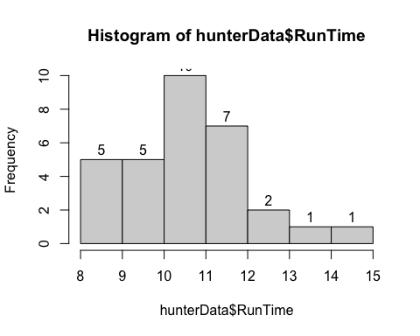

Above returns 1 table and 2 histograms. This table displays descriptive statistics of RunTime. The histograms display the distribution of Runtime. The last graph includes the label argument.

### Question 7

# difference between Q1 and Q3 for RunTime  
IQR <- 11.37 - 9.78  
  
# the upper limit for outliers  
11.27 + 1.5*IQR

## [1] 13.655

# boxplot  
boxplot(hunterData$RunTime)

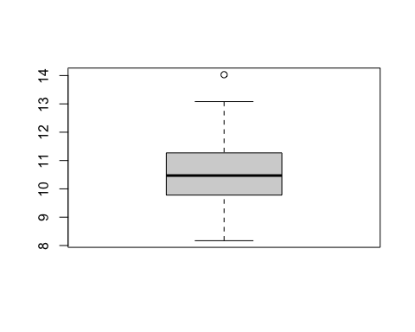

Boxplots are also useful to display data distribution. Instead of frequency, boxplots show quartile rage. Boxplots treat outliers differently. If an observation is 1.5 IQRs above Q3, then it is an upper limit outlier.

### Question 8

boxplot(hunterData$RunTime, ylab = "1.5 Mile Run Time (minutes)",  
 main = "Boxplot of the Run Times of n = 31 participants")

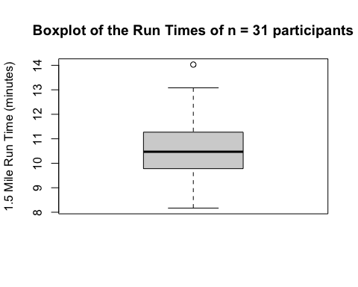

A picture is only worth a thousand words, if well labeled.