Library Workshop Exercise

Hunter

March 7th, 2022

**Go to** [**https://research.library.gsu.edu/c.php?g=972058&p=7685877**](https://research.library.gsu.edu/c.php?g=972058&p=7685877) **and complete the exercise by creating chunks and typing the codes. After completing the exercise, you need to submit an RMD file and a knitted WORD file. I already typed the first two codes as well as the last, but you need to run them.**

# Run this code to load and open the data  
SLID <- read.csv("https://raw.githubusercontent.com/GSU-Robinson/Data/main/SLID.csv")

head(SLID)

## wages education age sex language  
## 1 10.56 15.0 40 Male English  
## 2 11.00 13.2 19 Male English  
## 3 NA 16.0 49 Male Other  
## 4 17.76 14.0 46 Male Other  
## 5 NA 8.0 71 Male English  
## 6 14.00 16.0 50 Female English

### Frequency Tables:

Below is the code for the frequency distribution for the variable language in the SLID dataset.

table(SLID$language)

##   
## English French Other   
## 121 5716 497 1091

### Descriptive Statistics

Below is the code for calculating the descriptive statistics of the variable wages.

summary(SLID$wages)

## Min. 1st Qu. Median Mean 3rd Qu. Max. NA's   
## 2.300 9.235 14.090 15.553 19.800 49.920 3278

We can also calculate the descriptive statistics for all the variables in one command line.

summary(SLID)

## wages education age sex   
## Min. : 2.300 Min. : 0.00 Min. :16.00 Length:7425   
## 1st Qu.: 9.235 1st Qu.:10.30 1st Qu.:30.00 Class :character   
## Median :14.090 Median :12.10 Median :41.00 Mode :character   
## Mean :15.553 Mean :12.50 Mean :43.98   
## 3rd Qu.:19.800 3rd Qu.:14.53 3rd Qu.:57.00   
## Max. :49.920 Max. :20.00 Max. :95.00   
## NA's :3278 NA's :249   
## language   
## Length:7425   
## Class :character   
## Mode :character   
##   
##   
##   
##

### Cross Tabulation

Below is the code for conducting a crosstabulation and calculating the Chi-squared test.

table(SLID$sex, SLID$language)

##   
## English French Other  
## Female 55 2999 262 564  
## Male 66 2717 235 527

chisq.test(table(SLID$sex, SLID$language))

##   
## Pearson's Chi-squared test  
##   
## data: table(SLID$sex, SLID$language)  
## X-squared = 2.5248, df = 3, p-value = 0.4708

### Generating Variables

Below is the code for generating the variable age1 from an already existing variable age.

SLID$age1<-SLID$age

### Correlations

Below is the code for calculating the sample Pearson coefficient.

cor(SLID[,c("wages", "age")], use="complete.obs")

## wages age  
## wages 1.0000000 0.3614635  
## age 0.3614635 1.0000000

cor.test(SLID$wages, SLID$age, method = "pearson")

##   
## Pearson's product-moment correlation  
##   
## data: SLID$wages and SLID$age  
## t = 24.959, df = 4145, p-value < 2.2e-16  
## alternative hypothesis: true correlation is not equal to 0  
## 95 percent confidence interval:  
## 0.3347088 0.3876359  
## sample estimates:  
## cor   
## 0.3614635

### Linear Regression

Below is the RStudio code for our linear regression.

summary(lm(wages~age + sex + education + language, data= SLID))

##   
## Call:  
## lm(formula = wages ~ age + sex + education + language, data = SLID)  
##   
## Residuals:  
## Min 1Q Median 3Q Max   
## -26.081 -4.351 -0.797 3.233 35.903   
##   
## Coefficients:  
## Estimate Std. Error t value Pr(>|t|)   
## (Intercept) -8.045774 1.410540 -5.704 1.25e-08 ***  
## age 0.254676 0.008688 29.312 < 2e-16 ***  
## sexMale 3.466147 0.208618 16.615 < 2e-16 ***  
## education 0.920088 0.034677 26.533 < 2e-16 ***  
## languageEnglish 0.121644 1.276452 0.095 0.924   
## languageFrench 0.108275 1.336288 0.081 0.935   
## languageOther 0.269471 1.307689 0.206 0.837   
## ---  
## Signif. codes: 0 '***' 0.001 '**' 0.01 '*' 0.05 '.' 0.1 ' ' 1  
##   
## Residual standard error: 6.604 on 4007 degrees of freedom  
## (3411 observations deleted due to missingness)  
## Multiple R-squared: 0.2972, Adjusted R-squared: 0.2962   
## F-statistic: 282.5 on 6 and 4007 DF, p-value: < 2.2e-16

### Basic Graphing

A pie chart is best for showing the proportions of occurrence of the options in a nominal level variable.

pie(table(SLID$language))

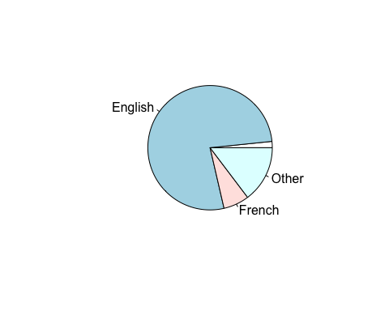

# This is your last chunk  
library(car)  
scatterplot(wages~education, regLine=FALSE, smooth=FALSE, boxplots=FALSE, data=SLID)

