Problem Set 1

Hunter Giles

2022-08-18

library(tidyverse)  
  
cars <- read_csv("data/cars.csv")

# Learning R

Tell me that you worked through the primers and videos and examples at the example page for this week:

The primers and videos were great!

# My first plots

Insert a chunk below and use it to create a scatterplot (hint: geom_point()) with diplacement (displ) on the x-axis, city MPG (cty) on the y-axis, and with the points colored by drive (drv).

ggplot(cars, aes(displ, cty)) +  
 geom_point() +  
 labs(title = "Corr: City & Displacement", y = "City", x = "Displacement")

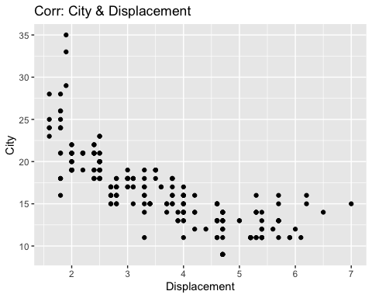

Insert a chunk below and use it to create a histogram (hint: geom_histogram()) with highway MPG (hwy) on the x-axis. Do not include anything on the y-axis (geom_histogram() will do that automatically for you). Choose an appropriate bin width. If you’re brave, facet by drive (drv).

ggplot(cars) +  
 geom_histogram(mapping = aes(hwy)) +  
 labs(title = "Highway Dist", x = "highway")

## `stat_bin()` using `bins = 30`. Pick better value with `binwidth`.

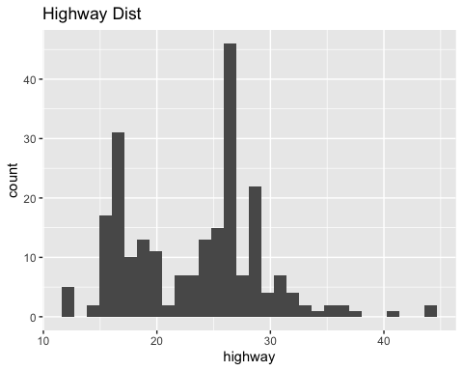

# My first data manipulation

Insert a chunk below and use it to calculate the average city MPG (cty) by class of car (class). This won’t be a plot—it’ll be a table. Hint: use a combination of group_by() and summarize().

df <- cars %>% group_by(class)  
summarise(df, mean = mean(cty))

## # A tibble: 7 × 2  
## class mean  
## <chr> <dbl>  
## 1 2seater 15.4  
## 2 compact 20.1  
## 3 midsize 18.8  
## 4 minivan 15.8  
## 5 pickup 13   
## 6 subcompact 20.4  
## 7 suv 13.5