Problem set 2: Regression

Hunter Giles

September 1, 2022

Table of Contents

library(tidyverse)  
library(broom)  
library(modelsummary)  
  
  
# Load penguins data  
penguins <- read_csv("data/penguins.csv")

# Task 1: Penguins

Between 2007 and 2009, researchers collected data on penguins in three islands in the Palmer Archipelago in Antarctica: Biscoe, Dream, and Torgersen. The penguins dataset has data for 342 penguins from 3 different species: Chinstrap, Gentoo, and AdÃ©lie. It includes the following variables:

* species: The penguin’s species (Chinstrap, Gentoo, and AdÃ©lie)
* island: The island where the penguin lives (Biscoe, Dream, and Torgersen)
* bill_length_mm: The length of the penguin’s bill, in millimeters (distance from the penguin’s face to the tip of the bill)
* bill_depth_mm: The depth of the penguin’s bill, in millimeters (height of the bill; distance from the bottom of the bill to the top of the bill)
* flipper_length_mm: The length of the penguin’s flippers, in millimeters
* body_mass_g: The weight of the penguin, in grams
* sex: The sex of the penguin
* year: The year the observation was made

## Exploratory analysis

What is the relationship between penguin weight and bill depth? This plot shows some initial trends:

ggplot(data = penguins,   
 aes(x = bill_depth_mm, y = body_mass_g)) +  
 geom_point()

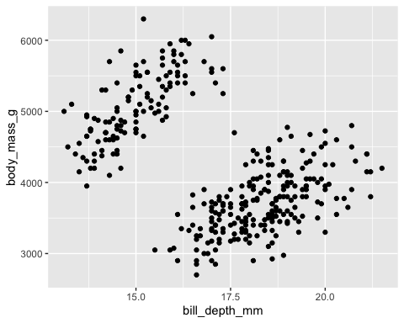

Make a new plot that colors these points by species. What can you tell about the relationship between bill depth and penguin weight?

ggplot(data = penguins,   
 aes(x = bill_depth_mm, y = body_mass_g, color = species)) +  
 geom_point()

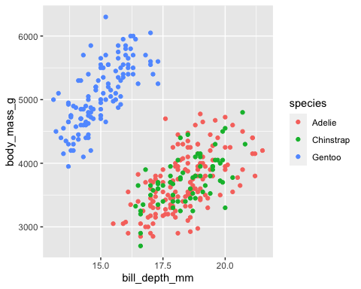

*There is a positive relationship between bill depth and body mass.*

Add a geom_smooth() layer to the plot and make sure it uses a straight line (hint: include method="lm" in the function). What does this tell you about the relationship between bill depth and body mass?

ggplot(data = penguins,   
 aes(x = bill_depth_mm, y = body_mass_g, color = species)) +  
 geom_point() +  
 geom_smooth(method = lm)

## `geom_smooth()` using formula 'y ~ x'

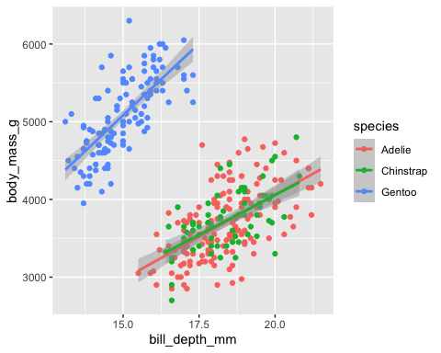

*The lines show the average increase in body mass as bill depth increases for a given species.*

Change the plot so that there’s a single line for all the points instead of one line per species. How does the slope of this single line differ from the slopes of the species specific lines? ***Why??***

ggplot(data = penguins,   
 aes(x = bill_depth_mm, y = body_mass_g)) +  
 geom_point(mapping = aes(color = species)) +  
 geom_smooth(method = lm)

## `geom_smooth()` using formula 'y ~ x'

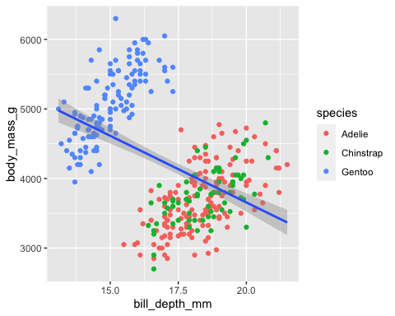

*This lines shows that there is a negative relationship between bill depth and body mass. From this visual we can infer that species biases the relationship.*

What is the relationship between flipper length and body mass? Make another plot with flipper_length_mm on the x-axis, body_mass_g on the y-axis, and points colored by species.

ggplot(data = penguins,   
 aes(x = flipper_length_mm, y = body_mass_g, color = species)) +  
 geom_point()

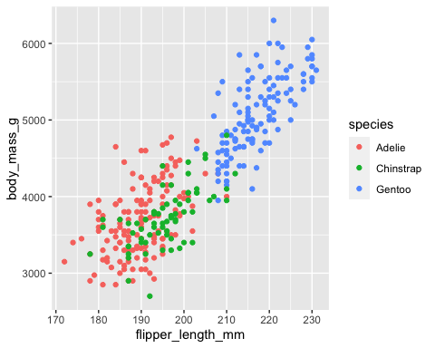

*There is a positive relationship between flipper length and body mass.*

Facet the plot by island (island)

ggplot(data = penguins,  
 aes(x = flipper_length_mm, y = body_mass_g, color = species)) +  
 geom_point() +  
 facet_wrap(vars(island))

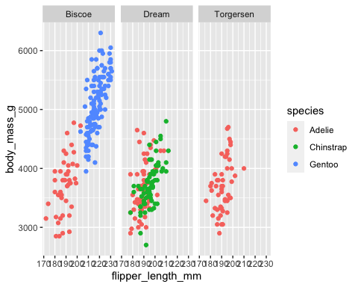

Tell a story about the relationship between flipper length and weight in these three penguin species.

*There is a positive correlation between body mass and flipper length for all species. On average the Gentoo species weighs more and has bigger flippers, while the Adelie and Chinstrap are smaller birds.*

Tell a story about the distribution of penguins across the three islands.

*The Adelie seems to be the most versatile bird, they live on all three islands, while Chinstrap and Gentoo are restricted to their respective habitats.*

## Models

### Predicting weight with bill depth

Does bill depth predict penguin weight?

model_depth_weight <- lm(body_mass_g ~ bill_depth_mm,  
 data = penguins)  
  
tidy(model_depth_weight, conf.int = TRUE)

## # A tibble: 2 × 7  
## term estimate std.error statistic p.value conf.low conf.high  
## <chr> <dbl> <dbl> <dbl> <dbl> <dbl> <dbl>  
## 1 (Intercept) 7489. 335. 22.3 1.13e-68 6829. 8148.  
## 2 bill_depth_mm -192. 19.4 -9.87 2.28e-20 -230. -153.

glance(model_depth_weight)

## # A tibble: 1 × 12  
## r.squared adj.r.squared sigma statistic p.value df logLik AIC BIC  
## <dbl> <dbl> <dbl> <dbl> <dbl> <dbl> <dbl> <dbl> <dbl>  
## 1 0.223 0.220 708. 97.4 2.28e-20 1 -2729. 5463. 5475.  
## # … with 3 more variables: deviance <dbl>, df.residual <int>, nobs <int>

INTERPRET THE COEFFICIENTS AND RESULTS HERE. What happens as bills get taller? Is the association statistically significant? How confident are you about these results? (Hint: look at the $R^{2}$)

*On average, as bill_depth increases by 1 mm, body_mass significantly decreases by 191 grams (p<.001). However, the simple regression only explains 22% of the variation (R^2 = .22), so we can infer that the model may suffer from an omitted variable problem.*

### Predicting weight with bill depth and flipper length

RUN A MODEL that predicts weight with bill depth and flipper length (i.e. body_mass_g ~ bill_depth_mm + flipper_length_mm)

reg1 <- lm(body_mass_g ~ bill_depth_mm + flipper_length_mm, data = penguins)

glance(reg1)

## # A tibble: 1 × 12  
## r.squared adj.r.squared sigma statistic p.value df logLik AIC BIC  
## <dbl> <dbl> <dbl> <dbl> <dbl> <dbl> <dbl> <dbl> <dbl>  
## 1 0.761 0.760 393. 540. 4.23e-106 2 -2527. 5062. 5077.  
## # … with 3 more variables: deviance <dbl>, df.residual <int>, nobs <int>

INTERPRET THESE RESULTS. Did the size of the bill depth coefficient change after controlling for flipper length?

*On average, as bill_depth increases by 1mm, body_mass increases by 22.6 grams at a .10 significance level. 1 mm increase in flipper_length increases body_mass by 51.5 grams (p<.01). The previous model’s omitted variable, flipper_length, biased down the bill_depth coefficient.*

### Predicting weight with bill depth, flipper length, and species

RUN A MODEL that predicts weight with bill depth, flipper length, and species.

reg2 <- lm(body_mass_g ~ bill_depth_mm + flipper_length_mm + species, data = penguins)

glance(reg2)

## # A tibble: 1 × 12  
## r.squared adj.r.squared sigma statistic p.value df logLik AIC BIC  
## <dbl> <dbl> <dbl> <dbl> <dbl> <dbl> <dbl> <dbl> <dbl>  
## 1 0.832 0.830 331. 417. 4.66e-129 4 -2467. 4946. 4969.  
## # … with 3 more variables: deviance <dbl>, df.residual <int>, nobs <int>

INTERPRET THESE RESULTS. What do the species coefficients mean? Did the bill depth coefficient change after controlling for both flipper length and species?

*In this model the Adelie species is used as a reference, so, on average, the Chinstrap is 131.97 grams lighter than the Adelie and the Gentoo is 1288 grams heavier. From the above results, we can see that species biases the bill_depth coefficient down when omitted.*

## All models at the same time

# Right now there's only one model here. Add the others from above (whatever you  
# called them) like so:   
modelsummary(list(model_depth_weight, reg1, reg2))

|  | Model 1 | Model 2 | Model 3 |
| --- | --- | --- | --- |
| (Intercept) | 7488.652 | -6541.907 | -4526.887 |
|  | (335.218) | (540.751) | (516.931) |
| bill_depth_mm | -191.643 | 22.634 | 182.364 |
|  | (19.417) | (13.280) | (18.358) |
| flipper_length_mm |  | 51.541 | 25.700 |
|  |  | (1.865) | (3.098) |
| speciesChinstrap |  |  | -131.968 |
|  |  |  | (51.400) |
| speciesGentoo |  |  | 1288.968 |
|  |  |  | (132.774) |
| Num.Obs. | 342 | 342 | 342 |
| R2 | 0.223 | 0.761 | 0.832 |
| R2 Adj. | 0.220 | 0.760 | 0.830 |
| AIC | 5463.3 | 5061.9 | 4945.7 |
| BIC | 5474.8 | 5077.3 | 4968.7 |
| Log.Lik. | -2728.667 | -2526.968 | -2466.846 |
| F | 97.414 | 539.824 | 416.867 |
| RMSE | 708.08 | 393.18 | 330.77 |

# Task 2: Food access and mortality

# Make sure you look at this dataset by clicking on its name in the Environment  
# panel in RStudio. Sort some of the different columns and look around to get a  
# feel for what's in the data  
food_health <- read_csv("data/food_health_politics.csv")

## Rows: 3143 Columns: 26  
## ── Column specification ────────────────────────────────────────────────────────  
## Delimiter: ","  
## chr (2): state, county  
## dbl (24): FIPS, low_access_pop, low_access_change, pct_low_access_pop, child...  
##   
## ℹ Use `spec()` to retrieve the full column specification for this data.  
## ℹ Specify the column types or set `show_col_types = FALSE` to quiet this message.

We’re interested in looking at the relationships between food access, mortality, and politics. Do do this, we look at data from three different sources:

* The USDA’s [Food Environment Atlas](https://www.ers.usda.gov/data-products/food-environment-atlas/documentation/)
* The CDC’s [“Compressed Mortality File 1999-2015 Series 20 No. 2U, 2016”](http://wonder.cdc.gov/cmf-icd10.html)
* 2016 election results (found all over the internet)

Each row in the dataset is a US county. The main outcome we care about is mortality_rate, or the number of deaths per 100,000 people in a county between 2013-2015. Other interesting variables in the dataset include:

* pct_low_access_pop: Percent of the county’s population with low access to food
* pct_children_low_access: Percent of the county’s children with low access to food
* grocery_stores_per_1000: Number of grocery stores in a county (per 1,000 residents)
* snap_stores_per_1000: Number of stores that accept SNAP (food stamps) in a county (per 1,000 residents)
* fastfood_per_1000: Number of fast food stores in a county (per 1,000 residents)
* per_dem_2012: Percent of the county that voted for Obama in 2012
* per_dem_2016: Percent of the county that voted for Clinton in 2016

## Exploratory analysis

### How related are mortality rate and access to food?

# Notice how this is a little different from what was in the complete example  
# with SAT scores. It's not possible to calculate correlations when there is  
# missing data. The `use = "complete.obs"` argument here tells R to ignore any  
# rows where either mortality_rate or pct_low_access_pop is missing  
cor(food_health$mortality_rate, food_health$pct_low_access_pop,  
 use = "complete.obs")

## [1] -0.1631545

SAY SOMETHING HERE. This is backwards from what you might expect, since it trends downward (i.e. the mortality rate is lower in counties with a greater proportion of the population with low access to food). Why might that be? Is there really a relationship?

*Intuitively, if the population has less access to food, then the mortality rate should increase. The negative relationship above is relatively weak, so there is likely another variable influencing this relationship.*

# Use warning=FALSE in the chunk options to remove the warning about missing data  
ggplot(food_health, aes(x = pct_low_access_pop, y = mortality_rate)) +  
 geom_point() +  
 geom_smooth(method = "lm") +  
 labs(x = "% of county with low access to food",   
 y = "Mortality rate (per 100,000 residents)")

## `geom_smooth()` using formula 'y ~ x'

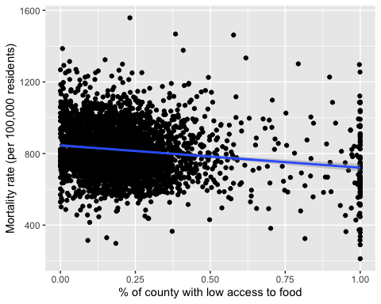

### How related are mortality rate and the prevalence of fast food restaurants?

cor(food_health$mortality_rate, food_health$fastfood_per_1000,  
 use = "complete.obs")

## [1] -0.04379786

SAY SOMETHING HERE

*Mortality rate and number of fastfood restaurants have a weak negative correlation. This makes since, while fastfood does help hunger, it also increases the risk of cardiovascular disease. The two opposing effects cancel out.*

ggplot(food_health, aes(x = fastfood_per_1000, y = mortality_rate)) +  
 geom_point() +  
 geom_smooth(method = "lm") +  
 labs(x = "Number of fast food stores in a county (per 1,000 residents)",   
 y = "Mortality rate (per 100,000 residents)")

## `geom_smooth()` using formula 'y ~ x'

## Warning: Removed 8 rows containing non-finite values (stat_smooth).

## Warning: Removed 8 rows containing missing values (geom_point).

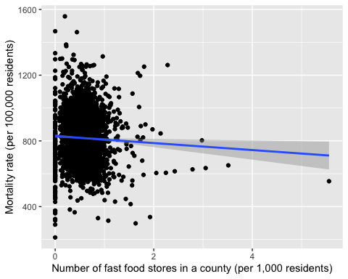

### How related are mortality rate and the prevalence of SNAP stores per 1,000 residents?

cor(food_health$mortality_rate, food_health$snap_stores_per_1000,   
 use = "complete.obs")

## [1] 0.444958

SAY SOMETHING HERE

*Mortality and number of store that accept snap have a moderate positive correlation. Counties that accept SNAP are likely to be poor which increases mortality.*

ggplot(food_health, aes(x = snap_stores_per_1000, y = mortality_rate)) +  
 geom_point() +  
 geom_smooth(method = "lm") +  
 labs(x = "Number of stores that accept SNAP (per 1,000 residents)",   
 y = "Mortality rate (per 100,000 residents)")

## `geom_smooth()` using formula 'y ~ x'

## Warning: Removed 31 rows containing non-finite values (stat_smooth).

## Warning: Removed 31 rows containing missing values (geom_point).

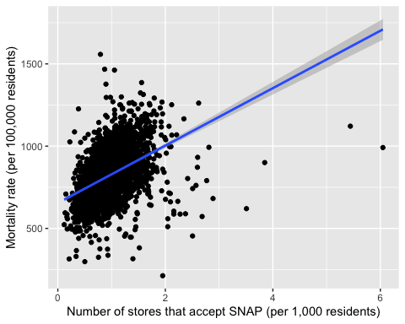

### How related are mortality rate and the percent of the county that voted for Democrats in 2016?

cor(food_health$mortality_rate, food_health$votes_dem_2016,   
 use = "complete.obs")

## [1] -0.1938325

SAY SOMETHING HERE

*There is a weak negative correlation between mortality rates and the number of democratic votes in 2016.*

ggplot(food_health, aes(x = votes_dem_2016, y = mortality_rate)) +  
 geom_point() +  
 geom_smooth(method = "lm") +  
 labs(x = "Percent of the county that voted for Clinton in 2016",   
 y = "Mortality rate (per 100,000 residents)")

## `geom_smooth()` using formula 'y ~ x'

## Warning: Removed 8 rows containing non-finite values (stat_smooth).

## Warning: Removed 8 rows containing missing values (geom_point).

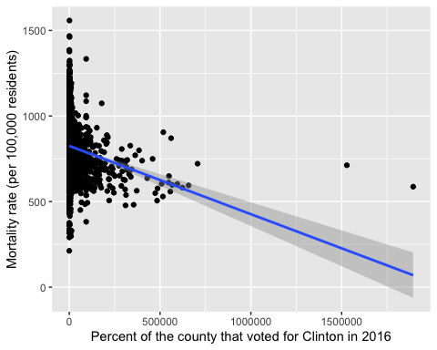

## Models

### Does access to food predict mortality?

SAY SOMETHING HERE

*Intuitively, low access to food should have a causal relationship with mortality. However, the above analysis only shows correlation.*

model_mortality_food <- lm(mortality_rate ~ pct_low_access_pop,  
 data = food_health)  
  
tidy(model_mortality_food, conf.int = TRUE)

## # A tibble: 2 × 7  
## term estimate std.error statistic p.value conf.low conf.high  
## <chr> <dbl> <dbl> <dbl> <dbl> <dbl> <dbl>  
## 1 (Intercept) 845. 4.06 208. 0 837. 853.   
## 2 pct_low_access_pop -125. 13.5 -9.23 4.94e-20 -151. -98.1

# View(select(food_health, mortality_rate, pct_low_access_pop))

glance(model_mortality_food)

## # A tibble: 1 × 12  
## r.squared adj.r.squared sigma statistic p.value df logLik AIC BIC  
## <dbl> <dbl> <dbl> <dbl> <dbl> <dbl> <dbl> <dbl> <dbl>  
## 1 0.0266 0.0263 146. 85.2 4.94e-20 1 -19948. 39901. 39920.  
## # … with 3 more variables: deviance <dbl>, df.residual <int>, nobs <int>

INTERPRET THE COEFFICIENTS AND RESULTS HERE. What happens as the percent of low access to food goes up by 1%? Is that significant? Again, this is backwards from what you’d expect—as the percent of low access goes up, mortality drops. Why might that be? How much do you trust this finding? (Hint: look at the R2 value)

*On average, as pct_low_access_pop increases by 1%, the county’s mortality rate drops by 1.24 (p<.001). The results seem backwards. This simple regression accounts for only 2.6% of the variation in mortality, meaning there are other variables biasing the pct_low_access_pop coefficient.*

### Do more SNAP stores per person predict mortality?

reg5 <- lm(data=food_health, mortality_rate ~ snap_stores_per_1000)  
tidy(reg5, conf.int = TRUE)

## # A tibble: 2 × 7  
## term estimate std.error statistic p.value conf.low conf.high  
## <chr> <dbl> <dbl> <dbl> <dbl> <dbl> <dbl>  
## 1 (Intercept) 654. 6.35 103. 0 642. 667.  
## 2 snap_stores_per_1000 174. 6.30 27.7 3.22e-151 162. 187.

glance(reg5)

## # A tibble: 1 × 12  
## r.squared adj.r.squared sigma statistic p.value df logLik AIC BIC  
## <dbl> <dbl> <dbl> <dbl> <dbl> <dbl> <dbl> <dbl> <dbl>  
## 1 0.198 0.198 131. 768. 3.22e-151 1 -19595. 39196. 39214.  
## # … with 3 more variables: deviance <dbl>, df.residual <int>, nobs <int>

#View(select(food_health, mortality_rate, snap_stores_per_1000))

SAY SOMETHING HERE. What happens as the proportion of SNAP stores goes up? Do you trust this number more or less than low access to food?’

*As snap_stores_per_1000 increases by 1, the mortality rate rises by 174. snap_stores_per_1000 is a much better predictor than pct_low_access_pop. We can infer this by looking at this model’s R^2 score (R^2 = .19). Intuitively, this makes sense. SNAP stores ate primarily in lower class locations, which have higher criminal activity, lower quality education, etc.*

### Do election results and access to food and SNAP stores predict mortality?

RUN A MODEL THAT PREDICTS MORTALITY WITH A BUNCH OF COVARIATES (i.e. mortality_rate ~ pct_low_access_pop + snap_stores_per_1000 + per_dem_2016 + anything else you want to throw in)

reg6 <- lm(mortality_rate ~ pct_low_access_pop + snap_stores_per_1000 + per_dem_2016 + grocery_stores_per_1000, data = food_health)  
tidy(reg6, conf.int = TRUE)

## # A tibble: 5 × 7  
## term estimate std.error statistic p.value conf.low conf.high  
## <chr> <dbl> <dbl> <dbl> <dbl> <dbl> <dbl>  
## 1 (Intercept) 746. 7.77 96.1 0 731. 761.   
## 2 pct_low_access_pop -86.2 12.4 -6.97 3.87e- 12 -111. -62.0  
## 3 snap_stores_per_1000 217. 6.05 35.9 1.22e-236 206. 229.   
## 4 per_dem_2016 -181. 14.2 -12.7 2.62e- 36 -208. -153.   
## 5 grocery_stores_per_… -221. 11.6 -19.0 4.55e- 76 -244. -198.

glance(reg6)

## # A tibble: 1 × 12  
## r.squared adj.r.squared sigma statistic p.value df logLik AIC BIC  
## <dbl> <dbl> <dbl> <dbl> <dbl> <dbl> <dbl> <dbl> <dbl>  
## 1 0.341 0.340 119. 400. 6.17e-278 4 -19163. 38338. 38374.  
## # … with 3 more variables: deviance <dbl>, df.residual <int>, nobs <int>

#View(select(food_health, mortality_rate, pct_low_access_pop, snap_stores_per_1000, per_dem_2016, grocery_stores_per_1000 ))

SAY SOMETHING HERE. Interpret the different coefficients. How predictive is this model (i.e. what’s the R2)? Do you believe this model?

*On Average, as pct_low_access_pop increases by 1%, mortality rate decreases by .86. As snap_stores_per_1000 increases by 1, mortality rate increases by 217. As per_dem_2016 increases by 1%, mortality rate decreases by 1.8. As grocery_stores_per_1000 increases by 1, mortality rate decreases by 220.89. This model accounts for 34.13% of the variation in mortality rate. The the models robustness has greatly increases from the simple regressions, so I am more likely to believe this one.*

### Mortality, contolling for state differences

RUN A MODEL with some number of plausible independent/explanatory variables. Include state as one of them

# Add other explanatory variables here  
model_with_state <- lm(mortality_rate ~ pct_low_access_pop + state + snap_stores_per_1000 ,  
 data = food_health)  
  
# This table is 50+ rows long! While it might be interesting to see changes in  
# intercept in relation to Alaska (the omitted state here), like how Alabama's  
# mortality rate is 137 higher than Alaska's while DC's is 84 lower, it's not  
# super helpful. Controlling for state does capture some of the state-specific  
# reasons for varying mortality though, so it's good to include. We just don't  
# really need to see all those coefficients. To remove them from this table of  
# results, filter them out. The "!" in R means "not", so here we're only looking  
# at rows that don't start with "state"  
tidy(model_with_state, conf.int = TRUE) %>%   
 filter(!str_starts(term, "state"))

## # A tibble: 3 × 7  
## term estimate std.error statistic p.value conf.low conf.high  
## <chr> <dbl> <dbl> <dbl> <dbl> <dbl> <dbl>  
## 1 (Intercept) 622. 23.3 26.7 4.22e-141 576. 667.   
## 2 pct_low_access_pop -95.2 11.6 -8.20 3.43e- 16 -118. -72.4  
## 3 snap_stores_per_1000 134. 5.69 23.6 2.20e-113 123. 146.

glance(model_with_state)

## # A tibble: 1 × 12  
## r.squared adj.r.squared sigma statistic p.value df logLik AIC BIC  
## <dbl> <dbl> <dbl> <dbl> <dbl> <dbl> <dbl> <dbl> <dbl>  
## 1 0.483 0.474 106. 54.7 0 52 -18788. 37683. 38009.  
## # … with 3 more variables: deviance <dbl>, df.residual <int>, nobs <int>

SAY SOMETHING ABOUT THIS MODEL

*By including state fixed effects, we are about to account for 48% of the variation in mortality rate.*

## All models at the same time

PUT ALL THE MODEL RESULTS IN THE SAME SIDE-BY-SIDE TABLE HERE

# Right now there are only two models here. Add the others from above (whatever   
# you called them) like so:   
# modelsummary(list(model_mortality_food, some_other_model, yet_another_model, etc))  
  
# Also, by default, modelsummary will include all the state coefficients, which  
# we don't want. We can omit specific coefficients with the `coef_omit`  
# argument. The ^ character means it'll omit coefficients that *start with*  
# "state". Without ^, it would omit any coefficient where the characters "state"  
# appeared anywhere in the name, which might be too greedy  
  
modelsummary(list(model_mortality_food, model_with_state, reg5, reg6),  
 coef_omit = "^state")

|  | Model 1 | Model 2 | Model 3 | Model 4 |
| --- | --- | --- | --- | --- |
| (Intercept) | 845.314 | 621.735 | 654.367 | 746.259 |
|  | (4.056) | (23.302) | (6.350) | (7.767) |
| pct_low_access_pop | -124.516 | -95.207 |  | -86.245 |
|  | (13.493) | (11.607) |  | (12.374) |
| snap_stores_per_1000 |  | 134.444 | 174.487 | 217.433 |
|  |  | (5.692) | (6.297) | (6.050) |
| per_dem_2016 |  |  |  | -180.566 |
|  |  |  |  | (14.165) |
| grocery_stores_per_1000 |  |  |  | -220.891 |
|  |  |  |  | (11.638) |
| Num.Obs. | 3116 | 3093 | 3112 | 3093 |
| R2 | 0.027 | 0.483 | 0.198 | 0.341 |
| R2 Adj. | 0.026 | 0.474 | 0.198 | 0.340 |
| AIC | 39901.5 | 37683.1 | 39196.3 | 38337.5 |
| BIC | 39919.6 | 38009.1 | 39214.4 | 38373.7 |
| Log.Lik. | -19947.736 | -18787.559 | -19595.130 | -19162.763 |
| F | 85.160 | 54.659 | 767.746 | 399.981 |
| RMSE | 145.93 | 106.05 | 131.37 | 118.79 |