CERDEC Computer GUI Layout

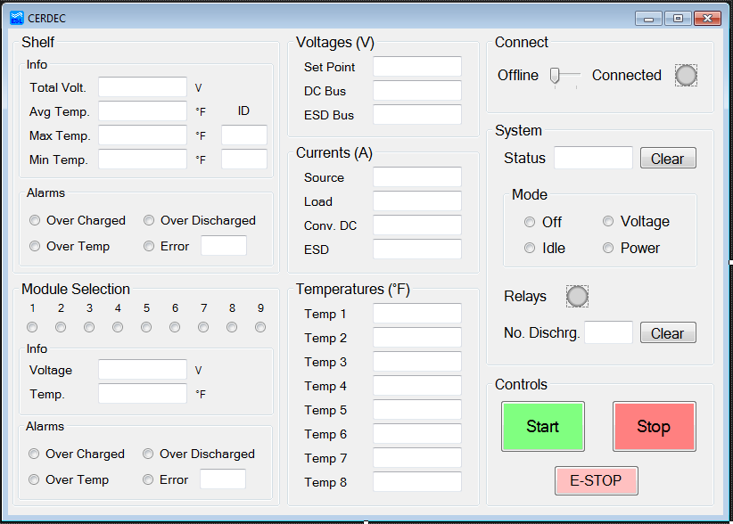

**Right Column – Control and Status**

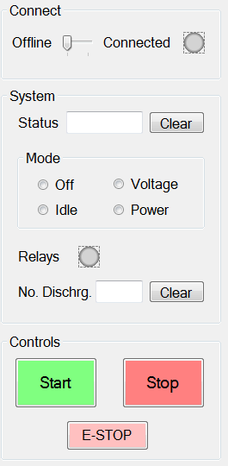

* Connect to Unit with LED to show status
  + Gray – Offline
  + Green - Connected
* System Status - Shows received status from the converter
* System Mode - Allows the user to select the operating mode
* Relay Status is simply an LED
  + Red – Open
  + Green – Closed
  + Orange – Fault/Alarm
* Number of Discharges – Keeps track of the number of discharges
* Start Button – sends the command to start the system
* Stop Button – Sends the command to stop the system
* E-STOP – Emergency Stop for the system

**Center Column – System Readings**

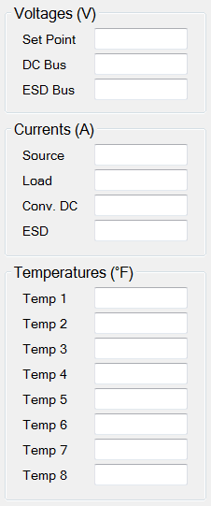

* Voltages – Displays values reported by the converter
  + Bus Voltage Set Point
  + Actual DC Bus Voltage
  + Actual ESD BUS Voltage
* Currents – Displays values reported by the converter
  + Actual Source Current
  + Actual Load Current
  + Actual Converter (DC) Current
  + Actual ESD Current
* Temperatures – Shows the 8 temperatures reported by the converter

**Left Column – External Controller Readings**

* 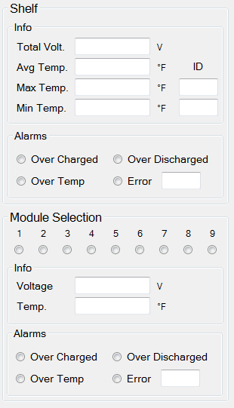Shelf – Info
  + Total Voltage for all of the capacitors
  + Average Temperature for the capacitors
  + Max Temperature and Module ID
  + Min Temperature and Module ID
* Shelf – Alarms
  + Over Charge, Over Temp, Over Discharge, Error and Error Code
* Modules Selection – Choose Module to display information about
* Module – Info
  + Selected module’s voltage
  + Selected module’s temperature
* Module – Alarms
  + Over Charge, Over Temp, Over Discharge, Error and Error Code