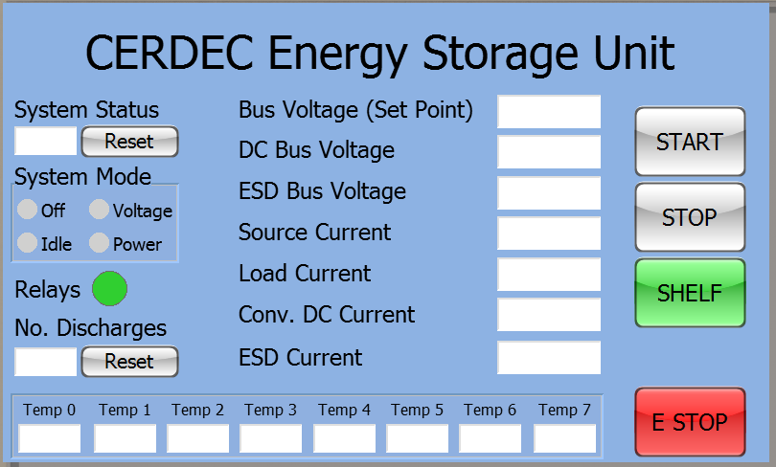

Overview Screen

* System Status - Shows received status from the converter
* System Mode - Allows the user to select the operating mode
* Relay Status is simply an LED
  + Red – Open
  + Green – Closed
  + Orange – Fault/Alarm
* Number of Discharges – Keeps track of the number of discharges
* Readings – Displays values reported by the converter
  + Bus Voltage Set Point
  + Actual DC Bus Voltage
  + Actual ESD BUS Voltage
  + Actual Source Current
  + Actual Load Current
  + Actual Converter (DC) Current
  + Actual ESD Current
* Start Button – sends the command to start the system
* Stop Button – Sends the command to stop the system
* Shelf Button – Goes to the “Shelf” screen and show shelf status
  + Green – No Alarms/Errors
  + Red – Either shelf alarm/error, or single module alarm/error
* Emergency Stop – Obvious and “out of the way”
* Temperatures – Shows the 8 temperatures reported by the converter

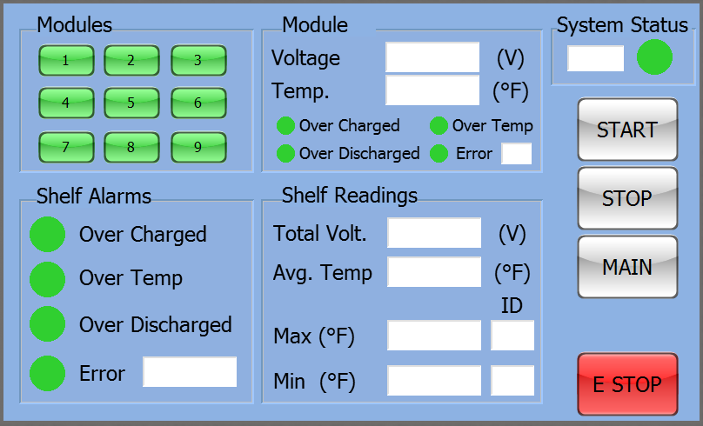

Shelf Screen

* Modules – Allows for quick selecting information about a module
  + Green – No alarms/errors
  + Red – Alarm/error
* Module #
  + Shows specifics for the selected module
* Shelf Alarms – Shows status of the various alarms and error codes reported by the shelf
* System Status with Hex code and indication LED for quick status assessment
  + Green – “On”
  + Gray – “Standby”
* Shelf Readings – Shows various readings received from the shelf
* Emergency Stop added to form as well