Construction environment:

windows10

Phpstudy

5.3.29

Project download address: https://gitee.com/sw1981/ForU-CMS?_from=gitee_search

Vulnerability File Directory

C:\phpStudy\PHPTutorial\WWW\ForU-CMS-dev\admin\cms_chip.php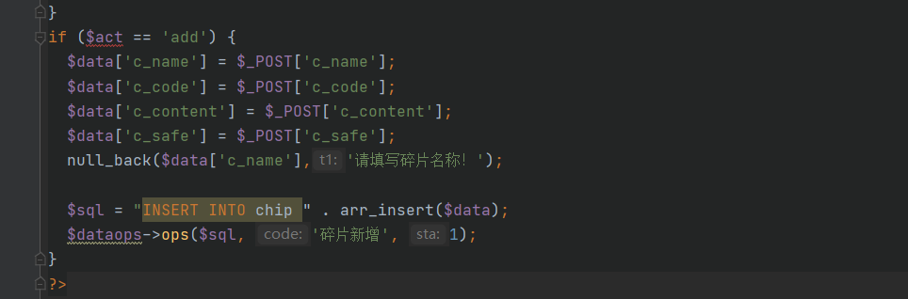

POST receives data transmitted by users

However, the process does not filter the xss attack payload input by the user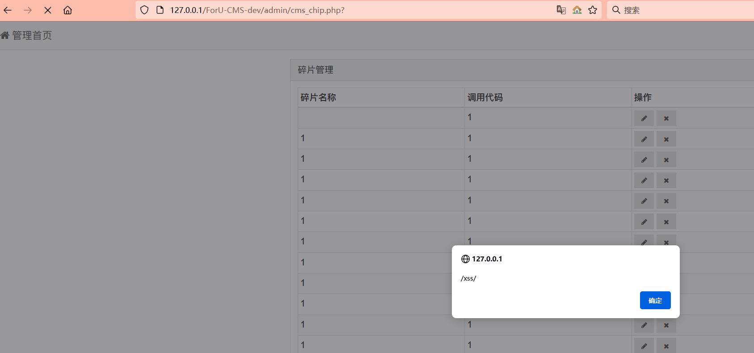

c_ name value

<img src="x" onerror="alert(/xss/);">