**Re-design of along-track filters for the various types of radar altimetry data.**

David Sandwell, June, 2013

Yao Yu, updated August 2019

The low-pass filtering of the altimeter data is done in three steps. (1) First the ~20Hz data are filtered and resampled at 5 Hz. The filter has a 0.5 gain at 6.7 km. At this point, the 5 Hz data can be edited. (2) The next step is to low-pass filter the 5 Hz data. This filter has a 0.5 gain at 10 km wavelength. These data and uncertainties are fed into the 1-minute gridding program where north and east slopes are produced. (3) Finally the north and east slopes are combined to form gravity anomalies and a 2-D low-pass filter is applied. Various 0.5 gain wavelengths for the 2-D are selected ranging from 14 km to 24 km.

Note that each altimeter data stream has its own sampling rate and ground-track velocity (Table 1) so all the low-pass filters need to be crafted so they all match in their wavenumber roll-off characteristics.

Table 1. Sampling characteristics of each altimeter.

|  |  |  |  |  |  |
| --- | --- | --- | --- | --- | --- |
| Satellite | Velocity (m/s) | *dt1 (sec)* | *dt2 (sec)* | *dx1 (m)*  20 Hz | *dx2 (m)*  5 Hz |
| Geosat | 6770 | .0980 | .1960 | 663.5 | 1326.9 |
| ERS-1 | 6690 | .0490 | .1961 | 327.9 | 1312.0 |
| Envisat | 6690 | .0557 | .2228 | 372.6 | 1490.5 |
| Jason-1 | 5740 | .05097 | .2039 | 292.6 | 1170.4 |
| CryoSat-LRM | 6779 | .04718 | .1887 | 319.8 | 1279.2 |
| CryoSat-SAR | 6779 | .04415 | .1766 | 299.8 | 1197.3 |
| CryoSat-SIN | 6779 | .04453 | .1761 | 299.3 | 1193.8 |
| Sentinel-3 | 6690 | .0493 | .1972 | 329.8 | 1319.2 |

Table provides the along-track sampling characteristics for the raw waveform data dt1 and dx1 as well as the 5Hz data dt2 and dx2.

**20 Hz Filter Design**

We use the Matlab program remez() to design FIR filters to begin the cut at a wavelength of 10 km and end at a wavelength of 5 km. The ½ gain of the filter is set to a wavelength of 6.7 km. An example of the filter designed for CryoSat-SAR follows. After application of this filter the data are resampled a 5 Hz or a spacing of about 1.3 km. This sampling completely captures the low-pass filtered signal. Note the standard 1 Hz sampling provided by the space agencies in their standard products will not capture the full spectrum of the data so the decimation will cause folding of the aliased wavelengths shorter than 14 km into the longer wavelength parts of the spectrum.

dsmac:Users:sandwell:Desktop:cryo_20Hz.pdf

Figure 1. (lower) Spectrum of low-pass filter (blue) designed for CryoSat SAR data. The filter starts to cut at a wavelength of 10 km and has complete attenuation at 5 km. The 0.5 gain occurs at 6.7 km. (upper) The shape of the 99-point FIR filter (blue) and the matching derivative filter (red).

Matching low-pass filters were designed by eye for each of the 7 types of altimeter data. A plot of all the filters versus distance is shown in Figure 2.



Figure 2. FIR filters to be applied to all the full-rate data are basically matched. Each filter is normalized to one so they have slightly different amplitudes but similar spectral response. All the filters are 99 points long except for Geosat, which is 49 points long.

**5 Hz Filter Design**

The resampled 5 Hz data form the condensed data record (CDR) that is further edited, and manipulated using a series of “alt” programs. The CDR data are processed in continuous data segments. There is a program called afilter where an additional low-pass filter can be applied. One option is to use a Gaussian filter. However Gaussian filters cause amplitude attenuation even at long wavelengths so again we have used the matlab program remez() to develop custom low-pass filters for each satellite based on their along-track sampling distance *dx2.* An example for the ERS-1 filter is shown in Figure 3.

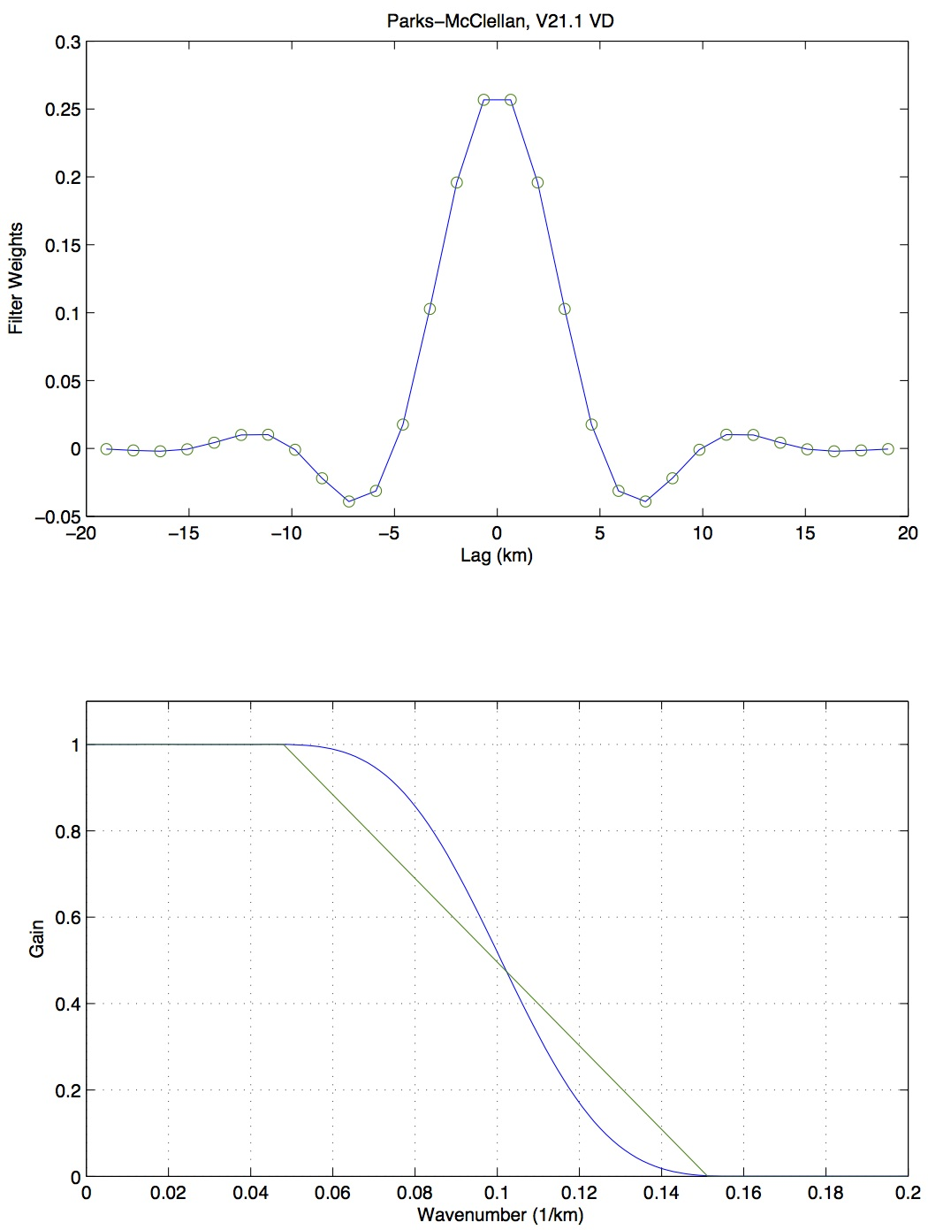

Figure 3. (lower) Spectrum of low-pass filter (blue) designed for ERS-1 data, which have been subsampled at 5 Hz. The filter starts to cut at a wavelength of 16 km and has complete attenuation at 6.7 km. The 0.5 gain occurs at 10 km. (upper) The shape of the 30-point FIR filter (blue).

Matching low-pass filters were designed by eye for each of the 7 types of altimeter data. A plot of all the filters versus distance is shown in Figure 4.



Figure 4. FIR filters applied to all the 5 Hz data are basically matched. Each filter is normalized to one so they have slightly different amplitudes but similar spectral response. All the filters are 30 points long.